Comparative Analysis of Machine Learning Models for Student Performance Prediction Across Multiple Educational Datasets

Tansel Ozyer^{1*,} Nefise Buse Uzun¹, Merve Karataş¹, Gül Akkoca¹, Merve Toprak¹, İrem Toprak¹, Furkan Altıngöz¹
¹Ankara Medipol University, Faculty of Engineering and Natural Sciences, Computer Engineering Department, Ankara, Turkey
Corresponding Author: Tansel Özyer - tansel.ozyer@ankaramedipol.edu.tr

Abstract

Student academic performance prediction is an important research topic in data mining and machine learning. This study aims to analyze the factors affecting student academic achievement and compare the performance of different machine learning models. For this purpose, six different student performance datasets were used. These datasets include academic, demographic, behavioral, family-related, and socioeconomic variables. In this study, several regression-based machine learning models were applied, including Linear Regression, Ridge Regression, Lasso Regression, Random Forest, Gradient Boosting, and XGBoost. The models were evaluated using MAE, MSE, RMSE, and R² metrics. The results showed that academic factors such as study hours, attendance, previous scores, and preparation-related variables had an important effect on student performance. In most datasets, linear-based models provided strong and interpretable results, while more complex models did not always improve prediction performance.

Overall, this study shows that machine learning can be used as an effective tool for predicting student achievement and understanding the main factors related to academic success.

Keywords: Machine Learning, Educational Data Mining, Student Performance Prediction, Random Forest, XGBoost.

1.Introduction
Predicting students’ academic performance has become a significant research subject in the fields of data mining and machine learning. Educational institutions collect large amounts of data regarding students’ academic achievement, attendance, study routine, family factors. Analyzing of the data helps to identify the factors that affect student performance and detect the student which is low academic achievement risk. Machine learning methods provides reliable and powerful tools that can predict the student’s future academic performance and clarify the complex relationships in the training data. This enables to educators better understand students’ needs and make data-driven decisions.
This research aims to compare the performances of different machine learning algortihms in predicting student achievement. For this purpose, six different training datasets with varying characteristics were used. Data sets include demographic, academic, behavioral, and socioeconomic variables, representing various factors that can influence student achievement. The factors that influence the success, especially in education, are not the same for every student. While study time may be more determining factor for some students, attendance, family support or previous academic achievement may influence others. Because of this, examining several datasets instead of examining one dataset provides a broader perspective for evaluating the student performance.
In this study, various regression-based machine learning models such as Linear Regression, Ridge Regression, Lasso Regression, Random Forest, Gradient Boosting, and XGBoost were applied and compared. The performance of the models was evaluated using common regression measures such as MAE, MSE, RMSE, and R². The main goal of comparing these models is to figure out which factors truly shape academic success, while also finding the most accurate prediction tool for different educational datasets.

Related Works

Systematic Reviews and the Maturation of the Field

Machine learning has become a widely used approach for predicting student academic performance. Previous studies show that this research area has developed considerably over the last fifteen years. In their systematic review of Educational Data Mining studies between 2009 and 2021, Rastrollo-Guerrero et al. [1] reported that absenteeism, quiz scores, midterm exam results, and learning environment factors were commonly used to predict student performance. They also found that decision tree-based models, especially C4.5 and Random Forest, were frequently preferred in these studies. Aldowah et al. [2] also reviewed 84 studies and found that previous academic achievement was one of the most commonly used predictors of student success. This point is important for comparing different datasets. For example, in the UCI Student Performance dataset, variables such as G1 and G2 represent earlier grades, while G3 represents the final grade. If G1 and G2 are used to predict G3, the model may achieve a high accuracy because these variables are already closely related to the final grade. Therefore, high model performance in this case may not always mean that the model has learned the real effects of social, behavioral, or educational factors. This issue should be considered carefully when interpreting prediction results

Ensemble Model Comparisons: Random Forest,XGBoost and LightGBM

Ensemble models are frequently used in student performance prediction because they can handle complex relationships between variables better than simple models. Monika et al. [3] compared several models, including Linear Regression, Random Forest, Gradient Boosting, XGBoost, LightGBM, Support Vector Regressor, and Stacking Regressor. These models are similar to the models used in the present study. Their results showed that gradient boosting-based models generally performed better than linear models. However, the difference between model performances depended on the selected features and whether the dataset contained variables that could cause data leakage. Okonkwo and Ade-Ibijola [4] also compared Random Forest and XGBoost in a student performance prediction task. Their findings showed that both models produced strong results, but Random Forest performed slightly better than XGBoost according to the main regression metrics. The authors explained this result by stating that Random Forest can work more reliably when some input variables are correlated with each other. This is important in student datasets because variables such as study duration, retention rate, and previous GPA may be related to one another. Murtaza et al. [5] reported that XGBoost is also a strong model because it can handle missing values and correlated variables effectively. This makes XGBoost useful for datasets where the variables are not evenly distributed or where the data structure is irregular. The same study also showed that model accuracy and interpretability can be considered together when SHAP-based explanation methods are used.

A more recent study published in Scientific Reports in 2025 [6] compared ensemble-based approaches using 5-fold cross-validation. In this study, LightGBM achieved the highest performance among the base learners, with an AUC score of 0.953 and an F1 score of 0.950. However, the Stacking model produced the best overall performance. The study also found that early academic indicators were the most influential variables according to SHAP analysis. This result again points to the importance of data leakage. If early grades or similar academic proxy variables are included in the model, the model may achieve high accuracy, but this may not fully explain the real effects of behavioral or socioeconomic factors on student success.

Socioeconomic Status and Parental Involvement

Academic performance is influenced not only by educational factors but also by family background and socioeconomic conditions. Yılmaz and Özkan [7] found that students from higher socioeconomic backgrounds generally perform better because they have better access to educational resources. Their study also showed that this effect can be observed across different schools, regions, and educational settings. In addition, parental expectations were identified as an important factor. High parental expectations may increase students’ motivation, study discipline, and academic resilience. A 2022 review including 42 studies [8] supports these findings. This review showed that home literacy support, parental encouragement, and family discussions about school are positively related to academic achievement, especially at the elementary and secondary school levels. These findings are directly related to the variables used in this study, such as parental education level, family income, and access to educational support.

Overall, these studies show that family and socioeconomic variables should not be considered as minor background information. Instead, they should be treated as important factors that can directly affect student performance. For this reason, these variables were included as key attributes in the classification framework presented in Chapter III.

Behavioral and Lifestyle Determinants: Sleep, Study Habits, and Engagement

The role of behavioral variables in academic performance has gained strong empirical support in recent years, particularly with the increasing use of survey-based and sensor-derived datasets. A longitudinal study conducted at Carnegie Mellon University [9] showed that students who slept less than six hours per night experienced a measurable decrease in their end-of-term grade point averages. The study also found that each hour of lost sleep was associated with an average decrease of approximately 0.07 points in GPA. This effect remained significant even after controlling for prior academic performance, race, gender, and first-generation student status. This dose-response relationship is directly related to the sleep variables used in this study, including sleep_hours and sleep_quality in the dataset3 dataset and sleep_hours in the dataset 4. Zhu et al. [10] broadened this perspective by examining metacognitive awareness, learning motivation, time management, and mental health as key factors affecting academic achievement. In their machine learning analysis of Chinese university students, these factors were identified as the most effective predictors of academic performance. The study also reported that XGBoost achieved the highest recall and accuracy values among the evaluated models.

Another important finding of the same study was that time management and participation quality had stronger predictive power than static demographic attributes. This finding is consistent with the feature design of the dataset 1, dataset 3, and dataset 4, where variables such as study_hours, participation_score, assignment_completion_rate, and social_media_hours directly represent students’ study habits, participation, and engagement levels. Therefore, this consistency supports the use of these variables as analytical dimensions in the cross-dataset synthesis presented in Chapter V.

Studies in Turkey

Several studies conducted in Turkey have also examined student performance prediction using machine learning methods. One of the early examples is a 2017 study by Gazi University [11], which used data collected from middle school students. This study made an important contribution to the literature by showing that family, demographic, and school-based variables can be used to predict Turkish, Math, and end-of-term grade point averages. The study applied decision tree and ensemble-based methods for this prediction task. Another study conducted at Dicle University [12] used survey data collected from 519 students. The results showed that Random Forest was the best-performing model. The study also identified family income and weekly study hours as the most important predictive features. This finding supports the idea that socioeconomic variables should be considered as key determinants of student achievement in the Turkish context. The study most closely related to the present research is the recent work from Bingöl University [13]. In that study, Exam_Score was predicted using a dataset of 6,607 samples. The dataset included variables such as study duration, attendance rate, sleep, prior achievement, peer influence, and learning difficulties. The study also used multiple evaluation metrics, including MAE, RMSE, and R², together with hyperparameter optimization. This data structure is directly similar to the D1 Dataset used in the comparative framework of the present study and provides a clear reference point for the methodological approach adopted in the early warning modeling framework.

Methodology

Data Collection / Dataset
This study aims to predict student academic performance using six different educational datasets obtained from publicly available sources. The datasets differ in terms of sample size, feature composition, target variables, and educational contexts. Some datasets focus on exam scores, while others include GPA-based academic performance indicators. The use of multiple datasets enables a comparative analysis of student success prediction across different data structures and learning environments.

In the Dataset 1 section of this study, the Student Performance Factors Dataset was used to predict student academic performance. The dataset was downloaded from the StudentPerformanceFactors.csv file available on Kaggle. The

dataset contains a total of 6,607 observations and 20 variables. This dataset brings together individual, family, academic, and environmental factors that may influence students’ academic success. The dataset includes numerical features such as Hours_Studied, Attendance, Sleep_Hours, Previous_Scores, Tutoring_Sessions, and Physical_Activity. In addition, it includes categorical features such as Parental_Involvement, Access_to_Resources, Motivation_Level, Family_Income, Teacher_Quality, School_Type, Peer_Influence, Learning_Disabilities, Parental_Education_Level, Distance_from_Home, and Gender.
In this study, Exam_Score was selected as the target variable. Since Exam_Score represents a student’s exam performance, the problem was considered as a regression problem. Therefore, the aim of this study is to predict exam performance based on students’ academic and social characteristics and to evaluate which model is more successful in this prediction task.
In the Dataset 2, the Students Performance Dataset from Kaggle was used. The dataset was created to analyze the factors affecting students’ academic performance. It contains information related to student’s study habits, parental education level, extracurricular activities. The dataset consists of 2392 student information and 15 variables. Variables include information such as students age, gender, ethnicity, parental education level, weekly study time, tutoring support, parental support.

Table 1. GPA grade classification and letter grade ranges.
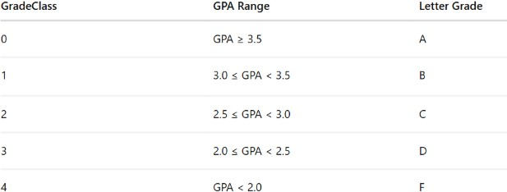

In this study GPA selected as the target variable. GPA is numerical variable representing students’ academic performance and ranges between 0 and 4. The dataset includes variable called GradeClass. This variable is created from GPA values. Because of this reason, GradeClass was not used during model training for avoid data leakage.
In Dataset 3, the Exam Score Prediction Dataset was used to analyze and predict students’ exam performance. The dataset contains 20,000 student records and 13 variables. It provides information about different factors that may be related to students’ exam results, such as study habits, attendance, learning environment, and exam difficulty.
The dataset consists of both numerical and categorical variables. The numerical variables are age, study_hours, class_attendance, sleep_hours, sleep_quality, facility_rating, exam_difficulty, and exam_score. The categorical variables are gender, course, internet_access, and study_method. The student_id column was not used in the analysis because it only represents a unique identification number for each student.
The exam_score variable was selected as the prediction target because it directly represents students' examination performance. Since this variable is a continuous numerical value, the study was treated as a regression problem. The main aim is to predict students’ exam scores using the other variables in the dataset and to compare the results of different machine learning models.
In Dataset 4, the Students Performance Dataset from Kaggle was used to analyze and predict students’ academic performance. The dataset includes 1,000 student records and 8 variables. It contains students’ exam results as well as some demographic and educational information that may be related to their academic success. The dataset has five categorical variables: gender, race/ethnicity, parental level of education, lunch, and test preparation course. It also includes three numerical variables: math score, reading score, and writing score. These scores show students’ performance in different academic areas.

A new variable, average_score, was created by averaging math, reading, and writing scores. This variable was selected as the prediction target because it provides a comprehensive representation of students' overall academic performance. Since average_score is continuous, the prediction task was formulated as a regression problem. The main purpose of this study is to predict students’ overall academic performance and examine how demographic and educational factors may affect this performance.

In Dataset 5, the "UCI Student Performance" dataset, compiled by Cortez and Silva (2008), examines the academic achievement and socio-demographic background of students in mathematics at two different secondary schools in Portugal (Gabriel Pereira and Mousinho da Silveira). In its original form, the dataset included 395 student records and
33 variables (17 categorical, 16 numerical) covering students' demographic characteristics, family structures, educational support, absenteeism, and in-term grades. Statistics for the main variables of the dataset are presented in Table 1.

G3 prediction is a regression problem since the target variable ranges from 0 to 20 as integer values. An important decision on pre-processing was taken early in the study. 38 students with a final grade of exactly 0 were excluded from analysis. Closer inspection of these records revealed that almost all these cases were associated with high absenteeism or multiple previous class failures. This trend is a strong indicator that these students have a very high probability of dropping the course altogether or never taking the final exam. Therefore, these records were interpreted as a separate structural anomaly, not related with the normal academic performance. To prevent potential bias and ensure the stability of the predictive models, these 38 observations were completely removed prior to any modeling phase, reducing the final working dataset to 357 records.
In Dataset 6, the Student Performance Dataset was used to analyze and predict students’ academic achievement. The dataset contains 5,000 student records and 16 variables. It includes demographic, academic, and family-related factors that may influence student performance.
The dataset consists of both numerical and categorical variables. Numerical variables include Age, Class, Study_Hours_Per_Day, Attendance_Percentage, Previous_Year_Score, Math_Score, Science_Score, English_Score, and Final_Percentage. Categorical variables include Gender, Parental_Education, Internet_Access, Extracurricular_Activities, Performance_Level, and Pass_Fail. Final_Percentage was selected as the target variable due to its ability to represent overall academic achievement. Since Final_Percentage is a continuous numerical variable representing overall academic performance, the problem was considered a regression task.
Additionally, an average_score variable was created using Math_Score, Science_Score, and English_Score to test and perform supplementary exploratory analysis. However, the primary prediction target remained Final_Percentage. To avoid data leakage, Math_Score, Science_Score, English_Score, Performance_Level, and Pass_Fail were excluded from model training. These variables are directly related to the target variable and could artificially increase model performance. The Student_ID variable was also removed because it only serves as a unique identifier and does not contribute to prediction.

Preprocessing
Before the modeling phase, various preprocessing steps were applied to the Dataset 1. First, the overall structure of the dataset was examined, numerical and categorical variables determined, and missing values checked. Missing values in numerical variables were imputed using the median, while missing values in categorical variables were imputed using the mode.
Next, the categorical variables were prepared to be suitable for machine learning models. Ordinal encoding applied to variables with an ordinal structure, while binary encoding applied to variables with two classes. For example, the values Low, Medium, and High were represented as 0, 1, and 2, respectively; variables such as Yes/No, Public/Private, and Male/Female were represented by the values 0 and 1.
The dataset was split using the train-test split method. 80% of the data was used as the training set, and 20% as the test set. As a result of this process, the training set contains 5,285 observations, and the test set contains 1,322 observations.
To minimize the impact of outliers, winsorization applied to numerical features in the training data. Additionally, scaling was performed using StandardScaler for some models. In particular, Linear Regression was trained on the scaled data.

Finally, as part of the feature engineering process, new features named study_consistency, rest_ratio, support_score, and disadvantage flag were created. These features were added to represent study habits, work-rest balance, level of support, and disadvantage status. After these steps, the total number of features reached 23.
Before model development, several preprocessing steps were applied to Dataset 2. First, dataset examined for missing and duplicate values. Analysis showed that there were no missing values and no duplicated variable.
Several new features were generated from variables:

Table 2. Engineered features and their definitions for Dataset 2.
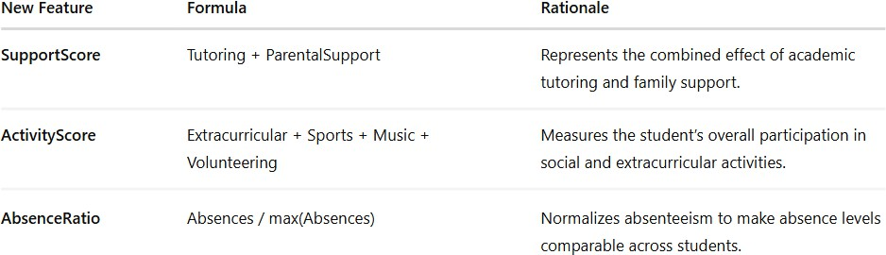

To evaluate the performance of model divided into two. For training %80, for test %20 Training set used to train the machine learning models. Test set used to evaluate model performance on unseen data.
Feature scaling applied for Ridge Regression and Lasso Regression models using StandardScaler. Scaling was necessary because these regression models are sensitive to differences. Before model development, several preprocessing steps were applied to Dataset 3. First, the dataset was examined to understand its size, variable types, and overall structure. The missing value check showed that there were no missing values in the dataset. Therefore, no additional cleaning process was required.
In the next step, the dataset was organized for the prediction task. The student_id column was removed because it only represents a unique identification number and does not provide meaningful information for prediction. The exam_score variable was selected as the target variable, and the remaining variables were used as predictors in the model. Since the dataset included categorical variables, gender, course, internet_access, and study_method were converted into numerical form using one-hot encoding. This allowed these variables to be included in machine learning models. Numerical variables were also scaled before training so that they could be processed on a similar scale.

After these transformations, the dataset was split into training and testing sets. 80% of the data was used for training, and 20% was reserved for testing. As a result, the training set contained 16,000 records, while the test set contained 4,000 records. With these preprocessing steps, Dataset 3 became suitable for model training and evaluation.

Before applying machine learning models to Dataset 4, the data was first prepared for analysis. In the first step, the general structure of the dataset was checked, and the variable types were reviewed. The dataset includes 1,000 records and 8 variables, consisting of both categorical and numerical data. The missing value check showed that there were no missing values in any column. For this reason, no filling or row deletion process was needed. During preprocessing, a new variable named average_score was created. This variable was calculated by taking the average of math score, reading score, and writing score. It was used as the target variable because it gives a general representation of each student’s academic performance.

After the target variable was created, the categorical variables were converted into numerical form. For this step, one-hot encoding was applied to gender, race/ethnicity, parental level of education, lunch, and test preparation course. In this way, text-based categories were transformed into binary columns that could be used by machine learning models.

Then, the dataset was separated into input variables (X) and the target variable (y). After this separation, the train-test split method was applied. In this process, 80% of the data was used for training and 20% was reserved for testing. As

a result, the training set included 800 records, while the test set included 200 records. After these preprocessing steps, Dataset 4 became ready for model training and evaluation.

Before model development, several preprocessing steps were applied to Dataset 5. The missing value check confirmed 0 missing values across all 33 columns, so no imputation was required. The only data cleaning step was removing the 38 records where G3 = 0 to focus the regression on genuine academic performance. After this step, the working dataset contains 357 observations.
All 17 categorical variables were converted to numeric form using Label Encoding. Each unique category value was mapped to an integer (e.g., school 'GP' → 0, 'MS' → 1; sex 'F' → 0, 'M' → 1). This transformation makes the data compatible with all scikit-learn regression estimators. One-hot encoding was not used to keep the feature space manageable and because tree-based models handle label-encoded categoricals effectively. Then six new features were created to capture interaction effects and composite patterns not directly available in the original variables:
Table 3. Engineered Features and Their Definitions for dataset 5.

New Features Formula Rationale

G1_G2_mean (G1 + G2) / 2 Mid-year performance average
G1_G2_product G1 × G2 Interaction between period grades G1_G2_diff G2 − G1 Grade trend (improvement/decline)

social_risk goout + Dalc + Walc
Combined social and alcohol risk

parent_edu_mean (Medu + Fedu) / 2 Average parental education level

support_score schoolsup + famsup + paid
Total academic support received

After feature engineering, the total number of features increased from 32 to 38. The engineered dataset was used specifically for the XGBoost models in Part 3, while the base 32-feature dataset was used for all other models. The dataset was split into 80% training (285 observations) and 20% test (72 observations) sets using random_state=42 for reproducibility. StandardScaler was applied to the Ridge Regression model to normalize feature magnitudes. The split was verified to contain no missing values in any partition.
Before using the machine learning models, several preprocessing steps were applied except data cleaning to Dataset
6. For the first step, the dataset was examined to understand its structure, variable types, and overall quality. The analysis showed that the dataset contained 5,000 records and did not include any missing values. Therefore, no imputation or data cleaning process was required. The dataset originally contained demographic, academic, and family-related variables. Since Student_ID only serves as a unique identifier, it was removed from the analysis because it does not provide useful information for prediction. To prevent and avoid data leakage, Math_Score, Science_Score, English_Score, Performance_Level, and Pass_Fail were excluded before model training. These variables are directly related to students’ final academic outcomes and could artificially increase model performance if included in the feature set. Categorical variables such as Gender, Parental_Education, Internet_Access, and Extracurricular_Activities were transformed into numerical format using one-hot encoding. This step allowed machine learning algorithms to process categorical information effectively. The remaining variables were separated into input features (X) and the target variable (y), where Final_Percentage was selected as the prediction target. Afterwards, the dataset was divided into training and testing subsets using an 80%-20% split ratio (which is 4,000-1,000). As a result, 4,000 observations were used for training and 1,000 observations were reserved for testing. For regression models that are sensitive to feature scales, numerical variables were standardized using StandardScaler. After completing these preprocessing steps, the dataset became suitable for model development and evaluation.

Model / Method

Since the target variable in Dataset 1, Exam_Score, is a numerical value, the study was conducted using a regression-based machine learning approach. Therefore, regression models were used to predict the student’s exam score instead of classification models. First, the Linear Regression model was applied as the baseline model. This model was chosen to assess the linear relationship between the independent variables and the target variable. Additionally, Linear Regression provides a clear and interpretable starting point for comparing the performance of more complex models. Subsequently, the Random Forest Regressor model was used. Random Forest is an ensemble method that combines the results of multiple decision trees. This model was evaluated because it can capture non-linear relationships between variables and reduces the risk of overfitting compared to a single decision tree model.
The study also utilized boosting-based models, namely the LightGBM Regressor and XGBoost Regressor. These models are ensemble learning methods that aim to reduce errors sequentially. They were tested on the regression problem specifically due to their capacity to learn complex data patterns.

In Dataset 2, the model development process focused on predicting students’ GPA values. First, Linear Regression was applied as the baseline model. This model aims to learn the linear relationship between the input variables and GPA. Among all tested models, Linear Regression achieved the best overall performance. Ridge Regression was also used as an improved version of Linear Regression with L2 regularization. The results of Ridge Regression were very similar to those of Linear Regression. This indicates that the dataset contains stable linear relationships, and that regularization did not significantly change the model performance. Lasso Regression was then applied with L1 regularization. Since Lasso can reduce some coefficients to zero, it can also be useful for feature selection. However, in this dataset, Lasso Regression showed lower performance compared to Linear Regression and Ridge Regression. Random Forest was used to improve prediction performance by combining multiple decision trees. The model achieved high R² scores and relatively low error values. However, it did not outperform the best-performing linear models. Gradient Boosting was also tested because it improves prediction accuracy by reducing errors step by step. This model achieved strong prediction performance and produced competitive results. XGBoost, which is an advanced boosting algorithm designed for both speed and prediction performance, was also applied. In this dataset, XGBoost achieved competitive results but performed slightly below the best-performing linear models. In addition, GridSearchCV was applied to optimize the Random Forest model parameters. The best parameter combination was found as follows:

max_depth = None, max_features = 0.5, min_samples_split = 2, and n_estimators = 100.

Overall, the results show that the linear models performed better than the more complex ensemble models in Dataset
2. This suggests that GPA prediction in this dataset is mainly explained by stable linear relationships between the variables.

In Dataset 3, the model development process focused on predicting students’ exam scores. The target variable, exam_score, is numerical; therefore, the study was designed as a regression problem.

First, Linear Regression was applied as the baseline model. This model was used to examine the general relationship between the input variables and students’ exam scores. After Linear Regression, Ridge Regression and Lasso Regression were applied. These models are regularized versions of linear regression and were included to control model complexity and improve prediction stability. Then, Random Forest Regressor was used to evaluate whether multiple decision trees could capture more complex relationships in the dataset. In addition, Gradient Boosting Regressor and XGBoost Regressor were applied as boosting-based models. These models learn sequentially by focusing on previous prediction errors and improving the prediction process step by step.

In Dataset 4, the target variable is average_score. Since this variable is numerical, the prediction task was handled as a regression problem. For this reason, regression models were used instead of classification models. Linear Regression was used as the first model in the study. This model was selected as a starting point because it is simple, clear, and easy to compare with other models. It also helps to understand whether the input variables have a linear relationship with the target variable. After Linear Regression, Ridge Regression and Lasso Regression were applied. These two models are also linear regression models, but they use regularization. Regularization helps control the model and can reduce overfitting. Therefore, these models were tested to see whether they could improve the prediction results. Tree-based models were also used in this study. First, the Decision Tree Regressor was applied. This model makes

predictions by dividing the data into smaller groups according to different feature values. Then, the Random Forest Regressor was used. Random Forest works with many decision trees instead of a single tree, so it can usually produce more reliable results. In addition, hyperparameter tuning was performed on the Random Forest model using Grid Search. Different parameter combinations were tested, and the best values were selected to create the Tuned Random Forest Regressor. Finally, the XGBoost Regressor model was also tested. XGBoost is a stronger tree-based model that improves itself step by step by focusing on previous prediction errors

In Dataset 5, the model development process targeted the prediction of students' final mathematics grades (G3). Since the target variable is continuous and numerical, the task was formulated as a regression problem rather than a classification task.
First, Linear Regression was implemented as the foundational baseline model to evaluate the presence of structural linear relationships between the engineered socio-behavioral attributes and the final academic outcome. Following the baseline setup, Ridge Regression was utilized to enforce L_2 regularization. This model was included to penalize large coefficients, control potential multicollinearity among highly correlated term grades (G1 and G2), and improve structural stability. Both linear-based models demonstrated highly stable and consistent generalization capabilities across the evaluation folds. To capture non-linear interactions and complex behavioral patterns that linear boundaries might fail to resolve, tree-based ensemble methods were comprehensively deployed. The Gradient Boosting Regressor was trained to sequentially minimize prediction errors step-by-step by fitting subsequent learners to the residuals of prior trees. Additionally, the Random Forest Regressor was introduced to enhance predictive performance by aggregating the outputs of numerous independent decision trees, thereby significantly reducing variance and minimizing the risk of overfitting compared to standalone decision trees. To achieve the optimal balance between bias and variance, hyperparameter tuning was systematically executed on the Random Forest model using Grid Search with cross-validation (GridSearchCV). Multiple parameter configurations were rigorously tested, leading to the selection of the optimal parameter combination: {max_depth: 10, max_features: 0.5, min_samples_split: 5, n_estimators: 100}. This optimization process yielded the Tuned Random Forest Regressor, which successfully mitigated overfitting, stabilized prediction intervals, and delivered the highest single-point predictive accuracy on the test set among all evaluated architectures.
The target variable in Dataset 6, Final_Percentage, is continuous, so the prediction problem was treated as a regression task. Several algorithms were tested to see which one could predict student performance most accurately. Linear Regression served as the baseline. It is easy to interpret and provides a solid starting point before evaluating more complex machine learning methods. Ridge and Lasso Regression were also included. These models add regularization to the linear approach, helping to control complexity and reduce the risk of overfitting. The analysis then moved to tree-based models. A Decision Tree Regressor was used to capture any non-linear relationships in the data. To achieve more stable predictions than a single tree can offer, a Random Forest Regressor was applied. The hyperparameters of this model were later optimized through Grid Search to create a tuned version. Boosting methods, specifically Gradient Boosting and XGBoost, were evaluated as well. These algorithms sequentially correct prediction errors to learn complex patterns. They are frequently used in educational data mining because of their strong predictive power.
Finally, all models were compared using MAE, MSE, RMSE, and R² metrics to identify the best approach for predicting the Final_Percentage values.

Analysis process
An analysis was carried out on Dataset 1 as a structured pipeline of machine learning. At the first step, Dataset 1 was analyzed with respect to the overall structure of data, which included such features of dataset as shape, variables, numerical features and categorical features. At the second step, dataset cleaning was executed. Missing values were detected and filled with the median for numerical variables and mode for categorical variables. Afterwards, categorical variables were encoded into numerical variables. At the third step, Dataset 1 was divided into training data and test data. Winsorization was performed on the training dataset to deal with outliers. After that, features were engineered and scaled using StandardScaler method of Linear Regression. At the fourth step, prediction models were built. Linear Regression, Random Forest, LightGBM and XGBoost models were selected as base models. Then, hyperparameters of LightGBM and XGBoost models were optimized using GridSearchCV algorithm. Finally, at the fifth step, models were compared by some criteria of performance. MAE, RMSE, R² and Cross-Validation R² were taken into account. The final model – Stacking Regressor model – was developed.

In Dataset 2 main objective was to predict students GPA scores using demographic, academic, and social-related variables. GPA was selected as the target variable for the regression task. After that, the dataset was checked for missing and duplicate values. Since no missing or duplicate records were found, no additional cleaning was required. The GradeClass variable was removed because it was directly related to GPA and could cause data leakage. Next, new features were created to improve the prediction process. The dataset was then divided into training and testing sets using 80%-20% split ratio. After preprocessing different regression models were trained. Including Linear Regression, Ridge Regression, Lasso Regression, Random Forest, Gradient Boosting, and XGBoost. Model performances were compared using MAE, RMSE, R², and Cross-Validation R² scores and feature importance analysis was performed to identify the most influential variables.
For Dataset 3, the analysis process began with an examination of the dataset structure. In this stage, the variables were reviewed, and exam_score was defined as the target variable for prediction.
Following this step, the dataset was prepared for model training. The student_id column was removed because it did not provide meaningful predictive information. The remaining variables were used as input features, and the dataset was split into training and testing sets. Before model development, the necessary preprocessing steps were applied to make the dataset suitable for regression models. The processed dataset was then used to train several models, including Linear Regression, Ridge Regression, Lasso Regression, Random Forest Regressor, Gradient Boosting Regressor, and XGBoost Regressor.
Finally, the trained models were evaluated using MAE, MSE, RMSE, and R² score. These metrics were used to compare model performance and assess the accuracy of exam score predictions.

The analysis of Dataset 4 was carried out as a step-by-step machine learning process. At the first step, the general structure of the dataset was examined. The number of rows and columns was checked, and the variables were reviewed as numerical and categorical features. At the second step, the dataset was checked for missing values. Since there were no missing values, no filling or row deletion was needed. Then, a new variable called average_score was created by taking the average of math score, reading score, and writing score. This variable was used as the target variable. At the third step, categorical variables were converted into numerical form using one-hot encoding. After this process, the dataset was divided into input variables (X) and the target variable (y). Then, the train-test split method was applied with an 80/20 ratio. At the fourth step, regression models were built for Dataset 4. Linear Regression, Ridge Regression, Lasso Regression, Decision Tree, Random Forest, Tuned Random Forest, and XGBoost models were used to predict students’ average scores. Grid Search was applied to the Random Forest model to obtain the Tuned Random Forest model.

Finally, at the fifth step, all models were compared using MAE, MSE, RMSE, and R² score. According to the results, Linear Regression gave the best overall performance for Dataset 4.

For dataset 5; at the first step, Dataset 5 was analyzed with respect to its overall data structure, checking dimensions (395 records, 33 features), identifying data types, and running descriptive statistics. At the second step, data cleaning and filtering were executed. Anomaly detection revealed 38 records with a final grade (G3) of exactly 0, which were systematically removed to avoid model bias. Categorical variables were then converted into numeric format using Label Encoding. At the third step, Dataset 5 was partitioned into training (80%) and testing (20%) datasets. To improve predictive power, feature engineering was performed to derive 6 interaction features, increasing the final predictor space to 38 variables. Standard scaling (Z-score normalization) was applied to the training split to optimize linear model convergence. At the fourth step, predictive models were built. Linear Regression, Ridge Regression, Gradient Boosting, and Random Forest were established as base models. Hyperparameter optimization was subsequently applied to the Random Forest model via GridSearchCV to prevent overfitting. At the fifth step, models were rigorously evaluated and compared using performance criteria including MAE, MSE, RMSE, R², and 5-Fold Cross-Validation R² scores to ensure model robustness and generalization capability.

Analyzing Dataset 6 involved a typical machine learning pipeline. The initial phase required scanning the data for missing values and reviewing basic statistical traits to gauge overall quality. Preprocessing started by dropping the Student_ID column, as it holds no predictive power. Preventing data leakage was a major priority. Therefore, any feature directly tied to the final outcome had to be excluded from the feature set. These dropped variables included Math_Score, Science_Score, English_Score, Performance_Level, and Pass_Fail. One-hot encoding then converted

the remaining categorical data into a usable numeric format. With Final_Percentage set as the target (y), the rest of the dataset formed the input features (X). An 80-20 split divided the data for training and testing purposes. The experiment proceeded by training a diverse set of regression models. The lineup featured Linear, Ridge, and Lasso regression, alongside tree-based approaches like Decision Trees and Random Forests (both raw and tuned). Gradient Boosting and XGBoost completed the list. Comparing their MAE, MSE, RMSE, and R² scores ultimately revealed which algorithm predicted the students' final percentages most effectively.

Findings

Exploratory Data Analysis
Exploratory Data Analysis (EDA) was conducted to investigate the distributions of target variables, examine relationships between predictors and academic performance indicators, and identify the most influential factors associated with student achievement. The analysis included distribution analysis, correlation matrix analysis, categorical variable analysis, and scatter plot analysis.

Target Variable Distribution Analysis
The target variables of all six datasets were examined using histograms, boxplots, probability plots, and Q-Q plots to evaluate their distributions and suitability for regression modeling.
Dataset 1 – Exam_Score
Figure 1 presents the distribution of Exam_Score using a histogram, box plot, and Q-Q plot. The scores are mostly clustered in the 60–70 range. The boxplot shows some outlier values on the high-score side. The Q-Q plot indicates a deviation from the distribution, particularly at the upper end. Therefore, Exam_Score is not perfectly normally distributed; however, its main distribution structure is interpretable for regression analysis.
The target variable, Exam_Score, has a mean of 67.24 and a standard deviation of 3.89. The majority of scores are concentrated in the 60–70 range. This tight distribution made it difficult for the models to clearly distinguish between low and high achievement groups.
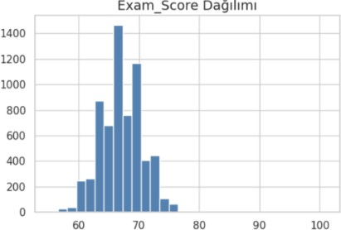
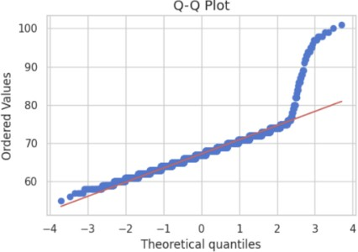
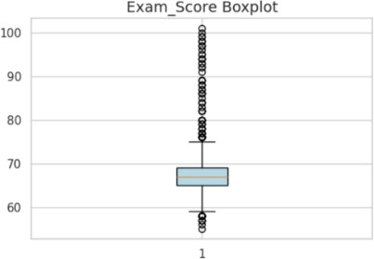

Figure 1. Distribution of Exam_Score using histogram, boxplot, and Q-Q plot.

Dataset 2 – GPA

Figure 2 presents the GPA distribution using a histogram and probability plot. GPA distribution appears balanced and approximately follows a normal distribution. Most students are concentrated around the middle GPA ranges. The probability plot shows that GPA values generally follow a normal distribution, although slight deviations can be observed at the lower and upper ends. The distribution of GPA values indicates that most students were in the middle achievement range. The average GPA was approximately 1.91, and most students had GPA values between 1.0 and 3.0.
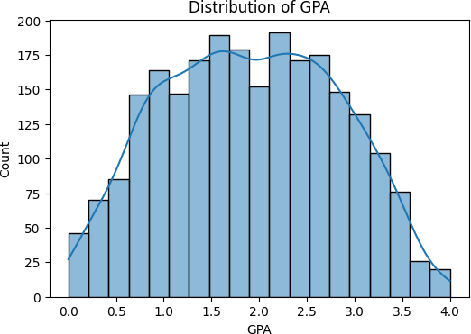
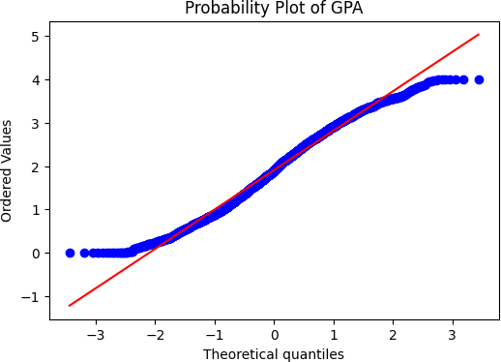
Figure 2. Distribution of GPA using a histogram and probability plot.

Dataset 3 – Exam Score

Figure 3 presents the distribution of exam_score using a histogram, boxplot, and Q-Q plot. The histogram shows that most exam scores are concentrated between 50 and 80, with the highest frequency around the 60–70 range. This indicates that most students achieved a moderate level of exam performance. The boxplot shows that the median score is around 60–65. The scores are spread over a wide range, but no extreme outliers are observed. The Q-Q plot shows that the scores follow a nearly linear pattern in the middle part of the distribution. However, there are deviations at the lower and upper ends. This means that exam_score is not perfectly normally distributed. Even so, the overall distribution is suitable for regression analysis. The average score was approximately 62.5, and most scores were concentrated between 50 and 80.
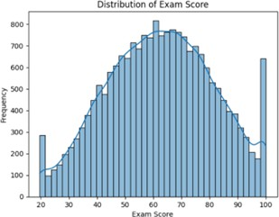
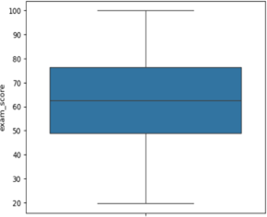
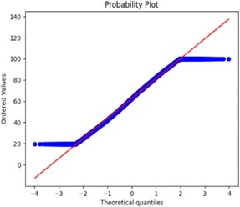

Figure 3. Distribution of Exam Score using a histogram, boxplot, and Q-Q plot.

Dataset 4 – Average Score

Figure 4 presents the distribution of average_score. The target variable was mostly concentrated between 60 and 80. This shows that most students had a moderate to good level of academic performance.The distribution was close to normal, although a small number of low-score outliers were observed.
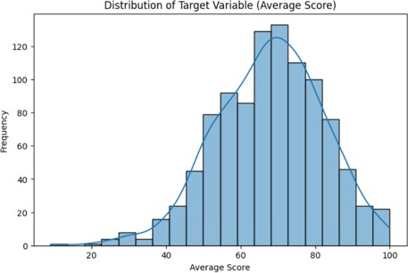
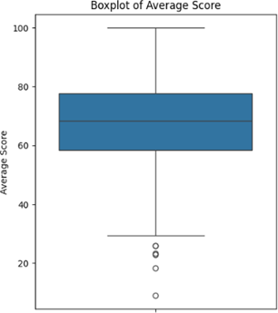
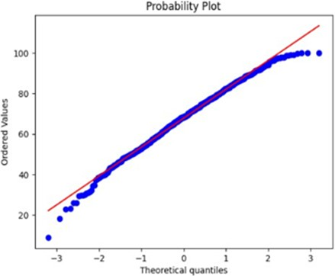

Figure 4. Distribution of Average Score using a histogram, boxplot, and Q-Q plot.

Figure 5 presents the distribution of G3 using a histogram, probability plot, and boxplot. The histogram shows that most G3 scores are concentrated between 8 and 16, with the highest frequency around the 10–12 range. This indicates that most students achieved a moderate level of academic performance. The boxplot shows that the median score is approximately 11. The scores are distributed across a relatively wide range, extending from 4 to 20, but no extreme outliers are observed. The probability plot shows that the values follow a nearly linear pattern along the theoretical reference line. However, slight deviations can be observed at the lower and upper ends of the distribution. This indicates that G3 is not perfectly normally distributed. Nevertheless, the overall distribution remains suitable for regression analysis. The average G3 score was approximately 11.52, and most scores were concentrated between 8 and 16.

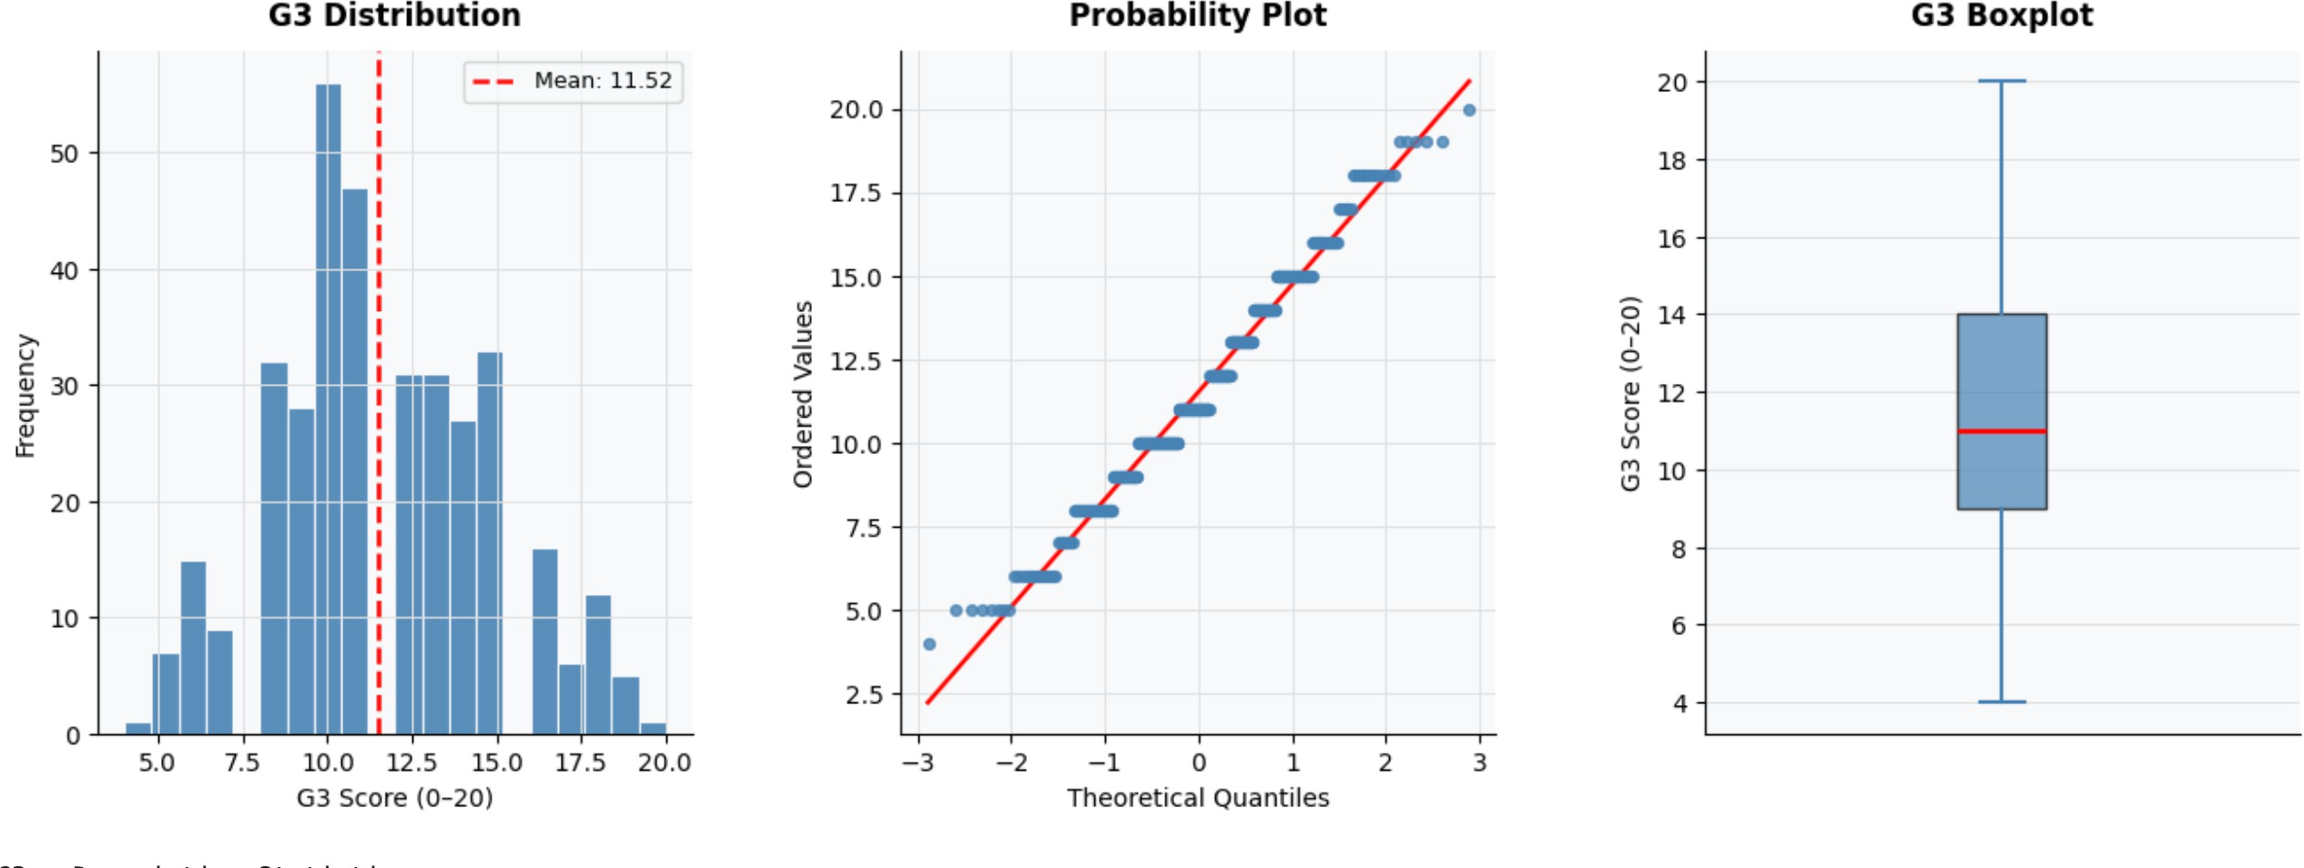

Figure 5. Distribution of G3 using a histogram, probability plot, and boxplot.

Dataset 6 – Final_Percentage
Figure 6 presents the distribution of Final_Percentage using a histogram, probability plot, and boxplot. The histogram shows that most Final_Percentage scores are concentrated between 55 and 85, with the highest frequency around the 65–75 range. This indicates that most students achieved a moderate level of academic performance. The boxplot shows that the scores are relatively well distributed with no severe outliers. The probability plot demonstrates that most observations follow a nearly linear pattern along the theoretical reference line. Although slight deviations can be observed at the lower and upper tails, the overall distribution is approximately bell-shaped. Therefore, Final_Percentage is considered suitable for regression analysis. The average performance level was concentrated around the middle achievement range, indicating that the majority of students demonstrated moderate academic success.
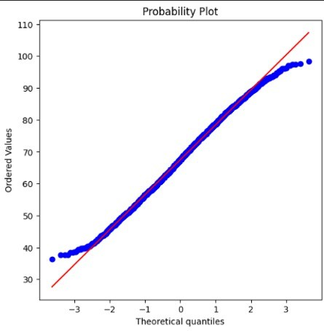
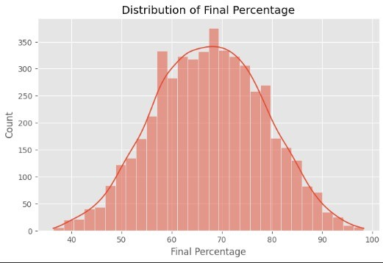
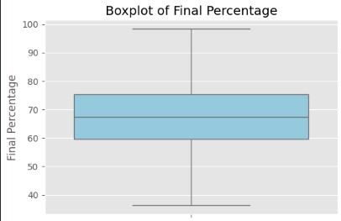

Figure 6. Distribution of Final Percentage using a histogram, probability plot, and boxplot.

Correlation Matrix Analysis
Correlation matrices were generated to investigate the relationships between numerical variables and academic performance indicators. This analysis helps identify the predictors most strongly associated with student achievement across the six datasets.

Dataset 1
Figure 7 presents the correlation matrix for Dataset 1. Hours_Studied exhibited the strongest positive relationship with Exam_Score (r = 0.45), followed by Attendance (r = 0.38) and Previous_Scores (r = 0.31). Sleep_Hours showed only a weak positive correlation with the target variable. These findings suggest that study habits, classroom participation, and prior achievement are the primary determinants of examination performance in this dataset.
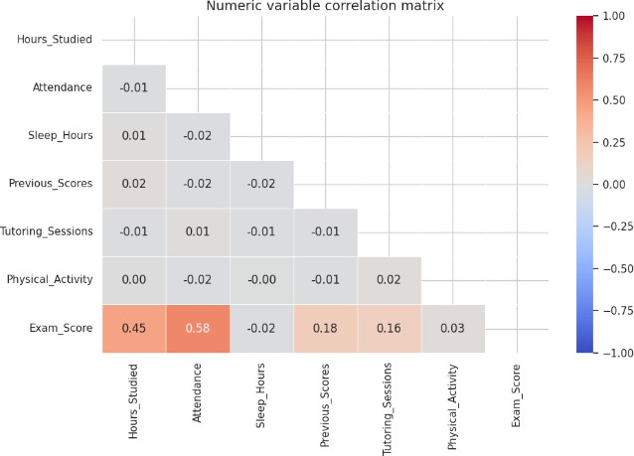
Figure 7. Correlation matrix of Dataset 1.

Dataset 2
Figure 8 presents the correlation matrix for Dataset 2. GPA demonstrated positive relationships with several educational and behavioral variables, including ParentalSupport, StudyTimeWeekly, Tutoring, and participation in extracurricular activities. Among these predictors, ParentalSupport showed one of the strongest positive associations with academic performance. In contrast, Absences exhibited a clear negative relationship with GPA, indicating that students with higher absenteeism levels generally achieved lower academic outcomes.
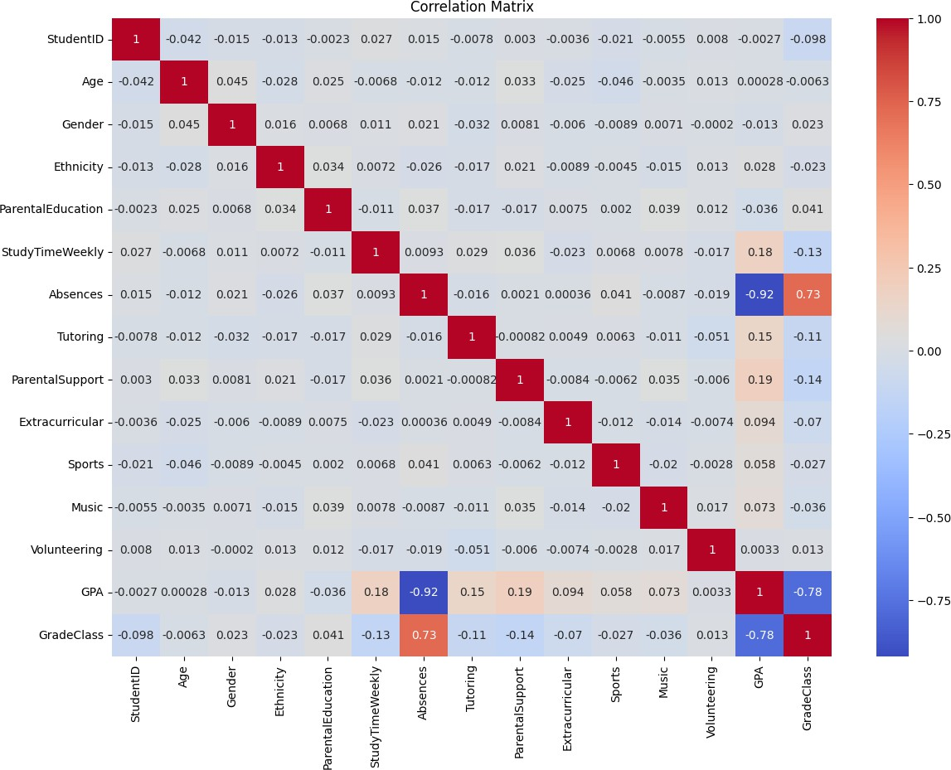
Figure 8. Correlation matrix of Dataset 2.

Dataset 3
Figure 9 presents the correlation matrix for Dataset 3. Study_hours exhibited the strongest positive correlation with exam_score (r = 0.72), making it the most influential predictor in the dataset. Class_attendance showed a moderate positive relationship (r = 0.31), while sleep_hours demonstrated only a weak association with examination performance. These findings highlight the dominant role of study behavior in determining student achievement.
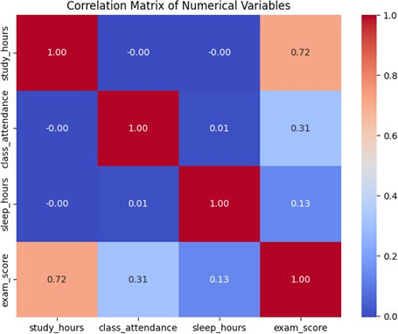
Figure 9. Correlation matrix of Dataset 3.

Dataset 4
Figure 10 presents the correlation matrix for Dataset 4. Strong positive relationships were observed among math score, reading score, writing score, and average_score. The strongest correlations with the target variable were observed for reading score (r = 0.97) and writing score (r = 0.97), followed by math score (r = 0.92). Additionally, reading and writing scores exhibited a strong mutual relationship (r = 0.95). These findings are expected because average_score was derived directly from the three subject scores.
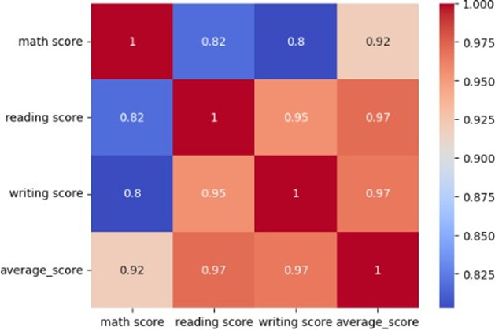
Figure 10. Correlation matrix of Dataset 4.

Dataset 5
Figure 11 presents the correlation matrix for Dataset 5. The strongest positive relationships with G3 were observed for G2 (r = 0.96) and G1 (r = 0.89), indicating that previous academic achievement is the most reliable predictor of future performance. Failures demonstrated a moderate negative correlation with G3 (r = –0.29), while absences showed a weaker negative relationship (r = –0.12). Overall, the results emphasize the importance of prior grades in predicting final academic outcomes.
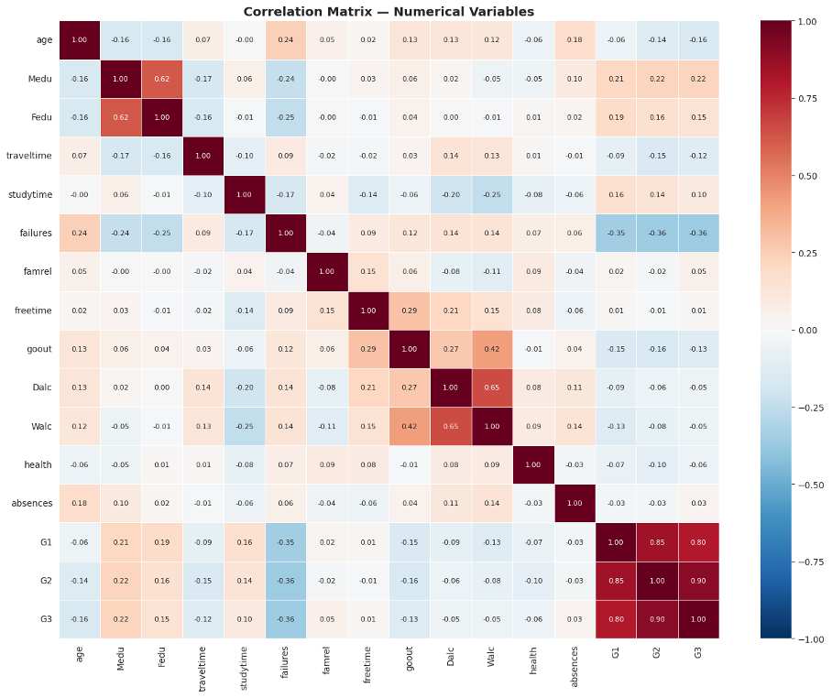
Figure 11. Correlation matrix of Dataset 5.

Dataset 6
Figure 12 presents the correlation matrix for Dataset 6. English_Score exhibited the strongest correlation with Final_Percentage (r = 0.59), followed by Science_Score (r = 0.57) and Math_Score (r = 0.56). These findings indicate that subject-specific academic achievement is strongly associated with overall performance. However, these variables were excluded from model training because they directly contribute to the calculation of the target variable and would introduce data leakage.

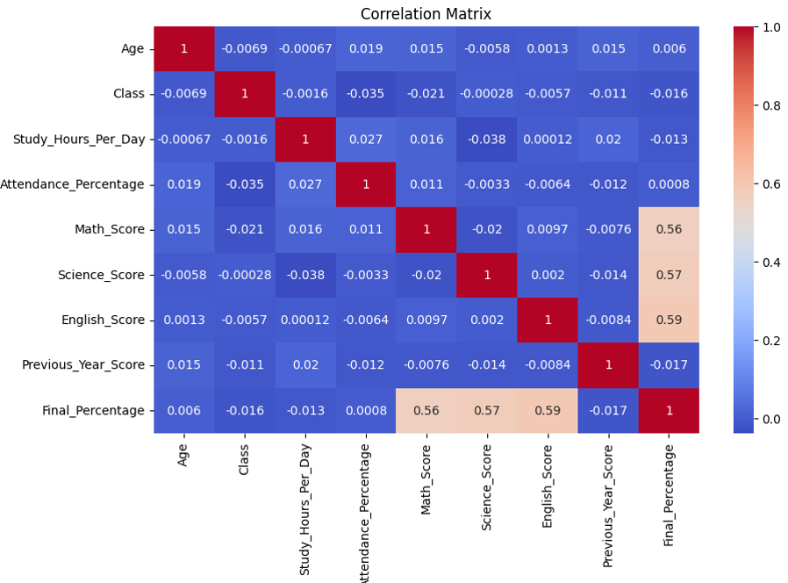
Figure 12. Correlation matrix of Dataset 6.

General Correlation Findings
Across all six datasets, previous academic achievement, study habits, and attendance-related variables consistently demonstrated the strongest relationships with student performance. In contrast, demographic characteristics generally exhibited weaker associations with the target variables. These findings suggest that behavioral and academic factors play a substantially greater role in predicting educational outcomes than static demographic attributes.

Boxplot Analysis
Boxplots were used to examine the relationship between categorical variables and academic performance indicators across the six datasets. This analysis provides insights into how behavioral, educational, and demographic factors influence student achievement.
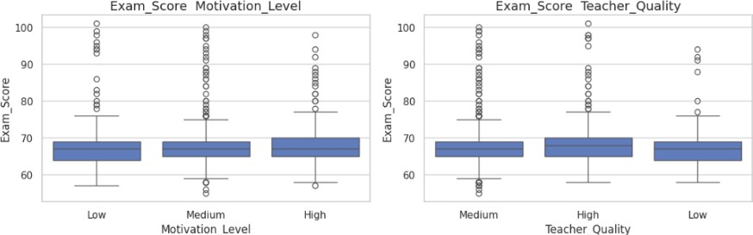
Figure 13. Exam_Score comparison by Motivation_Level and Teacher_Quality.
In dataset 1 We conducted group-based comparisons for categorical variables. In these graphs, the Motivation_Level and Teacher_Quality variables stood out in particular. As Motivation_Level increased, students’ scores also increased. Similarly, higher Teacher_Quality values were associated with higher Exam_Score values. Figure 13 Exam_Score values across Motivation_Level and Teacher_Quality categories. Students with higher motivation and better teacher quality generally achieved higher exam scores
In dataset 2 Ethnicity variable shows similar GPA distributions across categories. ParentalEducation shows that students who parents have higher education levels tend to achieve higher GPA values. Tutoring boxplot shows that students receiving tutoring support generally have higher GPA values. ParentalSupport analysis shows

positive relation. Students participating in extracurricular activities, sports, and music activities show higher GPA values. Volunteering activities do not show strong difference in GPA distributions.
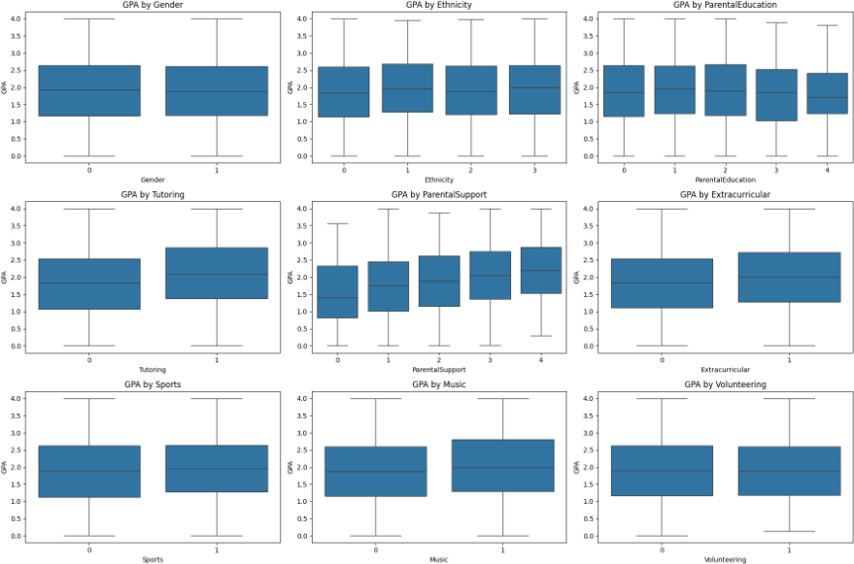

Figure 14. GPA comparison by categorical variables.

In dataset 3 boxplots were used to compare exam score distributions across different categorical variables. Students with better sleep quality generally achieved higher exam scores. A similar relationship is observed for facility_rating, as higher facility ratings are associated with higher exam scores. For study_method, coaching and mixed learning methods show slightly higher median scores compared to the other methods. Overall, these results indicate that sleep quality, study method, and facility rating may contribute to academic performance in Dataset 3.

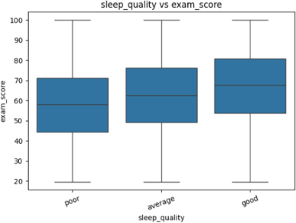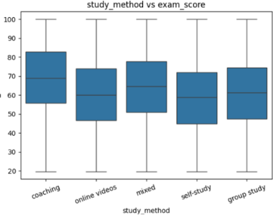
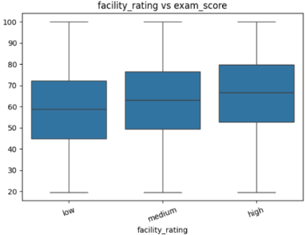

Figure 15. Exam score comparison by sleep quality, study method, and facility rating.

In dataset 4 The boxplots show that average scores change depending on lunch type and test preparation course status. Students with standard lunch have higher scores in general compared to students with free/reduced lunch. Their median score is also higher, which shows that this group performed better overall. For the test preparation course, students who completed the course seem to have better average scores than those who did not. The completed group has a higher median, and their scores are generally placed in a higher range.
Overall, these boxplots show that lunch type and test preparation course are related to student performance in Dataset
4. Students with standard lunch and students who completed the preparation course generally achieved higher average scores.
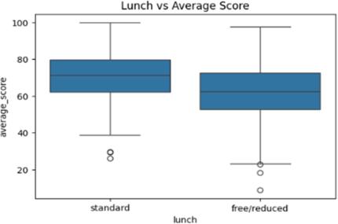
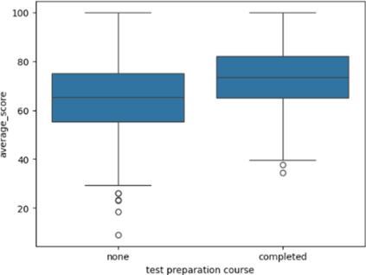

Figure 16. Average score comparison by lunch type and test preparation course.

In dataset 5 sex, address, schoolsup, famsup, higher, internet, and romantic were examined. These plots allowed us to identify potential differences in G3 median scores and spread among groups, offering insights into how demographic, social, and support-related factors might correlate with student performance. For a complete analysis, all generated boxplots and their corresponding median summaries were considered. When examining specific variables, several patterns emerge. Gender shows only a minimal effect on academic performance, with male students having a slightly higher median G3 than female students; however, the substantial overlap in interquartile ranges indicates that gender alone is not a strong explanatory factor. In contrast, students who aspire to pursue higher education exhibit a noticeably higher median G3 compared to those who do not, suggesting that motivation and future academic goals play a more significant role in performance. Access to resources also appears to have a modest influence. Students with internet access at home demonstrate a slightly higher median G3, which may reflect improved access to educational materials and study tools. Similarly, students living in urban areas show a marginally higher median compared to those in rural areas, although the distributions overlap considerably, indicating a limited practical effect. An interesting inverse pattern is observed in school support. Students receiving school support tend to have a lower median G3 than those who do not. This likely reflects a selection effect rather than a causal relationship, as additional support is typically provided to students who are already experiencing academic difficulties.
Overall, while some variables such as higher education aspiration show a clearer relationship with academic performance, most categorical factors exhibit overlapping distributions, suggesting that their individual impact on final grades is relatively limited when considered in isolation.

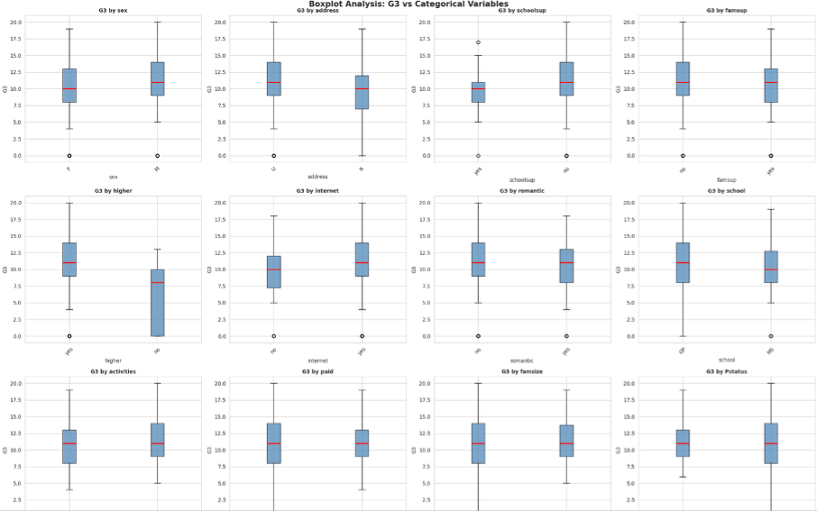

Figure 17. G3 comparison across categorical variables.

In dataset 6 Figure 18 shows the relationship between categorical variables and average scores in Dataset 6. Gender, Internet Access, and Extracurricular Activities exhibit very similar score distributions, indicating limited influence on academic performance. Students whose parents have higher educational levels achieve slightly higher average scores, although the differences are relatively small. The largest differences are observed in Performance Level and Pass/Fail categories, where students with higher performance classifications and passing status achieve considerably higher average scores. Overall, performance-related variables appear to be more strongly associated with academic achievement than demographic or environmental factors.

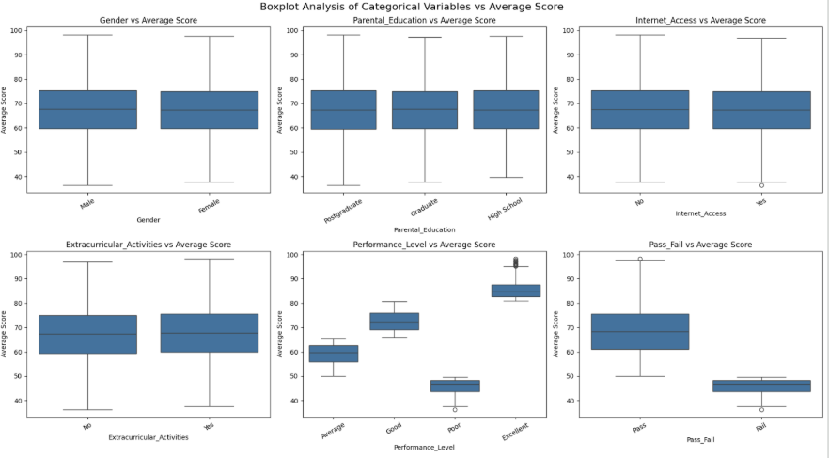

Figure 18. Average score comparison across categorical variables in Dataset 6.

4.2 Model Performance Evaluation
The predictive performance of multiple regression algorithms was evaluated across six student performance datasets. Model effectiveness was assessed using MAE, MSE, RMSE, and R² metrics. Lower MAE, MSE, and RMSE values indicate better prediction accuracy, whereas higher R² values indicate stronger explanatory power.

In dataset 1
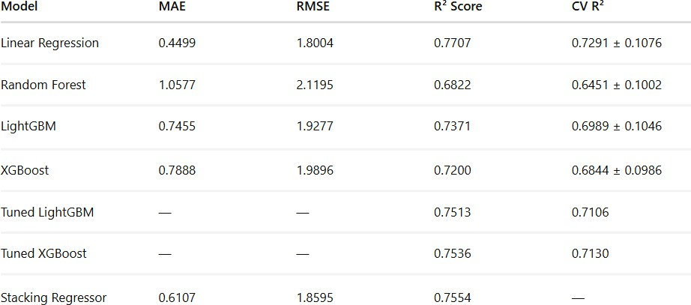

Figure 19. Model performance comparison for Dataset 1 using MAE, RMSE, R² Score, and CV R² metrics.

In Dataset 2, The model comparison results show model performances on Dataset 2. Linear Regression achieved best result, with the highest R² score (0.9532) and the lowest prediction errors. Ridge Regression produced almost identical results, while Lasso Regression also achieved very similar performance. Gradient Boosting, XGBoost, and Random Forest produced strong prediction results.But their performances were lower than those of the linear models. Among all tested models, Linear Regression was selected as the most successful model for Dataset 2. Small differences between the test and cross-validation scores also suggest that models generalized well and doesn’t have overfitting.

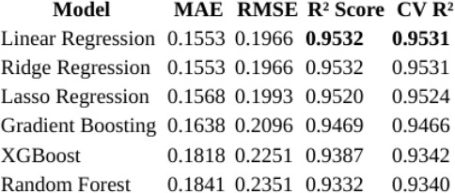

Figure 20. Model performance comparison for Dataset 2 using MAE, RMSE, R² Score, and CV R² metrics.

In dataset 3; The model comparison results show how each regression model performed on Dataset 3. Lasso Regression achieved the best overall result, with the lowest RMSE value and the highest R² score. Linear Regression and Ridge Regression produced very similar results, indicating that all three linear-based models performed well on this dataset. Gradient Boosting and XGBoost also achieved competitive results, although their performance was slightly lower than that of the linear models. Random Forest produced the highest error values and the lowest R² score, making it the weakest-performing model among those tested.
Overall, the findings indicate that linear-based regression models were more effective than tree-based ensemble models for predicting Exam_Score in Dataset 3.
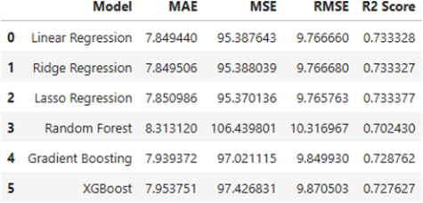

Figure 21. Model performance comparison for Dataset 3.

In dataset 4 figure presents the performance comparison of all regression models used in Dataset 4. The results show that Linear Regression achieved the best overall performance among the tested models. It produced the lowest MAE (10.49), the lowest MSE (179.60), the lowest RMSE (13.40), and the highest R² score (0.162). Ridge Regression gave almost the same results as Linear Regression. The differences between their error values and R² scores were very small. This shows that regularization did not make a clear improvement for Dataset 4. The Tuned Random Forest model performed better than the first Random Forest model. After tuning, the RMSE value decreased from 14.78 to 13.93, and the R² score increased from -0.019 to 0.095. This means that hyperparameter tuning helped the model, but the tuned version still stayed behind Linear Regression and Ridge Regression. Lasso Regression and XGBoost produced acceptable results, but their error values were higher than the best-performing models. Decision Tree gave the weakest result in this comparison, with the highest error values and the lowest R² score. In general, the results show that linear models worked better for Dataset 4 than tree-based models. Among all models, Linear Regression gave the most accurate predictions and was selected as the best model for this study.

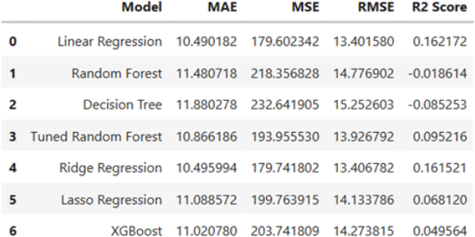

Figure 22. Model performance comparison for Dataset 4.

In dataset 5, All eight models were evaluated on the same 72-observation test set. Figure 23 presents the results sorted by test R² in descending order.
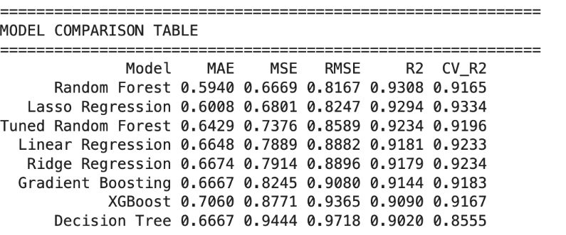
Figure 23. Performance comparison of all eight regression models on the held-out test set (N=72). Metrics: MAE
= Mean Absolute Error, MSE = Mean Squared Error, RMSE = Root Mean Squared Error, R2 = coefficient of determination on the test set, CV R2 = mean 5-fold cross-validated R2 on the training set.
Several findings stand out from Figure 23. Random Forest leads on single-test R² (0.9308) and records the lowest MAE (0.5940) and RMSE (0.8167), making it the best point-estimate predictor. Lasso Regression, however, achieves the highest CV R² of all eight models (0.9334) That means it generalizes most consistently across different data splits. This is an important finding. In practice, a model should perform consistently for different groups of students. Lasso showed more stable results across the cross-validation folds. For this reason, it may be a more reliable option for deployment. The largest performance gap in Table X is observed between Decision Tree and Random Forest. Decision Tree achieved the lowest test R² score (0.9020) and the lowest cross-validation R² score (0.8555). This suggests that the model learned the training data too closely and struggled to generalize to unseen data. Such behavior is a common sign of overfitting.
In contrast, Random Forest performed substantially better. Its cross-validation R² score increased from 0.8555 to 0.9165. This improvement demonstrates the main advantage of ensemble learning. By combining many decorrelated trees, Random Forest reduces variance while maintaining strong predictive performance. XGBoost ranked second-to-last in both evaluation metrics. However, this should not be interpreted as a weakness of the algorithm itself. The dataset contains only 285 training samples, which limits the amount of information available for learning. In addition, the selected hyperparameters (learning_rate = 0.05, max_depth = 4, and n_estimators = 200) were not specifically optimized for this dataset. Without hyperparameter tuning or additional feature engineering, XGBoost was unable to outperform the simpler models in this study.

In dataset 6, Figure shows the relationship between categorical variables and average scores in Dataset 6. Gender, Internet Access, and Extracurricular Activities exhibit very similar score distributions, indicating limited influence on academic performance. Students whose parents have higher educational levels achieve slightly higher average scores, although the differences are relatively small. The largest differences are observed in Performance Level and Pass/Fail categories, where students with higher performance classifications and passing status achieve considerably higher average scores. Overall, performance-related variables appear to be more strongly associated with academic achievement than demographic or environmental factors.
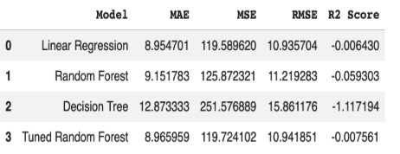
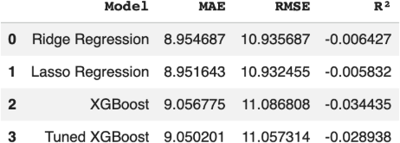

Figure 24. Model performance comparison for Dataset 6.

Discussion

Study Habits and Academic Performance
One of the most important findings in datasets was positive relationship between study habits and academic performance. Dataset 1 showed that Hours_Studied was among the variables have strong relation to Exam_Score. Dataset 2 showed that StudyTimeWeekly positively related with GPA. Similar results obtained in Dataset 3, where students who spent more time studying generally achieved higher exam scores. Dataset 6 identified Study_Hours_Per_Day as most important factor for Final_Percentage. This finding is supported by Ahmed et al. (2025) [14], who examined the relationship between study hours and academic performance. The study reported that students who dedicate more time to studying generally achieve better academic results. However, the authors also emphasized that study techniques, motivation, and time management play an important role in academic success. This finding is consistent with the study conducted by Zubair et al. (2024) [15], which reported a significant association between study time and academic achievement. Their results indicated that study time is an important factor influencing students’ academic outcomes. Therefore, the findings of Dataset 3 indicate that spending more time on studying is generally associated with better academic outcomes.

Attendance and Academic Success
Attendance-related variables emerged as important predictors across several datasets. Dataset 1 revealed a positive relationship between Attendance and Exam_Score. Similarly, Dataset 2 showed that Absences were negatively associated with GPA, while Dataset 3 indicated that students with higher class attendance generally achieved better examination scores. In Dataset 6, Attendance_Percentage was identified as one of the most influential predictors of Final_Percentage. These results are consistent with previous research highlighting the importance of regular attendance for academic success. Keppens (2023) [16] reported that different forms of school absenteeism negatively affect student achievement. Students who are frequently absent are generally less likely to achieve strong academic outcomes. Similar patterns were observed in Datasets 1, 2, and 3, where attendance-related variables demonstrated clear relationships with performance indicators. Additional evidence is provided by ERIC [17], which reported a negative association between absenteeism and academic performance. Students who attend classes regularly generally perform better than those with high absence rates. Regular attendance enables students to engage more actively in classroom activities, follow lessons more effectively, and complete learning tasks successfully.
Comparable results were reported by Varul et al. [18], who identified a significant positive relationship between class attendance and examination performance among medical students. Their study showed that students with higher attendance levels tended to achieve better academic outcomes. The patterns observed in Dataset 3 closely align with these findings and further support the positive contribution of regular attendance to academic success.
Similar conclusions were reported in the study Effect of Class Attendance on Academic Performance [19]. The authors found that students who attend classes regularly generally achieve higher academic performance than students with

lower attendance rates. The study emphasized that regular attendance improves engagement with course content and strengthens the overall learning process.

Previous Academic Achievement as a Predictor of Future Success
Another important pattern detected across datasets was strong relation between previous academic achievement and academic success. In Dataset 1 Previous_Scores showed strongest relationships with Exam_Score. Dataset 5 showed that G1 and G2 were the strongest predictors of G3. Dataset 6 anaylzed Previous_Year_Score important variables affecting Final_Percentage. This finding is supported by the study Key Factors Influencing Students’ Academic Performance (Al Husaini, M., & Ahmad Shukor, N. (2024).) [20]. The study reported that previous academic performance is one of the strongest predictors of future academic success. The authors found that students with higher previous grades generally achieve better academic outcomes in later assessments. The study also emphasized that previous scores reflect students’ knowledge, learning habits, and academic consistency.
Similar findings were reported by Doz et al. (2023) [21], who applied Random Forest Regression to predict student achievement. Their study showed that previous academic performance variables were the most influential predictors of students’ results. The authors concluded that prior grades provide a reliable indication of future academic success and contribute more strongly to prediction accuracy than most demographic or behavioral factors.
In addition, Cortez and Silva (2008) [22], in their study on Portuguese secondary school students, found that students’ earlier period grades were highly correlated with final academic performance. Their results demonstrated that previous grades consistently outperformed other social and family-related variables in predicting students’ final outcomes. These findings further support the view that academic achievement tends to remain relatively stable over time and that previous performance serves as a strong indicator of future success.
Additional evidence was provided by Yağcı (2024) [23], who reported that previous academic performance is one of the strongest predictors of students’ future achievement. The study emphasized that previous scores reflect not only students past grades but also their accumulated knowledge, learning habits, and consistency throughout the educational process. Similarly, Sarker et al. (2023) [24] found a strong relationship between students’ midterm performance and their final academic outcomes, suggesting that earlier academic success can serve as a reliable indicator of future achievement. These findings support the argument that students who perform well in previous assessments are more likely to maintain higher levels of academic performance over time.

Family Background, Educational Inequality and Academic Performance
Family-related variables were observed across several datasets, but their effects were generally weaker than those of direct academic factors such as study hours, attendance, and previous achievement. In Dataset 1, variables including Parental_Involvement, Family_Income, and Access_to_Resources were associated with student performance, but did not emerge among the strongest predictors. A similar pattern was observed in Dataset 2 and Dataset 5, where parental support and parental education appeared to contribute to academic achievement, albeit through more indirect pathways.
This interpretation is supported by earlier work. Parental involvement has been consistently linked to higher academic achievement [25, 26], and a parent's own level of education can predict how successfully a child does later in school [27]. What likely connects them is the family environment itself the academic expectations it sets, the learning support it offers, and the educational resources it makes available.
Parental involvement, however, does not work the same way for everyone. Its effect depends on the context. School quality, socioeconomic conditions, the learning environment, and student motivation can all change how much of a difference parents' involvement actually makes [29, 30]. Students from lower socioeconomic backgrounds may face extra barriers that limit these gains [31]. For this reason, the family-related variables in this study should be seen as background conditions that shape learning opportunities, not as the strongest direct predictors of performance.

Socioeconomic Factors and Educational Opportunities
Socioeconomic variables showed important relationships with student success. Dataset 4 identified lunch type is important feature for avarage_score. Test preparation status showed a positive association with student success. Dataset 1 and Dataset 5 showed that access to resources is imporant too.

This finding is consistent with previous research on school lunch quality and academic performance. Anderson, Gallagher, and Ritchie [32] found that healthier school meals were associated with higher academic test scores. Their study showed that students in schools offering healthier lunch options achieved better academic outcomes, and the effect was stronger among students from low-income backgrounds.
Similarly, Cohen et al. (2021) [33] conducted a systematic review of 47 studies examining universal school meal programs. The review found evidence that school meal programs including lunch were associated with improvements in diet quality and academic performance. These findings support the result obtained from Dataset 4, where lunch type emerged as the most influential factor affecting average_score. However, lunch type may reflect both nutritional quality and socioeconomic differences that influence student achievement.

Extracurricular Activities and Student Development
Analysis showed that extracurricular activities have positive effect on student success. In Dataset 2, students who joined extracurricular activities, sports, and music usually had higher GPA scores.
This result is supported by study of Fujita (2006) [34]. The study showed that students who participate in extracurricular activities often have better academic success. According to the research these activities help students improve discipline, responsibility, and social skills.
Similar results reported by Meadows et al. (2019) [35]. Study showed that participation in extracurricular activities is positively related with academic performance. Researchers stated that these activities increase student involment and help students for build a stronger connection with their schools.
Some researchers argue that participation in extracurricular activities may reduce time students spend studying. Study by University of Gadjah Mada [36] reported that extracurricular activities can cause time management problems and negatively affect academic success if students cannot balance their academic success and social activities.

Sleep and Lifestyle Factors
Lifestyle-related variables showed weaker but still meaningful relationships with academic performance. In Dataset 1, Sleep_Hours had a positive but weak relationship with Exam_Score, while Dataset 3 showed that students with better sleep_quality generally achieved higher exam scores. Dataset 5 also indicated that lifestyle-related behaviors, such as going out frequently and alcohol consumption, were negatively associated with final grades. These findings suggest that lifestyle factors may not always be the strongest direct predictors, but they still contribute to students’ learning conditions and academic outcomes.
Previous research supports the importance of sleep in academic success. Creswell et al. [38] found that longer nightly sleep duration was associated with higher GPA among first-year college students. Their study reported that each additional hour of nightly sleep was linked to an increase in GPA and emphasized that sleep supports cognitive functions such as attention, memory, and information processing. This finding is relevant to our results because sleep-related variables appeared in Dataset 1 and Dataset 3, even though their effect was weaker than study habits, attendance, and previous achievement.
Overall, sleep and lifestyle variables should be interpreted as supportive factors rather than the main predictors of academic performance. In this study, direct academic variables such as study hours, attendance, and previous academic achievement were more consistently influential across the datasets. However, poor sleep quality, insufficient sleep, and unhealthy lifestyle habits may still reduce students’ concentration, study efficiency, and learning performance. Therefore, lifestyle factors should not be ignored when analyzing student success, but they should be considered together with academic and behavioral variables.

Conclusion
This study examined the factors that influence student academic performance by using six different educational datasets and several machine learning regression models. The datasets contained a wide range of information, including academic, demographic, behavioral, family-related, and socioeconomic characteristics. This allowed the study to evaluate student achievement from different perspectives rather than focusing on a single aspect.

The results showed that study-related factors were the most consistent indicators of academic performance across the datasets. Variables such as study hours, attendance, and previous academic achievement were strongly associated with the target variables. In particular, Hours_Studied, StudyTimeWeekly, Study_Hours_Per_Day, Previous_Scores, G1, G2, and Previous_Year_Score repeatedly appeared among the most influential features. These findings suggest that students’ study habits and past academic results play an important role in determining future performance.
The analysis also revealed that family and socioeconomic factors have an effect on student achievement. Variables including parental support, parental education, family income, access to resources, lunch type, and test preparation status were related to academic performance in several datasets. Although these variables were generally less influential than direct academic factors, they still reflected the importance of educational opportunities and students’ learning environments.
When the machine learning models were compared, Linear Regression often provided the strongest or one of the strongest results across different datasets. Ridge Regression produced very similar outcomes, while more complex ensemble models such as Random Forest, Gradient Boosting, and XGBoost did not consistently achieve better performance. This suggests that the relationships within many of the analyzed datasets can be captured effectively using relatively simple linear models.
Overall, the findings demonstrate that machine learning methods can be used successfully to predict student academic performance and identify the factors most closely linked to educational achievement. These results may help educators and institutions better understand the needs of students and support early intervention efforts for those who may be at academic risk.
Future studies could benefit from using larger and more diverse educational datasets. Including additional psychological, behavioral, and learning-environment variables may further improve prediction performance and provide a more detailed understanding of the factors that contribute to student success.

Reference
- J. L. Rastrollo-Guerrero, J. A. Gómez-Pulido, and A. Durán-Domínguez, "Analyzing and predicting students' performance by means of machine learning: A review," Appl. Sci. , vol. 10, no. 3, p. 1042, 2020.
- H. Aldowah, H. Al-Samarraie, and W. M. Fauzy, "A systematic review on machine learning and factors influencing academic performance," Social Network Analysis and Mining , vol. 13, no. 1, 2023. [Online]. Available: https://www.sciencedirect.com/science/article/pii/S2772662223000449
- S. Monika et al., "A comparative analysis of ML models for predicting student performance," Brilliance: Research of Artificial Intelligence , vol. 4, 2024. [Online]. Available: https://jurnal.itscience.org/index.php/brilliance/article/view/4669
- C. Okonkwo and A. Ade-Ibijola, "Performance comparison of XGBoost and random forest for student academic performance prediction," European J. Comput. Sci. Inf. Technol. , vol. 13, no. 2, 2025. [Online]. Available: https://eajournals.org/ejcsit/vol13-issue-2-2025/
- M. Murtaza et al., "Machine learning models for academic performance prediction: Interpretability and application," Frontiers in Education , 2025. [Online].
Available: https://www.frontiersin.org/journals/education/articles/10.3389/feduc.2025.1632315/full
- Arévalo-Cordovilla, F.E., Peña, M. Evaluating ensemble models for fair and interpretable prediction in higher education using multimodal data. Sci Rep 15, 29420 (2025). [Online]. Available: https://www.nature.com/articles/s41598 025-15388-9
- Budiongan, K., Reyes, G. I., Liporada, K., Galo, M., & Bangeles, D. M. M. (2024). Socioeconomic Status, Parental Expectations, and Student Motivation as Predictors of Academic Performance of Grade 12 Senior High School Students. European Journal of Theoretical and Applied Sciences, 2(4), 385-396. [Online].
Available: https://doi.org/10.59324/ejtas.2024.2(4).32
- Turhan ŞENGÖNÜL, "A review of the relationship between parental involvement and children's academic achievement," Pegem J. Education and Instruction
, 2022. [Online]. Available: https://files.eric.ed.gov/fulltext/EJ1343324.pdf

- Carnegie Mellon University, "Nightly sleep is key to student success," Feb. 2023. [Online]. Available: Nightly Sleep Is Key to Student Success - News - Carnegie Mellon University
- X. Zhu et al., "Machine learning analysis of factors affecting college students' academic performance,"
PLOS ONE , 2025. [Online]. Available: https://www.ncbi.nlm.nih.gov/pmc/articles/PMC11700736/
- Murat GÖK, "Öğrenci başarısının makine öğrenmesi ile tahmini," Gazi Üniversitesi Mühendislik Mimarlık Fakültesi Dergisi , 2017. [Online]. Available: https://dergipark.org.tr/tr/do wnload/article-file/341510
- D. Zilyas and A. Yılmaz, “Makine öğrenmesi yöntemleri ile eğitim başarısının tahmini modeli,” Dicle University Journal of Engineering, vol. 14, no. 3, pp. 437–447, 2023, doi: 10.24012/dumf.1322273.
[Online]. Available: https://dergipark.org.tr/tr/download/article-file/3241995
- F. Özdemir, A. Taş, Y. Canbay, and A. Utku, “Makine Öğrenmesi Yöntemleri ile Öğrenci Akademik Başarısının Tahmin Edilmesi,”
Bingöl Üniversitesi Teknik Bilimler Dergisi, no. 1, Feb. 2026. [Online]. Available: https://dergipark.org.tr/tr/pub/buts/article/1878025
- https://www.researchgate.net/publication/392130530_Relationship_Between_Study_Hours_And_Academic_Pe rformance
- Zubair, M., et al. (2024). Study Time and Academic Achievement. International Journal of Multidisciplinary Research. [Online]. Available: https://www.allmultidisciplinaryjournal.com/uploads/archives/20240717175345_C-24-139.1.pdf
- Keppens, G. (2023). The impact of different types of school absenteeism on student achievement. International Journal of Educational Research. [Online]. Available: https://www.sciencedirect.com/science/article/pii/S0959475223000385
- Gottfried, M. A. (2023). Absenteeism and Academic Performance.
ERIC. [Online]. Available: https://eric.ed.gov/?id=EJ1360442
- Varul, M., et al. Effect of Class Attendance on Performance in Examination in Second Year Medical Students. [Online]. Available: https://www.researchgate.net/publication/315646323_Effect_of_Class_Attendance_o n_Performance_in_Examination_in_Second_Year_Medical_Students
- Effect of Class Attendance on Academic Performance. [Online]. Available: https://www.researchgate.net/publication/353810633_EFFECT_OF_CLASS_AT TENDANCE_ON_ACADEMIC_PERFORMANCE
- Al Husaini, M., & Ahmad Shukor, N. (2024). Key Factors Influencing Students' Academic Performance. [Online]. Available: https://www.researchgate.net/publication/384495579_Key_factors_influencing_s tudents'_academic_performance
- Doz, D., Cotič, M., & Felda, D. (2023). Random forest regression in predicting students' achievements and fuzzy grades. Mathematics, 11(19), 4129. https://doi.org/10.3390/math11194129
- https://www.scirp.org/reference/referencespapers?referenceid=1343240
- Yağcı, M. (2022). Educational data mining: prediction of students’ academic performance using machine learning algorithms. Smart Learning Environments, 9, 11.
https://link.springer.com/article/10.1186/s40561-022-00192-z
- Sarker, S., Paul, M. K., Thasin, S. T. H., & Hasan, M. A. M. (2024). Analyzing students’ academic performance using educational data mining. Computers and Education: Artificial Intelligence, 7, 100263.
https://www.sciencedirect.com/science/article/pii/S2666920X24000663
- Topor, D. R., Keane, S. P., Shelton, T. L., & Calkins, S. D. (2010). Parent Involvement and Student Academic Performance. [Online]. Available: https://pmc.ncbi.nlm.nih.gov/articles/PMC3020099

- Castro, M., et al. (2015). Parental Involvement on Student Academic Achievement: A Meta-Analysis. [Online].
Available: https://www.sciencedirect.com/science/article/abs/pii/S1747938X15000032
- Dubow, E. F., Boxer, P., & Huesmann, L. R. (2009). Long-Term Effects of Parents’ Education on Children's Educational and Occupational Success. [Online]. Available: https://pmc.ncbi.nlm.nih.gov/articles/PMC2853053
- Adil, A., & Khan, M. (2025). Factors Affecting Student Academic Performance: A Systematic Review.
ResearchGate. [Online]. Available: https://www.researchgate.net/publication/388309682
- Baldonado, J., et al. (2025). Parental Involvement and Academic Performance. [Online]. Available: https://www.ejournals.ph/article.php?id=31500
- Wang, X., & Wei, Y. (2024). The influence of parental involvement on students’ math performance: a meta-analysis. Frontiers in Psychology, 15, 1463359.
https://www.frontiersin.org/journals/psychology/articles/10.3389/fpsyg.2024.1463359/full
- Tan, C. Y. (2024). Socioeconomic Status and Student Learning: Insights from an Umbrella Review. Educational Psychology Review, 36, 100.
https://link.springer.com/article/10.1007/s10648-024-09929-3
- Anderson, M. L., Gallagher, J., & Ritchie, E. R. How the Quality of School Lunch Affects Students’ Academic Performance. Brookings Institution. [Online]. Available: https://www.brookings.edu/articles/how-the-quality-of-school-lunch-affects-students-academic-performance/
- Cohen, J. F. W., Hecht, A. A., McLoughlin, G. M., Turner, L., & Schwartz, M. B. (2021). Universal School Meals and Associations with Student Participation, Attendance, Academic Performance, Diet Quality, Food Security, and Body Mass Index: A Systematic Review. Nutrients, 13(3), 911. [Online]. Available: https://pmc.ncbi.nlm.nih.gov/articles/PMC8000006/
- Fujita, K. (2006). The Effects of Extracurricular Activities on the Academic Performance of Junior High Students. Undergraduate Research Journal for the Human Sciences,
5. [Online]. Available: https://publications.kon.org/urc/v5/fujita.html
- Meadows, B., et al. (2019). Impact of Extracurricular Activities on Academic Performance of Students at Secondary
Level. [Online]. Available: https://www.researchgate.net/publication/357797476_Impact_of_Extracurricular_Activit ies_on_Academic_Performance_of_Students_at_Secondary_Level
- University of Gadjah Mada. Extracurricular Activities and Academic Performance. Jurnal Pendidikan Kedokteran Indonesia. [Online]. Available: https://journal.ugm.ac.id/jpki/article/vie w/3911
- Sleep Quality and Academic Performance Among University Students. [Online]. Available: https://www.bibliomed.org/mnsfulltext/51/51-1714215275.pdf
- Creswell, J. D., Tumminia, M. J., Price, S., Sefidgar, Y., Cohen, S., Ren, Y., Brown, J., Dey, A. K., Dutcher, J. M., Villalba, D., Mankoff, J., Xu, X., Creswell, K., Doryab, A., Mattingly, S., Striegel, A., Hachen, D., Martinez, G., & Lovett, M. C. (2023). Nightly sleep duration predicts grade point average in the first year of college. PNAS, 120(8), e2209123120. Link: https://www.pnas.org/doi/10.1073/pnas.220912312

