- Update ReleaseNotes.txt
- Execute Build to get artifact.
- goto:
https://sourceforge.net/projects/tsqlt/files/tsqlt
- login
- this should show the file manager:
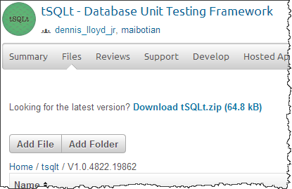
- Create new build folder under tSQLt using the version from the artifact:
- Upload tSQLt.zip, tSQLtSnippets(SQLPrompt).zip and ReadMe.txt
- Click on tSQLt.zip to mark as default download:
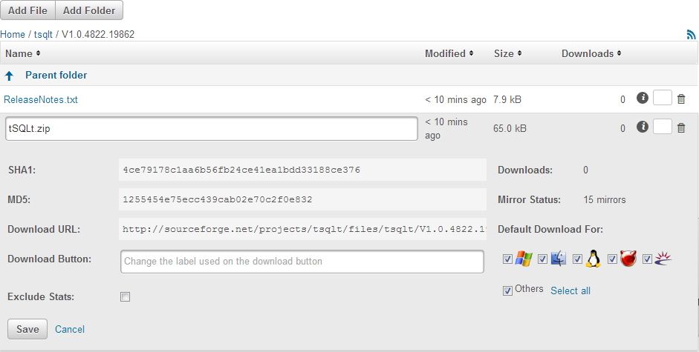

- Update release notes on tSQLt.org

- Send new-release-email

