- goto:
https://sourceforge.net/projects/tsqlt/develop
- login
- goto file manager:
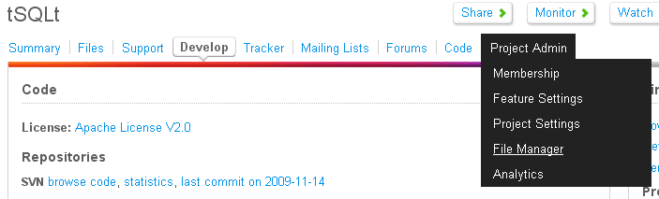
- Create new build folder under tSQLt:
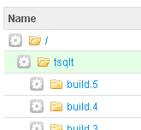
- Upload tSQLt.class.sql
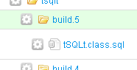
- Click on file to fill out file details:
