22660241 – Nguyễn Trung Hậu
TUẦN 04
Phần 1: Các lệnh cơ bản thao tác với Docker
- docker --version
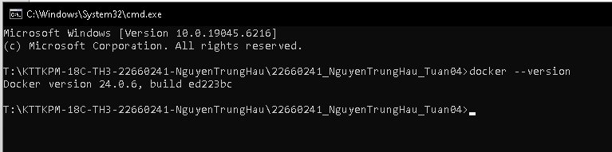
- docker run hello-world
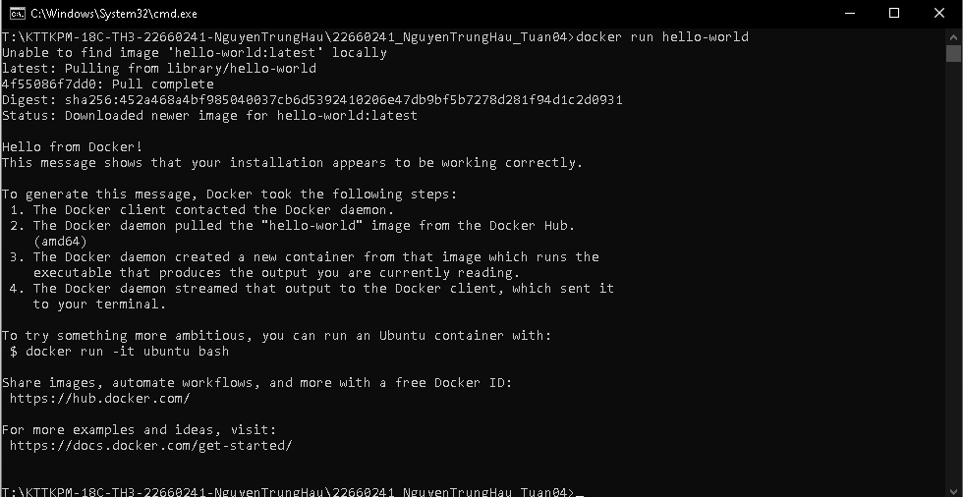
- docker pull nginx
- docker images
- docker run -d nginx
- docker ps
- docker ps -a
- docker logs <container_id>
- docker exec -it <container_id> /bin/sh
- docker stop <container_id>
- docker restart <container_id>
- docker rm <container_id>
- docker container prune
- docker rmi <image_id>
- docker image prune -a
- docker run -d -p 8080:80 nginx
- docker inspect <container_id>
- docker run -d -v mydata:/data nginx
- docker volume ls
- docker volume prune
- docker run -d --name my_nginx nginx
- docker stats
- docker network ls
- docker network create my_network
- docker run -d --network my_network --name my_container nginx
- docker network connect my_network my_nginx
- docker run -d -e MY_ENV=hello_world nginx
- docker logs -f my_nginx
- FROM nginx
    - COPY index.html /usr/share/nginx/html/index.html
- docker build -t my_nginx_image .
- docker run -d -p 8080:80 my_nginx_image

