

Sudan International University
Faculty of Engineering
Department of (Network and Telecommunication)

Performance analysis of NOMA in 5G network

A graduate project report submitted in partial fulfillment of the requirements for the degree of Bachelor of Science (Honours) in Network and Telecommunication Engineering

Submitted by:
Rogea Abo Algasim Mohamed Ahmed [ET-16-043]
Tanzel moutasim mohammed daowd [ET-16-045]
Hadeel Ismat Abd-Alla Mohamed-Ali [ET-16-018]

Supervised by
Dr.Ibrahim Khider Eltahir Date of submission [march 2022]

الأية

(وَمَا تَوْفِيقِي إِلَّا بِاللَّهِ ۚ عَلَيْهِ تَوَكَّلْتُ وَإِلَيْهِ أُنِيبُ)
[هود من الآية:88]

ACKNOWLEDGEMENT

First and foremost, we must thank Allah, the Ever-Magnificent; for his help and blessings.

Then we would like to express our special thanks for our supervisor (Dr. Ibrahim Khider Eltahir ) Who gave us a lot of help and Guidance .And all of the teachers through this Holy last five years One by one and we are very grateful for them.

Secondly from the deepest part of our hearts we would like to thank our parents and family because without them and their support we wouldn’t reach this stage. We are grateful to all the people who worked hard with us from the beginning till the completion of this research.

Finally, we would like to thank all of our friends and classmates who have become our brothers and sisters.

ABSTRACT

A new technique was focused on this research to leverage NOMA to improve the throughput of the 5G network. the non-orthogonal multiple axis NOMA scheme was proposed as a radio access strategy for improving system performance in 5G networks. Several users were served at the same time and frequency which might lead to excessive multiple axis interference. Multiple axis interference was combated successive interference cancellation SIC as A critical component of NOMA. And the research was focused on it. An overview of SIC coding order selection algorithms were provided in this research. Then spectral efficiency SE of NOMA networks was Talked about and how it was related to energy efficiency EE

TABLE OF CONTENTS
Page No. | Content
I | الاية
II | Acknowledgement
III | Abstract
IV | List of Contents
VI | List of Tables
VII | List of Figures
IX | List of Abbreviations
 | CHAPTER ONE: INTRODUCTION
1 | - General introduction
1 | 1.2 Problem statement
2 | 1.3 Thesis Objectives
2 | 1.4 methodology
2 | 1.5 Thesis outline
 | CHAPTER TWO: THEORETICAL BACKGROUND
3 | 2.1 Introduction
3 | 2.2 5th Generation Mobile Technology
3 | 2.2.1. Basic comparison
5 | 2.2.2. The importance of 5G
5 | 2.3. Non-Orthogonal Multiple Access (NOMA)
8 | 2.4. Previous Studies
8 | 2.4.1. Weiliang Han, Jianhua Ge, Jinjin Men, 2016:
10 | 2.4.2 Refik Caglar Kizilirmak,2016
14 | 2.4.3 Zhiguo Ding, Xianfu Lei, George K. Karagiannidis..ect,2017
18 | 2.4.4 Abbas Kiani, and Nirwan Ansari,2017
19 | 2.4.5. Zhanji Wu, Kun Lu, Chengxin Jiang, and Xuanbo Shao,2017
21 | 2.4.6. Xin Liu, Yongjian Wang, Shuai Liu, and Jing Meng,2018.
22 | 2.4.7. Omar A.Saraereh, Amer Alsaraira, Imran Khan,ect,2019
24 | 2.4.8. Osama M.S.Abuajwa. Chee Keong Tan,2019
26 | 2.4.9. Muzhumathi M, Niveethitha M, Padmapriya B, and Sivasankar,2020
28 | 2.4.10. Zuoyin Tang, and,Jianhua He,2020
 | CHAPTER THREE: METHODOLOGY
32 | 3.1Successive Interference Cancellation (SIC)
32 | 3.2. NOMA for downlink
35 | 3.3.NOMA for uplink
38 | 3.4. Imperfectness in NOMA
39 | 3.5. Spectral efficiency and energy efficiency
 | CHAPTER FOUR: RESULTS AND DISCUSSIONS
41 | 4.1 Simulation Description
43 | 4.2 Result and discussion
43 | 4.2.1 Rat Pairs
44 | 4.2.2 Impact of imperfect cancellation
45 | 4.2.3.SE-EE trade-off with NOMA
 | CHAPTER FIVE: CONCLUSION AND RECOMMENDATIONS
47 | 5.1 Conclusion
48 | 5.2 Recommendation
 | References
 | Appendices

LIST OF TABLES

Table No. | Title | Page No.
2.1 | Comparison between 3G, 4G and 5G Technology | 4
4.1 | Rate pairs with OFDMA and NOMA for downlink  NOMA, 𝑺𝑵𝑹_{𝟏} = 𝑺𝑵𝑹_{𝟐} = 𝟏𝟎𝒅𝑩. | 41
4.2 | Rate pairs with OFDMA and NOMA for downlink NOMA,${SNR}_{1}=20dB and {SNR}_{2}=10dB.$ | 41
4.3 | Achievable data at user 2 with imperfect SIC | 42
4.4 | EE-SE trade-off curves for NOMA an OFDMA. | 42

LIST OF FIGURES

Figure No. | Title | Page No.
2.1 | Network Generations | 4
2.2 | Deference Between Work of NOMA and OFDMA | 6
2.3 | Spectrum sharing for OFDMA and NOMA for two users | 11
2.4 | Successive interference cancellation (SIC) technology. | 11
2.5 | Block Diagram showing NOMA transmission in DL mode | 12
2.6 | Uplink NOMA system with two users. | 13
2.7 | An example of a NOMA downlink scheme with two users, denoted by U1 and U2, and one subcarrier | 17
2.8 | An illustration of the two forms of cooperative NOMA | 17
2.9 | Illustration of CAV networks and V2V communications. In the OMA scheme normal periodic CAM broadcast messages and CRVM message are transmitted in separate data packets. In the NOMA scheme CAM and CRVM messages can be superposed in one data packet transmission | 30
3.1 | Successive interference cancellation | 32
3.2 | Downlink NOMA for K users | 33
3.3 | Uplink NOMA for K users. | 36
3.4 | Network Model | 38
4.1 | Rate pairs with OFDMA and NOMA for downlink NOMA,${SNR}_{1}={SNR}_{2}=10dB.$ | 43
4.2 | Rate pairs with OFDMA and NOMA for downlink NOMA,${SNR}_{1}=20dB and {SNR}_{2}=10dB.$ | 44
4.3 | Achievable data at user 2 with imperfect SIC. | 45
4.4 | EE-SE trade-off curves for NOMA an OFDMA. | 46

LIST OF ABBREVIATIONS

Abb. | Description
NOMA | Non-Orthogonal Multiple Access
5G | Fifth-generation
OMA | Orthogonal Multiple Access
TDMA | Time Division Multiple Access
FDMA | Frequency Division Multiple Access
CDMA | Code Division Multiple Access
OFDMA | Orthogonal Frequency Division Multiple Access
UEs | User Equipment
NB | Node B or Base Station
SIC | Successive Interference Cancellation
IoT | Internet of Things
4G | Fourth Generation
2G | Second Generation
3G | Third Generation
BDMA | Beam Division Multiple Access
QoS | Quality of Service
1G | First Generation
WCDMA | Wideband Code Division Multiple Access
CDMA-200 | Code Division Multiple Access 2000
TD-SCDMA | Time Division-Synchronous Code Division Multiple Access
MC-CDMA | Multi-carrier code-division multiple access
LMPS | Localized multi-path selection
IP | Internet protocol
LAN | Local Area Network
WAN | Wide Area Network
PAN | Personal Area Network
WLAN | Wireless Local Area Network
HD | High-definition
NI | Network Interfacing
M2M | Machine-to-Machine
MIMO | Multiple-Input Multiple-Output
EH | Energy Harvesting
SWIPT | Simultaneous Wireless Information and Power Transfer
PSR | Power Splitting-based Relaying
MRC | Maximum-Ratio Combining
EE | Energy Efficiency
SE | Spectral Efficiency
BS | Base Station
K | Number of UEs With SIC
MPA | Message Passing Algorithm
LET-A | Long-Term Evolution Advanced
MUST | Multi-User Superposition Transmission
ATSC 3.0 | Advanced Television Systems Committee
LDM | Layered Division Multiplexing
JSAC | Jharkhand Space Applications Center
SCMA | Sparse Code Multiple Access
LDS | Low Density Signature
PDMA | Pattern Division Multiple Access
mmWave | Millimeter-Wave
CR | Cognitive Radio
PLS | Physical Layer Security
MEC | Mobile Edge Computing
MUD | Multi-User Detection
RBs | Resource Blocks
IMT | International Mobile Telecommunication
eMBB | Enhanced Mobile Broad-Band
mMTC | Massive Machine Type Communcation
URLLC | Ultra-Reliable and Low Latency Communcation
3GPP | 3rd Generation Partnership Project
Rel-14 | Release 14
SI | Study-Item
Rel-15 | Release 15
NR | New Radio
AMI | Advanced Metering Infrastructure
SIN | Signal to Noise Ratio
LDPC | Low-Density Parity-Check
ARQ | Automatic Repeat Request
HARQ | Hybrid Automatic Repeat Request
PU | Primary User
SU | Secondary User
PFDM | Primary User First Decoding Mode
SFDM | Secondary User First Decoding Mode
FTPA | Fractional Power Allocation
GA | General Availability
PA | Power Allocation
CSI | Channel State Information
WF—PF | Water-Filling —Proportional Fairness
NOMA-OS-WF | NOMA-Orthogonal Signaling-Water-Filling
PF | Proportional Fairness
SVD | Singular Value Decomposition
SU-MIMO | Single User—Multiple-Input Multiple-Output
EPA | Equal Power Allocation
AP | Access point
API | Application Program Interfaces
SDN/NFV | Software Defined Networking /Network Functions Virtualization
SINR | Signal to Interference plus Noise Ratio
MU-MIMO | Multi-users—Multiple-Input Multiple-Output
PDSCH | Physical Downlink Shared Channel
CAV | Connected Autonomous Vehicles
V2V | Vehicle to Vehicle
LiDAR | Light Detection and Ranging
V2I | Vehicle to Infrastructure
CAM | Connected and Automated Mobility
CRVM | Commissioners Annuities Reserve Valuation Method
V2X | Vehicle to Everything
𝑥𝑘 | The individual information conveying OFDM waveform
𝛼𝑘 | The power allocation coefficient for the UEk
𝜌𝑇 | The total available power at the BS
𝑔𝑘 | The channel attenuation factor for the link between the BS and the UEk
wk(t) | The additive white Gaussian noise at the UEk with mean zero and density 𝑁 (𝑊⁄𝐻 ).
W | Transmission Bandwidth
𝐹′ | The target fairness index in the network
P | Transmission Power
∈ | Cancellation error
𝑃 T | The total signal power
W | The system bandwidth
N0 | Noise Density
P static | Static Power

Chapter
One

Chapter One
Introduction

1.1 Introduction
In this thesis, we explore the concept of Non-Orthogonal Multiple Access (NOMA) method for the 5G networks. All of the current cellular networks implement Orthogonal Multiple Access (OMA) techniques such as time division multiple access (TDMA), frequency division multiple access (FDMA) or code division multiple access (CDMA) together. However, none of these techniques can meet the high demands of future radio access systems.
The characteristics of the OMA schemes can be summarized as follows. In TDMA, the information for each user is sent in non-overlapping time slots, so that TDMA-based networks require accurate timing synchronization, which can be challenging, particularly in the uplink. In FDMA implementations, such as orthogonal frequency division multiple access (OFDMA), information for each user is assigned to a subset of subcarriers. CDMA utilizes codes in order to separate the users over the same channel. NOMA is fundamentally different than these multiple access schemes which provide orthogonal access to the users either in time, frequency, code or space. In NOMA, each user operates in the same band and at the same time where they are distinguished by their power levels [1].

The main function of NOMA is to serve multiple UEs (User Equipment) using single 5G-NB (Node B or Base Station). It serves multiple users on same time/frequency resources. NOMA uses superposition coding at the transmitter such that the successive interference cancellation (SIC) receiver can separate the users both in the uplink and in the downlink channels [2]
There are two main techniques employed in NOMA for multiple access.
- Power Domain: Here NOMA achieves multiplexing based on different power levels.
- Code Domain: Here NOMA achieves multiplexing based on different codes.
1.2 Problem Statement
Today’s wireless networks allocate radio resources to users based on the orthogonal multiple access (OMA) principle. However, as the number of users increases, OMA based approaches may not meet the stringent emerging requirements including very high spectral efficiency, very low latency, massive device connectivity, and be energy efficient. Non-orthogonal multiple access (NOMA) principle emerges as a solution to improve the spectral efficiency while allowing some degree of multiple access interference at receivers.

1.3 Thesis Objective
The research objectives are to:
- How to collective information about NOMA.
- How to increase the Throughput.
- How to enhance the Spectral Efficiency.
- How to improve energy efficiency.
- How to mitigate the Interference.
1.4 Methodologies
The methodology of this thesis is divided into five stages. The first stage of the is gathering data and information to help in writing the research. The second stage is to design the system and simulation by using finite element software (MATLAB). The third stage is getting the results. The fourth stage is processing and analyzing the results, and in the fifth stage the discussions.
1.5 Thesis outline
The rest of this thesis include the following
Chapter one: Introduction
Chapter two: Describes the previous studies.
Chapter three: Shows the methodology.
Chapter four: Presets the simulation and results.
Chapter five : Explain the conclusion and recommendation.

REMOVE THIS PAGE

Chapter
Two

Chapter Two
Theoretical Background
2.1 Introduction
Mobile networks have matured over the last two decades from a data speed perspective, but they continue to evolve to enable many new use cases for people and IoT (Internet of Things) devices. Today, the 4G and 5G use the same technologies worldwide; however, it wasn’t the case before the fourth generation of mobile networks. The first generation of mobile networks is now obsolete, but we still have 2G, 3G, 4G and 5G networks active in most parts of the world [3].
2.2 5th Generation Mobile Technology
5G Technology stands for 5th Generation Mobile Technology. 5G technology has changed to use cell phones within very high bandwidth. 5G is a packet switched wireless system with wide area coverage and high throughput. 5G technologies use CDMA and BDMA and millimeter wireless that enables seed greater than 100Mbps at full mobility and higher than1Gbps at low mobility. The 5G technologies include all types of advanced features which make 5G technology most powerful and in huge demand in the near future. It is such a huge collection of technology being integrated into a small device. The 5G technology provides the mobile phone users more features and efficiency. A user of mobile phone can easily hook their 5G technology gadget with laptops or tablets to acquire broadband internet connectivity. Up till now following features of the 5G technology have come to surface- High resolution is offered by 5G for extreme mobile users, it also offers bidirectional huge bandwidth, higher data rates and the finest Quality of Service (QoS) [1].
2.2.1. Basic comparison
To truly understand how we got here, it’s useful to chart the unstoppable rise of wireless standards from the first generation (1G) to where we are today, on the beginning of a global 5G rollout.

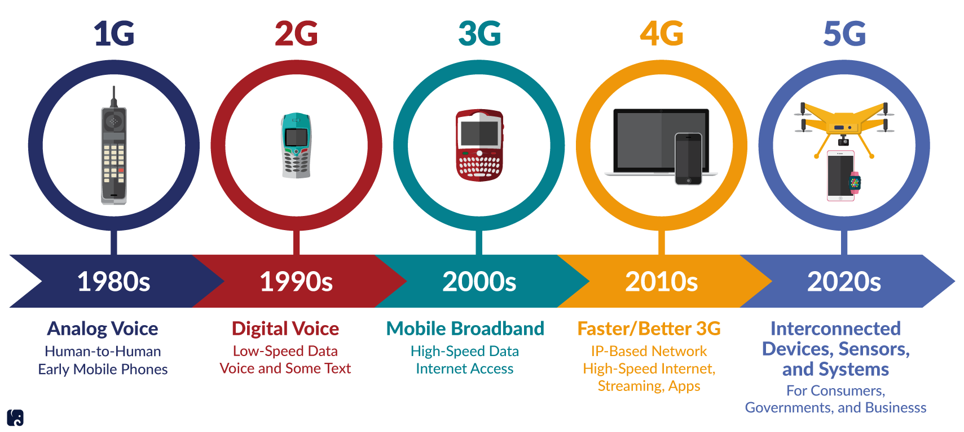
Figure 2.1: Network Generations [4]
Table 2.1 Comparison between 3G, 4G and 5G Technology [5]
Technology/ features | 3G | 4G | 5G
Data Bandwidth | 2Mbps | 2Mbps to 1Gbps | 1Gbps & Higher (as demand)
Frequency Band | 1.8 - 2.5 GHz | 2 - 8 GHz | 3-300GHz
Standards | WCDMA CDMA-200 TD-SCDMA | All access convergence including: OFMDA, MC-CDMA Network-LMPS | CDMA & BDMA
Technology | Broad bandwidth CDMA,IP technology | Unified IP And seamless combination of broadband LAN/WAN/ PAN and WLAN | Unified IP and seamless combination of broadband, LAN/WAN/PAN/WLAN [19] and technologies for 5G new deployment (could be OFDM etc.)
Service | Integrated high quality audio, video and data | Dynamic information access, wear-able devices, HD streaming; global roaming; | Dynamic information access, wear-able devices, HD streaming; any demand of users; upcoming all technologies; global roaming smoothly;
Multiple Access | CDMA | CDMA | CDMA & BDMA & NOMA
Core Network | Packet Network | All IP Network | Flatter IP Network & 5G Network Interfacing(5G-NI)
Definition | Digital Broadband, packet data | Digital Broad band, Packet data, All IP | Digital Broadband, Packet data All IP, Very high throughput
Hand off | Horizontal | Horizontal & Vertical | Horizontal & Vertical
Start from | 2001 | 2010 | 2015

2.2.2. The importance of 5G
The spectrum used for mobile communications is becoming congested. Current networks cannot always meet consumer demands for data. During periods of heavy use, consumers may experience slow speeds, unstable connections, delays, or loss of service. The effects can range from annoyances like a streaming movie freezing to life-threatening transmission delays between first responders in an emergency.
The demand for data will continue to grow as the number of devices connected to the internet grows. The number of smartphone users in the United States has increased from nearly 63 million in 2010 to an estimated 238 million in 2018. In 2018 there were 17.8 billion connected devices globally, 7 billion of which were connected devices such as smart home equipment. By 2025 the total number of connected devices is projected to exceed 34 billion.
Industries and consumers will rely on 5G networks to power the devices and transmit the data that drive their daily activities. They will need networks that can provide constant connections, minimal lag times, increased bandwidth to access and share data, and the ability to quickly compile and compute data.
In the health care sector, 5G could enable services such as remote patient monitoring, consultation, and even remote surgery. In transportation, 5G will be the backbone that autonomous vehicles rely on. A 2017 study from Deloitte estimated, “self-driving cars enabled by wireless connectivity could reduce emissions by 40-90%, travel times by nearly 40% and delays by 20%.”[6]

2.3. Non-Orthogonal Multiple Access (NOMA)
Non-orthogonal multiple access (NOMA) is one of the most promising radio access techniques in next-generation wireless communications. NOMA is an essential enabling technology for the fifth generation (5G) wireless networks to meet the heterogeneous demands on low latency, high reliability, massive connectivity, improved fairness, and high throughput. The key idea behind NOMA is to serve multiple users in the same resource block, such as a time slot, subcarrier, or spreading code
Compared to orthogonal frequency division multiple access (OFDMA), which is the current de facto standard orthogonal multiple access (OMA) technique, NOMA offers a set of desirable potential benefits, such as enhanced spectrum efficiency, reduced latency with high reliability, and massive connectivity [7].

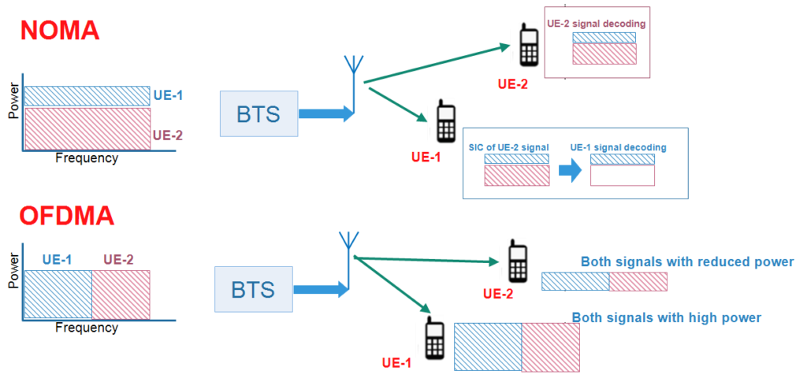
Figure 2.2: Deference Between Work of NOMA and OFDMA[7]

In OFDMA, different User Equipment (UE) signals are transmitted at different frequency resources, but in case of NOMA, different UE signals are transmitted at same frequency but at different power levels depending upon the position of UE to the cell. The performance gain of NOMA compared to that of OFDMA increases when the difference in channel gain and the path loss between UEs is large. According to this simple two-UE case, NOMA provides a higher sum rate than OFDMA. In fact, the cell-center UE gains in terms of rate since this UE is bandwidth-limited and thus benefits more from being able to use double bandwidth, even if this comes at the price of much lower transmit power. Meanwhile, the cell-edge UE also gains in terms of rate since it is power-limited; its transmit power is only slightly reduced under NOMA but its transmit bandwidth can be doubled.
The available NOMA techniques can broadly be divided into two major categories, power-domain NOMA and code-domain NOMA. Power-domain NOMA attains multiplexing in power domain based on different power levels, whereas code-domain NOMA achieves multiplexing in code domain based on different codes. There’s a lot in common between the CDMA and Code-domain NOMA, especially in the uplink process, despite the complicated new technology, the output performance is still in comparison to OFDMA, thus the researchers are seeking more improvements in the Power-domain NOMA.
Recent studies demonstrate that NOMA has the potential to be applied in various fifth generation (5G) communication scenarios, including Machine-to-Machine (M2M) communications and the Internet-of-Things (IoT). Moreover, there are some existing evidence of performance improvement when NOMA is integrated with various effective wireless communications techniques, such as cooperative communications, multiple-input multiple-output (MIMO), beamforming, space–time coding, network coding, full-duplex.
Since the principle of NOMA allows multiple users to be superimposed on the same resource, this leads to interference for such systems. Consequently, existing resource management and interference mitigation techniques, especially for ultra-dense networks, need to be revisited due to the incorporation of additional interference this new technology brings. For the similar reason, beamforming and the resultant other problems (e.g., precoding) in massive-MIMO systems introduce additional challenges and need to be solved in order to achieve full utilization of these technologies. From the perspective of physical layer, existing channel coding, modulation and estimation related problems need to be revised as well. Cognitive, cooperative, and visible light communications all are conducive paradigms under NOMA systems compared to conventional systems. However, the resultant evolved problems due to the incorporation of this new technology need to be solved before acquiring benefits from these paradigms. Although NOMA technique offers numerous advantages, the enhanced information sensing ability of more users via this technique, leads to higher security and privacy threat. Therefore, a series of security problems from the physical to application layers need to be solved in order to build a robust, efficient and effective system via this technique [7].

2.4. Previous Studies
This part, show the previous studies on the analysis of NOMA in 5G. Two papers are chosen for any year from 2016 to 2020 to review.
2.4.1. Weiliang Han, Jianhua Ge, Jinjin Men, 2016:
Non-orthogonal multiple access (NOMA), which is an effective solution to improve spectral efficiency, has been considered as an emerging candidate for the fifth generation multiple access. In addition, simultaneous wireless information and power transfer, which aims to maximize energy efficiency, has received significant attention. In this study, the authors design NOMA for downlink energy harvesting (EH) multiple-antenna relaying networks. The base station communicates with multiple mobile users simultaneously via an EH relay node. In the first slot, the relay node harvests energy from the received signals; and in the second slot, the relay node uses the harvested energy to broadcast the received signals to all mobile users. Antenna selection is adopted at the base station while maximal-ratio combining is applied at the mobile users. The outage performance for the NOMA-EH relaying networks is studied over Nakagami-m fading and closed-form expressions for the outage probability are obtained. In addition, the presented simulation results demonstrate the correctness of the authors’ analysis and the advantage of NOMA over conventional orthogonal multiple access
The motivation of NOMA is to improve the spectral efficiency of wireless network, another key objective of fifth generation (5G) networks is to improve energy efficiency. In practice, the relay nodes may have limited capacity batteries, recharging or replacing batteries of relay nodes may be inconvenient and can incur a high cost in some scenarios. On the other hand, energy harvesting (EH) can collect energy from ambient environment, such as solar, vibration, wind or other physical phenomena, which has attracted much attention. However, the availability of these energy sources is limited by environment or climate. Simultaneous wireless information and power transfer (SWIPT) is a new emerging EH technology, which depends on the usage of radio-frequency signals to provide all-weather stable power supply. Therefore, it is reasonable to combine SWIPT with NOMA relaying networks, and this model has its practical applications. For example, in wireless sensor networks, the source node transmits information to multiple access points via a mobile relay, which does not have energy itself or has limited battery reserves. The authors proposed the time switching-based relaying protocol and power splitting-based relaying (PSR) protocol for EH relay system. The authors studied a wireless-powered uplink communication system with NOMA, and time-allocation methods were proposed in order to maximize the individual data rates and to improve fairness of all users. The authors in [14] applied SWIPT into cooperative NOMA networks, where the NOMA users close to the source were acted as EH relays to help far NOMA users. However, as far as the authors are aware, the literatures combining SWIPT with NOMA relaying systems are limited, and the existing works are focused on single-antenna system and Rayleigh fading channels. Moreover, Nakagami-m distribution models empirical data better than Rayleigh distribution, and it is useful for a wider class of fading environments, which comprises the Rayleigh fading (m = 1) as a special case.
Inspired by this fact, in this paper the NOMA-based EH (NOMA-EH) multiple-antenna relaying network is investigated under Nakagami-m fading, where the relay node scavenges energy from the received signals following the PSR protocol and then the remaining signals are forwarded to all mobile users by the relay node with the harvested energy. The signal power splitting ratio, depicting the trade-off between the harvesting energy and the forward signals’ power, is a crucial factor for the system outage probability. The main contributions of this paper are summarized as follows:
- We combine SWIPT with NOMA relaying networks to prolong the lifetime of energy-constrained wireless networks. To further improve the system performance, the transmit antenna that maximizes the instantaneous channel gain between the base station and the relay node is selected at the base station, and maximal-ratio combining (MRC) is applied at the mobile users.
- The outage performance for the considered network is studied. In particular, closed-form expressions for the outage probability are attained, which is the theoretical basis to provide valuable guidelines in the actual communication system design.
- Numerical examples are conducted in order to verify the theoretical analysis. Meanwhile, the comparisons between NOMA-EH and orthogonal multiple access (OMA)-EH demonstrate the superiority of NOMA. Moreover, the impact of relay location on the outage performance and energy efficiency is investigated, which shows that the worst relay location is the half-way point between users and the base station. In addition, the influence of the signal power splitting ratio on outage performance is studied in both serious path-loss scenario and general case.
In this paper, the combination of NOMA with multiple-antenna EH relaying networks is investigated over Nakagami-m fading channel. We concentrate on the outage performance of NOMA-EH relaying networks and expressions for the outage probability are attained in closed-form. Finally, simulation results demonstrate that the worst relay locations for both NOMA-EH and OMA-EH relaying networks are the half-way point between users and the base station. Furthermore, it is shown that NOMA-EH provides significant performance gain over OMA-EH in terms of outage performance and EE, and NOMA can provide better user fairness and spectral efficiency since more users can be served at the same time. For further work, we will apply NOMA into multiple-relay multiple-antenna EH relaying networks, where a joint relay and antenna selection scheme can be proposed[8].
2.4.2 Refik Caglar Kizilirmak,2016
The author explored the concept of non-orthogonal multiple access (NOMA) scheme for the future radio access for 5G. First he provides the fundamentals of the technique for both downlink and uplink channels and then discuss optimizing the network capacity under fairness constraints. they also further discuss the impacts of imperfect receivers on the performance of NOMA networks. Finally, they are discussing the spectral efficiency (SE) of the networks that employ NOMA with its relations with energy efficiency (EE). prove that the networks with NOMA outperform other multiple access schemes in terms of sum capacity, EE and SE.
Non-orthogonal multiple access (NOMA)
He considers orthogonal frequency division multiplexing (OFDM) as the modulation scheme and NOMA as the multiple access scheme. In conventional 4G networks, as natural extension of OFDM, orthogonal frequency division multiple access (OFDMA) is used where information for each user is assigned to a subset of subcarriers. In NOMA, on the other hand, all of the subcarriers can be used by each user. [Figure 1] illustrates the spectrum sharing for OFDMA and NOMA for two users. The concept applies both uplink and downlink transmission.
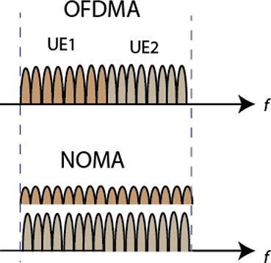

Figure 2.3: Spectrum sharing for OFDMA and NOMA for two users[9].
Superposition coding at the transmitter and successive interference cancellation (SIC) at the receiver makes it possible to utilize the same spectrum for all users. At the transmitter site, all the individual information signals are superimposed into a single waveform, while at the receiver, SIC decodes the signals one by one until it finds the desired signal. Figure 2.4 illustrates the concept. In the illustration, the three information signals indicated with different colors are superimposed at the transmitter. The received signal at the SIC receiver includes all these three signals. The first signal that SIC decodes is the strongest one while others as interference. The first decoded signal is then subtracted from the received signal and if the decoding is perfect, the waveform with the rest of the signals is accurately obtained. SIC iterates the process until it finds the desired signal.
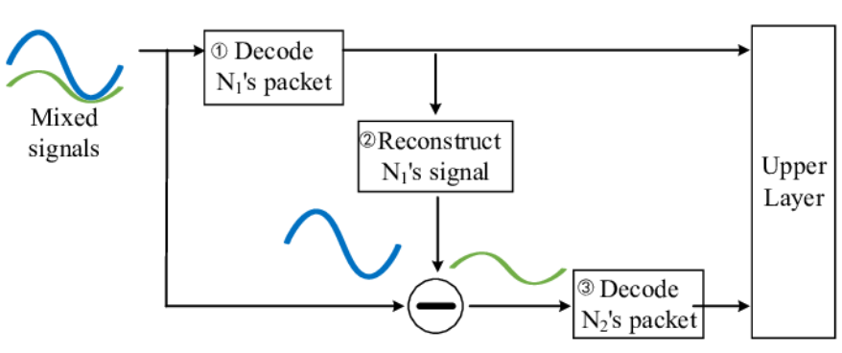

Figure 2.4: Successive interference cancellation (SIC) technology.

The success of SIC depends on the perfect cancellation of the signals in the iteration steps. The transmitter should accurately split the power between the user information waveforms and superimpose them. The methodology for power split differs for uplink and downlink channels.
NOMA for downlink
In NOMA downlink, the base station superimposes the information waveforms for its serviced users. Each user equipment (UE) employs SIC to detect their own signals. Figure 3 shows a BS and K number of UEs with SIC receivers. In the network, it is assumed that the UE₁ is the closest to the base station (BS), and UE_{K} is the farthest.
The challenge for BS is to decide how to allocate the power among the individual information waveforms, which is critical for SIC. In NOMA downlink, more power is allocated to UE located farther from the BS and the least power to the UE closest to the BS. In the network, all UEs receive the same signal that contains the information for all users. Each UE decodes the strongest signal first, and then subtracts the decoded signal from the received signal. SIC receiver iterates the subtraction until it finds its own signal. UE located close to the BS can cancel the signals of the farther UEs. Since the signal of the farthest UE contributes the most to the received signal, it will decode its own signal first.
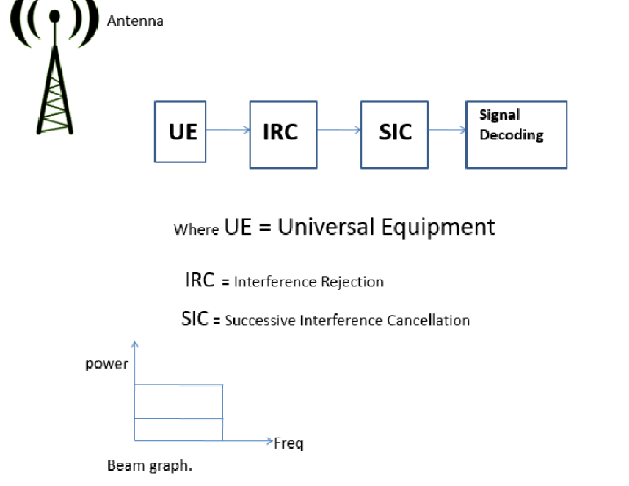

Figure 2.5 Block Diagram showing NOMA transmission in DL mode
NOMA for uplink
Uplink implementation of NOMA is slightly different than the downlink. Figure 4 depicts a network that multiplexes K UEs in the uplink using NOMA. This time, BS employs SIC in order to distinguish the user signals.

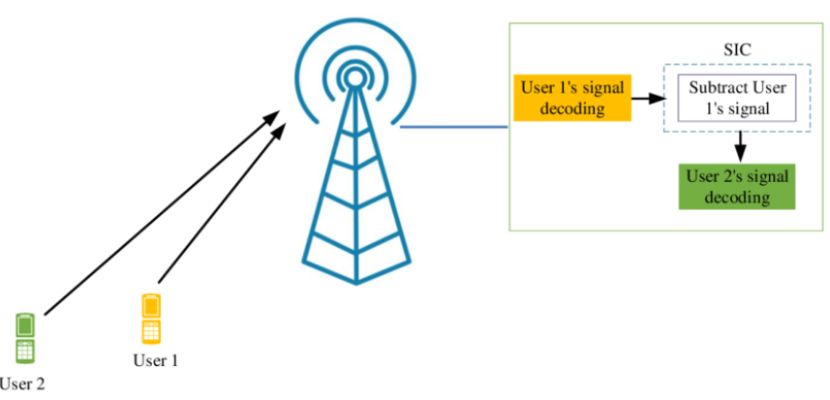

Figure 2.6: Uplink NOMA system with two users.
Imperfectness in NOMA
They have a discussion so far in the previous sections assume perfect cancellation in the SIC receiver. In actual SIC, it is quite difficult to subtract the decoded signal from the received signal without any error. In this section, we revisit the NOMA concept with cancellation error in the SIC receiver.
Here, we consider the downlink only; however, the discussions can easily be extended for the uplink. Recall that SIC receiver decodes the information signals one by one iteratively to obtain the desired signal. In SIC, after decoding the signal, one should regenerate the original individual waveform in order to subtract it from the received signal. Although it is theoretically possible to complete this process without any error, in practice, it is expected to experience some cancellation error.
Spectral efficiency and energy efficiency
Most analysis so far included the throughput performance of the network. In addition to spectral efficiency (SE) of NOMA, in this section, they analyze the energy efficiency (EE) of NOMA systems, in their analysis, they combined the static power consumption of the network due to the power amplifiers in addition to the power consumed for the information waveform.
The total power consumption at the transmitter can be represented as the sum of the information signal power and the power consumed by the circuits (mainly by power amplifiers).
The energy efficiency and spectral efficiency relationship (EE-SE) in Shannon theory does not consider the power consumption of the circuit and consequently is monotonic where a higher SE always results in a lower EE. When the circuit power is considered, the EE increases in the low SE region and decreases in the high SE region. The peak of the curve (or the corresponding derivative of the EE-SE relationship) is where the system has the maximum energy efficiency. This point is called “green point”.
In this paper they introduce the basics of NOMA and shower performance over conventional OFDMA in terms of sum capacity, energy efficiency and spectral efficiency. they also mentioned the impact of imperfectness at the SIC receiver on the system performance. With its distinct features, NOMA stays as the strongest candidate for the future 5G networks. There are, however, still some challenges for successful implementation of NOMA. First of all, it requires high computational power to run SIC algorithms particularly for high number of users at high data rates. Second, power allocation optimization remains as a challenging problem, particularly when the UEs are moving fast in the network. Finally, SIC receiver is sensitive to cancellation errors which can easily occur in fading channels. It can be implemented with some other diversity techniques like multiple-input-multiple-output (MIMO) or with coding schemes in order to increase the reliability and accordingly reduce the decoding errors. There are recent works that implement MIMO for NOMA, however, is still far from its potential and requires further investigation[9].
2.4.3 Zhiguo Ding, Xianfu Lei, George K. Karagiannidis..ect,2017
NOMA is a critical enabling technology for fifth-generation (5G) wireless networks to address heterogeneous demands for low latency, high dependability, huge connection, better fairness, and high throughput. NOMA is based on the idea of serving numerous users in the same resource block, such as a time slot, subcarrier, or spreading code. The NOMA principle is a broad framework, with numerous newly suggested 5G multiple access systems serving as examples. This survey covers the most recent NOMA research and advancements, as well as their applications. As a result, the papers in this special issue are integrated into the existing literature. Future NOMA research issues in 5G and beyond are also mentioned.Non-orthogonal multiple access (NOMA) has emerged as a key design paradigm for fifth-generation (5G) wireless networks' radio access approaches. NOMA is based on the same key notion, in which each orthogonal resource block, such as a time slot, a frequency channel, or a spreading code, serves multiple users. Traditional orthogonal multiple access (OMA) approaches, such as time division multiple access (TDMA) and orthogonal frequency division multiple access (OFDMA), serve a single user in each orthogonal resource block, in contrast to NOMA. With the following simple example, the spectral inefficiency of OMA may be demonstrated. Consider a scenario in which one user with extremely poor channel conditions must be serviced for the sake of fairness, such as when this user has high-priority data or has not been served in a long time. In this situation, the adoption of OMA means that, despite the bad channel circumstances, one of the scarce bandwidth resources will be solely used by this user. Obviously, this has a negative influence on the entire system's spectrum efficiency and throughput. When NOMA is used in this case, it assures that not only the user with bad channel conditions is served, but also users with better channel conditions can also use the same bandwidth resources as the weak user. As a result, if user fairness must be ensured, NOMA's system throughput can be much higher than OMA's. In addition to improving spectral efficiency, academic and industrial research has shown that NOMA can efficiently enable vast connectivity, which is critical for assuring that the upcoming 5G network can support Internet of Things (IoT) functions.
Although the application of NOMA in cellular networks is new, comparable concepts in information theory have been explored for a long time. Superposition coding, successive interference cancellation (SIC), and the message passing algorithm (MPA), for example, were all invented more than two decades ago the notion of NOMA, or the removal of orthogonality, has never been employed in earlier generations of cellular networks.
NOMA is not the same as the code division multiple access system (CDMA). In reality, CDMA is based on the premise that individuals may be distinguished by leveraging variances in their spreading codes, whereas NOMA encourages numerous users to share the same code. As a result, the chip rate for CDMA must be significantly greater than the supported information data rate; for example, supporting a data rate of 10 Gbps may need a chip rate of a few hundred Gbps, which is challenging to achieve with current technology.
Because of its interoperability with various communication technologies, NOMA can be easily integrated into present and future wireless systems. NOMA, for example, has been proved to be interoperable with traditional OMA protocols like TDMA and OFDMA. As a result, NOMA has been proposed for inclusion in the 3GPP long-term evolution advanced (LTE-A) standard, where NOMA is known as multi-user superposition transmission (MUST). The NOMA concept, in particular, ensures that two users are served simultaneously on the same OFDMA subcarrier without requiring any modifications to the LTE resource blocks (i.e., OFDMA subcarriers) without requiring any changes to the LTE resource blocks (i.e., OFDMA subcarriers). NOMA has also recently been included in the upcoming digital television standard (ATSC 3.0), where it is referred to as layered division multiplexing (LDM). Using the NOMA principle and superimposing numerous data streams, the spectral efficiency of TV broadcasting is increased. The above examples show that NOMA has a lot of promise, not just for 5G networks but also for other emerging and present wireless systems.
This survey's purpose is to provide a complete overview of the most recent NOMA research results and developments, including the papers published in this JSAC special issue. In particular, in Sections II and III, the design of single-carrier and multi-carrier NOMA is explored, with power-domain NOMA, SCMA, LDS, and PDMA as examples. Multiple-input multiple-output (MIMO) NOMA and cooperative NOMA are discussed in Sections IV and V, respectively. The combination of NOMA with millimeter-wave (mmWave) communications is investigated in Section VI. In Section VII, some key NOMA implementation challenges are examined, and in Section IX, concluding thoughts are presented.
When the NOMA principle is applied to a single orthogonal resource block, such as a single carrier, the power domain offers a spectrally efficient technique to realize multiple access. Multiple users can be served in the same time slot, OFDMA subcarrier, or spreading code using power-domain NOMA, and multiple access is achieved by allocating various power levels to distinct users. MUST, a two-user downlink power-domain NOMA scheme in which a base station (BS) feeds two single-antenna users at the same OFDMA subcarrier, is an example of this variant of NOMA[10].
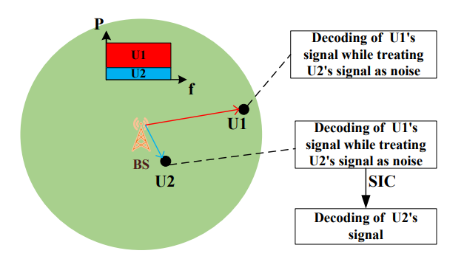
Figure 2.7: An example of a NOMA downlink scheme with two users, denoted by U1 and U2, and one subcarrier[10]
Conventional power NOMA gives users with bad channel conditions more power, ensuring user fairness; nevertheless, traditional power-domain NOMA cannot guarantee users' QoS targets. NOMA based on cognitive radio (CR) is a popular form of power-domain NOMA that assures that part or all of the customers' QoS requirements are met. CR-main NOMA's idea is to treat NOMA as a specific example of cognitive ratio, the power allocation policy is meant to meet the users' predefined QoS criteria
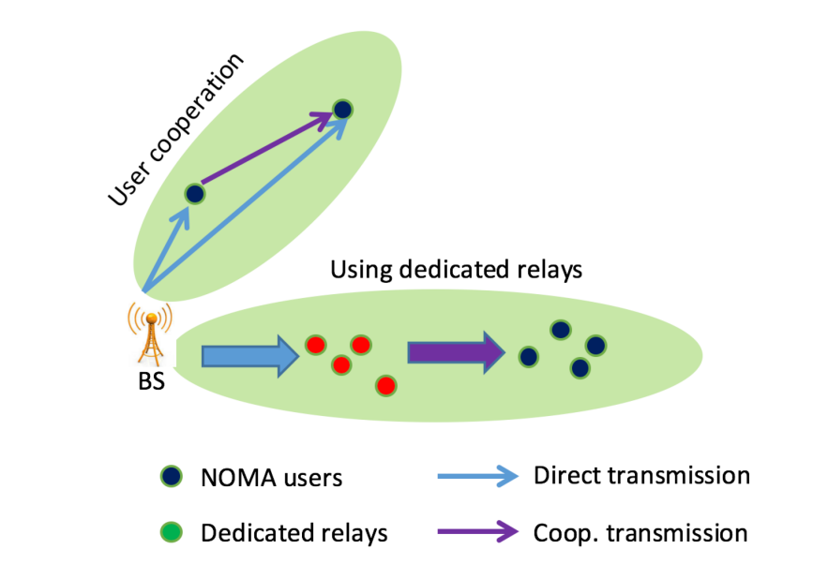

Figure 2.8 An illustration of the two forms of cooperative NOMA[10]

This paper demonstrated that grouping those two users from a set of users yields the highest performance gain over OMA. And by using the strong user as a relay, cooperative NOMA can successfully assist the user with weak channel conditions. In practice, this user may not want to relay because it will eat up its own energy and reduce battery life. The effect of user and antenna choice on cooperative SWIPT-NOMA is investigated. The SWIPT-NOMA approach can greatly simplify the design of power allocation policies while also ensuring that users' QoS requirements are met. To get a fundamental knowledge of the synergy between NOMA and cognitive radio networks, more research is required. The NOMA approach can be integrated with physical layer security (PLS) in scenarios with external eavesdroppers. The power allocation coefficients, in particular, are designed based on the channel circumstances of authorized users.
2.4.4 Abbas Kiani, and Nirwan Ansari,2017
With the rapid growth of the Internet of Things (IoT), 5G wireless networks must be able to deliver vast connection of (IoT) devices while also meeting the demand for low latency. Non-Orthogonal Multiple Access (NOMA) has been identified as a possible solution for 5G networks to considerably boost network capacity in order to meet these objectives. Mobile Edge Computing (MEC) is emerging as one of the important emerging technologies for reducing latency and improving Quality of Service (QoS) for 5G networks, parallel to the development of NOMA approaches. This study provides an edge computing aware NOMA technique that can enjoy the benefits of uplink NOMA in decreasing MEC users' uplink energy in order to reap the potential profits of NOMA in the context of MEC.
Non-Orthogonal Multiple Access (NOMA) approaches have recently received a lot of investigation since they are seen as possible solutions for 5G. NOMA allows numerous users to share the same resources, unlike Orthogonal Multiple Access (OMA) approaches, which allocate radio resources orthogonally to multiple users. More users can be served by simultaneously serving several users over the same radio resources, resulting in a large boost in network capacity. This benefit is still available, but it comes at the cost of intra-cell interference and increased receiver complexity. NOMA splits the users in the power domain based on their individual channel conditions and applies effective Multi-User Detection (MUD) techniques such as Successive MUD to deal with intra-cell interferences and complexity.
In this article, they propose a novel NOMA augmented edge computing model that captures the gains of uplink energy efficiency in MEC users' energy consumption. We design an efficient heuristic algorithm for user clustering and RBs allocation, and formulate a convex optimization problem for the transmission power control. They also evaluate the effects of computing capacity and its division strategy of computing Resource Blocks (RBs) on the total energy consumption; and they show the performance of our proposed scheme and algorithm via extensive simulations [11].
In this study, they have proposed an edge commuting aware NOMA technique, which can leverage the gains of uplink NOMA in reducing MEC users’ energy consumption. Specifically, they have formulated a NOMA based optimization framework that minimizes the energy consumption of MEC users via optimizing the user clustering, computing and communication resource allocation, and transmit powers. In particular, they have investigated the joint allocation of the frequency and computing RBs to the users that are assigned to different order indices within the NOMA clusters. They have also designed an efficient heuristic algorithm for user clustering and RBs allocation, and formulated a convex optimization problem for the power control to be solved independently per NOMA cluster. Moreover, they have evaluated and demonstrated the effectiveness of the proposed NOMA scheme in lowering the energy consumption via simulation.
2.4.5. Zhanji Wu, Kun Lu, Chengxin Jiang, and Xuanbo Shao,2017
Non-orthogonal multiple access (NOMA) technology can achieve higher spectrum efficiency and support more massive connectivity. Many mainstream companies have proposed NOMA technologies for the fifth generation (5G) wireless communication standard. By comparing the performance of these technologies, some promising schemes and directions are suggested for the future 5G development. With the rapid development of mobile Internet of Things (IoT), much more User Equipment (UEs) and much higher data-rate pose big challenges for the future mobile wireless network. In 2014, the International Mobile Telecommunication (IMT)-2020 promotion group proposed the vision and requirements of the fifth generation (5G) wireless communication. 5G aims to support much higher Spectral Efficiency (SE) and much more massive connectivity, and new non-orthogonal multiple access (NOMA) is one key technology to meet these strict requirements. The typical application scenarios of 5G consist of enhanced Mobile Broad-Band (eMBB), massive Machine Type Communications (mMTC) and Ultra-Reliable and Low Latency Communications (URLLC). Each scenario has distinct service feature and requirement.
The study on NOMA started from the 3rd Generation Partnership Project (3GPP) Release 14 (Rel-14) since September 2014, and it is ongoing at the Study-Item (SI) step of 3GPP (Rel-15) until May 2018 By the end of June 2019, 3GPP (Rel-16) will accomplish the final 5G New Radio (NR) submission, including description template, compliance template, and self-evaluation results. The current target is to provide self-evaluation against (eMBB), (mMTC) and (URLLC) requirements and test environments for 5G New Radio (NR) standardization. The conventional Orthogonal Multiple Access (OMA) technology allocates orthogonal time and frequency resources for multiple users, and each user's receiver can take advantage of this orthogonality to separate out its own signal from others simply.
The NOMA technique utilizes the superposition coding principle to multiplex multiple users onto the same time and frequency resources. Therefore, NOMA can enlarge the number of connections by introducing controlled symbol collisions. Actually, NOMA can approach the capacity bound of the multi-user system more closely than OMA [12].
The main contributions of this paper can be summarized in proposing an overall classification of NOMA schemes which are key candidates in 5G according to their characteristics, systematically summarize the transceiver block diagram of each category, and detail basic principles, key features and transmission-reception algorithms of all NOMA schemes. They comprehensively compare all these NOMA and OMA schemes in terms of theoretical analysis, simulation performance and receiver complexity. Thus, some promising schemes and directions are suggested for the future 5G NOMA development.
In this article, the latest NOMA schemes proposed for the 5G standard are comprehensively studied and compared. Firstly, they classify these schemes into four categories: scrambling- based, spreading-based, coding-based and interleaving-based NOMA schemes. Key characteristics and transceiver algorithms of each NOMA scheme are detailed and compared.
Theoretically, it is proved by the multi-user AMI analysis that NOMA schemes can obtain significant SNR gain for given achievable sum-rate.
Practically, comprehensive simulation results verify such remarkable gain, even for the realistic channel estimation and the grant-free scenario.
It seems that coding-based and spreading-based NOMA schemes have some advantages in terms of bigger connectivity and robustness. However, they think that there is still some improvement room for these schemes to combine the NOMA signatures (patterns) with 5G-adopted powerful LDPC codes, high-order modulation, and incremental redundancy hybrid ARQ (HARQ) schemes [12].
2.4.6. Xin Liu, Yongjian Wang, Shuai Liu, and Jing Meng,2018.
The cognitive radio divided users into two sections, the far user, and the near user. The far user has the poorest channel and he is the Primary User (PU), and the near one is the Secondary User (SU). In this paper Non-Orthogonal Multiple Access (NOMA) based Cognitive Radio (CR) has been proposed to access the multiple sub-channel of Secondary User (SU) both at the absence and presence of (PU) By two types of decoding moods Primary User First Decoding Mode (PFDM) ‏ For the primary user (PU), and secondary user first decoding mode (SFDM) for the secondary user (SU) at the transmitter side. The (SU) senses the ideal spectrum by performing Spectrum Sensing which can be seen as a binary detection problem. energy detection is widely used to detect the (PU) through comparing the accumulated energy statistic of the (PU) signal to a pre-settled threshold. The (PU) is detected to be absent if the energy statistic is below the threshold. A low false alarm probability implies that the idle channel is reliably detected, but a high detection probability shows that the presence of the (PU) is accurately detected. The detection performance is determined by the sensing time, which can be extended to reduce false alarm probability and boost detection probability. The performance of energy detection is reflected by false alarm probability and detection probability. low falls Alarm probability indicates higher reliable detection of the Ideal channel, highly detection probability means higher accurate detection on the presence of the (PU).
Listen-before- talk presented a talk spectrum access system in which the frame was divided into sensing and transmission slots, and the (SU) may work in the transmission slot after the sensing slot found an idle channel. A sensing-throughput tradeoff approach was presented to find the optimal sensing time while maximizing the (SU)'s throughput. The multichannel (CR) was developed, which could boost the (SU)'s throughput.
NOMA was proposed to solve optimization problems seek to maximize normalize the throughput of the Secondary User (SU) By jointly optimizing algorithms to solves these problems by Optimizing spectrum resource including number of sub-channels and sub-channel transmission power, and proposed to improve spectrum efficiency of 5G communication which can support spectrum access of multiple users in Power-Domain. In NOMA multiple users can be multiplexed on same sub-channels by applying superposition coding on the transmitter Side.
(CR) System improve current statistic spectrum utilization by allowing the secondary user (SU) To access ID on spectrum allocated to the primary user (PU).
They present a NOMA-based CR in this study that can access the spectrum in both the absence and presence of the PU. The NOMA signals are decoded by the receiver using PFDM and SFDM, respectively. The SU can achieve flawless throughput in the PFDM, but the sub-channel power must be managed to ensure the PU throughput. The SU throughput in the SFDM, on the other hand, is reduced due to the PU's interference. They have introduced two spectrum resource optimization problems aimed for PFDM and SFDM, which seek to improve SU throughput by jointly optimizing the number of sub-channels and sub-channel power [13].
2.4.7. Omar A.Saraereh, Amer Alsaraira, Imran Khan,ect,2019
The rapid development of the mobile Internet and the Internet of Things and the popularization of the application of intelligent terminals have placed higher demands on future wireless networks. The new generation of mobile communication systems (5G) needs to further expand the system capacity to meet the emerging new business. In the face of increasingly tight spectrum resources, the traditional multiple access method has got difficulties to meet the demand, so the industry proposes to adopt a new type of multiple access mode in 5G, namely non-orthogonal multiple access (NOMA). NOMA technology can significantly improve system spectral efficiency and support large-scale user access and has become one of the key technologies of 5G. For traditional orthogonal multiple access (OMA) technology, a single user is allocated a single radio resource, such as Frequency Division or Time Division, and NOMA technology introduces a power domain, which can allocate the same resource to multiple users, that is, multiple users can share the same resource block so that the system can accommodate users, regardless of the number of system orthogonal resource blocks. The NOMA technology adopts superposition coding at the transmitting end, and allocates less power to users with good channel conditions through the power division multiplexing technology, and allocates more power for users with poor channel conditions, thereby achieving better user fairness.
Compared with OMA, the complexity of the receiver of the NOMA system will increase, but its biggest advantage is that it can obtain higher spectral efficiency, which is equivalent to increasing the complexity of the receiver in exchange for spectral efficiency.
As processor performance continues to increase, more advanced receivers can be used on the device, and the implementation of NOMA technology in real-world systems is also possible using multi-user separation via a successive interference cancellation (SIC) technique at the receiver. In the NOMA system, it is impractical to superimpose all users on the same resource block because of the large decoding delay and serious error propagation.
Therefore, it is necessary to reduce the number of users superimposed on the same resource block by means of user grouping. Reasonable user grouping and power allocation algorithms can reduce the interference between user signals and improve system capacity. However, the complexity of the algorithm increases exponentially with the increase in the number of users. When the number of users is large, the algorithm is impractical.
This paper proposes an improved user grouping and power allocation scheme, aiming to further reduce the complexity of the algorithm and optimize the system capacity. The optimization model is established with the goal of maximizing system capacity. Through the step-by-step optimization idea, the complex non-convex optimization problem is decomposed into two sub-problems to be solved separately. Firstly, all users are grouped based on the greedy method, and then the power allocation is performed on the sub-carriers of the fixed group.
Considering that the linear water filling algorithm does not need iteration, but the performance of the iterative water-filling algorithm can be obtained, this paper uses the linear water filling algorithm for all subcarriers having power allocated, and the total multiplexing power of each subcarrier is obtained; The Fractional Power Allocation (FTPA) method is used to allocate power to the subcarrier superimposed users. The simulation results show that the proposed algorithm can obtain the throughput performance similar to the existing optimal algorithm under the condition of greatly reducing the complexity.
In the NOMA system, User Grouping Scheme, the sender superimposes the signals of multiple users on the power domain and transmits them simultaneously. Therefore, different user grouping schemes have a great impact on system performance. An exhaustive algorithm is used to traverse the search for all possible user combinations, and then the system performance under different user grouping results is compared to obtain the best user grouping. However, the exhaustive algorithm has a high degree of complexity and is not applicable in practice. In order to reduce the complexity of the exhaustive search.
this paper considered the greedy algorithm to perform user selection on each subcarrier. The basic idea of the greedy algorithm is to always use the best choice in the current step as the optimal strategy when solving the problem.
Also in this paper Complexity Analysis, the proposed user grouping method based on the GA scheme was mainly used in the user grouping on the subcarrier. For the convenience of discussion, only the complexity analysis of the 8 of 13 user grouping situation on a single subcarrier was performed, and the number of user combinations on the subcarrier was considered.
In conclusions, the problem of downlink resource allocation in the OFDM-NOMA system was studied with the goal of maximizing system capacity. Through the idea of step-by-step optimization, the optimization problem was decomposed into two sub-problems: user grouping and power allocation. Firstly, a subcarrier user grouping strategy based on GA was adopted. When the performance better to the exhaustive algorithm was obtained, the required number of iterations decreases, and the computational complexity was effectively reduced. Secondly, a low-complexity power allocation algorithm was proposed. The linear water filling algorithm was combined with the FTPA method. The linear water filling algorithm was used to allocate power to all sub-carriers, and the sub-carrier superimposed users were allocated power by FTPA. The linear water-filling power allocation algorithm did not need to perform multiple iterations, but its capacity performance was completely close to the iterative water-filling algorithm. The simulation results show that the proposed user grouping and power allocation scheme could further reduce the complexity based on the optimization of the capacity of the NOMA system. A further extension of this study is to consider the MIMO integration and analyze various important parameters[14].
2.4.8. Osama M.S.Abuajwa. Chee Keong Tan,2019
One of the proposed radio access strategies for improving system performance in 5G networks is the Non-Orthogonal Multiple Access (NOMA) scheme. The power-domain NOMA technique performs superposition coding (SC) at the transmitter and successive interference cancellation (SIC) at the receiver and is one of the most basic NOMA schemes. The importance of Power Allocation (PA) in achieving successful SIC and high system throughput cannot be overstated. This research focuses on power distribution in NOMA-based 5G networks to enhance throughput. In terms of throughput analysis, the objective functions, algorithms, constraints, and limitations of the system design in power allocation strategies for NOMA-based 5G networks are thoroughly explored and described.
The NOMA scheme is envisioned as an upcoming radio access mechanism for 5G networks with high bit-rate and capacity. Researchers are interested in finding an alternate system to the existing OMA because to the ever-increasing demand for capacity by consumers. Under poor channel conditions, the OMA technique's bandwidth resource allocation provided a low spectral efficiency. The NOMA system, on the other hand, tends to allocate bandwidth to users regardless of channel state. This is a huge improvement over OMA in terms of spectrum efficiency.
NOMA has the ability to provide large capacity while also improving spectral efficiency. However, implementing the NOMA method in 5G networks poses numerous hurdles for a variety of reasons. The user pairing complexity and channel state information (CSI) requirements are the most common among them.
This study focuses on power-domain NOMA, which uses power allocation (PA) algorithms to allow users to share the same resources across time and frequency domains. To solve different difficulties related to throughput maximization in NOMA-based 5G networks, the resource allocation and PA systems will be investigated in depth.
The following is a breakdown of the paper's structure. They discuss the main elements of NOMA system and covers resource allocation approaches, as well as issue formulation, algorithms, and system designs and the various PA algorithms to analyze throughput performance, compare the methods of water-filling–Proportional Fairness (WF-PF) and water-filling combined with NOMA-Orthogonal signaling (NOMA- OS-WF). Furthermore, the amount of potential users.
In the POWER ALLOCATION PA NOMA schemes, the channel gain information is utilized to allocate the transmission power. These PA schemes allocate different power levels to different users based on their channel conditions. Users with the weak channel conditions get more allocated power to enable the user to decode its signal while the users with the stronger channel condition will be able to decode their signal too.
The iterative water–filling–based PA takes channel gains into account as a main signal for user pairing approaches. The proportional fairness (PF) algorithm uses singular value decomposition (SVD) to rank users based on their channel gains, increasing the complexity of the MIMO system by adding extra stages and schemes to categorize users. Because calculating channel gains for SU-MIMO is challenging, the suggested technique has a higher computational complexity. The NOMA resource allocation problem is mathematically described, and its tractability is characterized and examined in terms of the users' channel gains, total power budget, individual power limit, and maximum number of multiplexed users per subcarrier. A framework for a combination of algorithms
In terms of a bigger number of cell-edge users while considering a limited number of users in the cell, the water filling-based PA outperforms the equal power allocation (EPA). They presented a matching algorithm for AP association and resource allocation that yields a greater system throughput than the other approaches. As a result, the number of users increases, and the AP I the yam a off yam throughput improves. The matching approach improves system throughput by limiting interference when APs are paired systematically rather than randomly. These arguments suggest that the APs association is the best multi-user system. To enable the system to associate, the proposed strategy used NOMA techniques[15].
2.4.9. Muzhumathi M, Niveethitha M, Padmapriya B, and Sivasankar,2020
Wireless Communication is the fastest growing and most vibrant technological areas in the communication field. Wireless Communication is a method of transmitting information from one point to other, without using any connection like wires, cables or any physical medium. Generally, in a communication system, information is transmitted from transmitter to receiver that are placed over a limited distance. Communication Systems can be Wired or Wireless and the medium used for communication can be Guided or Unguided. 5G is the next generation technology which will offer agile and safe communication. With the 5G technology the data speeds are expected to be 100 times higher than the 4G networks. The basic purpose of 5G is to transform smartphones, smart TV’s, any electronic gadget that can be connected to internet is expected to have consistent speed that will be 100 times faster than the current 4G network. The Fifth Generation(5G) technology is beyond the mobile internet to enormous Internet of tings (IOT). The major difference between 5G & 4G technology is, 5G technology is 100 times more agile than the 4G technology.
The 5G network uses less power consumption, and 1milli second latency time. In simple words the 5G technology is beyond Mobile phones it revolutionizes the gigantic IOT things. Technology in 5G are: New radio frequencies, Frequency range 1 (< 6 GHz), Frequency range 2 (> 24 GHz), FR2 coverage, Massive MIMO, Edge computing, Small cell, Beamforming, Wifi-cellular convergence, NOMA (non-orthogonal multiple access), SDN/NFV, Channel coding. NOMA scheme is envisioned as an emerging radio access technique to achieve high bit-rate and capacity for 5G networks. The ever-increasing demand of capacity by users have generated interest of researchers to seek alternative scheme to the existing OMA. The bandwidth resources allocation in OMA technique offered a low spectral efficiency under poor channel condition. Conversely, the NOMA scheme tends to allocate bandwidth for users regardless of their channel condition. This is a significant improvement of the spectral efficiency over OMA. NOMA can provide high capacity and enhance spectral efficiency[16].
Proposed Method
A NOMA-based 5G system consists of multiple users sharing the same subcarrier served by a base station (BS). The users will be multiplexed on the same frequency using different level of transmit power. This setup can also have applied for code or time domain. In the NOMA-based system, both multiplexed users will receive a combined signal for both users. Based on the NOMA concepts, SIC is applied on the multiplexed users who receive a stronger signal. The transmitted signal is a linear combination of the two messages for multiplexed users where SIC is applied at the receiver side. The transmitted signals carry the intended message to the users are multiplexed on the same frequency. Users are assumed to experience better channel condition than one another. Thus, Users will perform SIC, which firstly decodes the message of other. Subsequently, Users cancels it from the received signal and decodes its intended message. On the other hand, Users will consider the signal of other User as noise and decodes the intended message from the received signal. The achievable throughput for NOMA-based system can be expressed, where the subcarrier bandwidth is the signal to interference plus noise ratio (SINR) for users. Users SNR value is increased to get accurate data. Users experience the better data transmission while the noise is less.
Throughput Using Mimo-Noma
In a MU-MIMO scenario, due to the simultaneous transmission of data to multiple users, inter-user interference will be present at the receiver. Inter-user interference at the receiver can be canceled using precoding techniques at the transmitter. Two linear precoding techniques for MU-MIMO transmission are channel inversion and block diagonalization. The Physical Downlink Shared Channel (PDSCH) Throughput Performance in a Multiuser Multiple-Input Multiple-Output (MU-MIMO) Scenario with LTE(NOMA).
The proposed system discussed about the key concept and advantages of NOMA techniques, which constitute one of the promising technologies for future 5G systems. We have implemented the NOMA scheme to improve the efficient usage of limited network resources. We also highlighted a range of key challenges, opportunities and future research trends related to the design of NOMA. It is expected that NOMA will play an important role in future 5G wireless communication systems supporting massive connectivity and low latency. we have presented the fundamentals of NOMA and demonstrated its superior performance over conventional OFDMA in terms of sum capacity, energy efficiency and spectral efficiency. All are using LTE; LTE becomes the mostly used network. So interference is high in LTE due to more number of users. By this we proposing the idea of using PDSCH (Physical Downlink Shared Channel) in MIMONOMA reduces the interference even though the users are more. This is done in transmitter itself to transmit the data to the specified receiver. In this a code-word is generated for each transmission so the data can be send to its receiver without scattering or lost by its transmitter. This all can be done only when the noise and signal has been easily differentiated by the transmitter, it can be executed by increasing the SNR value, as higher the SNR value the transmission will be better. By this the throughput will also be very efficient. Future work - SIC receiver is sensitive to cancellation errors which can easily occur in fading channels. It can be eliminated with some other diversity techniques with coding schemes in order to increase the reliability and accordingly reduce the decoding errors. Interference by noise is also to be limited, so noise reduction schemes by increasing SNR, to its high rate is to be done.
2.4.10. Zuoyin Tang, and,Jianhua He,2020
Connected autonomous vehicles (CAV) holds great potentials of improving road safety and efficiency. However ultra-reliability and low latency vehicle to everything (V2X) communication service is required to fully unleash the potentials of CAV. In this paper they investigate distributed vehicle to vehicle (V2V) for CAV, which supports not only broadcast but also multicast/unicast communications. Power domain Nonorthogonal multiple access (NOMA) is applied to deal with the CAV traffic patterns, which are different from those in the traditional connected vehicle applications. With NOMA the signals for long range broadcast with major power and signals for short range neighbors with small power can be superposed in one transmission. With the application of NOMA the channel load can be reduced and communication reliability and latency will be improved. The framework and operation of NOMA enhanced distributed V2V system are designed. Qualitative and quantitative benefits of the proposed scheme are analyzed. Simulation results show that the proposed scheme can achieve a gain of more than 80% on network capacity under the investigated scenarios, with large performance improvement in terms of communication throughput and reliability.
Road safety and car pollution are two major global trans potation issues, e.g., road accidents claim more than 1 million lives worldwide every year, and transport pollution contributes significantly to the global climate change and extreme weathers. Automotive manufacturers and IT companies are racing to bring autonomous vehicles onto roads to tackle the road transport challenges, However the autonomous vehicles alone cannot provide the required safety for autonomous vehicles especially under adverse weather conditions, even they are equipped with increasingly powerful sensors (e.g., camera, radar and LiDAR) and computing resources. Connected vehicles is receiving revived interests from industry and academia, as it can work with autonomous vehicles to provide safer and more efficient transport. The integrated connected vehicles and autonomous vehicles, which is called connected autonomous vehicles (CAV), holds great potentials on building cooperative context awareness and cooperative driving to achieve the goals of zero road accidents.
In view of the CAV communication needs and the capabilities of the V2X technologies, we are motivated to investigate the 5G V2X technologies with focus on distributed V2V communications for CAV. For advanced CAV applications, the vehicles will have different traffic patterns in the traditional connected vehicles, which mainly transmit periodic safety data packets (with information such as position and driving status) by broadcast to build mutual driving context awareness. In addition to the general short broadcast data packet for long range coverage, the CAVs will also share more specific and richer information (such as detected objects and camera views) with close range vehicles for applications such as cooperative perception and cooperative driving, by the means of unicast, multicast or broadcast. To improve the V2V communication performance for CAV, they apply power domain non-orthogonal multiple access (NOMA) to the 5G distributed V2V, which is ideally fit for the CAV traffic patterns. With NOMA the signals for long range broadcast and short range neighbors can be super composed in one transmission. Application of NOMA can reduce the channel load, and communication reliability and latency will be improved. While the proposed idea can be extended for NOMA in other domains (such as code domain) and vehicle to infrastructure (V2I) for CAV
[17].
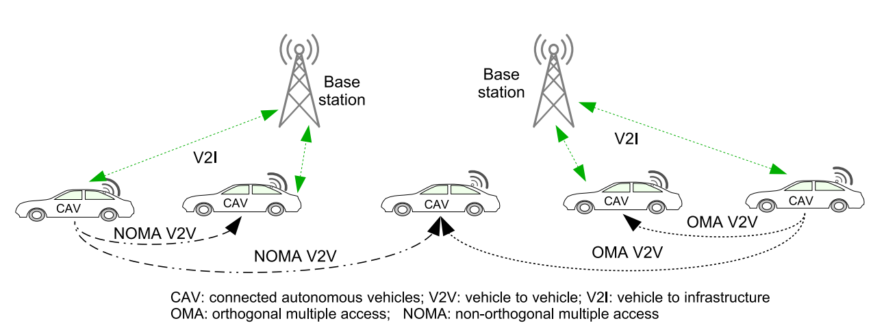
Figure 2.9: Illustration of CAV networks and V2V communications. In the OMA scheme normal periodic CAM broadcast messages and CRVM message are transmitted in separate data packets. In the NOMA scheme CAM and CRVM messages can be superposed in one data packet transmission [17].

NOMA in Vehicular Communications
In an orthogonal multiple access (OMA) system, such as orthogonal frequency division multiple access (OFDMA), frequency-time resource is allocated exclusively to at most one user equipment (UE) simultaneously in the same cell. NOMA systems allow simultaneous allocation of the same frequency resource to multiple UEs in the same cell. Non-orthogonal resource allocation and signal reception can be achieved in power and code domains. Due to the superior spectrum efficiency and massive connectivity NOMA has been widely studied recently for 5G systems. As NOMA can improve communication latency and channel access capacity, its application to V2X received increasing interests. It is noted that most of the existing research works on NOMA application to V2X are focused on the V2I links, where resource allocation is centralized. And the performance evaluation is mainly based on theoretic analysis. In this paper they focus on the V2V links where resources are allocated in a distributed way by the vehicles. And the performance evaluation is conducted with a discrete events driven simulator.
In this paper they proposed a NOMA enhanced distributed V2V scheme for CAV, for advanced cooperative perception and driving safety applications. Power domain NOMA is applied to deal with the CAV traffic patterns, with signals for long range broadcast with major power and signals for short range neighbors with small power being superposed in one transmission. With the application of NOMA the traffic loads on both control and data channels can be reduced, and communication reliability and latency will be improved [17].

Chapter
Three

Chapter Three
Methodology

3.1Successive Interference Cancellation (SIC)
is a technique used by a receiver in a wireless data transmission that allows decoding of two or more packets that arrived simultaneously (in a regular system, more packets arriving at the same time cause a collision )
SIC is achieved by the receiver decoding the stronger signal first, subtracting it from the combined signal and then decoding the difference as the weaker signal.

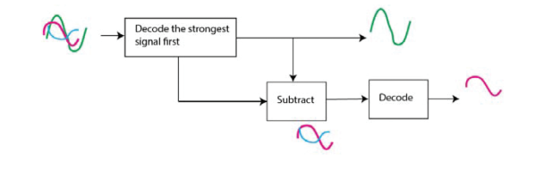
Figure 3.2. Successive interference cancellation

3.2. NOMA for downlink
In NOMA downlink, the base station superimposes the information waveforms for its serviced users. Each user equipment (UE) employs SIC to detect their own signals. Figure 3. shows a BS and K number of UEs with SIC receivers. In the network, it is assumed that the UE1 is the closest to the base station (BS), and UEK.is thefarthest
The challenge for BS is to decide how to allocate the power among the individual information waveforms, which is critical for SIC. In NOMA downlink, more power is allocated to UE located farther from the BS and the least power to the UE closest to the BS. In the network, all UEs receive the same signal that contains the information for all users. Each UE decodes the strongest signal first, and then subtracts the decoded signal from the received signal. SIC receiver iterates the subtraction until it finds its own signal. UE located close to the BS can cancel the signals of the farther UEs. Since the signal of the farthest UE contributes the most to the received signal, it will decode its own signal first [1].

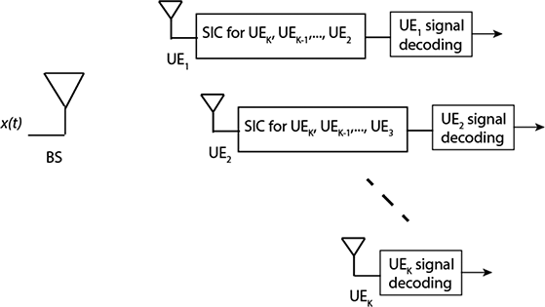
Figure 3.2: Downlink NOMA for K users

The transmitted signal by the BS can be written as
$X\left(t\right)=\sum_{k=1}^{k}{\sqrt{α_{k}P_{T}X_{k}}}\left(t\right)$ (3.1)

Where $x_{k}$ is the individual information conveying OFDM waveform,$α_{k}$is the power allocation coefficient for the UEk , and$ρ_{T}$is the total available power at the BS. The power allocated to each UEk then becomes${ ρ}_{k}=α_{k}ρ_{T}$ The power is allocated according to the distance of UEs to the BS: UE1 is the closest to the BS, so it is allocated the least power, whereas UEK is the farthest one, therefore it has the highest power.
The received signal at the UEk is
$y_{k}\left(t\right)=x\left(t\right)g_{k}+w_{k}\left(t\right)$ (3.2)
Where $g_{k}$is the channel attenuation factor for the link between the BS and the UEk, and $w_{k}\left(t\right)$ is the additive white Gaussian noise at the UEk with mean zero and density $N_{0}\left(W/{H_{z}}\right)$.
Let us consider the farthest user first. The signal it decodes first will be its own signal since it is allocated the most power as compared the others. The signals for other users will be seen as interference. Therefore, the signal-to-noise ratio (SNR) for UEK can be written as
${SNR}_{k}=\frac{P_{K}g_{k}^{2}}{N_{0}W+\sum_{i=1}^{k-1}{P_{i}g_{k}^{2}}}$ (3.3)
Where $W$ is the transmission bandwidth.
For the closest UE1, the last signal it decodes will be its signal. Assuming perfect cancellation, the SNR for UE1 becomes
${SNR}_{1}=\frac{P_{1} {g_{1}}^{2}}{N_{0}W}$ (3.4)
In general, for the UEk, the SNR becomes
${SNR}_{k}=\frac{P_{K}g_{k}^{2}}{N_{0}W+\sum_{i=1}^{k-1}{P_{i}g_{k}^{2}}}$ (3.5)

When NOMA is used, the throughput (bps) for each UE can be written as
$R_{K}=W\log_{2}\left[1+\frac{P_{K}g_{k}^{2}}{N+\sum_{i=1}^{K-1}{P_{i}g_{k}^{2}}}\right]$ (3.6)
In OFDMA, on the other hand, UEs are assigned to a group of subcarriers in order to receive their information. When the total bandwidth and power are shared among the UEs equally, the throughput for each UE for OFDMA becomes
$R_{k}=w_{k}\log_{2}\left[1+\frac{P_{k}g_{k}^{2}}{N_{k}}\right]$ (3.7)
Where $W_{k}=\frac{W}{K}$and $N_{k}=N_{0}W_{k}$
The sum capacity for both OFDMA and NOMA can be written as
$R_{T}=\sum_{k=1}^{K}{R_{k}}$ (3.8)
We further define fairness index as [4]
$F=\frac{{\left(\sum{R_{k}}\right)}^{2}}{k\sum{R_{k}^{2}}}$ (3.9)
indicates how fair the system capacity is shared among the UEs, that is, when F gets
close to 1, the capacity for each UE gets close to each other. We can set the objective of the power allocation mechanism as to maximize the sum capacity $R_{T}$ under a fairness constraint for NOMA systems. The optimization problem is then formulated as

maximize $W\log_{2}\left[1+\frac{P_{K}g_{k}^{2}}{N+\sum_{i=1}^{K-1}{P_{i}g_{k}^{2}}}\right]$ (3.10)
subject to :$\sum_{k=1}^{k}{p_{k}≤P_{T}}$
$$P_{k}≥,∀k$$
$$F=\acute{F}$$
Where $F^{'}$ is the target fairness index in the network. The power allocation coefficients $α_{k}$ or each UEk can be obtained with exhaustive search.
3.3. NOMA for uplink
Uplink implementation of NOMA is slightly different than the downlink. Figure 3.3 depicts a network that multiplexes K UEs in the uplink using NOMA. This time, BS employs SIC in order to distinguish the user signals [1].

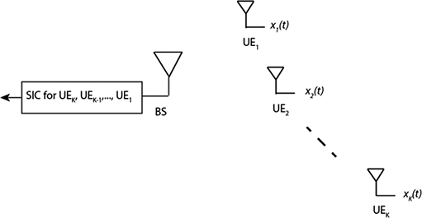
Figure 3.3. Uplink NOMA for K users.

In the uplink, the received signal by the BS that includes all the user signals is written as
$y\left(t\right)=\sum_{k=1}^{K}{x_{k}\left(t\right)g_{k}+w\left(t\right)}$ (3.11)
where${ g}_{k}$is the channel attenuation gain for the link between the BS and the UEk,$x_{k}\left(t\right)$ is the information waveform for the kth UE, and $w\left(t\right)$ is the additive white Gaussian noise at the BS with mean zero and density $N_{0}\left(w/{H_{z}}\right)$ In the uplink, the UEs may again optimize their transmit powers according to their locations as in the downlink. However, here we assume that the users are well distributed in the cell coverage, and the received power levels from different users are already well separated. This assumption is more natural from practical point of view, since power optimization requires connection between all the UEs which may be difficult to implement.
At the receiver, the BS implements SIC. The first signal it decodes will be the signal from the nearest user. The SNR for the signal for the UE1 can be written as, including others as interference,
$R_{1}=\frac{Pg_{1}^{2}}{N+\sum_{i=2}^{K}{Pg_{i}^{2}}}$ (3.12)
where P is the transmission power of UEs and$N=N_{0}W$.
The last signal that the BS decodes is the signal for the farthest user $UE_{k}$. Assuming perfect cancellation, the SNR for$UE_{k}$can be written as
${SNR}_{K}=\frac{Pg^{2}K}{N}$ (3.13)

Generally, for the kth UE, the SNR becomes

${SNR}_{K}=1+\frac{Pg_{k}^{2}}{N+\sum_{i=k+1}^{K}{Pg_{i}^{2}}}$ (3.14)

The throughput (bps) for each UE can be written as

$R_{k}=W\log_{2}\left[1+\frac{Pg_{k}^{2}}{N+\sum_{i=k+1}^{K}{Pg_{i}^{2}}}\right]$ (3.15)
In OFDMA, on the other hand, UEs are allocated orthogonal carriers in order to receive their information. When the total bandwidth and power are shared among the UEs equally, the throughput for each UE for OFDMA becomes

$R_{K}=W_{k}\log_{2}\left[1+\frac{P_{k}g_{k}^{2}}{N_{k}}\right]$ (3.16)

Where $W_{k}=\frac{W}{K}$ and $N_{K}=N_{0}W_{k}$.

The sum capacity for both OFDMA and NOMA can be written as

$R_{T}=\sum_{K=1}^{K}{R_{K} .}$ (3.17)

3.4. Imperfectness in NOMA
Before looking into what imperfect SIC is, let's take a look at the network model that we are going to use. This is how our network is going to look like. We have a downlink NOMA network with two users. The base station (BS) has two separate messages to transmit to each user. User 1 is the far user/weak user and, user 2 is the near user/strong user.
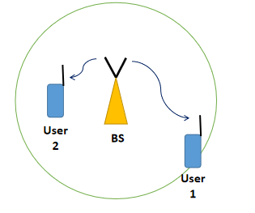
Figure 3.4 Network Model
SIC is perfect if:
- User 2 estimates the data of user 1 from y2y2 correctly by direct decoding
- User 2 correctly multiplies the estimate of user 1's data with $\sqrt{α1}$
(This may look trivial for now because we are using static power allocation and hence $\sqrt{α1}$ is fixed and known to user 2. But there are better power allocation techniques available which compute the optimum $\sqrt{α1}$ and $\sqrt{α2}$ dynamically based on channel conditions, target rates etc., In those cases, user 2 must multiply the estimate of user 1's data with the correct and actual $\sqrt{α1}$ used when the signal is transmitted.)
- User 2 must subtract the result obtained in the previous step from y2
Ideally, if SIC is perfect, y2y2 would become
y2 = h2P$\sqrt{α1 x1}$ + h2P$\sqrt{α2 x2}$ + w2−h2P$\sqrt{α1 x1}$ = h2P$\sqrt{α2 x2}$ + w2 (3.18)

after SIC.
If anything goes wrong, then SIC would be imperfect. By imperfect SIC, we mean that a residue of x1 component is still present in y2 after SIC. That is, after imperfect SIC, y2 becomes
y′2= $\sqrt{ϵ}$h2P $\sqrt{α1 x1}$+h2P$\sqrt{α2 x2}$+w2 (3.19)
where, ϵ is the fraction of residue of X1 component left due to SIC error.
Recall that SIC receiver decodes the information signals one by one iteratively to obtain the desired signal. In SIC, after decoding the signal, one should regenerate the original individual waveform in order to subtract it from the received signal. Although it is theoretically possible to complete this process without any error, in practice, it is expected to experience some cancellation error.
In downlink, the SNR for the kth user with cancellation error is written in eq [3.5]
${SNR}_{K}=\frac{P_{K}g_{k}^{2}}{N_{0}W+\sum_{i=1}^{k-1}{P_{i}g_{k}^{2}+∈\sum_{i=k+1}^{K}{P_{i}g_{k}^{2}}}}$ (3.20)
where$∈$ is cancellation error term that represents the remaining portion of the cancelled message signal. In the previous section, the third term in the denominator is not included since perfect cancellation is assumed there.
3.5. Spectral efficiency and energy efficiency
Most analysis so far included the throughput performance of the network. In addition to spectral efficiency (SE) of NOMA, in this section, we analyze the energy efficiency (EE) of 90 Towards 5G Wireless Networks - A Physical Layer Perspective NOMA systems. In our analysis, we incorporate the static power consumption of the network due to the power amplifiers in addition to the power consumed for the information waveform. The total power consumption at the transmitter can be represented as the sum of the information signal power and the power consumed by the circuits (mainly by power amplifiers). Considering the downlink, the total power consumed by the BS can then be written as
$P_{total}=P_{T}+P_{static }$ (3.21)
where$P_{T }$is the total signal power as mentioned earlier and${ P}_{static}$ is the power consumed by the circuitry[1] .
Energy efficiency (EE) is defined as the sum rate over the total consumed power of the base station
$EE=\frac{R_{T}}{P_{total }}=SE\frac{W}{P_{total}} \left({bits}/{joale}\right)$ (3.22)
where SE is the spectral efficiency$R_{T}/W$ in terms of bps/Hz.

Chapter
Four

Chapter Four
Simulation and Results

4.1 Simulation Description

with just a few lines of MATLAB code the Rate pairs with OFDMA and NOMA for downlink NOMA , 𝑺𝑵𝑹𝟏 = 𝑺𝑵𝑹𝟐 = 𝟏𝟎𝒅𝑩, Rate pairs with OFDMA and NOMA for downlink NOMA,𝑺𝑵𝑹𝟏 = 𝟐𝟎𝒅𝑩 𝒂𝒏𝒅 𝑺𝑵𝑹𝟐 = 𝟏𝟎𝒅𝑩, Achievable data at user 2 with imperfect SIC, and EE-SE trade-off curves for NOMA an OFDMA Were plotted by using MATLAB The goal of the simulation is to show the comparison between two cases of the two users' distance and the imperfections of the SIC decoding method

Table 4.1: Rate pairs with OFDMA and NOMA for downlink
NOMA, 𝑺𝑵𝑹_{𝟏} = 𝑺𝑵𝑹_{𝟐} = 𝟏𝟎𝒅𝑩.

Parameter | Value
P | 1
G1 | 10
G2 | 10

Table 4.2: Rate pairs with OFDMA and NOMA for downlink NOMA,${SNR}_{1}=20dB and {SNR}_{2}=10dB.$
Parameter | Value
P | 1
G1 | 10
G2 | 20

Table 4.3: Achievable data at user 2 with imperfect SIC
Parameter | Value
d1 | 1000
d2 | 500
a1 | 0.75
a2 | 0.25
eta | 4
err | [0 10^-4 10^-3 10^-2]
h1 | sqrt(d1^eta)*(randn(1,N)+1i*randn(1,N))/sqrt(2)
h2 | sqrt(d2^eta)*(randn(1,N)+1i*randn(1,N))/sqrt(2)
g1 | (abs(h1)).^2
g2 | (abs(h2)).^2

Table 4.4:EE-SE trade-off curves for NOMA an OFDMA.
Parameter | Value
B | 5∗10⁶
𝑁₀ | 10−₂₁
N | 𝑁₀∗𝐵
G1 | 10−₁₂
G2 | 10−₁₄
P | 100

4.2 Result and discussion

4.2.1 Rate pairs
In this study there are two users in the network are assumed for the sake of discussion and analyze the boundaries of the achievable rate regions for these two users. the a symmetric downlink channel was considered so that the users are at equal distance to the BS.𝑆𝑁𝑅₁ = 𝑆𝑁𝑅₂ = 10𝑑𝐵. Figure [4.1] shows the boundaries of the achievable rate regions𝑅₁𝑎𝑛𝑑 𝑅₁for NOMA and OFDMA. As illustrated in Figure [4.1], NOMA achieves higher rate pairs than the OFDMA except at the corners points (where the rates are equal to the single user capacities). When the fairness is high, both users experience 1.6 bps/Hz throughputs with both NOMA and OFDMA. However, when the fairness is lower, both sum capacity and individual throughputs are higher with NOMA. Figure [4.2] shows rate pairs when the channel is asymmetric, that is,𝑆𝑁𝑅₁ = 20𝑑𝐵 𝑎𝑛𝑑 𝑆𝑁𝑅 ₂ = 10𝑑𝐵. NOMA achieves much higher rate pairs than OFDMA, particularly for the farther user,𝑈𝐸₂
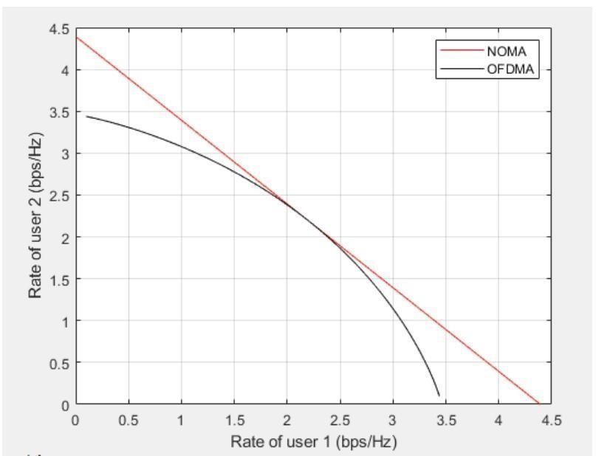
Figure 4.1. Rate pairs with OFDMA and NOMA for downlink
NOMA,𝑺𝑵𝑹_{𝟏} = 𝑺𝑵𝑹_{𝟐} = 𝟏𝟎𝒅𝑩.
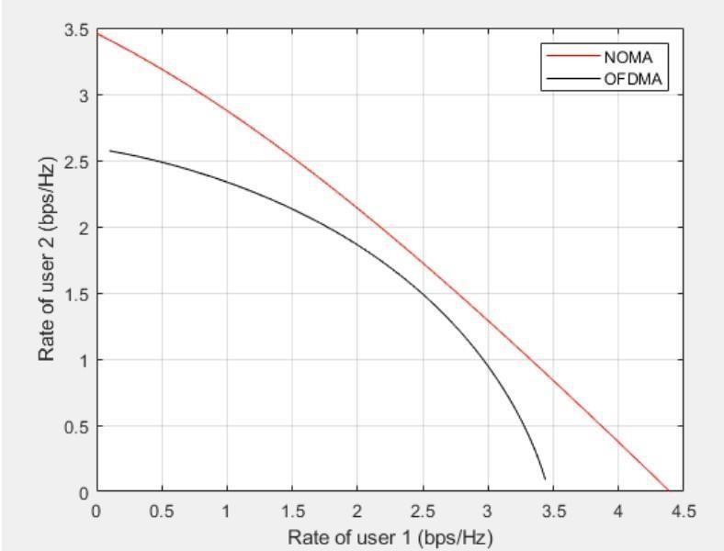

Figure 4.2

.

Rate pairs with OFDMA and NOMA for downlink NOMA,

.

4.2.2. Impact of imperfect cancellation
Figure [4.3] shows the plot of the achievable rates at user 2 for different values of
SIC error using MATLAB. plotting user 2's achievable data rate alone and not user 1's because user 1 does not perform SIC and hence his achievable data rate will not be affected. The resulting plot look like this
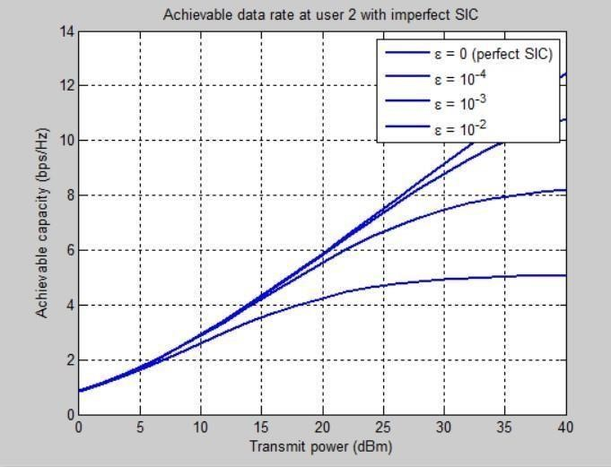
Figure 4.3. Achievable data at user 2 with imperfect SIC
See that the achievable rate degrades as SIC error increases.

4.2.3.SE-EE trade-off with NOMA
Here, the EE and SE of NOMA were compared with OFDMA. And the downlink was considered . The system bandwidth is taken as 𝑊 = 5𝑀𝐻𝑧 The Channel gains forUE1𝑎𝑛𝑑 𝑈𝐸2are, respectively, taken as g12 = −120d𝐵 and 𝑔22 = −140𝑑𝐵. Noise density N0 is taken as −150 𝑑𝐵𝑊⁄𝐻𝑧 . We assume that the static power consumption at the BS is Pstatic = 100W Figure [4.4] shows the obtained EE-SE curves for this setup. It is seen that NOMA achieves higher EE and SE than OFDMA system. The green-points occur for NOMA and OFDMA when 𝑃𝑇 is at
17 W and 18 W, respectively. At these points, both systems achieve their maximum EE. NOMA clearly outperforms OFDMA at green point and beyond for both EE and SE.

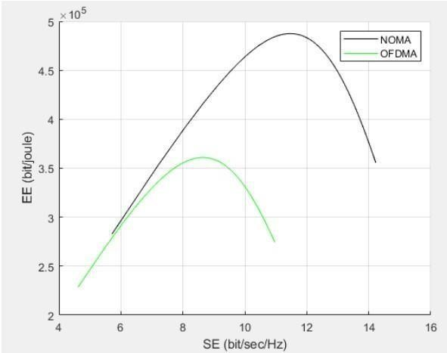
Figure 4.4. EE-SE trade-off curves for NOMA an OFDMA.

Chapter
Five
Chapter five
Conclusion and Recommendation

5.1 Conclusion

In this article thesis, the NOMA schemes proposed for the 5G standard are comprehensively studied and compared with the OMA and 0FDMA. NOMA has been investigated from various viewpoints. The fundamentals of NOMA and demonstrated its superior performance were presented over conventional OFDMA in terms of sum capacity, energy efficiency and spectral efficiency. orthogonal frequency division multiplexing (OFDM) was considered as the modulation scheme and NOMA as the multiple access scheme. In conventional 4G networks, as natural extension of OFDM, orthogonal frequency division multiple access (OFDMA) is used where information for each user is assigned to a subset of subcarriers. In NOMA, on the other hand, all of the subcarriers can be used by each user. illustrates the spectrum sharing for OFDMA and NOMA for two users. The concept applies both uplink and downlink transmission.
The impact of imperfectness at the SIC was mentioned witch is a technique used by a receiver in a wireless data transmission that allows decoding of two or more packets that arrived simultaneously and it’s achieved by the receiver decoding the stronger signal first subtracting it from the combined signal and then decoding the difference as the weaker signal.
First of all, NOMA requires high computational power to run SIC algorithms particularly for high number of users at high data rates. The EE and SE of NOMA were compared with OFDMA. Energy Efficiency (EE), is becoming an inevitable trend for future wireless network design. Recent works have concentrated on the relationship between EE and SE and provided good thoughts into the EE-SE tradeoff. In this paper, the EE-SE trade-off problem was studied for NOMA systems in downlink. The trade-off problem is formulated as a nonconvex optimization topic in which the main idea is to maximize the EE by imposing a satisfying minimum SE The Quality of Service (QoS) requirement for each user is also introduced to ensure optimality. For this, an optimal power allocation is proposed. Through simulations, we demonstrate the proposed schemes efficiency in achieving a flexible trade-off between EE and SE.

5.2 Recommendation

In the future work, firstly we advise to enhance the SIC algorithm at the receiver’s side to segregate user’s information. However, during SIC process, information of the user(s) with weaker channel gain is extracted by user(s) with stronger channel gain. It can raise major security concerns,
e.g. session hijacking, eavesdropping, identity theft, and others, for users with weaker channel gains. Therefore, this research aims to analyze and verify a secure SIC algorithm for NOMA based systems. Secondly to make more researches about NOMA channels and witch one is best to use.

References

- Kizilirmak, R. C. (2016). Non-Orthogonal Multiple Access (NOMA) for 5G Networks. In Towards 5G Wireless Networks - A Physical Layer Perspective. InTech. https://doi.org/10.5772/66048
- “Advantages of NOMA | Disadvantages of NOMA | Non-Orthogonal Multiple Access” n.d., Home of RF and Wireless Vendors and Resources, accessed 10 December 2021, https://www.rfwireless-world.com/Terminology/Advantages-and-Disadvantages-of-NOMA.html
- “The Importance of 5G”, 2019, Senate Republican Policy Committee, accessed 20 December 2021, https://www.rpc.senate.gov/policy-papers/the-importance-of-5g
- Joshi, N. C. (n.d.). Mobile Communication-5G Technology. International Journal of Research in Humanities & Soc. Sciences, 4(2). pp. 18-24 www.raijmr.com
- Han, W, J. Ge , J. Men. (2016). Performance analysis for NOMA energy harvesting relaying networks with transmit antenna selection and maximal-ratio combining over nakagami-m fading. IET Communications, 10(18), 2687–2693. https://doi.org/10.1049/iet-com.2016.0630
- Kiani, A., & Ansari, N. (2017). Edge Computing Aware NOMA for 5G Networks. https://doi.org/10.1109/JIOT.2018.2796542
- Ding, Z., Lei, X., Karagiannidis, G. K., Schober, R., Yuan, J., & Bhargava, V. (2017). A Survey on Non-Orthogonal Multiple Access for 5G Networks: Research Challenges and Future Trends. IEEE Journal on Selected Areas in Communications, 35(10), pp. 2181-2195, Oct. 2017. http://arxiv.org/abs/1706.05347
- Liu, X., Wang, Y., Liu, S., & Meng, J. (2018). Spectrum Resource Optimization for NOMA-Based Cognitive Radio in 5G Communications. IEEE Access, 6, 24904–24911. https://doi.org/10.1109/ACCESS.2018.2828801
- Wu, Z., Lu, K., Jiang, C., & Shao, X. (2018). Comprehensive Study and Comparison on 5G NOMA Schemes. IEEE Access, 6, 18511–18519. https://doi.org/10.1109/ACCESS.2018.2817221
- Saraereh, O. A., Alsaraira, A., Khan, I., & Uthansakul, P. (2019). An efficient resource allocation algorithm for OFDM-based NOMA in 5G systems. Electronics (Switzerland), 8(12). https://doi.org/10.3390/electronics8121399
- Abuajwa, O. M. S., Tan, C. K., & Le, C. K. (2019). Throughput analysis for non-orthogonal multiple access (NOMA)-based 5G networks. International Journal of Recent Technology and Engineering, 8(3 Special Issue), 101–108. https://doi.org/10.35940/ijrte.C1019.1083S19
- Muzhumathi, M. (n.d.). PERFORMANCE ANALYSIS OF NOMA TECHNIQUES FOR 5G NETWORKS (Vol. 6).
- Tang, Z., & He, J. (n.d.). NOMA Enhanced 5G Distributed Vehicle to Vehicle Communication for Connected Autonomous Vehicles.

Appendices
MATLAB code for Figure 4.1
clear all;
clc;
%%% NOMA parameters
count = 1;P = 1;
G1 = 10;
G2 = 10;
count = 1;
for alpha = 0:0.01:1 %power splitting factor
P1 = P*alpha;
P2 = P - P1;
R1(count) = log2(1 + P1*G1);
R2(count) = log2(1 + P2*G2/(P1*G2 + 1));
count = count + 1;
end
hold on;
plot (R1,R2,'r');
grid on;

for alpha = 0:0.01:1 %bandwidth splitting factor
P1 = P/2;
P2 = P/2;
R1(count) = alpha*log2(1 + P1*G1/alpha);
R2(count) = (1-alpha)*log2(1 + P2*G2/(1-alpha));
count = count + 1;
end
hold on;
plot(R1,R2,'k');
xlabel('Rate of user 1 (bps/Hz)');
ylabel('Rate of user 2 (bps/Hz)');
grid on;
box on;
legend('NOMA','OFDMA')

MATLAB code for Figure 4.2
clear all;
clc;
%%% NOMA parameters
count = 1;P = 1;
G1 = 10;
G2 = 20;
count = 1;
for alpha = 0:0.01:1 %power splitting factor
P1 = P*alpha;
P2 = P - P1;
R1(count) = log2(1 + P1*G1);
R2(count) = log2(1 + P2*G2/(P1*G2 + 1));
count = count + 1;
end
hold on;
plot (R1,R2,'r');
grid on;

for alpha = 0:0.01:1 %bandwidth splitting factor
P1 = P/2;
P2 = P/2;
R1(count) = alpha*log2(1 + P1*G1/alpha);
R2(count) = (1-alpha)*log2(1 + P2*G2/(1-alpha));
count = count + 1;
end
hold on;
plot(R1,R2,'k');
xlabel('Rate of user 1 (bps/Hz)');
ylabel('Rate of user 2 (bps/Hz)');
grid on;
box on;
legend('NOMA','OFDMA')

MATLAB code for Figure 4.3
clc; clear variables; close all;

N = 10^5;

d1 = 1000; d2 = 500; %Distances of users from base station (BS)
a1 = 0.75; a2 = 0.25; %Power allocation factors
eta = 4; %Path loss exponent
err = [0 10^-4 10^-3 10^-2]; %SIC error %Generate rayleigh fading coefficient for both users
h1 = sqrt(d1^-eta)*(randn(1,N)+1i*randn(1,N))/sqrt(2);
h2 = sqrt(d2^-eta)*(randn(1,N)+1i*randn(1,N))/sqrt(2);

g1 = (abs(h1)).^2;
g2 = (abs(h2)).^2;

Pt = 0:2:40; %Transmit power in dBm
pt = (10^-3)*10.^(Pt/10); %Transmit power in linear scale
BW = 10^6; %System bandwidth
No = -174 + 10*log10(BW); %Noise power (dBm)
no = (10^-3)*10.^(No/10); %Noise power (linear scale)

p = length(Pt);

for ep = 1:length(err)
for u = 1:p
gamma_2d = a2*pt(u)*g2./(err(ep)*a1*pt(u)*g2+no);
R2d = log2(1+gamma_2d);
R2d_av(u) = mean(R2d);
end
plot(Pt, R2d_av, 'linewidth', 2); hold on;
end
grid on;
xlabel('Transmit power (dBm)');
ylabel('Achievable capacity (bps/Hz)');
title('Achievable data rate at user 2 with imperfect SIC');
legend('\epsilon = 0 (perfect SIC)', '\epsilon = 10^{-4}','\epsilon = 10^{-3}','\epsilon = 10^{-2}')

MATLAB code for Figure 4.4
clear all;
clc;
B = 5*10^6; %bandwidth Hz
N0 = 10^-21; %-150 dBw/Hz
N = N0*B; % dBW
G1 = 10^-12; %-120 dB
G2 = 10^-14; %-140 dB
Pcircuit = 100; %watt
%%%%%%%%%%%%%%%%%%%%%%%%%%%%%%%%%%%%%% NOMA
count = 1;
for p = 1:1:100 %W
P1 = p*0.1; %allocate less power to UE1
P2 = p - P1;
R1 = B*log2(1 + P1*G1/N);
R2 = B*log2(1 + P2*G2/(P1*G2 + N));
R = R1 + R2;
SE(count) = R/B; % bit/sec/Hz
EE(count) = (R/(Pcircuit + p)); % bit/watt.sec
count = count + 1;
end
hold on;
plot(SE,EE,'k');
xlabel('SE (bit/sec/Hz)');
ylabel('EE (bit/joule)');
grid on;
% OFDMA
count = 1;
greenpoint = 0;
maxEE = -1000;
for p = 1:1:100 %Watt
P1 = p/2;
P2 = p/2;
R1 = (B/2)*log2(1 + P1*G1/(N0*B/2));
R2 = (B/2)*log2(1 + P2*G2/(N0*B/2));
R = R1 + R2;
SE_line(count) = R/B; % bit/sec/Hz
EE_line(count) = (R/(Pcircuit + p)); % bit/watt.sec = Mbit/joule
count = count + 1;
end
hold on;
plot(SE_line,EE_line,'g-');
xlabel('SE (bit/sec/Hz)');
ylabel('EE (bit/joule)');
grid on;

