CAVENDISH UNIVERSITY UGANDA
COM321 SIMULATION AND MODELLING
CONTINUOUS ASSESSMENT TEST 1 (CAT 1)

NAME: TUGUME ANDREW
COURSE: BDSAI YEAR II SEMESTER II
CAT1 ANSWERS

Attached is the historical dataset on road accident in Uganda, adapted from (Okiring,
2023).
Use it to answer the following questions:
a) Produce this graph; hence, determine the model and evaluate the performance of
the model. (6 marks)

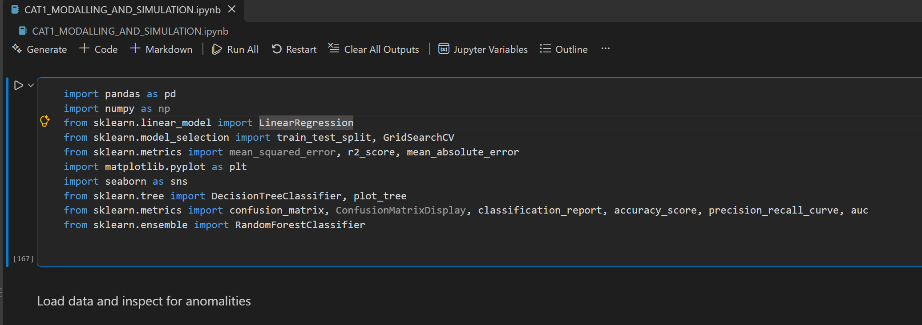
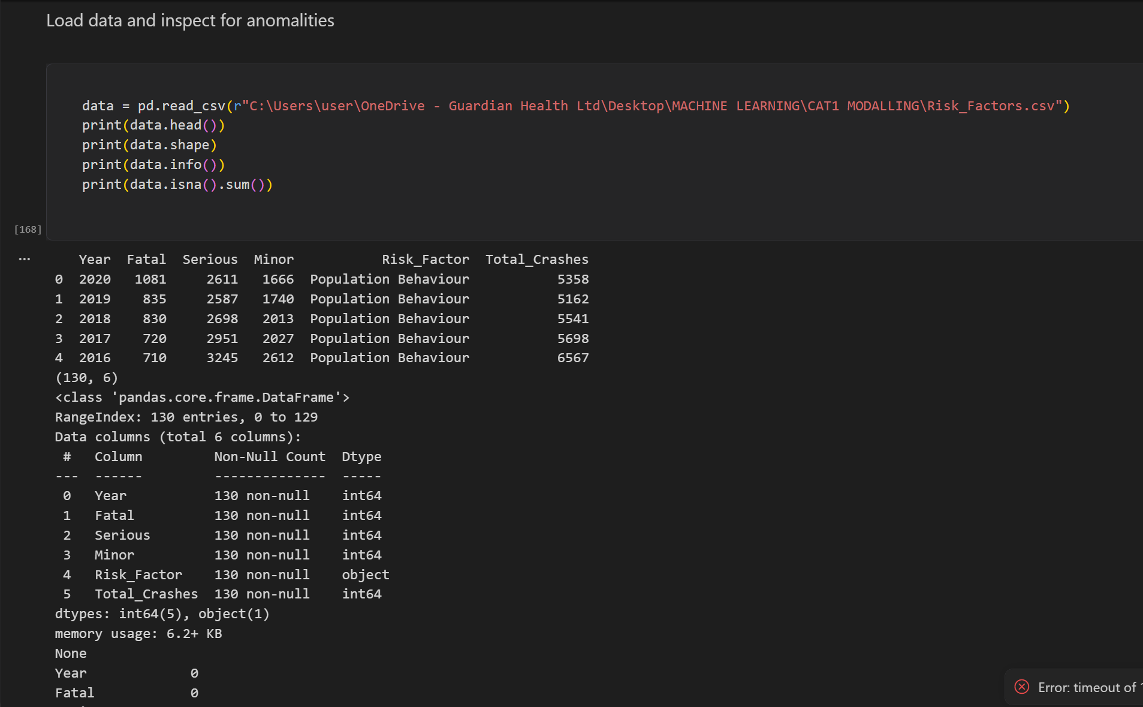
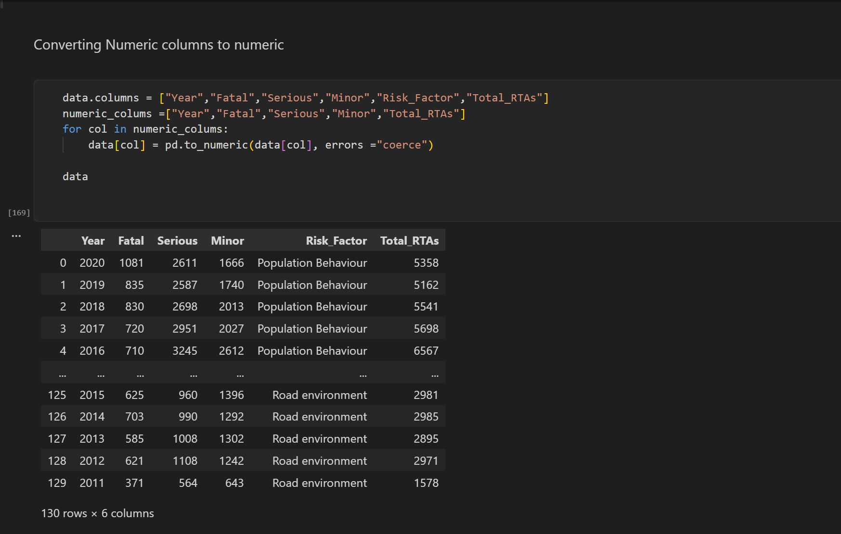

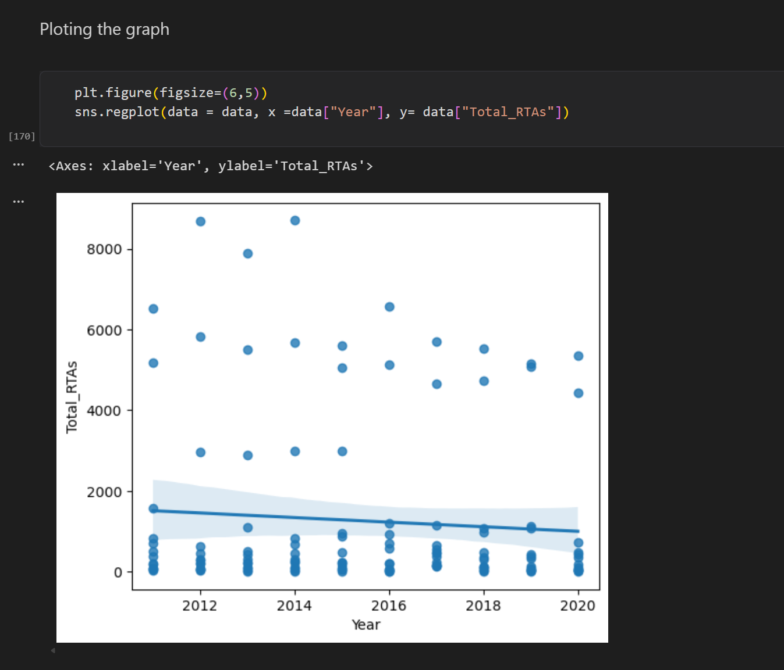

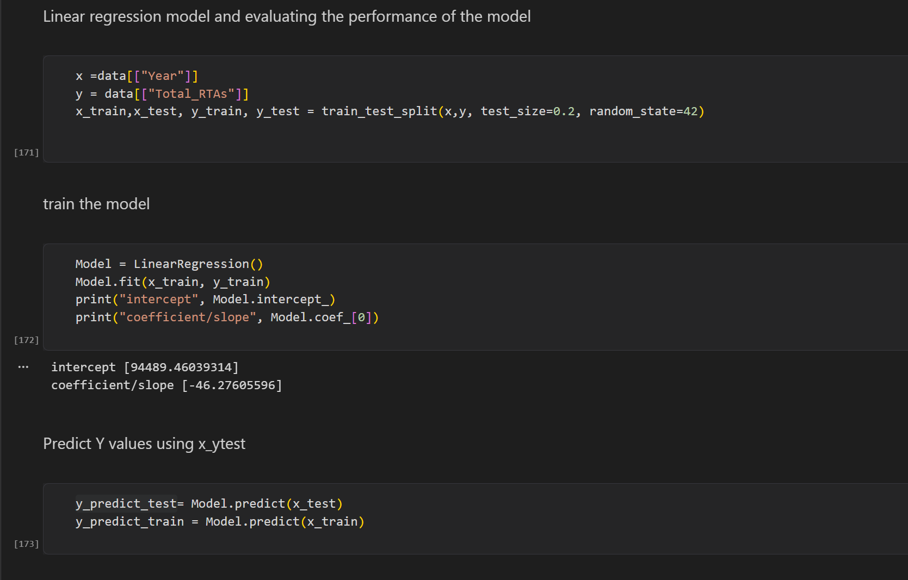
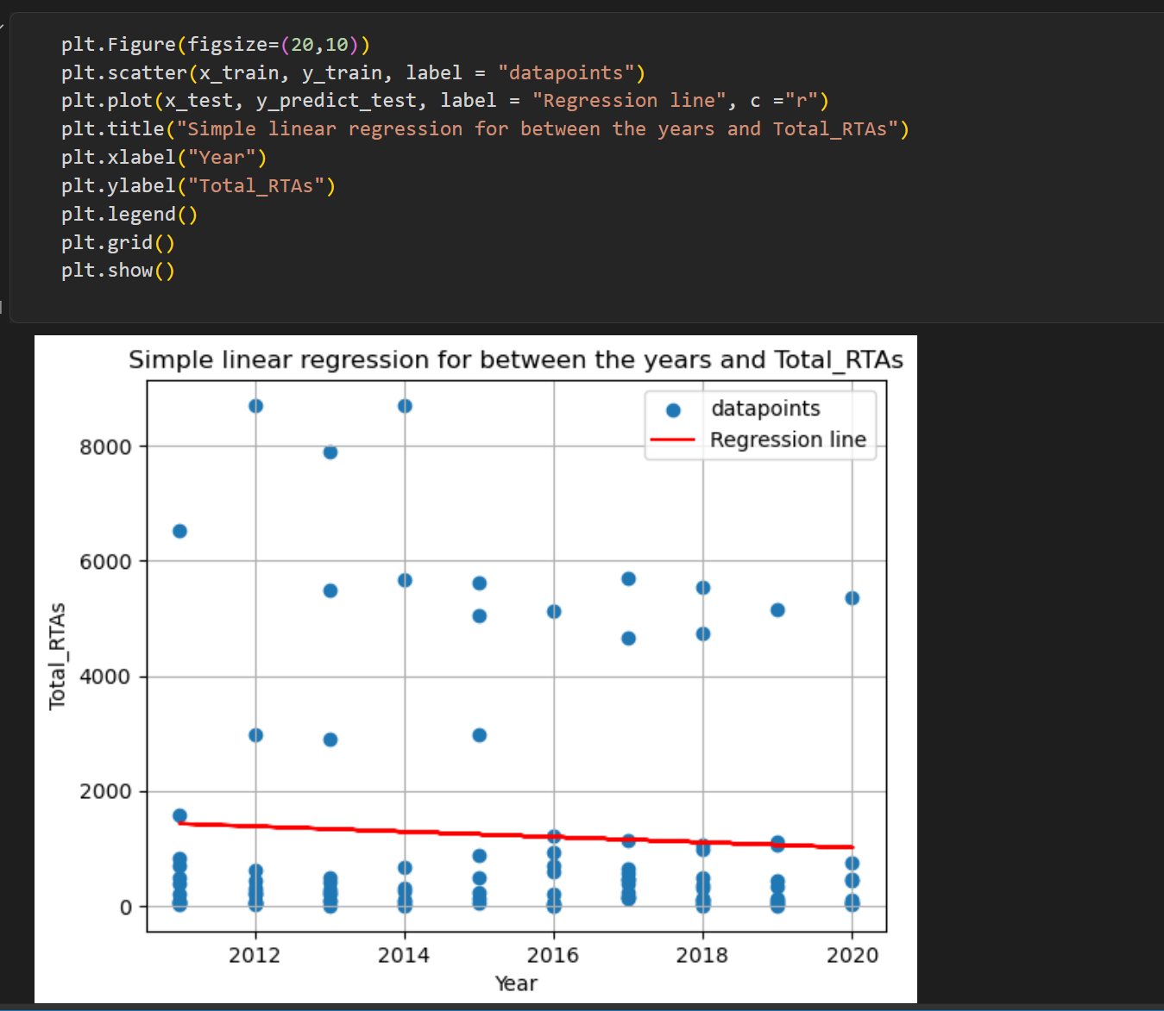
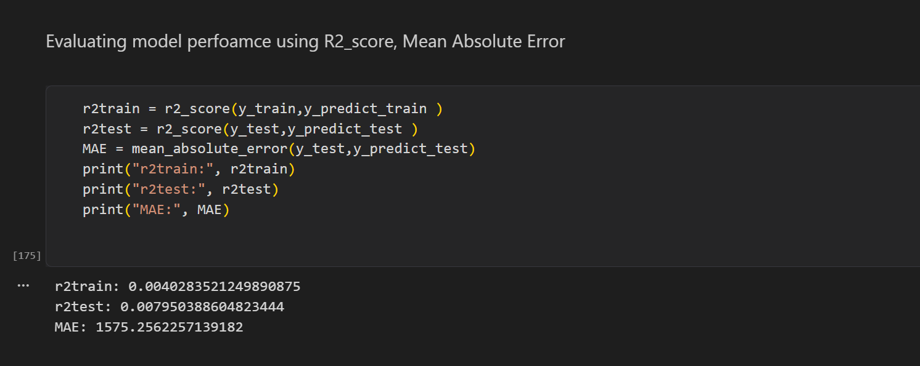

b) Given that risk factor is our target feature, use a decision tree classifier to model the
dataset by producing: (6 marks)
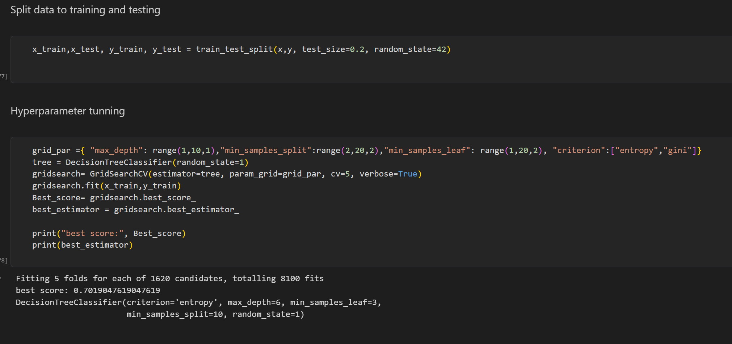
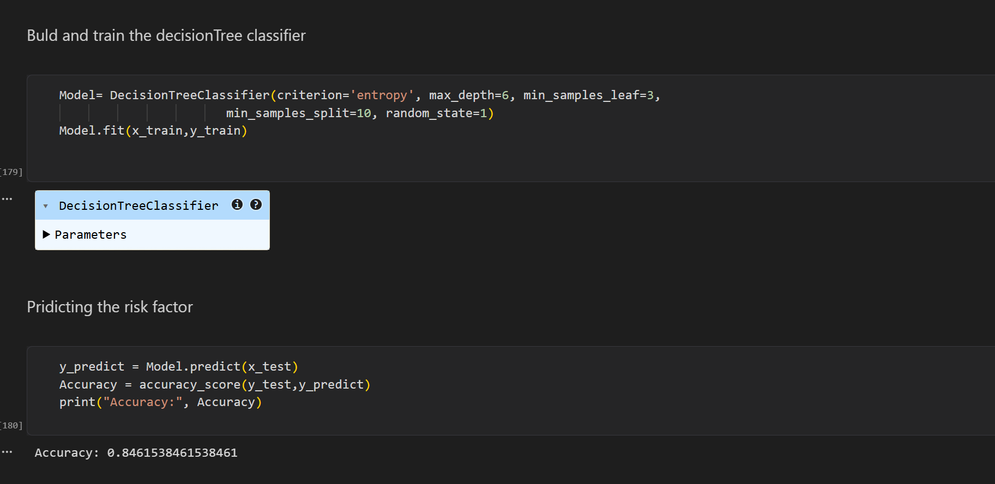

- The Decision Tree diagram
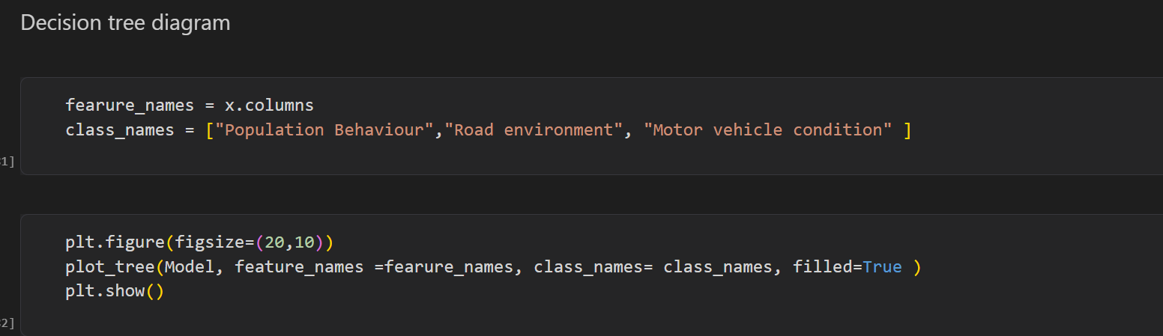
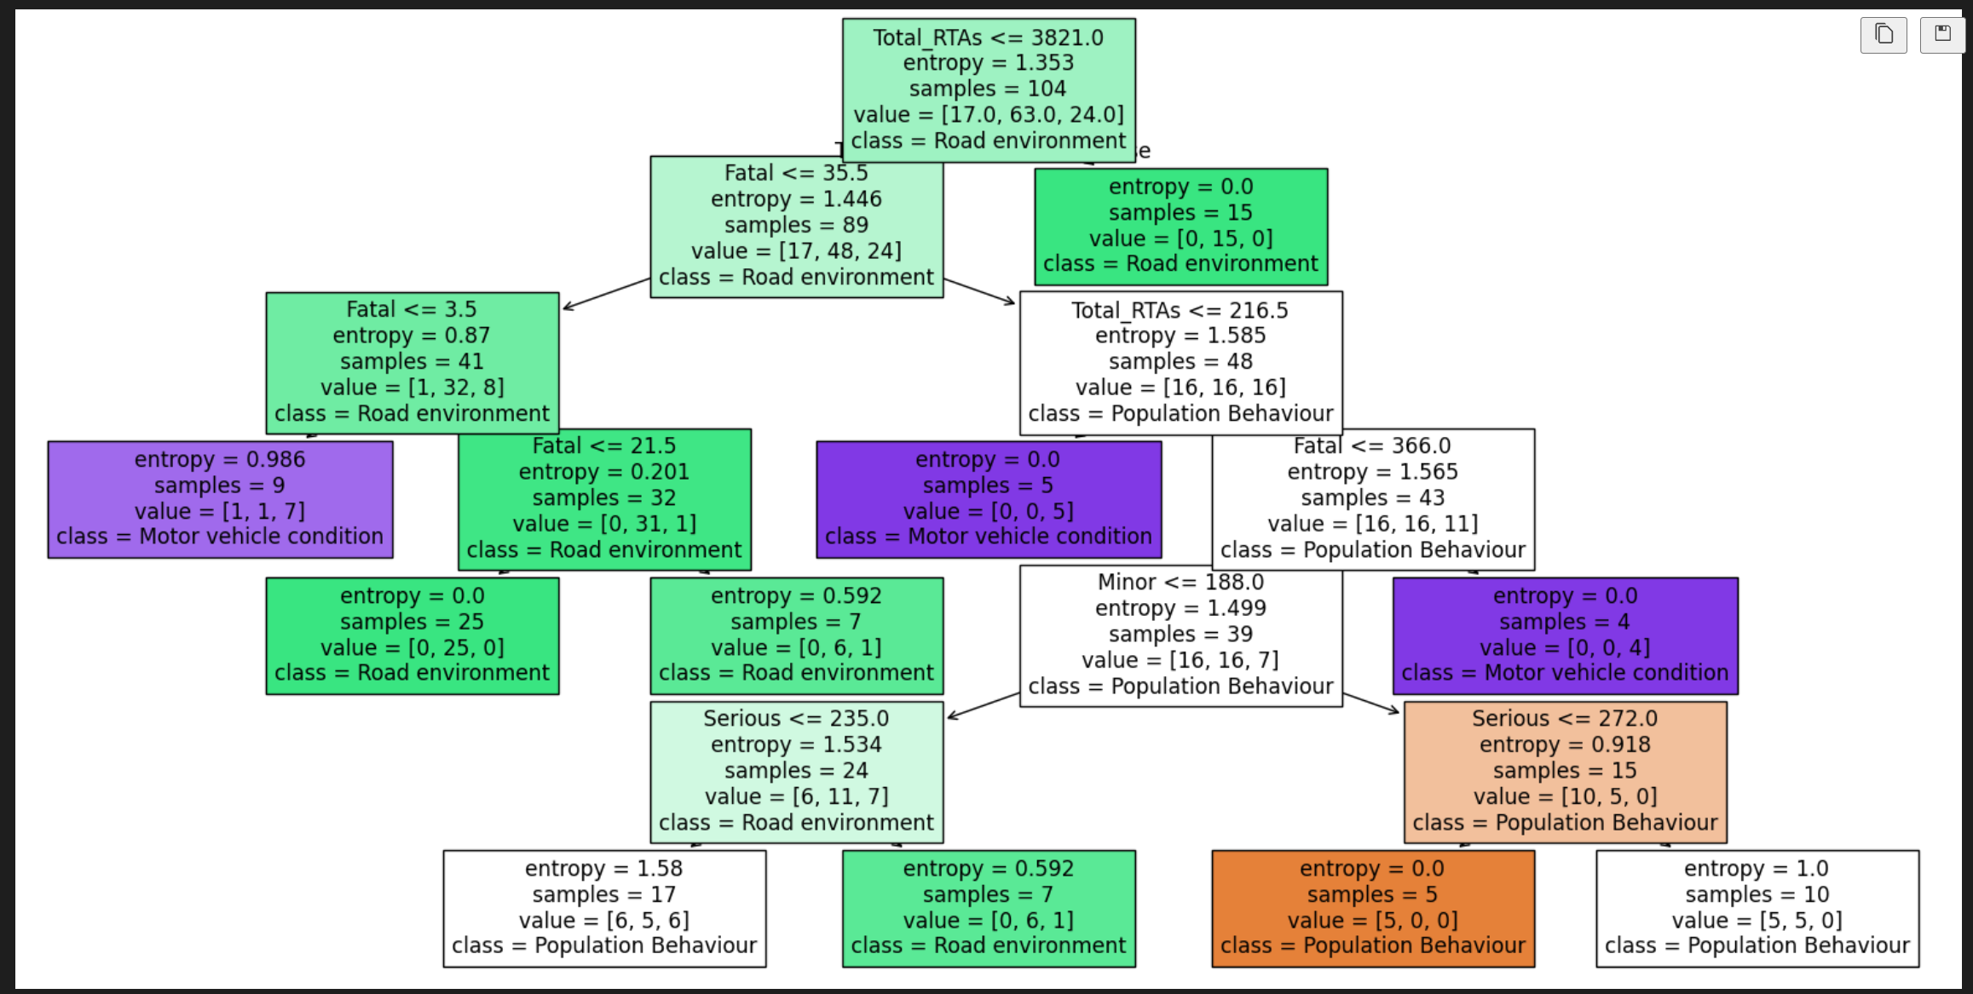

- The confusion matrix table.
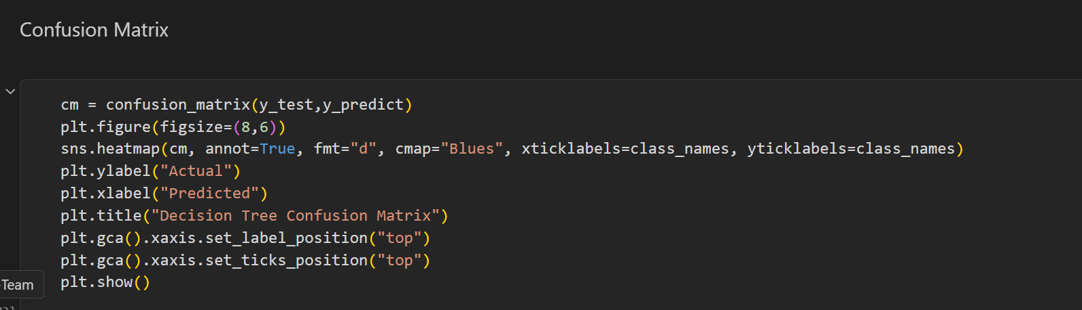
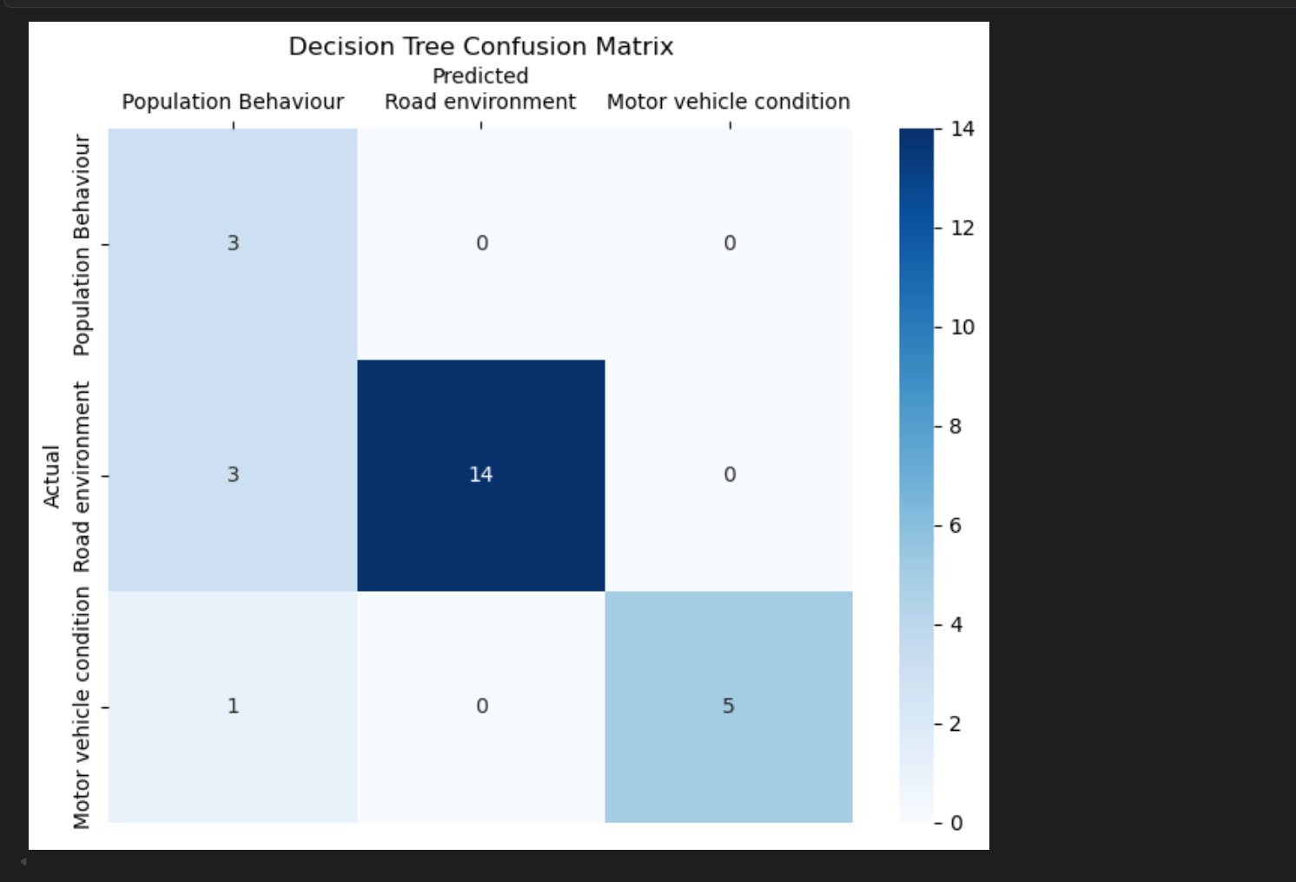
- Precision, recall, and F1-score values.
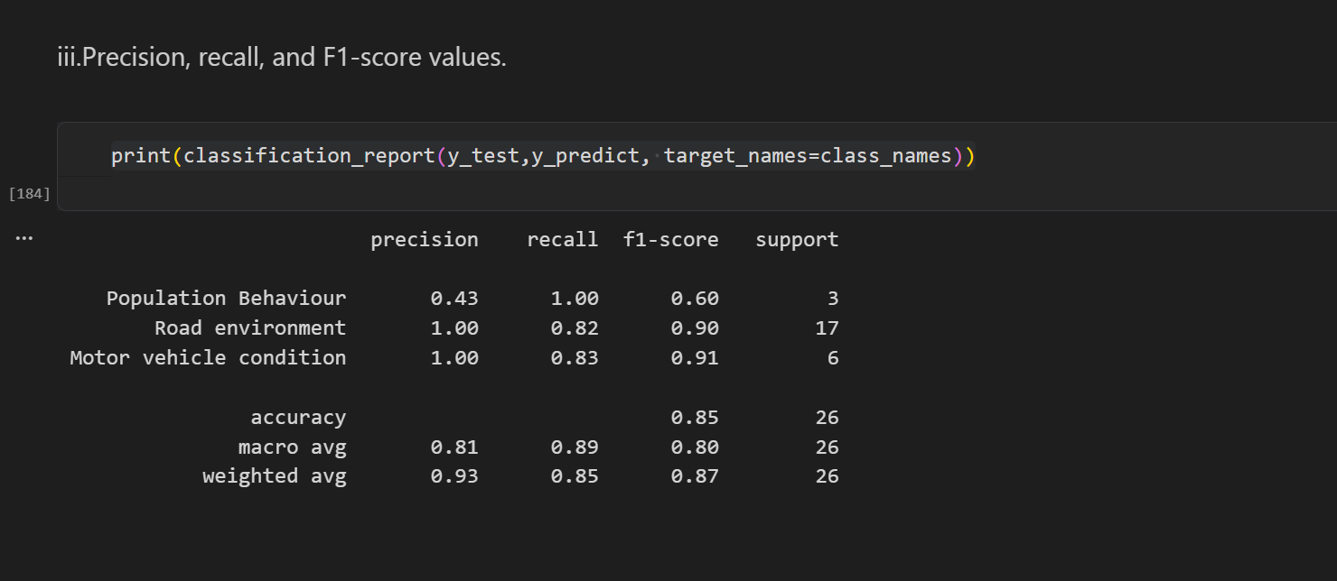

c) Given risk factor is our target feature, use a Random Forest classifier to model the
dataset by producing: (6 marks)
- The confusion matrix table.
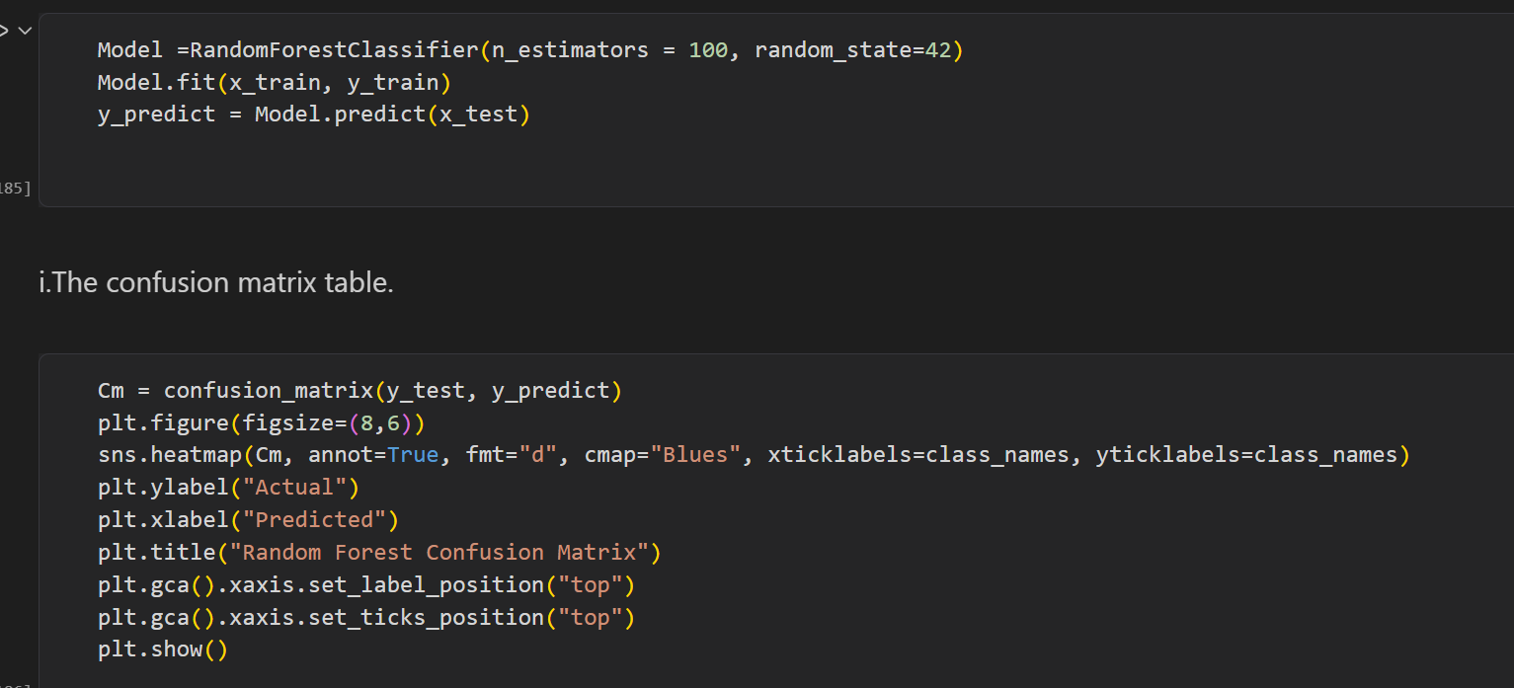
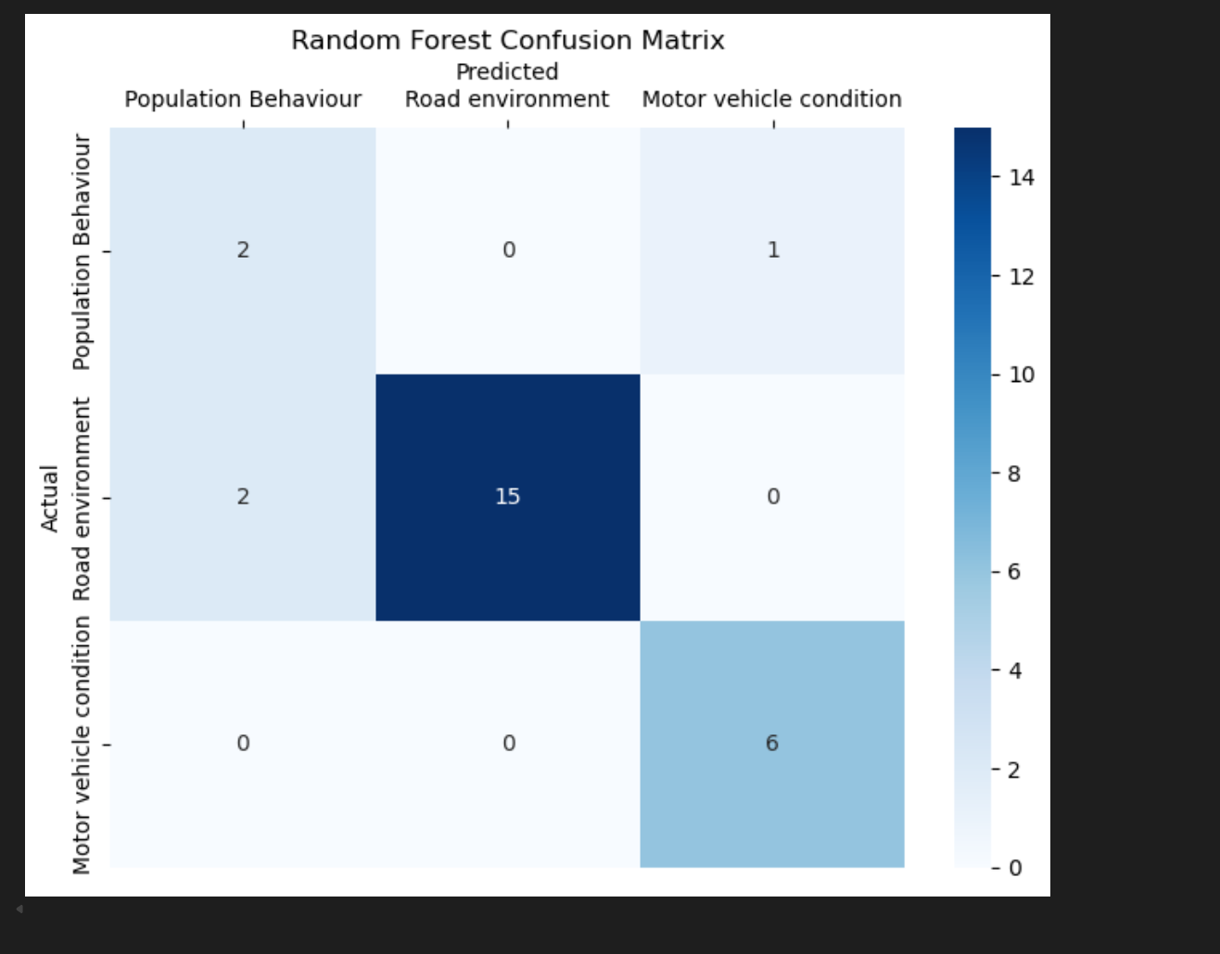
- Precision, recall, and F1-score values.
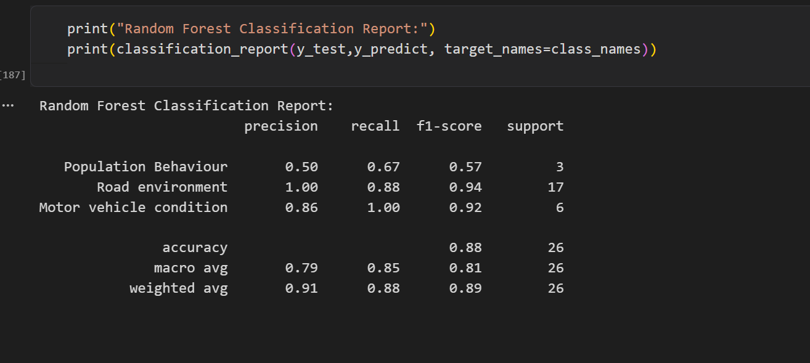
d) Produce a graph to show PR-AUC for the population behaviour risk factor. (2 marks)
