Relation-Aware Visual Grounding and Geometric Localization for MARC 2026
Anonymous Submission

Abstract—We present a modular offline agent for the Meta-Sejong AI Robotics Challenge (MARC) 2026, which must interpret a natural-language mission, select the fixed CCTV view containing the requested object or person, return a structured world-frame grounding result, and subsequently drive to and retrieve the object. A local YOLO11 detector covering 34 classes is combined with rule-based command parsing, constraint-based camera gating, relation-aware candidate selection, deterministic situation assessment, and calibrated ray-plane localization with a contact-point coordinate convention. Because the fixed cameras observe disjoint regions, camera selection is posed as constraint satisfaction over independent textual cues rather than as ranking by detection confidence, and every gate releases when it cannot narrow the candidate set. Situation assessment applies the organizers' published posture-by-support rules, so it transfers to unseen backgrounds. A tiled sub-detector recovers the small object classes whose whole-frame confidence is structurally low, and a COCO-pretrained keypoint model corrects the submitted coordinate for person targets. For retrieval, a LiDAR obstacle layer supplies the parked vehicles and pedestrians absent from the platform's static occupancy map, and depth-only floor segmentation refines the grasp point without inheriting the CCTV-to-robot domain mismatch. On the 33 public Chungmu missions the system scores 75.4 of 100 in Stage 1, selecting the correct camera in 31 rounds and classifying the target type or situation correctly in all 33.
Keywords—multi-camera visual grounding, spatial-relation reasoning, geometric localization, search and rescue, digital twin
I. INTRODUCTION
MARC 2026 is conducted in an Isaac Sim digital twin of a university campus. In Stage 1 an agent receives a natural-language mission, analyzes fixed CCTV observations, and submits a GroundingResult containing the selected camera, target type, landmark and relation when applicable, situation category for person missions, and world-frame coordinates for the target and anchor; in Stage 2 the same grounding drives a mobile manipulator that retrieves the object and delivers it to its owner [1]. The evaluation runtime is disconnected from the Internet and the official background may differ from the public practice scene, so models must be bundled locally and rules must transfer beyond memorized practice answers.
Four difficulties couple in this task. The visual vocabulary spans small lost objects, large landmarks, and human postures. The same class recurs across cameras and within a frame, so the highest-confidence detection is not necessarily the referred target. Direct commands and narrative descriptions must normalize to identical semantic fields. Finally, a bounding box does not identify a physical contact point, yet a world coordinate is required.
Perception uses a locally bundled YOLO11 detector [2] and localization follows standard ray-plane geometry [6]. Landmark-based grounding has been shown to transfer to unseen outdoor environments [4], which motivates our use of landmarks as the primary camera cue. Unlike vision-based fall detection, which maps posture directly to a hazard decision [5], our situation module treats posture as one input to a context rule. Our contributions are:
• Constraint-based camera gating: camera selection is posed as constraint satisfaction over two independent textual cues rather than ranking by confidence, since the fixed cameras observe disjoint regions; each gate releases when it cannot narrow the candidate set, so it can only improve the candidate list
• Two-level candidate ranking: proximity decides among landmark instances within a camera, while relation agreement decides across cameras, where raw distances are not comparable
• Deterministic situation assessment: the submitted category is computed from posture and supporting surface using the organizers' published rule tables, which transfer to the unseen competition background by construction
• Contact-point localization: all submitted coordinates use the support-surface height rather than the object center, matching the ground-truth convention recovered from the scenario definition; person targets are additionally corrected by ankle keypoints in the horizontal image direction only
• Sensing-based retrieval: a LiDAR obstacle layer with scan-derived ground estimation supplies the dynamic obstacles missing from the platform's occupancy map, and depth-only floor segmentation refines the grasp point at the last moment
II. PROPOSED GROUNDING PIPELINE
A round takes a mission string m and frames from N = 6 fixed cameras and submits
y = ( c*, o, l, r, s, x_{t}, x_{a} )
where c* is the selected camera, o the target type, l the reference landmark, r one of eight spatial relations, s the situation category for person missions, and x_{t}, x_{a} the world coordinates of target and anchor. Fig. 1 summarizes the path: the parser and detector run independently and are joined in candidate grounding, after which a situation rule is applied to person missions and geometric projection produces the coordinates. Only local weights and deterministic rules are required at runtime; auxiliary modules are additive, so disabling them leaves the primary path unchanged.
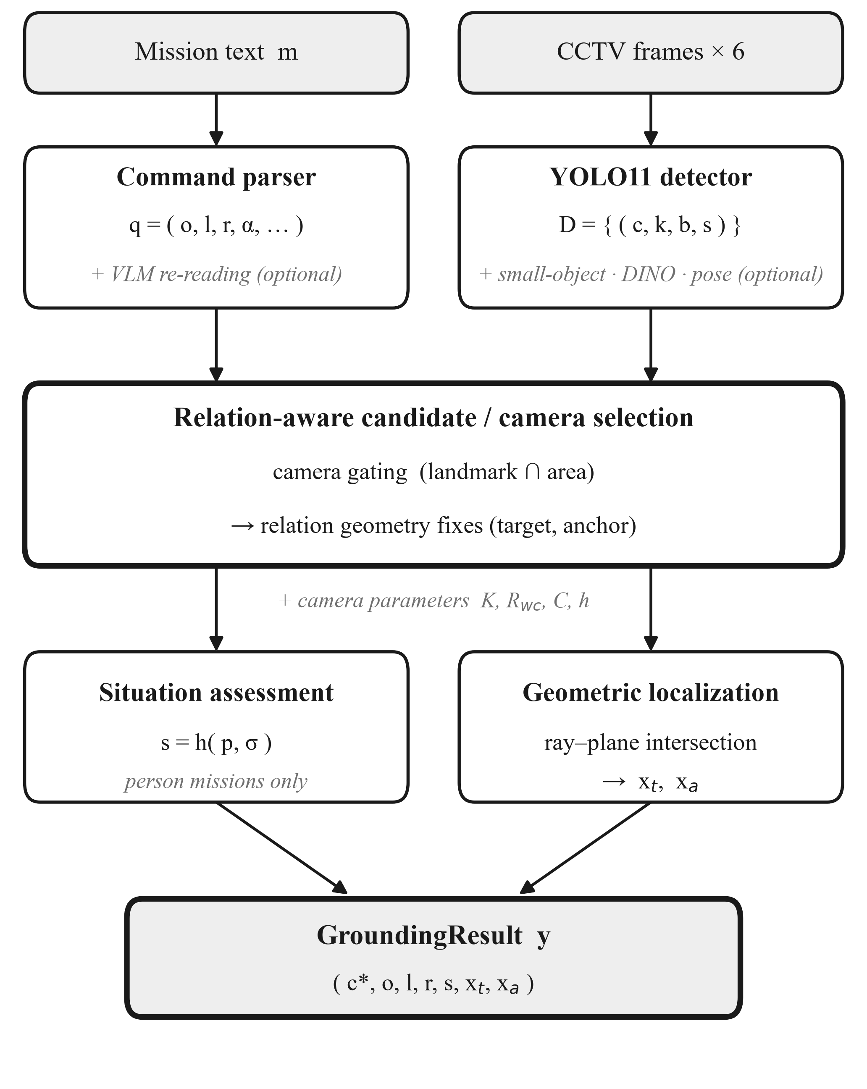
Fig. 1. Modular offline Stage 1 pipeline. Gray italics mark additive modules that intervene only conditionally.
• Command parsing: each mission string is normalized and matched against synonym dictionaries built over the official asset roster, yielding q = (τ, o, l, r) of task family, target class, landmark, and relation. The same dictionaries absorb narrative phrasings, and relations from decisive wording are submitted as parsed while ambiguous wording only hints the geometry stage. Person missions additionally yield a coarse pose bucket and an area cue, and an open-space flag marks commands that describe the location as empty ground
• Multi-camera detection: a unified YOLO11 detector covering 34 classes — 10 target objects, 15 landmarks, and 9 human postures — runs on the most recent frame of every camera at the native CCTV resolution, producing detections d = (c, k, b, s) of camera, class, box, and confidence. Postures are classified directly, so situation assessment needs no separate pose model. Several small object classes are detected unreliably at whole-frame resolution, so a tiled sub-detector is routed for those classes and its results are merged into the same detection set; it only adds candidates, so the primary path is unchanged when it is absent
• Camera gating: two independent cues narrow the candidate set G ⊆ C. When the command names a landmark l, only cameras detecting l are retained, G_{L} = { c : ∃ d ∈ D_{c} , class(d) ≈ l }. When the command names only an area α, its defining classes are used instead — Φ(parking) = vehicle classes, Φ(park) = {picnic_table, bench} — and the area is accepted only when one camera dominates:
G_{A} = argmax_{c} n_{c} if n⁽¹⁾ ≥ γ · n⁽²⁾
with n_{c} the indicator count in camera c and n⁽¹⁾, n⁽²⁾ the two largest counts. The cues are combined as G_{L} ∩ G_{A} when both are available and the intersection is non-empty, otherwise G_{L}, then G_{A}, and finally all cameras. Gating is thus a pure fallback layer.
• Candidate selection: target-anchor pairs are ranked at two levels. Within a camera, where raw distances are comparable, the nearest landmark instance wins by proximity
π = max( 0 , 1 − max(0, gap) / δ_{near} )
Across cameras, where raw distances are not comparable, relation agreement is primary: c* = argmax κ(f_{c}) with κ = (bucket, π, conf). Person missions invert this to κ = (π, bucket, conf), because relation is unscored there and the oriented bounding box of a lying person inflates along the viewing direction, monocular depth being unobserved.
• Relation geometry: relations are decided in the world XY plane. A target horizontally over the anchor footprint is on or above by vertical arrangement, and an on-candidate is re-projected onto the anchor's top plane before its coordinate is accepted; beside and near are separated by the surface distance between the two oriented bounding boxes, which unlike center distance is not dominated by landmark extent; directional relations are resolved by sign along the ground-projected optical axis, and only when the text supplies a directional hint
• Open-space commands: when the command names no landmark and marks the location as empty ground, the nearest-pair preference opposes the instruction, since emptiness means the absence of adjacent objects. Target and landmark selection are therefore decoupled — the target is the candidate with the greatest clearance and the landmark remains its nearest neighbor:
t* = argmax_{t} min_{a} gap(a,t) , a* = argmin_{a} gap(a, t*)
The rule requires both that no landmark is named and that the parser set the open-space flag, so a command such as "in the empty space next to it" is excluded; it also abstains when the two best candidates have comparable clearance.
• Graceful degradation: if no target is found, person missions relax the posture constraint and re-search; if the target is still absent the landmark alone is submitted with x_{t} ← x_{a}, since the median anchor-to-target separation lies well inside the coordinate tolerance whereas an empty submission scores zero
• Situation assessment: for person missions the category is s = h(p, σ) of posture p and supporting surface σ. The nine postures map onto four posture classes and the support tokens onto five support classes, giving the rule matrix of Table I. Resolution proceeds as incapacitation override (person_prone yields accident anywhere), then the matrix, then the posture default; an unrecognized label degrades to normal rather than raising. The support token is the landmark class when the relation to the selected anchor is on or above, and otherwise the area cue parsed from the command, so missions such as "collapsed on the parking lot floor" reach the matrix through parking → transit
TABLE I. SITUATION RULE MATRIX R[POSTURE CLASS][SUPPORT CLASS]
 | seating | rest_ground | transit | non_mount | vehicle_fallen
upright | abnormal | normal | normal | abnormal | abnormal
seated | normal | normal | abnormal | abnormal | abnormal
low | abnormal | abnormal | abnormal | abnormal | abnormal
prostrate | abnormal | normal | emergency | emergency | emergency

The prostrate row shows why posture alone is insufficient: an identical lying posture is normal on grass but an emergency on a walkway or against a vehicle.
• Geometric localization: the bottom center of the selected box, u = (x_{min} + x_{max})/2 and v = y_{max}, is back-projected onto the camera-specific ground plane z = h supplied by the platform. With K the intrinsic matrix, R_{wc} the camera-to-world rotation, and C the camera center [6],
d_{w} = R_{wc} · K⁻¹ [ u, v, 1 ]ᵀ , X_{w} = C + ( h − C_{z} ) / (d_{w})_{z} · d_{w}
This point is the camera-side contact line of the object, not its center, so it is pushed away from the camera along the viewing direction by the footprint radius recovered from the projected box width. Submitted coordinates use the support-surface height for target and anchor alike: re-projecting the ground truth of the scenario definition shows the answer for a 1.7 m person lying within ±0.1 m of the ground, which a center convention would miss by half the body height. For person targets a COCO-pretrained keypoint model supplies the ankle position, and the horizontal image coordinate is replaced by it — only the horizontal one, because vertical pixel error is amplified by the shallow viewing angle upon back-projection. The ankle matters because the ground truth for a person is the feet, whereas the box centre sits at mid-body and is displaced by half the body length once the person is lying down.
III. STAGE 2 RETRIEVAL
Stage 2 reuses the Stage 1 grounding to interpret the task description and then drives a mobile manipulator to the object and on to the owner zone. Two gaps between the provided interfaces and the task drive the design.
• Sensed local obstacles: the platform's occupancy map contains static road surface only, so parked vehicles, bicycles, and people are invisible to a planner that trusts it, and the robot drives into them. We therefore add a LiDAR obstacle layer that folds each sweep into a local grid consumed by the same A* planner. Ground points are removed by estimating the ground height from the sweep itself (a low percentile of the returns) rather than by an absolute height threshold: terrain in the public scene alone spans 1.2 m, so a fixed threshold would classify whole regions as either obstacle or floor. This is an obstacle layer, not SLAM — localization and the global map are already provided. A stall-memory fallback, which marks the spot where the chassis stopped making progress, remains as the last resort for what the sensor cannot see, such as kerbs and low steps
• Depth-based grasp refinement: the pick point derived from the reveal hint is only approximate. Before the fixed waypoint sequence commits to a grasp, the base camera's depth image is back-projected into the arm frame, the floor height is taken as the median depth over the frame (most pixels are floor), and the grasp point is set to the centroid of the largest blob raised above it. Using depth alone avoids the domain mismatch between the CCTV imagery the detector was trained on and the robot's own camera
The remaining sequence is: stow the arm to lower the centre of gravity, navigate to a standoff point in front of the object, rotate in place to face it, close the final distance with a straight approach, and grasp. Grip feedback drives a bounded retry loop that also covers a grasp that misses the basket on placement, and grasp offsets are keyed by the revealed target type so that object-specific geometry is respected. All legs share one simulation-time budget.
IV. EXPERIMENTAL RESULTS AND DISCUSSION
Evaluation separates detector validation from end-to-end scoring. Detector validation uses the held-out synthetic split and reports precision, recall, AP50, and AP50-95 per class group. End-to-end evaluation runs the agent on all public missions with network access disabled, recording the GroundingResult and scorer output for every round; semantic fields are scored by exact match and coordinates by Euclidean XY error. Table II reports the field-level breakdown of a live run over the 33 public missions.
TABLE II. STAGE 1 FIELD-LEVEL RESULTS (33 PUBLIC MISSIONS, LIVE RUN)
Field | Score | Exact / applicable
camera_id | 9.39 / 10 | 31 / 33
target type or situation | 15.00 / 15 | 33 / 33
landmark | 7.89 / 10 | 15 / 19
relation | 9.47 / 10 | 18 / 19
anchor_coord | 10.64 / 15 | —
target_coord | 23.00 / 40 | 18 / 33 at full credit
Stage 1 total | 75.4 / 100 | 33 rounds

The field-level pattern supports the design decisions. Camera selection, formulated as constraint satisfaction over landmark and area cues, is correct in 31 of 33 rounds; in the two exceptions the requested class was not detected in the correct camera at all, so that camera never entered the candidate set. Selection therefore chose correctly in every round in which a correct candidate existed, which is precisely the property the gating design is built to guarantee: each gate releases rather than discarding when it cannot narrow the set, so it can remove a wrong camera but never the right one.
Deterministic situation assessment, taken directly from the organizers' rule tables rather than fitted to the practice scene, classifies the target type or situation exactly in all 33 rounds. The contact-point coordinate convention is supported in turn: the anchor coordinate scores 13-14 of 15 even in rounds where the target coordinate scores zero, and since both come from the same projection this indicates that the geometry and the convention are sound while the target field is scored against a far tighter tolerance — plausibly the physical extent of the object. Gains in localization precision therefore convert into full-credit rounds rather than incremental points.
Person missions average 86.6 and lost-item missions 67.2. The gap follows from where the design contributes most: person rounds draw on both the deterministic situation rules and the ankle-keypoint correction, whereas lost-item rounds rest on the target coordinate, the field with the tightest tolerance.
The remaining loss is bounded by perception rather than by reasoning. Both camera errors, and most zero-credit target coordinates, occur when the requested class is absent from the detector output, and no selection rule recovers a candidate that never enters the set. A separate case arises when the command names no landmark and several vehicles lie at comparable distance: proximity alone cannot identify the intended reference, which calls for a cue beyond geometry and is left for future work.
V. CONCLUSION
We proposed a modular offline agent for MARC 2026 joining local multi-class detection, deterministic parsing, constraint-based camera gating, relation-aware candidate selection, contact-point localization, and sensing-based retrieval. The architecture maps directly to the GroundingResult schema and exposes separate failure points for language, perception, camera selection, situation reasoning, and geometry. On the public missions it reaches 75.4 of 100 in Stage 1 with 93.9% camera accuracy and exact type or situation classification throughout. The remaining loss is concentrated in the target coordinate, whose near-binary scoring means further precision converts directly into full-credit rounds; the two camera errors trace to detector recall rather than to the selection logic. Future work will estimate the support point and support plane without relying on scene-specific exceptions, and will replace proximity with a stronger cue where several same-class landmarks are equidistant.
Both vocabularies also remain closed: an untrained class cannot be found, and a phrasing outside the parser's dictionaries leaves its field unset. Grounding DINO [3] re-detection and a local language model are integrated behind switches for these two cases; both are disabled here and contribute nothing to the reported score, but they indicate how the vocabulary could be opened without altering the rest of the pipeline.
REFERENCES
[1] MARC 2026 Organizing Committee, "MARC 2026 Developer Guide," ver. 2026.1.0, 2026. [Online]. Available: https://marc-challenge.github.io/marc-dev-guide/en/
[2] G. Jocher and J. Qiu, "Ultralytics YOLO11," software, ver. 11.0.0, 2024. [Online]. Available: https://github.com/ultralytics/ultralytics
[3] S. Liu et al., "Grounding DINO: Marrying DINO with grounded pre-training for open-set object detection," in Proc. Eur. Conf. Comput. Vis. (ECCV), 2024, pp. 38-55.
[4] M. Berg, D. Bayazit, R. Mathew, A. Rotter-Aboyoun, E. Pavlick, and S. Tellex, "Grounding language to landmarks in arbitrary outdoor environments," in Proc. IEEE Int. Conf. Robot. Autom. (ICRA), 2020, pp. 208-215.
[5] D. R. Beddiar, M. Oussalah, and B. Nini, "Fall detection using body geometry and human pose estimation in video sequences," J. Vis. Commun. Image Represent., vol. 82, Art. no. 103407, 2022.
[6] R. Hartley and A. Zisserman, Multiple View Geometry in Computer Vision, 2nd ed. Cambridge, U.K.: Cambridge Univ. Press, 2004.

