Relation-Aware Visual Grounding and Geometric Localization for MARC 2026
Anonymous Submission

Abstract—We present a modular offline agent for the Meta-Sejong AI Robotics Challenge (MARC) 2026 that interprets a natural-language mission, selects the CCTV view containing the target, submits a world-frame grounding result, and retrieves the object. A locally bundled 34-class YOLO11 detector is combined with rule-based command parsing, constraint-based camera gating, relation-aware candidate selection, situation assessment taken from the organizers' posture-by-support rules, and ray-plane localization under a contact-point coordinate convention. Because the fixed cameras observe disjoint regions, camera selection is posed as constraint satisfaction over textual cues rather than as ranking by detection confidence. For retrieval, a LiDAR obstacle layer adds obstacles missing from the occupancy map and depth refines the grasp. On the 33 public Chungmu missions the system scores 75.4 of 100 in Stage 1, selecting the correct camera in 31 rounds and classifying the target type or situation correctly in all 33.
Keywords—multi-camera visual grounding, spatial-relation reasoning, geometric localization, search and rescue, digital twin
I. INTRODUCTION
MARC 2026 is held in an Isaac Sim digital twin of a university campus. In Stage 1 an agent receives a natural-language mission, analyzes fixed CCTV frames, and submits a GroundingResult: the selected camera, target type, landmark and relation, a situation category for person missions, and world-frame coordinates of target and anchor. In Stage 2 a mobile manipulator retrieves the object and delivers it to its owner [1]. The evaluation runtime is offline and its background may differ from the public scene, so models are bundled locally and rules must transfer beyond the practice answers.
The task couples four difficulties: the vocabulary spans small objects, large landmarks, and human postures; the same class recurs across and within cameras, so the most confident detection is not necessarily the referred one; direct and narrative phrasings must map to identical fields; and a bounding box does not identify the physical contact point that the coordinate requires.
We build on YOLO11 [2] and ray-plane geometry [6]. Landmarks are the primary camera cue because landmark-based grounding transfers to unseen outdoor scenes [4], and, unlike fall detection that maps posture directly to a hazard [5], posture is one input to a context rule. Our contributions are:
• Constraint-based camera gating: candidate cameras are narrowed by landmark and area cues, and each gate releases rather than emptying the set; proximity ranks candidates within a camera and relation agreement across cameras
• Deterministic situation assessment: the category is computed from posture and supporting surface with the organizers' published rule tables
• Contact-point localization: coordinates use the support-surface height, and person targets are corrected by ankle keypoints
• Sensing-based retrieval: a LiDAR obstacle layer supplies obstacles missing from the occupancy map, and depth refines the grasp point
II. PROPOSED GROUNDING PIPELINE
A round takes a mission string m and frames from N = 6 fixed cameras and submits
y = ( c*, o, l, r, s, x_{t}, x_{a} )
where c* is the selected camera, o the target type, l the landmark, r one of eight relations, s the situation category, and x_{t}, x_{a} the world coordinates of target and anchor. In Fig. 1 the parser and detector run independently and are joined in candidate grounding; a situation rule is then applied to person missions and geometric projection yields the coordinates. Auxiliary modules are additive, so disabling them leaves the primary path unchanged.
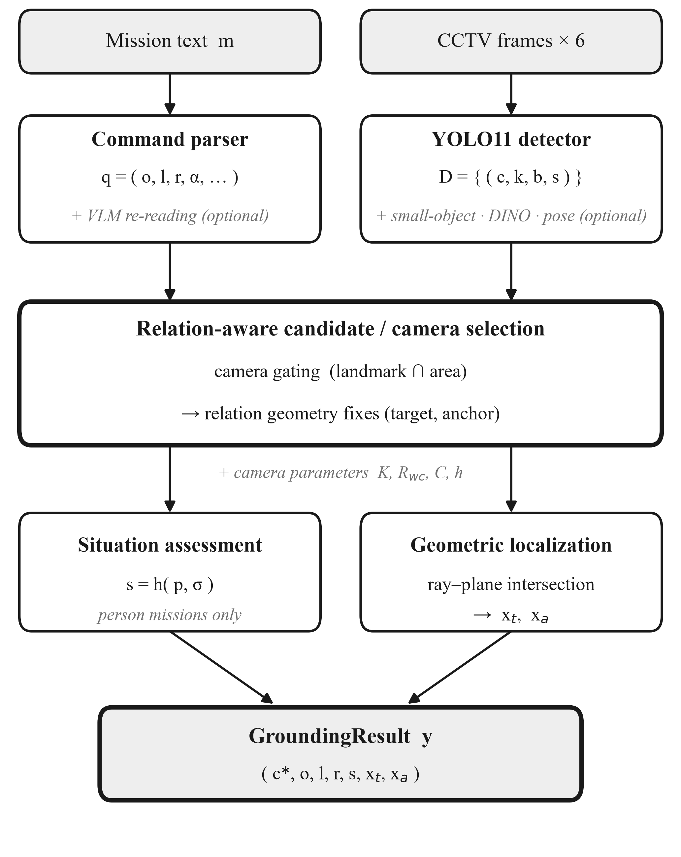
Fig. 1. Modular offline Stage 1 pipeline. Gray italics mark additive modules that intervene only conditionally.
• Command parsing: the mission is normalized and matched against synonym dictionaries built over the official asset roster, giving q = (τ, o, l, r) of task family, target, landmark, and relation. Decisive relation wording is submitted as parsed, while ambiguous wording only hints the geometry stage. Person missions also yield a pose bucket and an area cue, and an open-space flag marks commands that describe empty ground
• Multi-camera detection: one YOLO11 detector covering 34 classes (10 targets, 15 landmarks, 9 human postures) runs on the latest frame of every camera at native resolution, giving detections d = (c, k, b, s). Postures are classified directly, so situation assessment needs no separate pose model. A tiled sub-detector adds candidates for small classes whose whole-frame confidence is low
• Camera gating: two cues narrow the candidate set G ⊆ C. A named landmark l retains the cameras detecting it, G_{L} = { c : ∃ d ∈ D_{c} , class(d) ≈ l }. A named area α uses its defining classes, Φ(parking) = vehicles and Φ(park) = {picnic_table, bench}, and is accepted only when one camera dominates:
G_{A} = argmax_{c} n_{c} if n⁽¹⁾ ≥ γ · n⁽²⁾
with n_{c} the indicator count in camera c and n⁽¹⁾, n⁽²⁾ the two largest counts. The cues are combined as G_{L} ∩ G_{A} when non-empty, otherwise G_{L}, then G_{A}, and finally all cameras. Gating therefore never empties the candidate set, although it can still drop the correct camera when the landmark is missed there while a same-class detection exists elsewhere.
• Candidate selection: target-anchor pairs are ranked at two levels. Within a camera, where raw distances are comparable, the nearest landmark instance wins by proximity
π = max( 0 , 1 − max(0, gap) / δ_{near} )
Across cameras, where raw distances are not comparable, relation agreement is primary: c* = argmax κ(f_{c}) with κ = (bucket, π, conf). Person missions use κ = (π, bucket, conf), because relation is unscored there and the box of a lying person inflates along the unobserved depth direction. If no target is found, person missions relax the posture constraint, and if it is still absent the landmark alone is submitted with x_{t} ← x_{a}, since an empty submission scores zero.
• Relation geometry: relations are decided in the world XY plane. A target over the anchor footprint is on or above by vertical arrangement and is re-projected onto the anchor's top plane; beside and near are separated by the surface distance between the two oriented boxes, not by center distance; directional relations use the sign along the ground-projected optical axis, only when the text gives a directional hint
• Open-space commands: when no landmark is named and the parser marks the location as empty ground, the nearest-pair preference opposes the instruction, so the target is the candidate with the greatest clearance to any landmark and the landmark remains its nearest neighbor; the rule abstains when the two best clearances are comparable
• Situation assessment: for person missions s = h(p, σ) of posture p and supporting surface σ. Nine postures map to four posture classes and the support tokens to five support classes (Table I). Resolution applies an incapacitation override (person_prone yields accident anywhere), then the matrix, then the posture default; unknown labels degrade to normal. The support token is the landmark class when the relation is on or above, otherwise the command's area cue, so "collapsed on the parking lot floor" reaches the matrix through parking → transit
TABLE I. SITUATION RULE MATRIX R[POSTURE CLASS][SUPPORT CLASS]
 | seating | rest_ground | transit | non_mount | vehicle_fallen
upright | abnormal | normal | normal | abnormal | abnormal
seated | normal | normal | abnormal | abnormal | abnormal
low | abnormal | abnormal | abnormal | abnormal | abnormal
prostrate | abnormal | normal | emergency | emergency | emergency

The prostrate row shows why posture alone is insufficient: an identical lying posture is normal on grass but an emergency on a walkway or against a vehicle.
• Geometric localization: the bottom center of the selected box, u = (x_{min} + x_{max})/2 and v = y_{max}, is back-projected onto the camera-specific ground plane z = h supplied by the platform. With K the intrinsic matrix, R_{wc} the camera-to-world rotation, and C the camera center [6],
d_{w} = R_{wc} · K⁻¹ [ u, v, 1 ]ᵀ , X_{w} = C + ( h − C_{z} ) / (d_{w})_{z} · d_{w}
This point is the camera-side contact line, so it is pushed away from the camera by the footprint radius recovered from the box width. Coordinates use the support-surface height for target and anchor alike: re-projecting the scenario ground truth places a lying 1.7 m person within ±0.1 m of the ground, which a center convention would miss by half the body height. For persons, whose ground truth is the feet, a COCO-pretrained keypoint model supplies the ankle, whose horizontal image coordinate replaces the box center. Its vertical coordinate is used only for prostrate postures, where the box bottom is the body part nearest the camera rather than the feet; upright persons keep the box bottom, because vertical pixel error is amplified by the shallow viewing angle.
III. STAGE 2 RETRIEVAL
Stage 2 reuses the Stage 1 grounding to interpret the task and drives a mobile manipulator to the object and then to the owner zone.
• Sensed local obstacles: the occupancy map holds only the static road, so parked vehicles, bicycles, and people are invisible to the planner. A LiDAR obstacle layer folds each sweep into a local grid used by the same A* planner. Ground returns are removed with a ground height estimated from the sweep itself per azimuth sector rather than with an absolute threshold, since terrain in the public scene alone spans 1.2 m. A stall memory covers kerbs and low steps the sensor misses
• Depth-based grasp refinement: the pick point from the reveal hint is approximate. The base camera's depth is back-projected into the arm frame, the median height is taken as the floor, and the grasp point is set to the centroid of points raised above it within a window around the navigation estimate, which excludes nearby large objects; using depth alone avoids a CCTV-to-robot domain gap
The arm is stowed, the robot navigates to a standoff point, rotates to face the object, approaches straight, and grasps; grip feedback drives a bounded retry loop, and grasp offsets are keyed by the revealed target type.
IV. EXPERIMENTAL RESULTS AND DISCUSSION
End-to-end evaluation runs the agent on all 33 public missions with network access disabled; semantic fields are scored by exact match and coordinates by Euclidean XY error. Table II gives the field-level breakdown of a live run.
TABLE II. STAGE 1 FIELD-LEVEL RESULTS (33 PUBLIC MISSIONS, LIVE RUN)
Field | Score | Exact / applicable
camera_id | 9.39 / 10 | 31 / 33
target type or situation | 15.00 / 15 | 33 / 33
landmark | 7.89 / 10 | 15 / 19
relation | 9.47 / 10 | 18 / 19
anchor_coord | 10.64 / 15 | —
target_coord | 23.00 / 40 | 18 / 33 at full credit
Stage 1 total | 75.4 / 100 | 33 rounds

Camera selection is correct in 31 of 33 rounds; in both exceptions the requested class was not detected in the correct camera, which therefore never entered the candidate set. Every round with a correct candidate was resolved correctly, an empirical outcome rather than a guarantee, since gating can exclude a camera whose landmark is missed.
Situation assessment, taken from the organizers' rule tables rather than fitted to the practice scene, is exact in all 33 rounds. The anchor coordinate scores 13-14 of 15 even in rounds where the target coordinate scores zero; since both come from the same projection, the target field appears to be scored against a far tighter tolerance, so gains in precision convert into full-credit rounds. Person missions average 86.6 and lost-item missions 67.2, the latter resting on that target coordinate.
The remaining loss is bounded mainly by perception: both camera errors and most zero-credit target coordinates occur when the requested class is absent from the detector output. When no landmark is named and several vehicles lie at comparable distance, proximity alone cannot identify the reference; this is left for future work.
V. CONCLUSION
We presented a modular offline agent for MARC 2026 whose stages map onto the GroundingResult schema and isolate failures in language, perception, camera selection, situation reasoning, and geometry. It reaches 75.4 of 100 in Stage 1 on the public missions with 93.9% camera accuracy; the remaining loss lies in the target coordinate and detector recall. Both vocabularies remain closed, so an untrained class or an unlisted phrasing is missed; Grounding DINO [3] re-detection and a local language model are integrated behind switches but disabled in all reported results.
REFERENCES
[1] MARC 2026 Organizing Committee, "MARC 2026 Developer Guide," ver. 2026.1.0, 2026. [Online]. Available: https://marc-challenge.github.io/marc-dev-guide/en/
[2] G. Jocher and J. Qiu, "Ultralytics YOLO11," software, ver. 11.0.0, 2024. [Online]. Available: https://github.com/ultralytics/ultralytics
[3] S. Liu et al., "Grounding DINO: Marrying DINO with grounded pre-training for open-set object detection," in Proc. Eur. Conf. Comput. Vis. (ECCV), 2024, pp. 38-55.
[4] M. Berg, D. Bayazit, R. Mathew, A. Rotter-Aboyoun, E. Pavlick, and S. Tellex, "Grounding language to landmarks in arbitrary outdoor environments," in Proc. IEEE Int. Conf. Robot. Autom. (ICRA), 2020, pp. 208-215.
[5] D. R. Beddiar, M. Oussalah, and B. Nini, "Fall detection using body geometry and human pose estimation in video sequences," J. Vis. Commun. Image Represent., vol. 82, Art. no. 103407, 2022.
[6] R. Hartley and A. Zisserman, Multiple View Geometry in Computer Vision, 2nd ed. Cambridge, U.K.: Cambridge Univ. Press, 2004.

