Task # 1

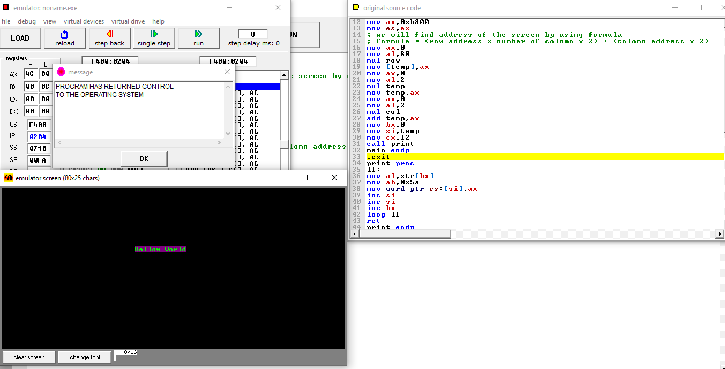

.model small

.stack 100h

.data

temp dw ? ; it will store correct address of the screen by using cursor position

row db 9 ; cursor position x axis

col db 31 ; cursor position y axis

str db "Hellow World"

.code

main proc

mov ax,@data

mov ds,ax

mov ax,0xb800

mov es,ax

; we will find address of the screen by using formula

; formula = (row address x number of colomn x 2) + (colomn address x 2)

mov ax,0

mov al,80

mul row

mov [temp],ax

mov ax,0

mov al,2

mul temp

mov temp,ax

mov ax,0

mov al,2

mul col

add temp,ax

mov bx,0

mov si,temp

mov cx,12

call print

main endp

.exit

print proc

l1:

mov al,str[bx]

mov ah,0x5a

mov word ptr es:[si],ax

inc si

inc si

inc bx

loop l1

ret

print endp

Task # 2

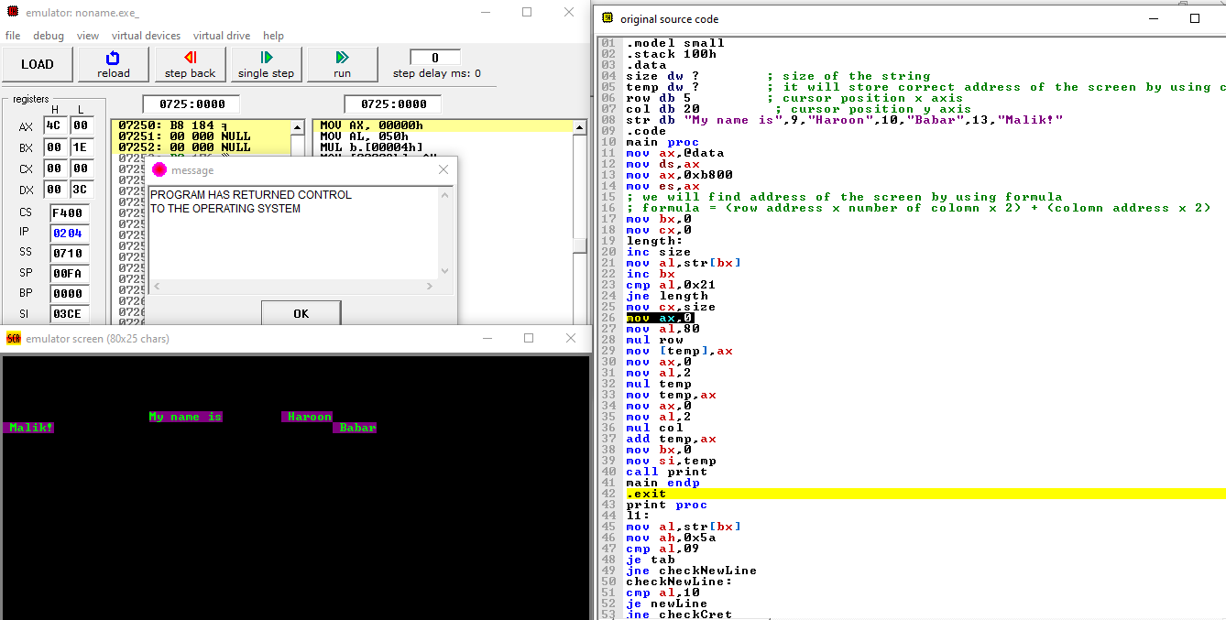

.model small

.stack 100h

.data

size dw ? ; size of the string

temp dw ? ; it will store correct address of the screen by using cursor position

row db 5 ; cursor position x axis

col db 20 ; cursor position y axis

str db "My name is",9,"Haroon",10,"Babar",13,"Malik!"

.code

main proc

mov ax,@data

mov ds,ax

mov ax,0xb800

mov es,ax

; we will find address of the screen by using formula

; formula = (row address x number of colomn x 2) + (colomn address x 2)

mov bx,0

mov cx,0

length:

inc size

mov al,str[bx]

inc bx

cmp al,0x21

jne length

mov cx,size

mov ax,0

mov al,80

mul row

mov [temp],ax

mov ax,0

mov al,2

mul temp

mov temp,ax

mov ax,0

mov al,2

mul col

add temp,ax

mov bx,0

mov si,temp

call print

main endp

.exit

print proc

l1:

mov al,str[bx]

mov ah,0x5a

cmp al,09

je tab

jne checkNewLine

checkNewLine:

cmp al,10

je newLine

jne checkCret

checkCret:

cmp al,13

je cret

jne continue

tab:

add si,16

jmp continue

newline:

add si,160

jmp continue

cret:

mov dl,col

add dl,dl

sub si,dx

mov dx,0

mov dx,size

add dx,dx

sub si,dx

sub si,2

jmp continue

continue:

mov word ptr es:[si],ax

inc si

inc si

inc bx

loop l1

ret

print endp

Task # 3

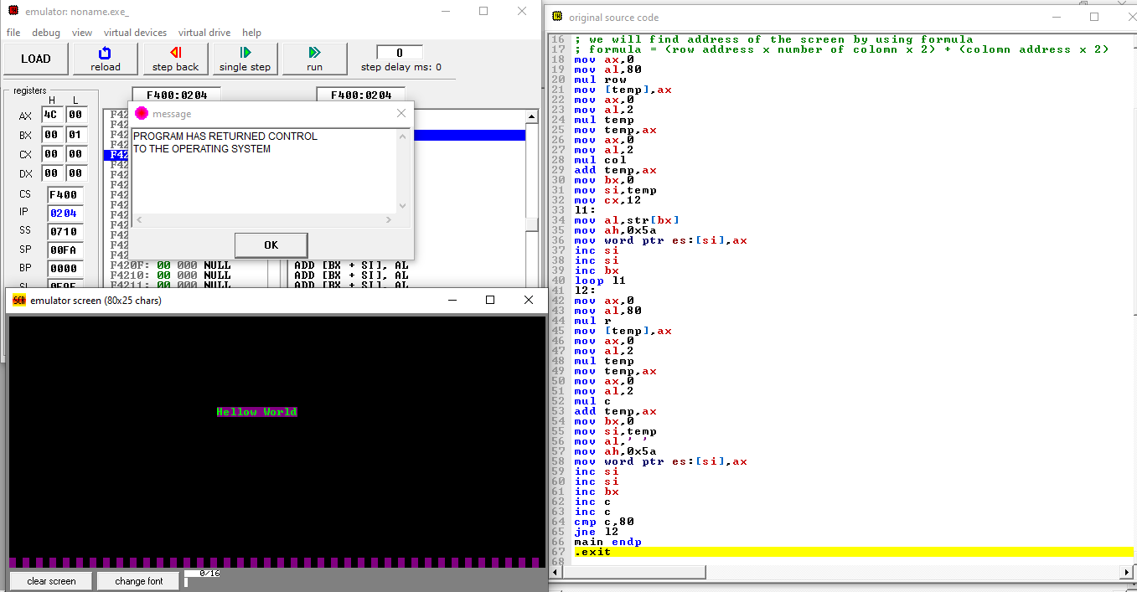

.model small

.stack 100h

.data

r db 24

c db 0

temp dw ? ; it will store correct address of the screen by using cursor position

row db 9 ; cursor position x axis

col db 31 ; cursor position y axis

str db "Hellow World"

.code

main proc

mov ax,@data

mov ds,ax

mov ax,0xb800

mov es,ax

; we will find address of the screen by using formula

; formula = (row address x number of colomn x 2) + (colomn address x 2)

mov ax,0

mov al,80

mul row

mov [temp],ax

mov ax,0

mov al,2

mul temp

mov temp,ax

mov ax,0

mov al,2

mul col

add temp,ax

mov bx,0

mov si,temp

mov cx,12

l1:

mov al,str[bx]

mov ah,0x5a

mov word ptr es:[si],ax

inc si

inc si

inc bx

loop l1

l2:

mov ax,0

mov al,80

mul r

mov [temp],ax

mov ax,0

mov al,2

mul temp

mov temp,ax

mov ax,0

mov al,2

mul c

add temp,ax

mov bx,0

mov si,temp

mov al,' '

mov ah,0x5a

mov word ptr es:[si],ax

inc si

inc si

inc bx

inc c

inc c

cmp c,80

jne l2

main endp

.exit

--------------------------------------------------------------------------------------------------------------------------------------------