Task # 1

For 0x1(int 65h)

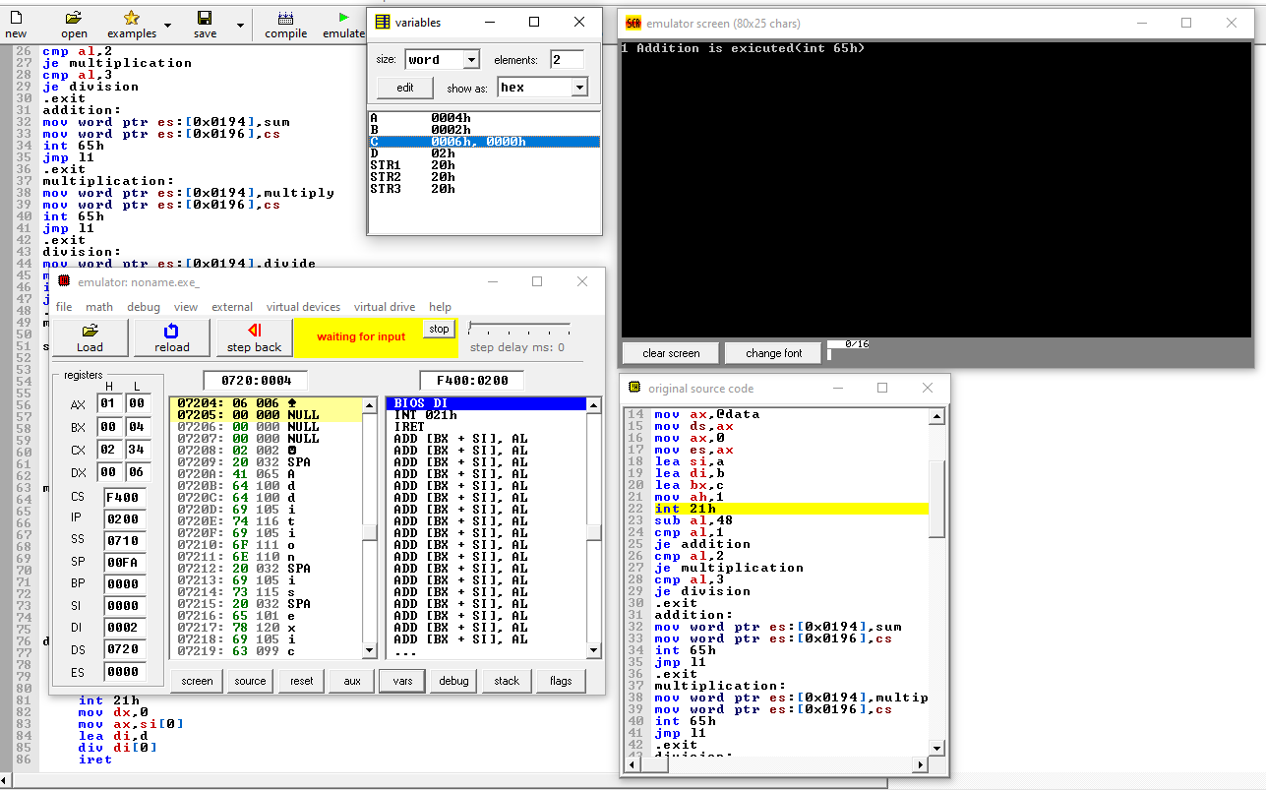For 0x2(int 65h)

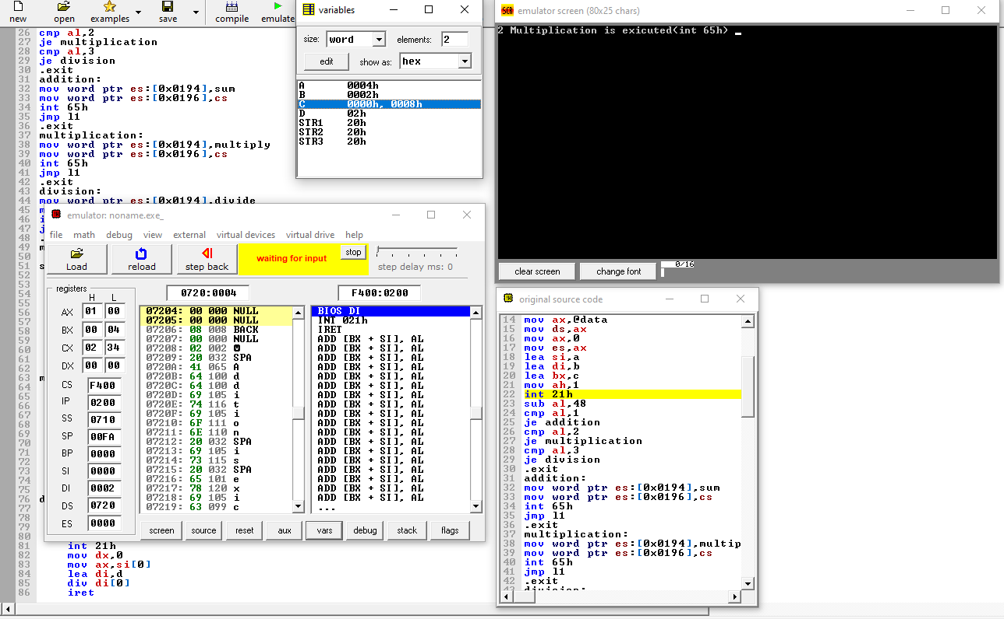

For 0x3(int 65h)

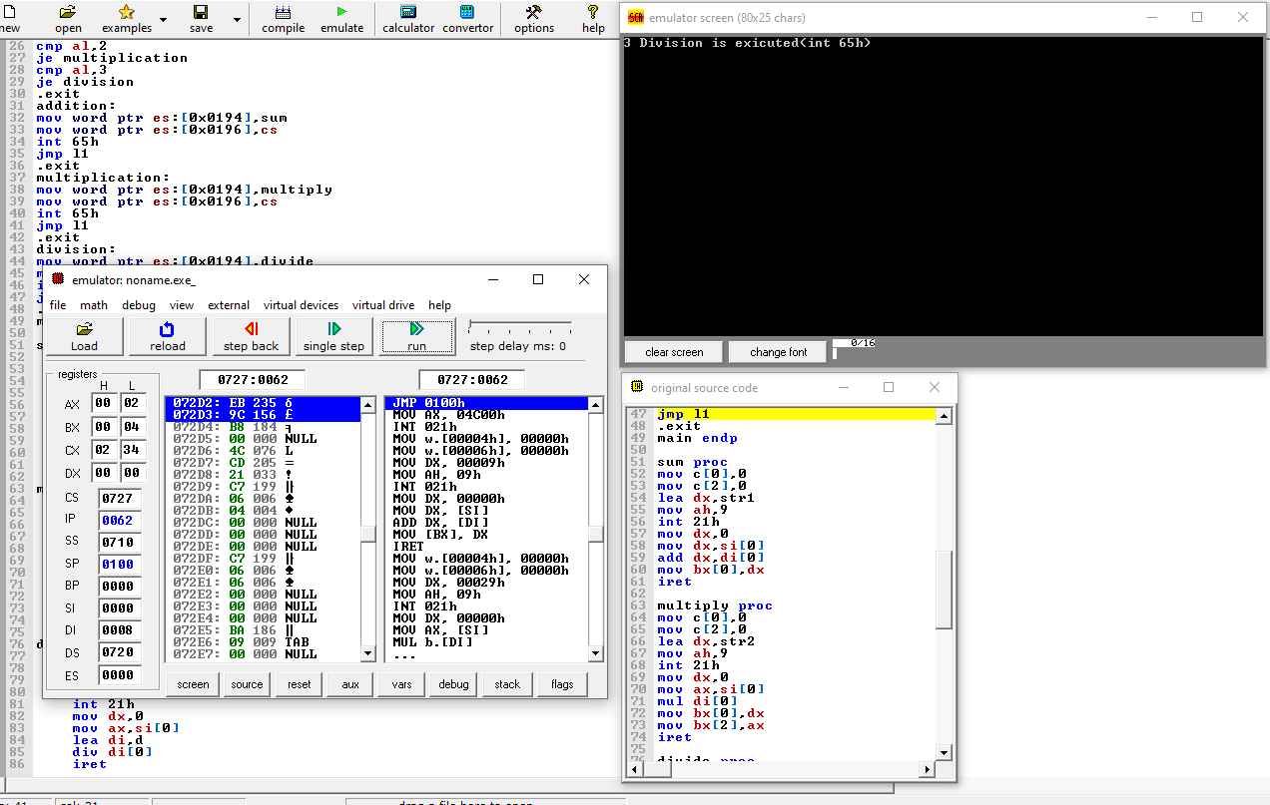

.model small

.stack 100h

.data

a dw 4

b dw 2

c dw 2 dup(0)

d db 2

str1 db " Addition is exicuted(int 65h) $"

str2 db " Multiplication is exicuted(int 65h) $"

str3 db " Division is exicuted(int 65h) $"

.code

main proc

l1:

mov ax,@data

mov ds,ax

mov ax,0

mov es,ax

lea si,a

lea di,b

lea bx,c

mov ah,1

int 21h

sub al,48

cmp al,1

je addition

cmp al,2

je multiplication

cmp al,3

je division

.exit

addition:

mov word ptr es:[0x0194],sum

mov word ptr es:[0x0196],cs

int 65h

jmp l1

.exit

multiplication:

mov word ptr es:[0x0194],multiply

mov word ptr es:[0x0196],cs

int 65h

jmp l1

.exit

division:

mov word ptr es:[0x0194],divide

mov word ptr es:[0x0196],cs

int 65h

jmp l1

.exit

main endp

sum proc

mov c[0],0

mov c[2],0

lea dx,str1

mov ah,9

int 21h

mov dx,0

mov dx,si[0]

add dx,di[0]

mov bx[0],dx

iret

multiply proc

mov c[0],0

mov c[2],0

lea dx,str2

mov ah,9

int 21h

mov dx,0

mov ax,si[0]

mul di[0]

mov bx[0],dx

mov bx[2],ax

iret

divide proc

mov c[0],0

mov c[2],0

lea dx,str3

mov ah,9

int 21h

mov dx,0

mov ax,si[0]

lea di,d

div di[0]

iret