Task # 1

a) MOV AX,27

Valid

b) MOV AL,97Fh

Invalid because of size not matching

c) MOV SI,9516

Invalid because we can’t singe direct value

d) MOV DS, BX

valid

e) MOV BX, CS

Valid

f) MOV AX,23FB9h

Invalid because of size not matching

g) MOV DS, BH

Invalid because destination operand cannot be a segment register (DS, CS, SS, ES). Also size not match

h) MOV DS,9BF2

Invalid because we can’t singe direct value

i) MOV CS,3490

Invalid because we can’t singe direct value

j) MOV DS, ES

Valid

k) MOV ES, BX

Valid

Task # 2

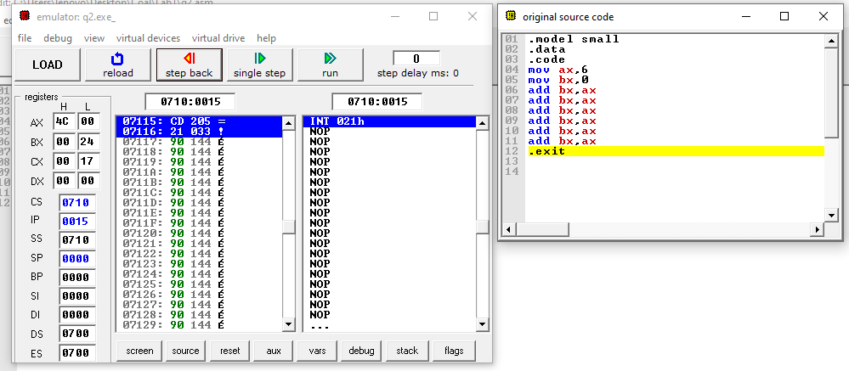 Task # 3

