Task # 1

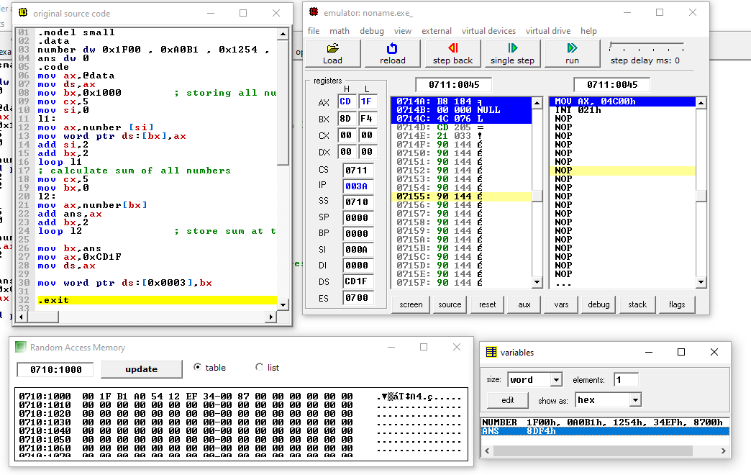

.model small

.data

number dw 0x1F00 , 0xA0B1 , 0x1254 , 0x34EF , 0x8700

ans dw 0

.code

mov ax,@data

mov ds,ax

mov bx,0x1000 ; storing all numbers in ds with little inian notation

mov cx,5

mov si,0

l1:

mov ax,number [si]

mov word ptr ds:[bx],ax

add si,2

add bx,2

loop l1

; calculate sum of all numbers

mov cx,5

mov bx,0

l2:

mov ax,number[bx]

add ans,ax

add bx,2

loop l2 ; store sum at the physical address

mov bx,ans

mov ax,0xCD1F

mov ds,ax

mov word ptr ds:[0x0003],bx

.exit

Task # 2

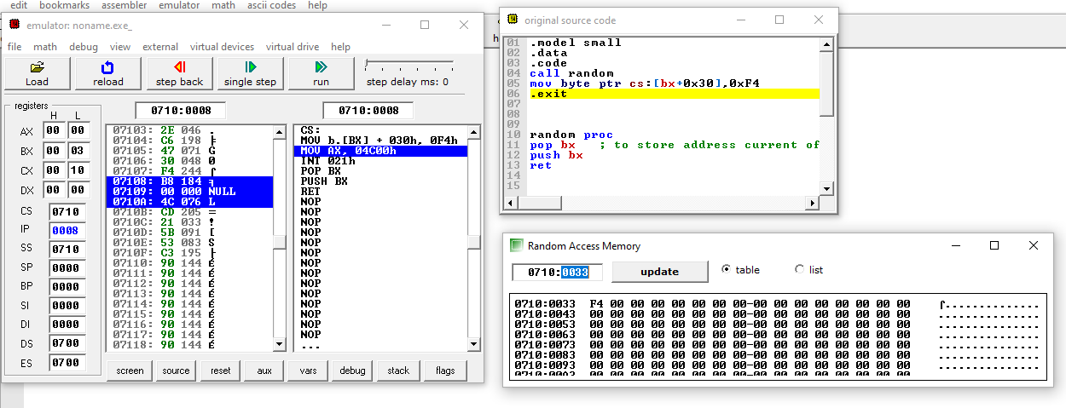

.model small

.data

.code

call random

mov byte ptr cs:[bx+0x30],0xF4

.exit

random proc

pop bx ; to store address current offsett

push bx

ret