Task # 1

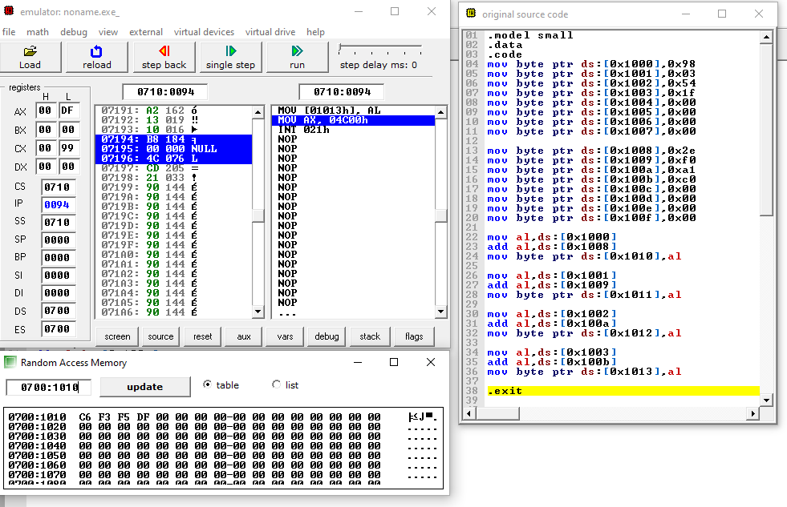

.model small

.data

.code

mov byte ptr ds:[0x1000],0x98

mov byte ptr ds:[0x1001],0x03

mov byte ptr ds:[0x1002],0x54

mov byte ptr ds:[0x1003],0x1f

mov byte ptr ds:[0x1004],0x00

mov byte ptr ds:[0x1005],0x00

mov byte ptr ds:[0x1006],0x00

mov byte ptr ds:[0x1007],0x00

mov byte ptr ds:[0x1008],0x2e

mov byte ptr ds:[0x1009],0xf0

mov byte ptr ds:[0x100a],0xa1

mov byte ptr ds:[0x100b],0xc0

mov byte ptr ds:[0x100c],0x00

mov byte ptr ds:[0x100d],0x00

mov byte ptr ds:[0x100e],0x00

mov byte ptr ds:[0x100f],0x00

mov al,ds:[0x1000]

add al,ds:[0x1008]

mov byte ptr ds:[0x1010],al

mov al,ds:[0x1001]

add al,ds:[0x1009]

mov byte ptr ds:[0x1011],al

mov al,ds:[0x1002]

add al,ds:[0x100a]

mov byte ptr ds:[0x1012],al

mov al,ds:[0x1003]

add al,ds:[0x100b]

mov byte ptr ds:[0x1013],al

.exit

Task # 2

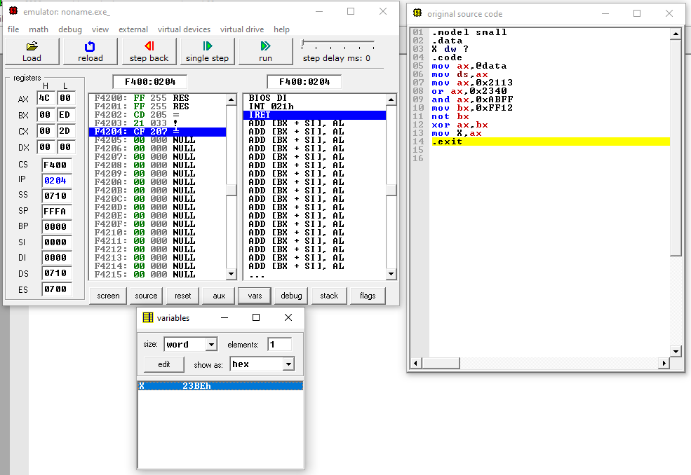

.model small

.data

X dw ?

.code

mov ax,@data

mov ds,ax

mov ax,0x2113

or ax,0x2340

and ax,0xABFF

mov bx,0xFF12

not bx

xor ax,bx

mov X,ax

.exit

Task # 3

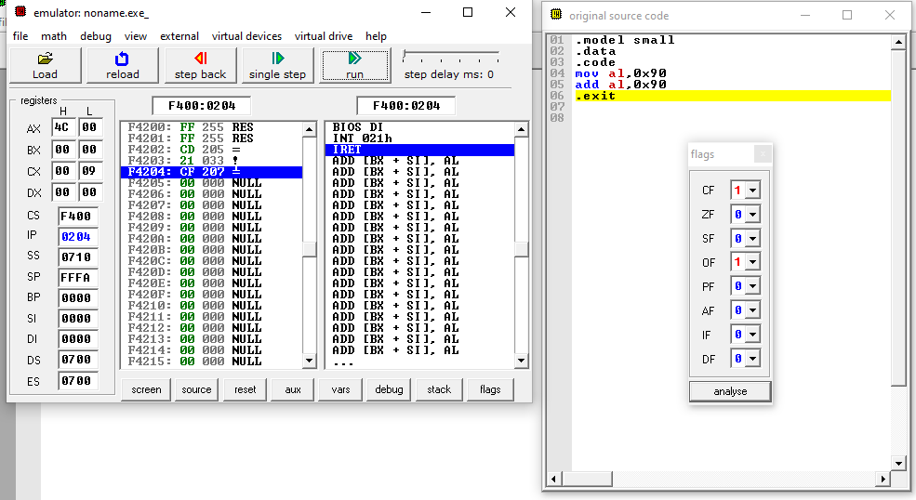

.model small

.data

.code

mov al,0x90

add al,0x90

.exit