Task # 1

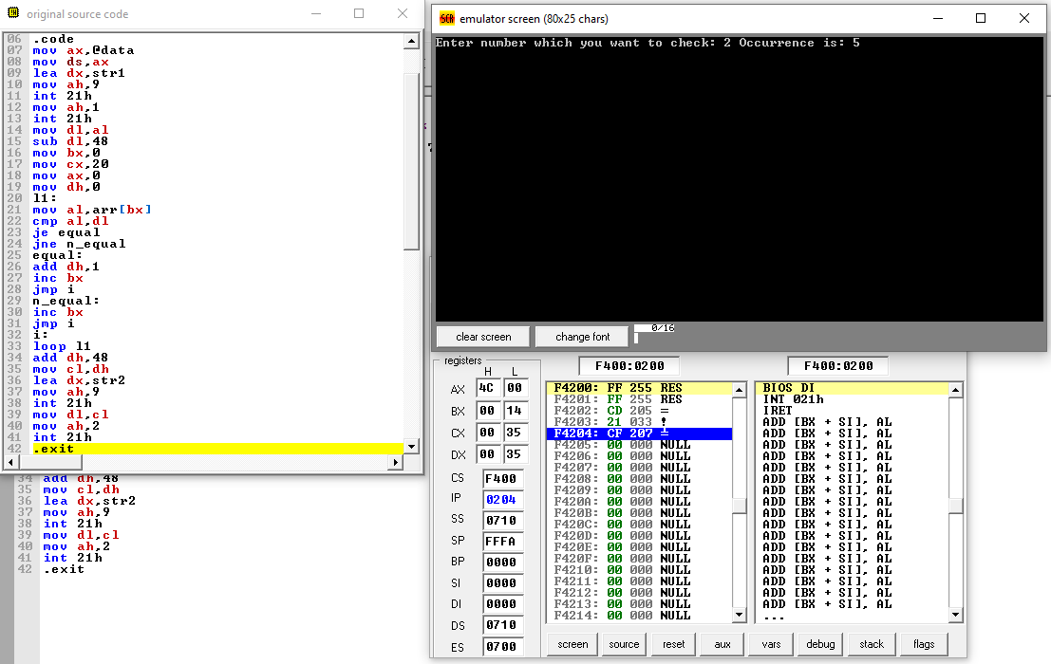.model small

.data

str1 db "Enter number which you want to check : $"

str2 db " Occurrence is : $"

arr db 9,2,4,6,5,4,2,1,2,1,2,3,6,7,8,9,4,2,6,7

.code

mov ax,@data

mov ds,ax

lea dx,str1

mov ah,9

int 21h

mov ah,1

int 21h

mov dl,al

sub dl,48

mov bx,0

mov cx,20

mov ax,0

mov dh,0

l1:

mov al,arr[bx]

cmp al,dl

je equal

jne n_equal

equal:

add dh,1

inc bx

jmp i

n_equal:

inc bx

jmp i

i:

loop l1

add dh,48

mov cl,dh

lea dx,str2

mov ah,9

int 21h

mov dl,cl

mov ah,2

int 21h

.exit

Task # 2

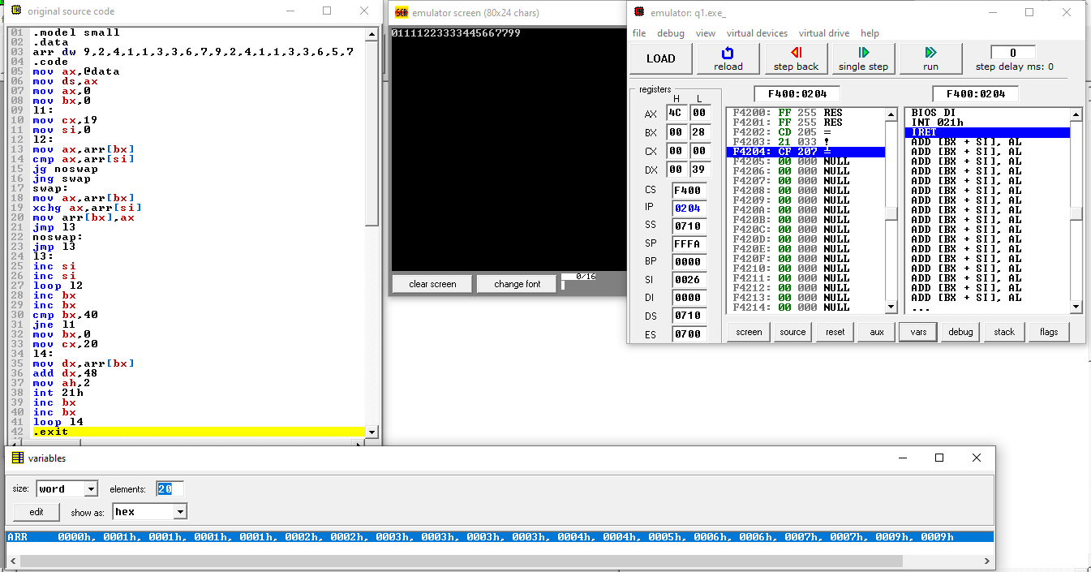.model small

.data

arr dw 9,2,4,1,1,3,3,6,7,9,2,4,1,1,3,3,6,5,7

.code

mov ax,@data

mov ds,ax

mov ax,0

mov bx,0

l1:

mov cx,19

mov si,0

l2:

mov ax,arr[bx]

cmp ax,arr[si]

jg noswap

jng swap

swap:

mov ax,arr[bx]

xchg ax,arr[si]

mov arr[bx],ax

jmp l3

noswap:

jmp l3

l3:

inc si

inc si

loop l2

inc bx

inc bx

cmp bx,40

jne l1

mov bx,0

mov cx,20

l4:

mov dx,arr[bx]

add dx,48

mov ah,2

int 21h

inc bx

inc bx

loop l4

.exit