TASK#1

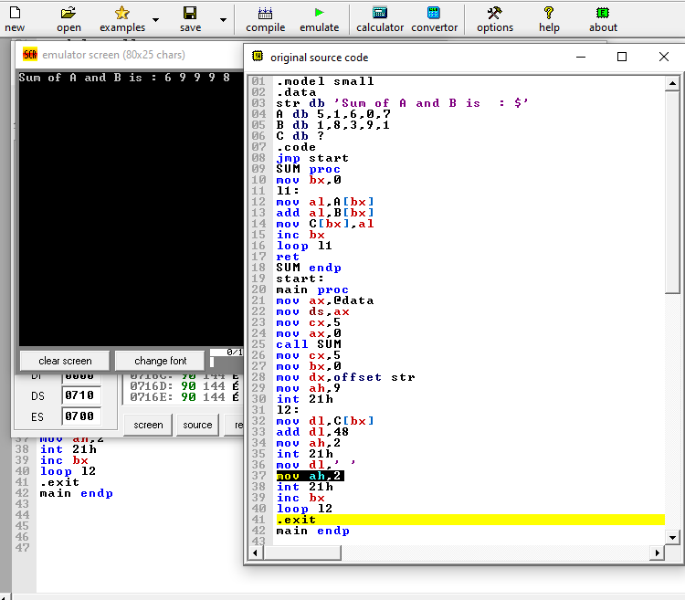

.model small

.data

str db 'Sum of A and B is : $'

A db 5,1,6,0,7

B db 1,8,3,9,1

C db ?

.code

jmp start

SUM proc

mov bx,0

l1:

mov al,A[bx]

add al,B[bx]

mov C[bx],al

inc bx

loop l1

ret

SUM endp

start:

main proc

mov ax,@data

mov ds,ax

mov cx,5

mov ax,0

call SUM

mov cx,5

mov bx,0

mov dx,offset str

mov ah,9

int 21h

l2:

mov dl,C[bx]

add dl,48

mov ah,2

int 21h

mov dl,' '

mov ah,2

int 21h

inc bx

loop l2

.exit

main endp

TASK#2

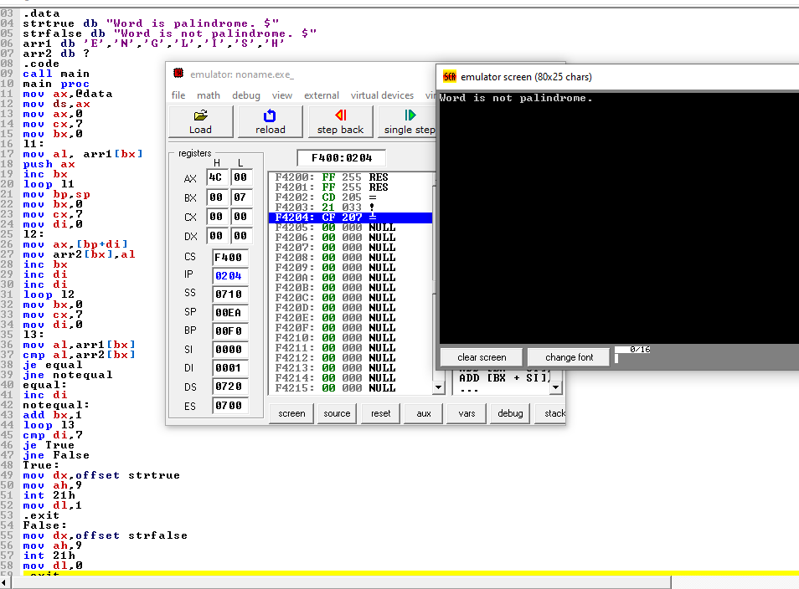

.model small

.stack 100h

.data

strtrue db "Word is palindrome. $"

strfalse db "Word is not palindrome. $"

arr1 db 'E','N','G','L','I','S','H'

arr2 db ?

.code

call main

main proc

mov ax,@data

mov ds,ax

mov ax,0

mov cx,7

mov bx,0

l1:

mov al, arr1[bx]

push ax

inc bx

loop l1

mov bp,sp

mov bx,0

mov cx,7

mov di,0

l2:

mov ax,[bp+di]

mov arr2[bx],al

inc bx

inc di

inc di

loop l2

mov bx,0

mov cx,7

mov di,0

l3:

mov al,arr1[bx]

cmp al,arr2[bx]

je equal

jne notequal

equal:

inc di

notequal:

add bx,1

loop l3

cmp di,7

je True

jne False

True:

mov dx,offset strtrue

mov ah,9

int 21h

mov dl,1

.exit

False:

mov dx,offset strfalse

mov ah,9

int 21h

mov dl,0

.exit

main endp