TASK # 1

Index by Index multiplication

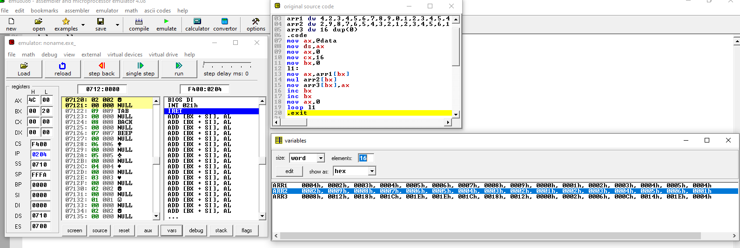

.model small

.data

arr1 dw 4,2,3,4,5,6,7,8,9,0,1,2,3,4,5,4

arr2 dw 2,9,8,7,6,5,4,3,2,1,2,3,4,5,6,1

arr3 dw 16 dup(0)

.code

mov ax,@data

mov ds,ax

mov ax,0

mov cx,16

mov bx,0

l1:

mov ax,arr1[bx]

mul arr2[bx]

mov arr3[bx],ax

inc bx

inc bx

mov ax,0

loop l1

.exit

Real multiplication of matrix(2 by 2)

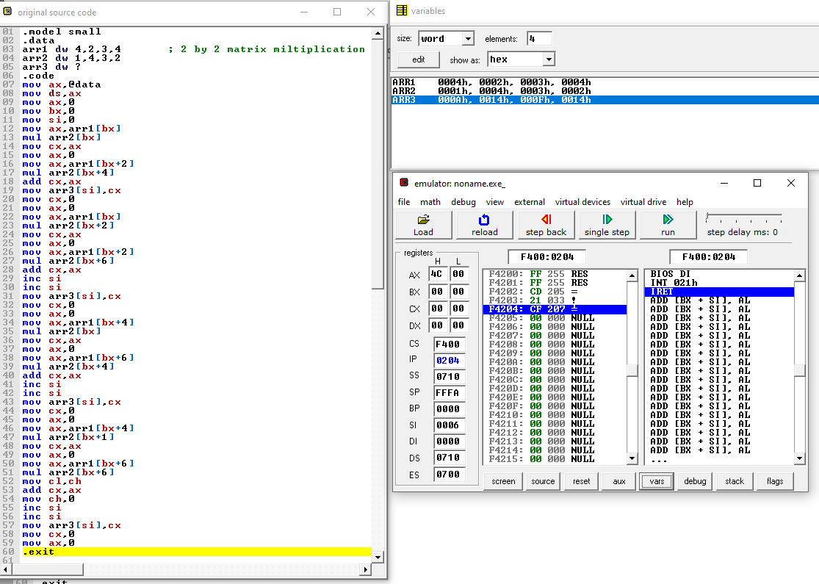

.model small

.data

arr1 dw 4,2,3,4 ; 2 by 2 matrix miltiplication

arr2 dw 1,4,3,2

arr3 dw ?

.code

mov ax,@data

mov ds,ax

mov ax,0

mov bx,0

mov si,0

mov ax,arr1[bx]

mul arr2[bx]

mov cx,ax

mov ax,0

mov ax,arr1[bx+2]

mul arr2[bx+4]

add cx,ax

mov arr3[si],cx

mov cx,0

mov ax,0

mov ax,arr1[bx]

mul arr2[bx+2]

mov cx,ax

mov ax,0

mov ax,arr1[bx+2]

mul arr2[bx+6]

add cx,ax

inc si

inc si

mov arr3[si],cx

mov cx,0

mov ax,0

mov ax,arr1[bx+4]

mul arr2[bx]

mov cx,ax

mov ax,0

mov ax,arr1[bx+6]

mul arr2[bx+4]

add cx,ax

inc si

inc si

mov arr3[si],cx

mov cx,0

mov ax,0

mov ax,arr1[bx+4]

mul arr2[bx+1]

mov cx,ax

mov ax,0

mov ax,arr1[bx+6]

mul arr2[bx+6]

mov cl,ch

add cx,ax

mov ch,0

inc si

inc si

mov arr3[si],cx

mov cx,0

mov ax,0

.exit

TASK # 2

I am using 3 by 3 matrix because example shows3x3...

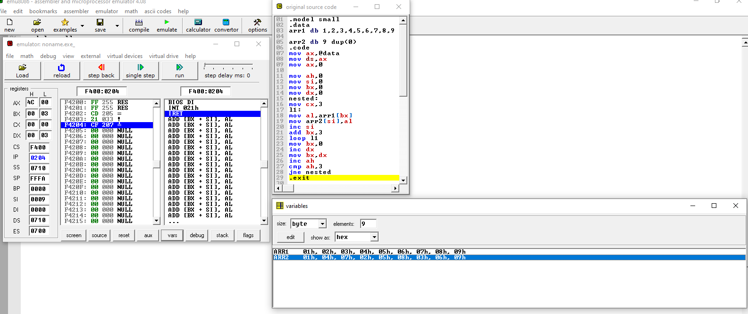

.model small

.data

arr1 db 1,2,3,4,5,6,7,8,9

arr2 db 9 dup(0)

.code

mov ax,@data

mov ds,ax

mov ax,0

mov ah,0

mov si,0

mov bx,0

mov dx,0

nested:

mov cx,3

l1:

mov al,arr1[bx]

mov arr2[si],al

inc si

add bx,3

loop l1

mov bx,0

inc dx

mov bx,dx

inc ah

cmp ah,3

jne nested

.exit