

**Introduction to Database System**

**Spring 2022**

# **Final Term Lab**

# **VERSION I**

**Time Allowed: 90 min**

|  |  |
| --- | --- |
| Name: |  |
| Registration No |  |
| Serial Number (of attendance sheet) |  |

|  |  |  |  |
| --- | --- | --- | --- |
|  | DDL | DML | Total |
| Total Marks | 15 | 35 | 50 |
| Ob. Marks |  |  |  |

**Instructions:**

1. **This is a closed book, closed notes paper.**
2. **Understanding questions is part of the paper**. Therefore, no queries will be entertained during examination.
3. chess.sql file is uploaded on teams/portal. Use those files to attempt the DML section of paper.
4. Use proper indentation/formatting while writing queries. Not properly indenting will deduct 5% marks.
5. **You need to make an MS Word with your name and registration should be mentioned on each page.**
6. **You need to write only queries with output in MS Word file, you need to write query (text form) + its output table (picture) if any.**
7. **You will solve the DDL + DML section only in word docx.**

# **Part 1 DDL** **[15 Marks]**

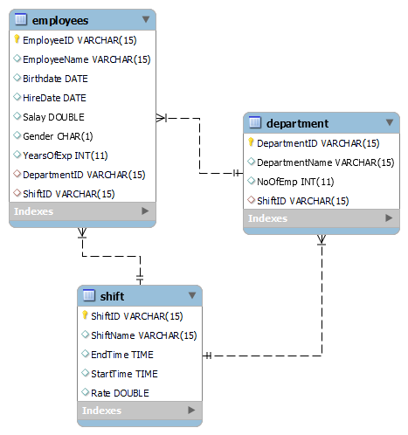

**Q1.** Implement the employee table with its attributes. Make primary keys and foreign keys if any. **[5 Marks]**

**Q2.** Make the required modifications [10 **Marks]**

1. Add a column in email in the employee’s table.
2. Add constraint in employees table as a foreign key from shift table and from department table.
3. Change the data type of salary from double to integer.
4. Set default value of Shift Name in **Shift** table to “Morning”.

**Part 2 DML**  **[35 Marks]**

**Import chess.sql schema.**

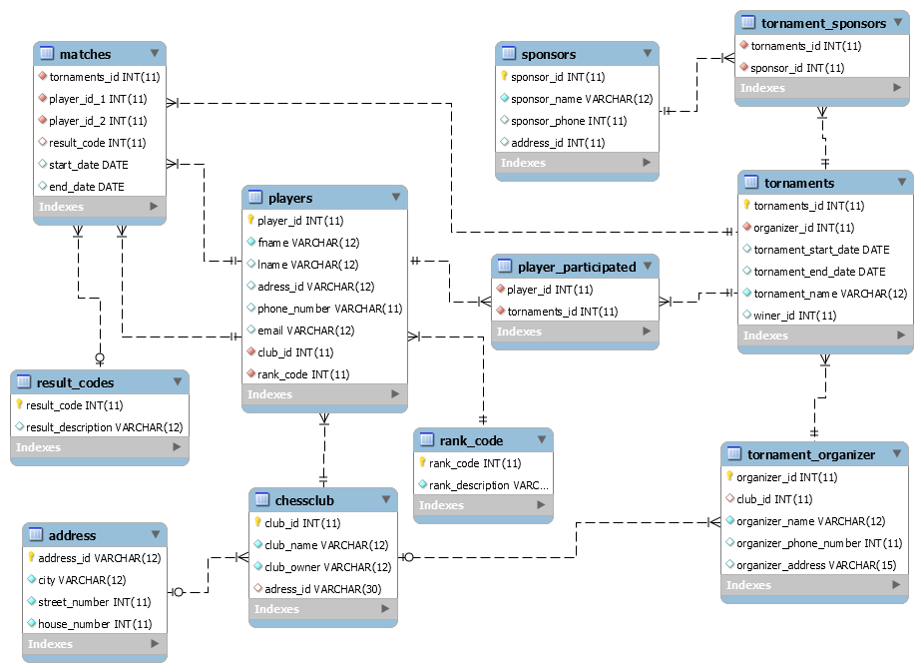

**Solve the following questions from the above schema: (5+6+6+6+12)**

**Q#1:**

Print the count of the player who have played in the club which is not present in Lahore.

**[use nested query].**

**Q#2:**

Create a view as your name that displays every organizer name with total count of tournaments organized by him in ascending order. **[use correlated query]**.

**Q#3:**

Display name of those players who played in the most resent match. **[Don’t use cross product]**.

**Q#4:**

Print the name of player who have participated in more than one tournament that are held in Karachi. **[Don’t use cross product]**

**Q#5:**

Create a view of ‘Players’ named as participants and by using this table in a stored procedure named tournament players, display first name of all those players that participated in tournament whose end date is in year 2002 and then returns the result in the output variable by using multiple parameters**.[View and Stored Procedure]**