**Name: Taaha Hussain Khan**

**Roll No: L1F21BSCS0917**

**Section: A21**

**ITC- ASSIGNMENT**

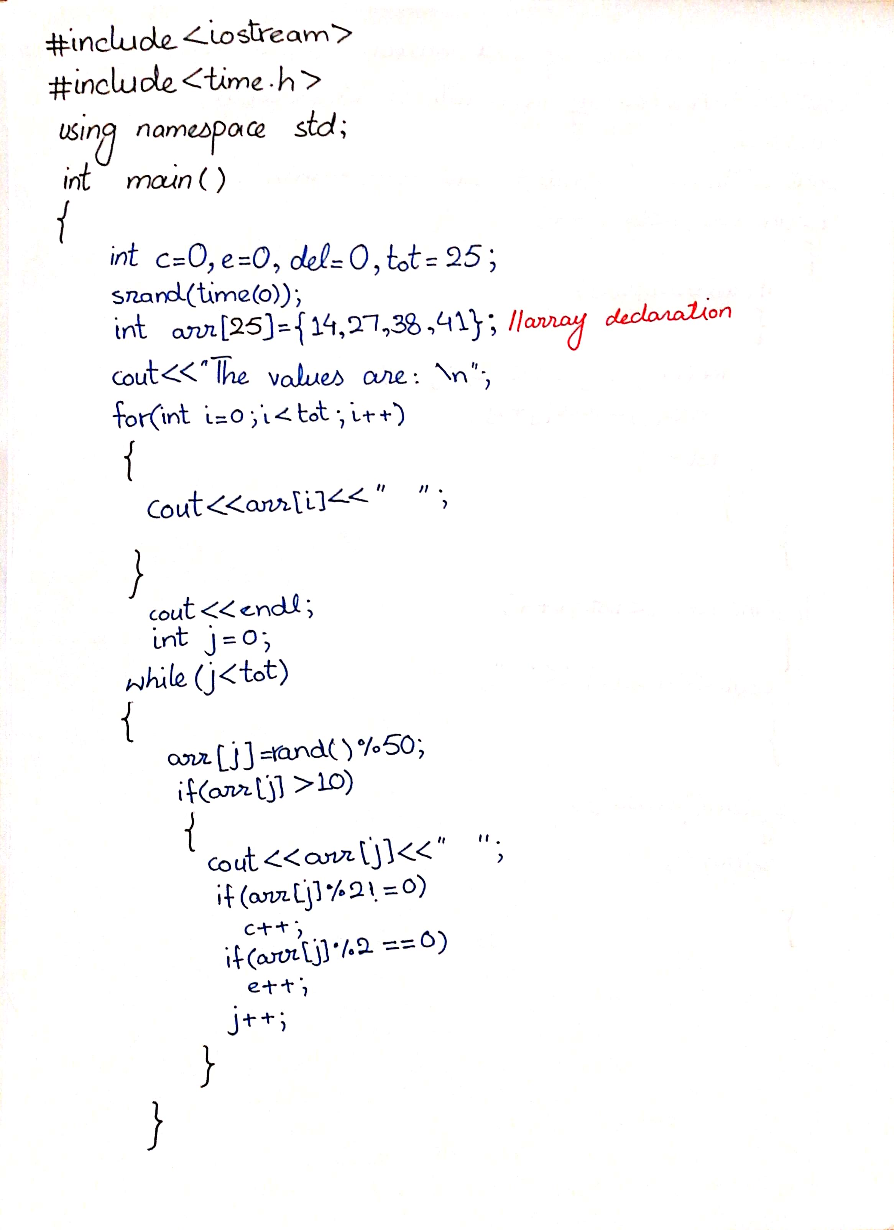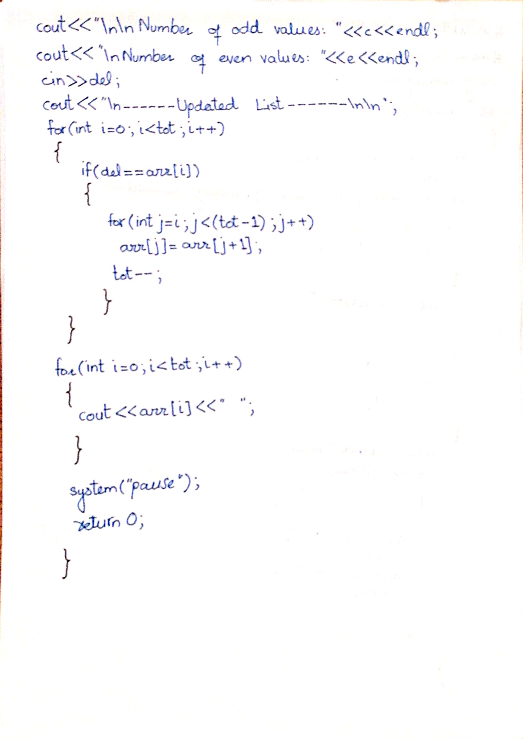

#include<iostream>

#include<time.h>

using namespace std;

int main()

{

int c = 0, e = 0, del = 0, tot = 25;

srand(time(0));

int arr[25] = { 14, 27, 38, 41 };//array declaration and partial initiallization

cout << "The values are: \n";

for (int i = 0; i < tot; i++)

{

cout << arr[i] << " ";

}

cout << endl;

int j = 0;

while( j < tot)

{

arr[j] = rand() % 50;

if (arr[j] > 10)

{

cout << arr[j] << " ";

if (arr[j] % 2 != 0)

c++;

if (arr[j] % 2 == 0)

e++;

j++;

}

}

cout << "\n\nNumber of odd values: " << c << endl;

cout << "\nNumber of even values: " << e << endl;

cout << "\nEnter a value : ";

cin >> del;

cout << "\n------Updated List------\n\n";

for (int i = 0; i < tot; i++)

{

if (del == arr[i])

{

for (int j = i; j < (tot - 1); j++)

arr[j] = arr[j + 1];

tot--;

}

}

for (int i = 0; i < tot; i++)

{

cout << arr[i] << " ";

}

system("pause");

return 0;

}

