
Assignment 01: Git-Based Collaboration for an ML Project
Final Collaboration & MLOps Reproducibility Report

Zaneeha Afzal — BSDSF23A011
Taaiba Usman— BSDSF23A041

1. Team Overview & Repository Details
Repository URL: https://github.com/taaibausman/TaZ-dragons-ml-collab
Team Name: TaZ-dragons
Selected Dataset: Titanic Survival Prediction Dataset (UCI / Kaggle tabular dataset)
Member Name | GitHub Handle | Assigned Role | Primary Responsibilities
Zaneeha Afzal | @Neeha2005 | Data & Platform Co-Owner | DVC data tracking, dataset updates, pre-commit hooks, data checks, notebook pairing
Taaiba Usman | @taaibausman | Model & Platform Co-Owner | Training pipeline, hyperparameter configs, GitHub Actions CI, release candidate & tags

2. Phase 1: Team and Repository Setup
Formed a 2-person team ('TaZ-dragons'), created the repository 'TaZ-dragons-ml-collab', configured Git user identities, assigned split platform co-owner roles, and configured branch protection rules on GitHub.

3. Phase 2: Project Scaffolding & Initial Import
Established Cookiecutter Data Science layout (configs/, data/, models/, notebooks/, src/, tests/, .github/). Pinned dependencies in requirements.txt & pyproject.toml. Created strict .gitignore excluding datasets and binary models from Git history.

4. Phase 3: Guard Rails (Pre-commit Hooks & Secret Scanning)
Configured .pre-commit-config.yaml with ruff, nbstripout, check-added-large-files (1MB limit), and detect-secrets. Verified that pre-commit intercepts and blocks 2MB files and fake API keys.
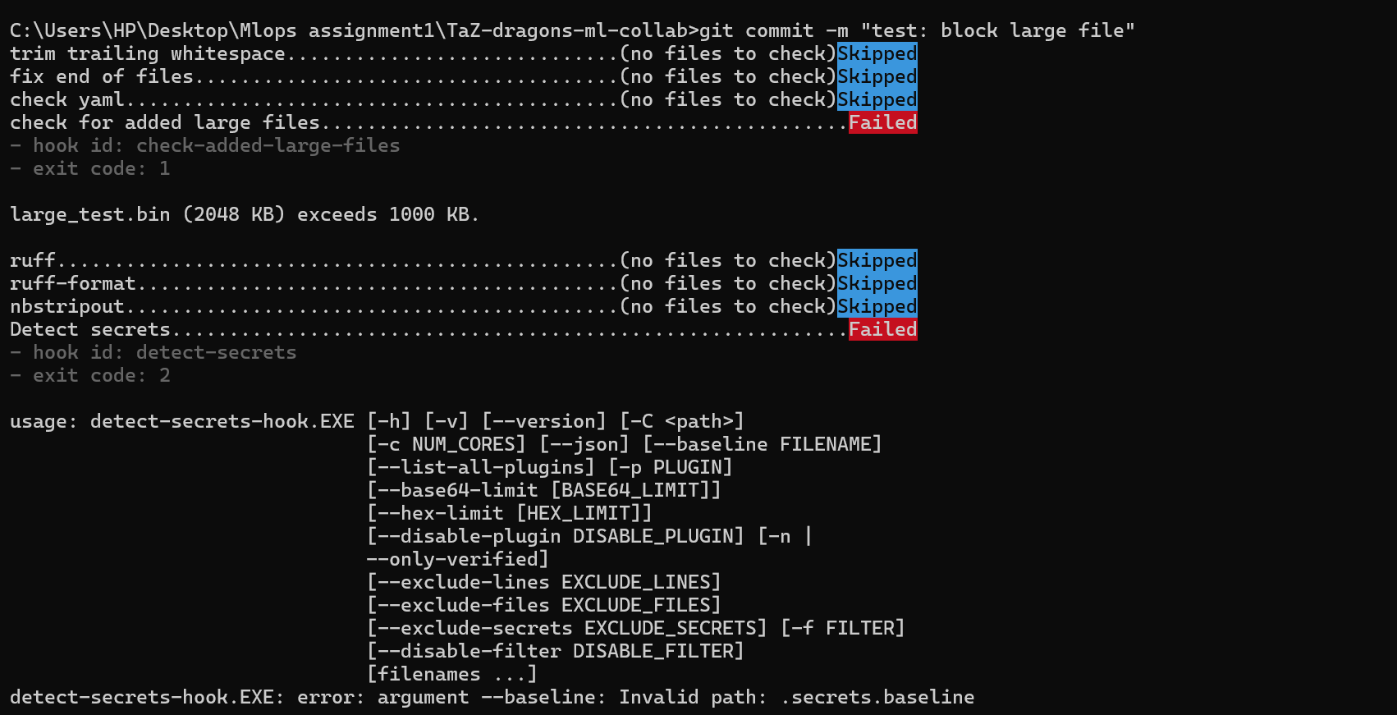

5. Phase 4: Data Versioning with DVC
Initialized DVC, tracked raw dataset 'data/raw/titanic.csv' using DVC pointer 'titanic.csv.dvc', configured local cache remote storage, and opened PR data/initial-dataset -> dev.
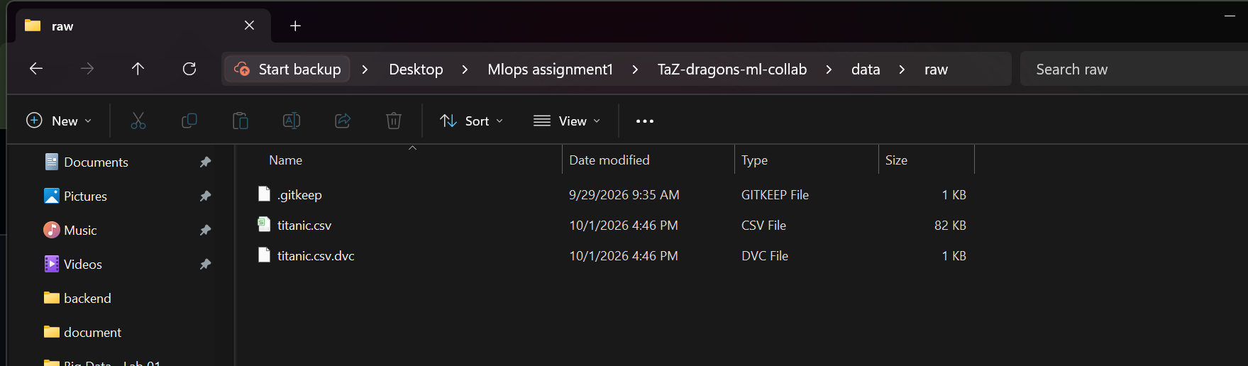

6. Phase 5: Notebooks Done Right
Created exploratory notebook 'notebooks/01-eda.ipynb' paired with Jupytext ('notebooks/01-eda.py'). Extracted reusable feature function 'compute_family_size' into 'src/features.py' with unit test in 'tests/test_features.py'. Enforced nbstripout to strip cell outputs.

7. Phase 6: Reproducible Pipeline
Constructed 3-stage DVC DAG (prepare -> train -> evaluate) defined in dvc.yaml. Centralized seeds (42) and hyperparameters in params.yaml. Executed 'dvc repro' to generate dvc.lock and baseline metrics.json.
Baseline Pipeline Metrics (metrics.json):
Accuracy | Precision | Recall | F1 Score | ROC AUC
0.7672 | 0.5660 | 0.4412 | 0.4959 | 0.7794

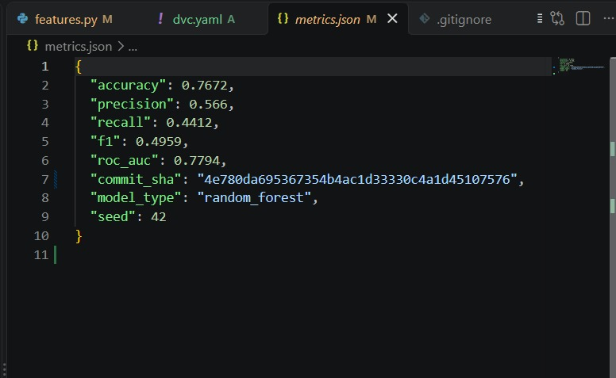

8. Phase 7: Experiments & Multi-Member Collaboration
Executed hyperparameter tuning experiments across branches (exp/zaneeha-n-estimators). Compared metrics via 'dvc exp show'. Retained exp/zaneeha-n-estimators as an abandoned experiment branch to document experiment drift. Simulated and resolved a real merge conflict in params.yaml via git rebase dev.
Run Name | Branch | n_estimators | Accuracy | F1 Score | Status / Result
Baseline | dev | 100 | 0.7672 | 0.4874 | Baseline
piano-flux | exp/zaneeha-n-estimators | 50 | 0.7634 | 0.4918 | Winner (Best F1 & ROC AUC)
sheen-jive | exp/zaneeha-n-estimators | 150 | 0.7672 | 0.4874 | Evaluated
minus-taro | exp/zaneeha-n-estimators | 250 | 0.7672 | 0.4874 | Evaluated
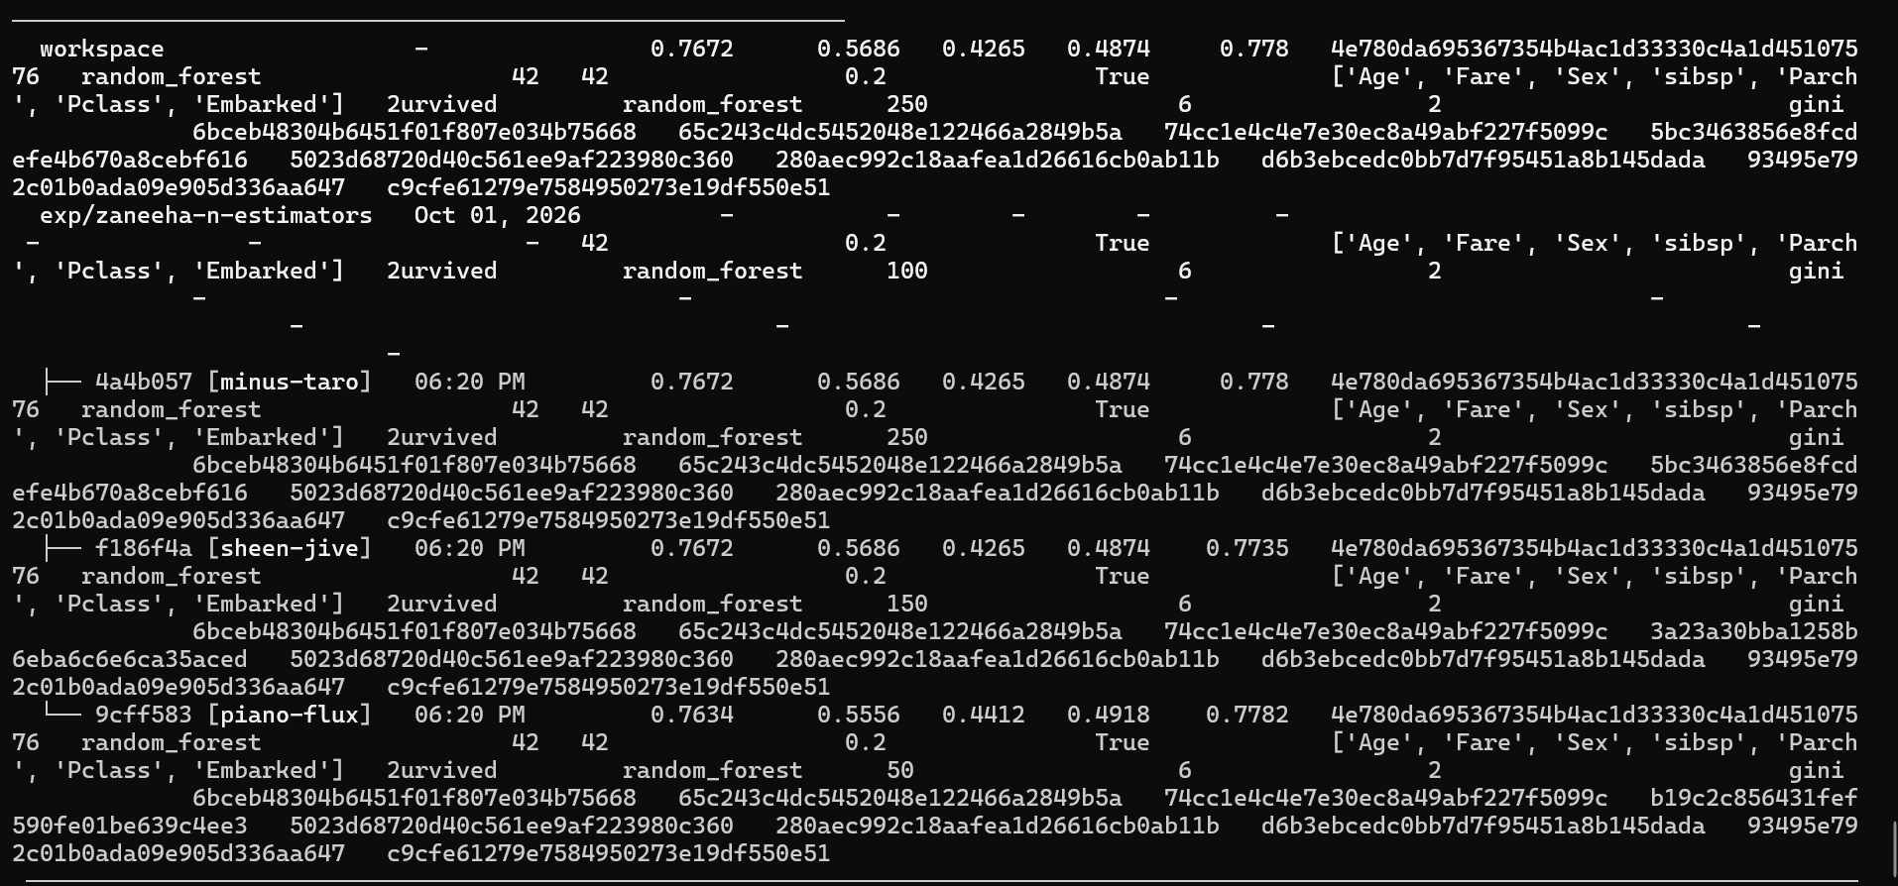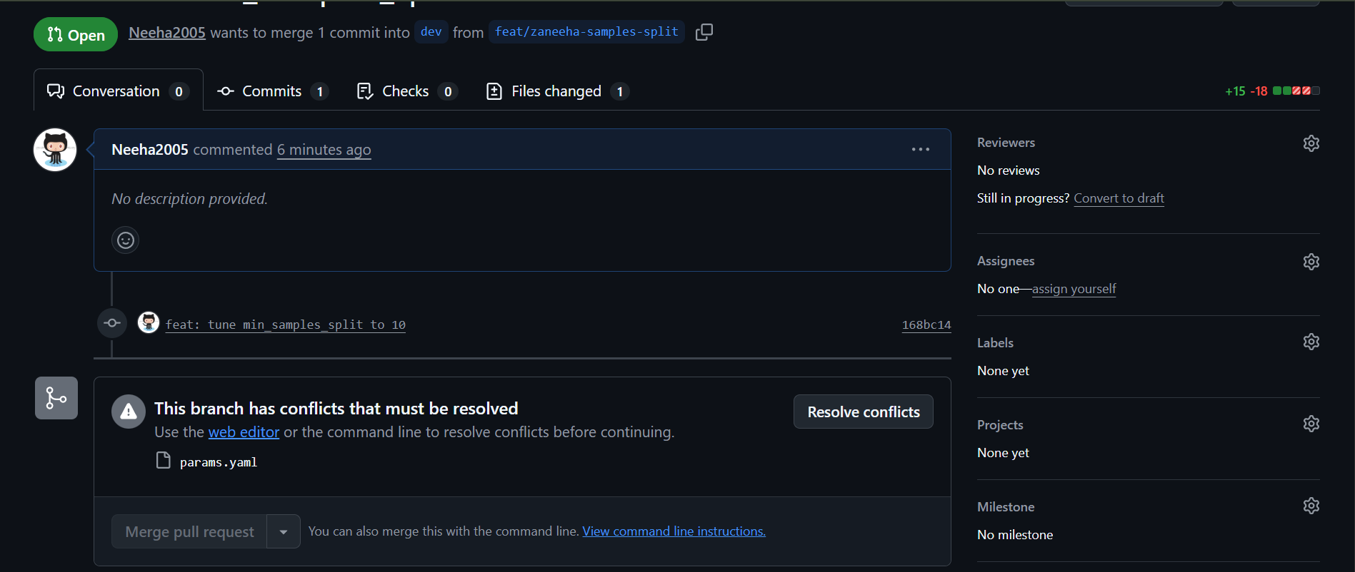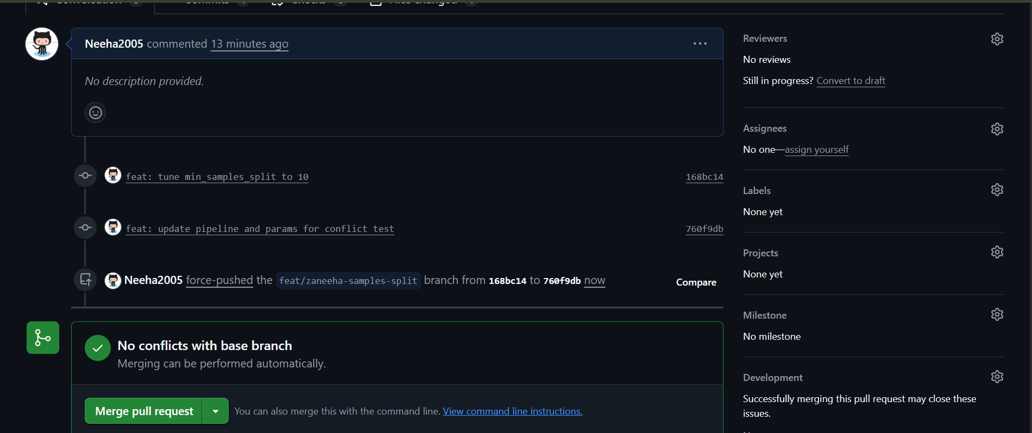

9. Phase 8: Continuous Integration (GitHub Actions)
Added GitHub Actions CI workflow in .github/workflows/ci.yml running on PRs into dev, staging, and main. Automated Ruff linting, Pytest unit tests, Data schema/null checks, and Smoke Training.
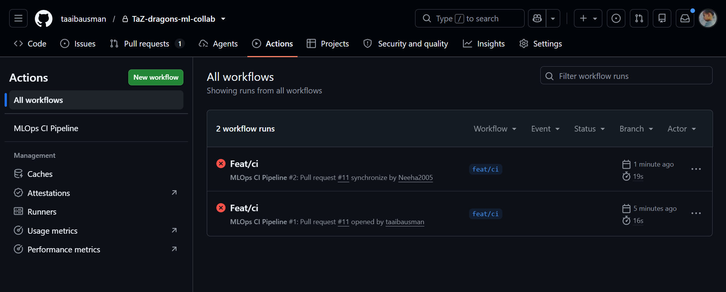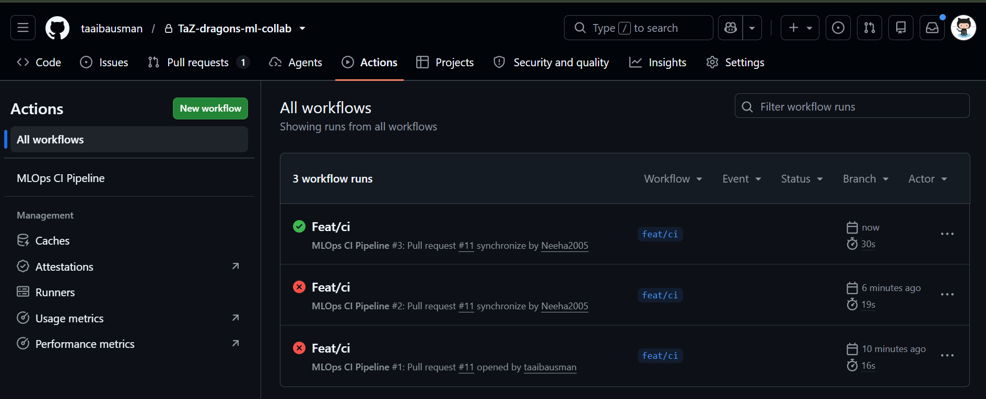

10. Phase 9: Production Release & Tagging
Promoted dev -> staging -> main. Performed independent reproducibility verification with 'dvc pull && dvc repro' yielding identical metrics. Tagged production model release 'model-v1.0' on main.
Metric / Artifact Parameter | Empirical Value
Release Tag | model-v1.0
Production Commit SHA | 5faae18
Data DVC Hash | 74cc1e4c4e7e30ec8a49abf227f5099c
Random Seed | 42
Final Accuracy | 0.7672
Final F1 Score | 0.4959
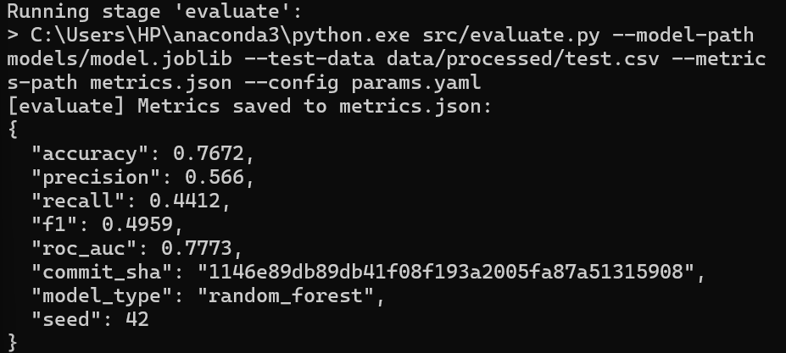
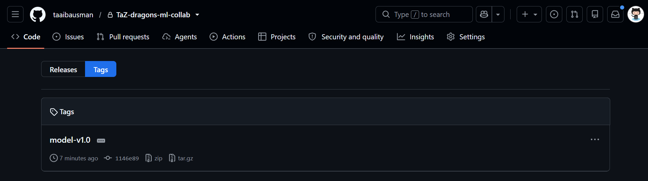

11. Retrospective & Member Contributions

Team Retrospective
1. What Broke: Initial pre-commit execution encountered Windows AppLocker policy restrictions on virtual environment binary scripts, which was resolved by invoking modules via 'python -m dvc'. Concurrent hyperparameter tuning on params.yaml required manual merge conflict resolution via git rebase dev.
2. What We Standardized: Strict Conventional Commits standard across all branches, 3-stage DVC pipeline DAG, and mandatory GitHub Actions CI checks on all pull requests.

Individual Member Contributions
Zaneeha Afzal (Data & Platform Co-Owner): Configured pre-commit hooks, set up initial DVC dataset versioning, created Jupytext paired EDA notebook, conducted hyperparameter experiment runs on n_estimators, performed conflict resolution via git rebase, and verified independent end-to-end pipeline reproducibility.
Taaiba Usman (Model & Platform Co-Owner): Designed model training pipeline, structured hyperparameter configurations, built GitHub Actions CI workflow (ci.yml), executed hyperparameter tuning experiments on max_depth, managed release candidates, and created production tag model-v1.0.

