**Installation Instructions:**

1. Copy the folder “R Installation” to your C drive or other preferred location. Do not choose a location in “Program Files” as folders in this directory typically need special read/write permissions that the software does not have.
2. Navigate to the RStudio.exe executable, which can be found in the …\R Installation\RStudio-0.99.467\bin folder.
3. Open RStudio. You will be prompted to select your computer’s preferred installation of R. Select the “Choose a specific version of R” radio button and then click on the “Browse” button.

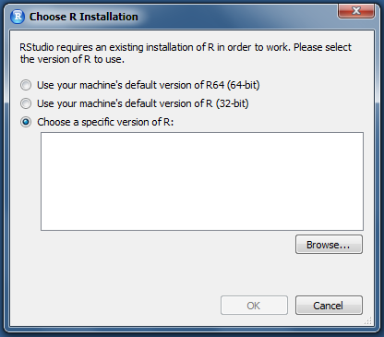

1. Navigate to the following folder in the R Installation directory: …\R Installation\R\R-3.2.0\bin\x64. Once you have navigated to the folder, select it by clicking “Select Folder”.

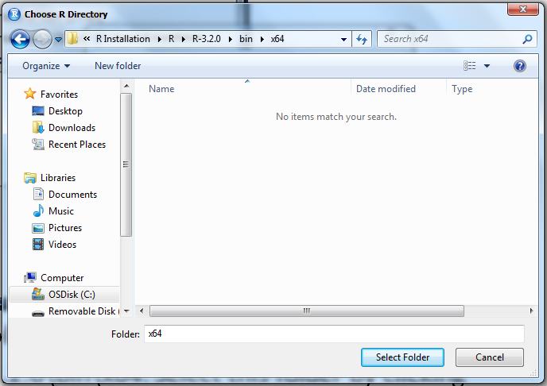

1. You should now see a file listed in the dialog box for the 64 bit version of R. Confirm this selection by clicking “OK”.

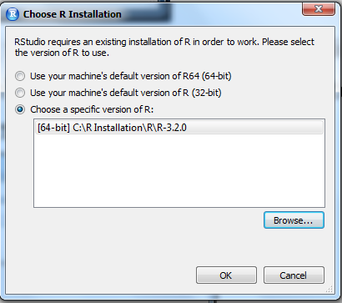

1. RStudio should now open. Once it is open, select “Open Project” from the File dropdown menu. Navigate to the directory …\R Installation\JournalVis x.x then select the JournalVis.Rproj file and open it.

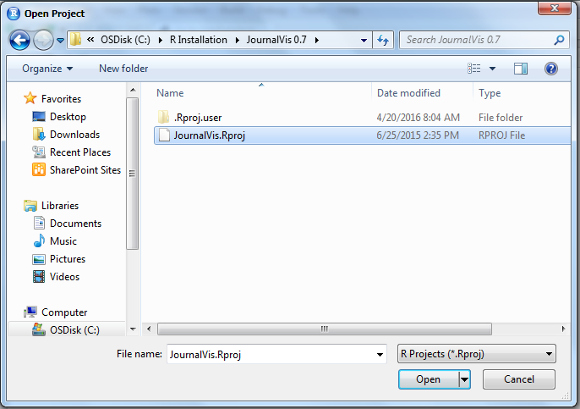

1. The application files will now be displayed in the bottom right corner of the RStudio window. Click on the hyperlinked filename of the file named “ui.R”. This will open the file and display it in the main window on the left side of Rstudio.

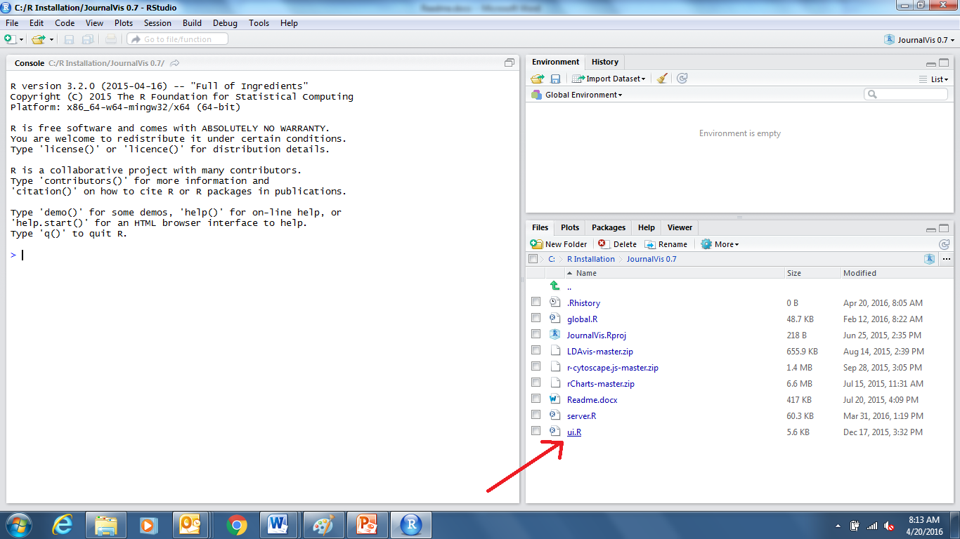

**Usage instructions:**

1. Open RStudio. If the JournalVis project is not open, follow steps 6 and 7 from the installation instructions above to open the JournalVis project and prepare the application for use.
2. Start the application by clicking on the green “Run App” arrow in the middle of the top of the screen. The application will now be launched in the RStudio browser.

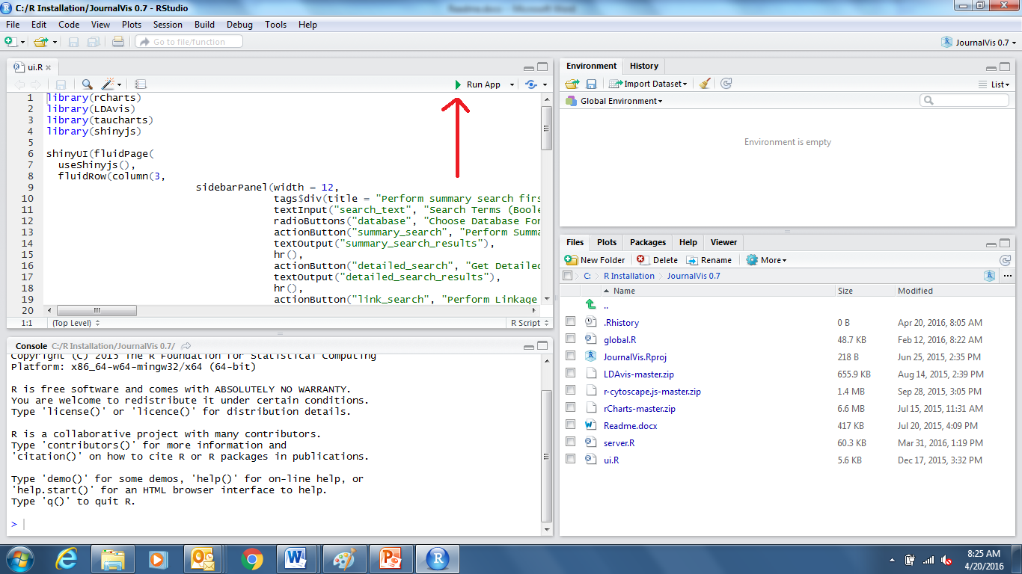

1. The application window will now open and initialize. If you would like to enable zooming on the article map, click on the “Open in Browser” button at the top-left corner of the application window. This will open the application in your most recently used browser. Please note that Internet Explorer is not fully supported. Firefox and Chrome are both compatible.

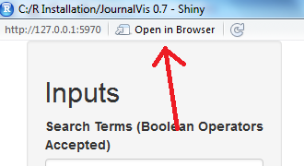

1. Perform the article search as shown below. All databases except for pubmed are in experimental states but should be functional. Please note that the OPS database patent search uses a special syntax which can be found here: <http://www.epo.org/searching-for-patents/technical/espacenet/ops.html#tab3> under the OPS version 3.1 documentation download.

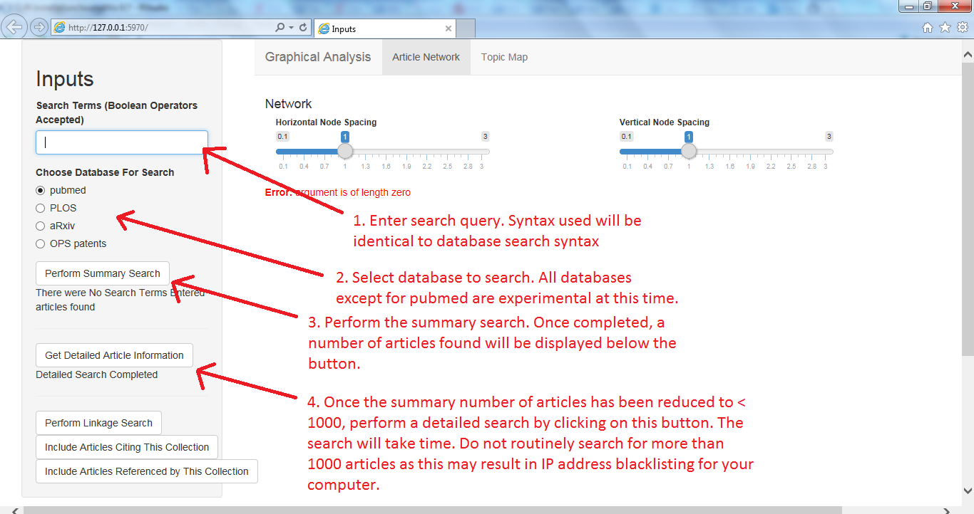

1. Explore the results:
   1. The resulting network shows the articles arranged by year on the vertical axis, sized by number of citations, and linked by references. The network can be rescaled as appropriate by using the sliders at the top of the page.

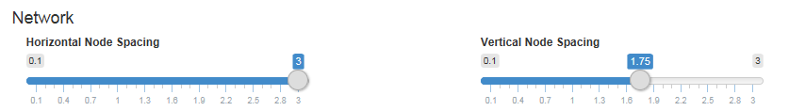

* 1. Hover your cursor over an article to display title, year, and author details. Click on the article to display the abstract. The Document ID is a hyperlink that will open a new browser window or tab that displays the entire article detail on the database’s website:

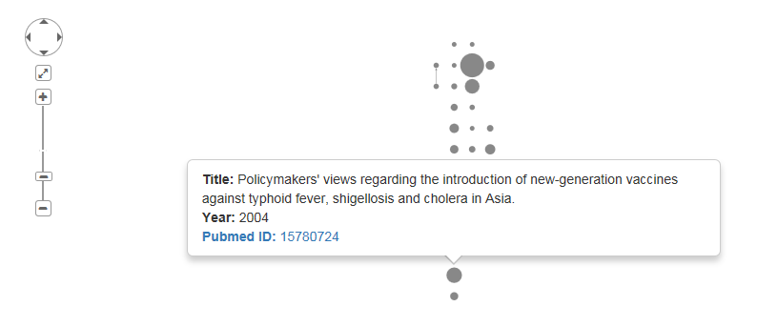

* 1. Select groups of keywords and article types in the summary bar graphs at the bottom of the page to color the nodes based on those attributes. The filter buttons found above the bar graphs allow you to filter the article results to include or exclude the highlighted articles from the article set being analyzed:

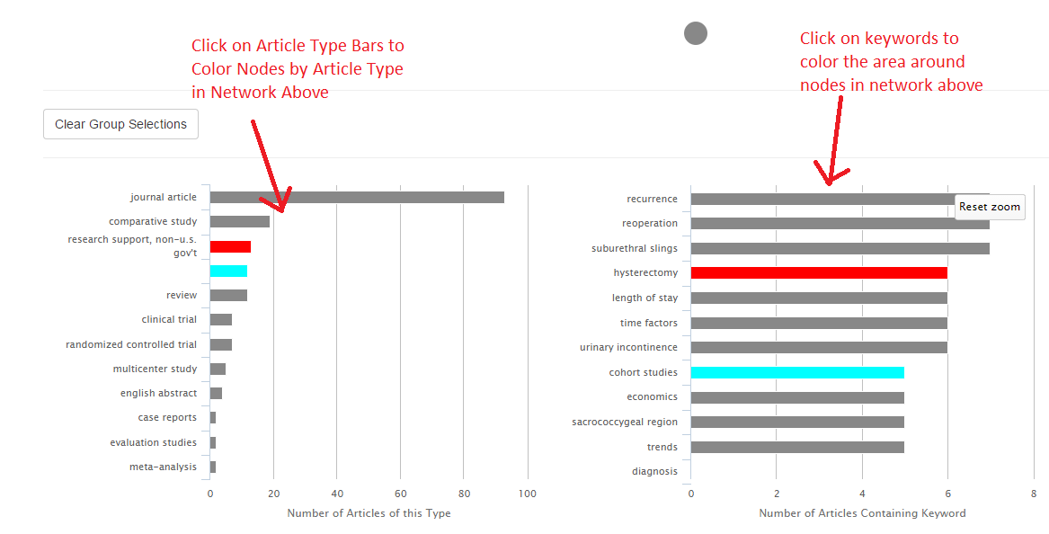

1. Once you have selected and filtered the article list, you can create a topic model of all remaining articles by clicking on the next tab in the analysis window. Once clicked, a topic model will be run. This may take some time so please be patient while the model is constructed:

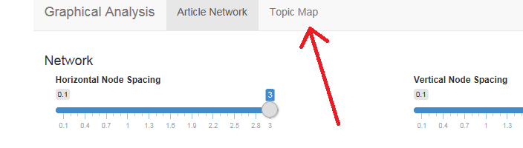

1. The topic model attempts to construct a set of topics that describe the articles being analyzed. For example, a group of articles about cars may have a topic about fuel efficiency and a topic about comfort. Each article may be made up of more than one topic. In the example above, a review of a car will be likely to contain both the topic about comfort and the topic about fuel efficiency. The topic model will appropriately identify complex relationships like these. The information created by the topic model is presented in several different ways:
   1. The topics are projected onto a 2d map in such a way that two topics close to one another on the map are more likely to be related than two topics that are far away from one another. The size of each topic bubble relates to how often the topic is represented in the document collection:

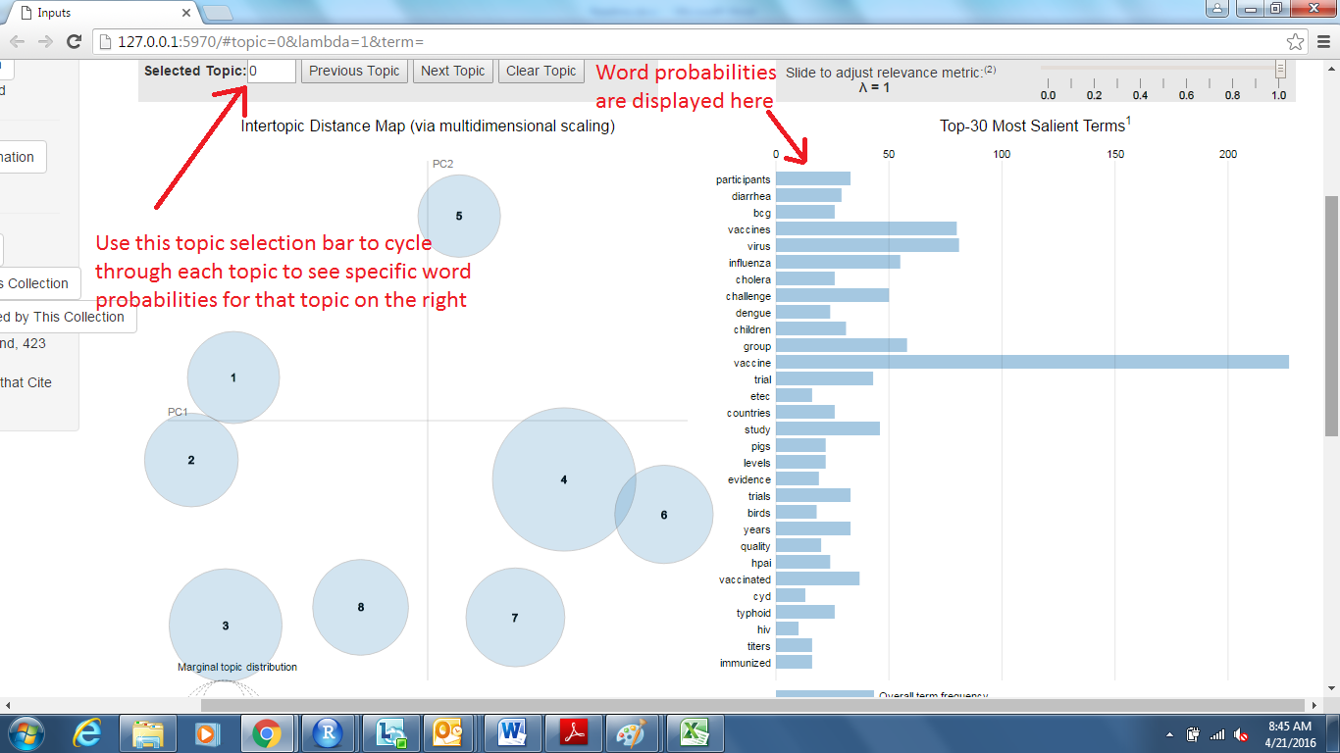

* 1. To examine the topics, use the arrows to cycle through each topic to see the relevant words for that topic on the right hand side of the page. When a topic is selected, it will turn red and the probability list on the right will change to represent the word probabilities for that topic in red with the overall word probabilities of the entire document set in blue for comparison:

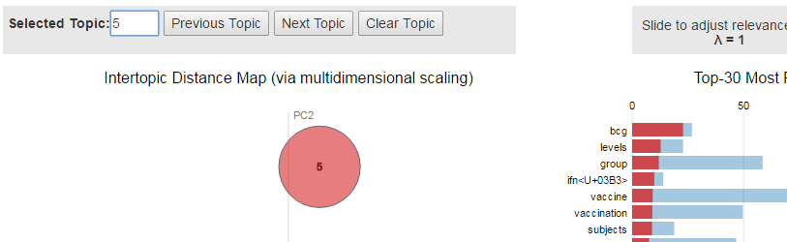

* 1. If you hover the mouse over a word in the word probability list, the topic circles will be resized to reflect the likelihood of that word appearing in each topic. In the example below, the cursor is hovering over the word “mice”, causing the topic map to enlarge topics 4, 6, and 7 to reflect the fact that those topics have a high likelihood of containing that word. The other topics (not pictured) have shrunk down to be nearly invisible since they are very unlikely to contain the word “mice”.

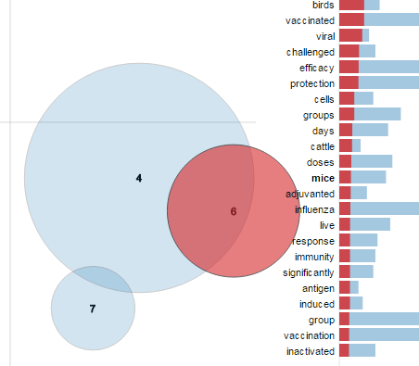

* 1. The topic model also accounts for the fact that probabilities change over time. To see how a topic changes over time, select a topic by clicking on it with the mouse. The topic will be highlighted and a graph will be generated on the bottom of the page to reflect the change in overall probability over time. In the example below, topic 6 is much more likely to appear in documents created after 2010 than in documents created before 2005:

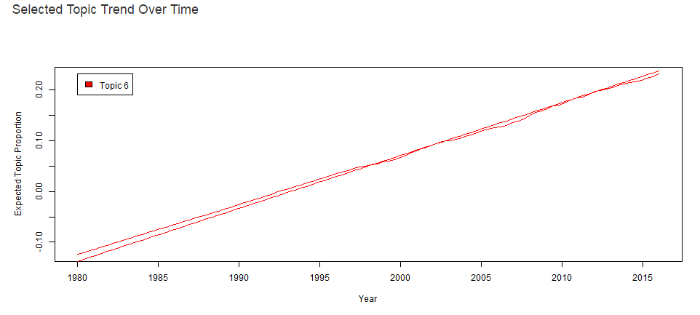

* 1. To find a specific topic, the search function may be used. There is a search field near the top of the page. Enter keywords into the search bar to find a topic that is most likely to contain all of the keywords. In the example below, a search conducted using the terms “dengue fever” identifies topic 3 as the most likely topic for this term with a term probability of 0.33:

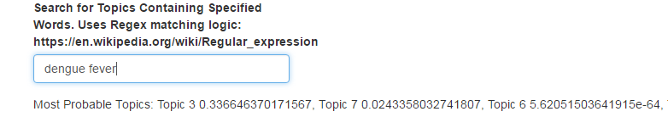

1. Once your topics of interest have been identified. Click on the “Clear Topic Selections” button at the top of the page to clear all topic selections. Then click on the topic or topics that you want to use to filter the documents list. In the example below, topics 1 and 2 have been selected. All selected topics are displayed on the “Selected Topic Trend Over Time” graph on the bottom of the page:

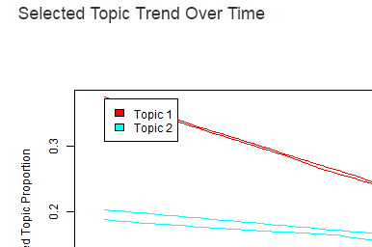

1. Once the topics have been selected, navigate back to the document map by clicking on the “Article Network” tab at the top of the page. Note that you can navigate back and forth between these two tabs at any time once a search has been completed:

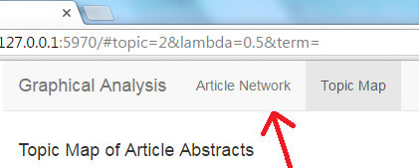

1. The document map presented in step 5, above, is now shown again. However, the map is now filtered using the topics selected on the Topic Map. Documents that are very relevant to the selected topic(s) will be opaque. Documents that are not relevant will be translucent or invisible. Opacity is calculated on a variable scale such that the more opaque a document is, the more relevant it is. In the example below, we see the relevancy of documents based on the earlier selection of topics 1 and 2:

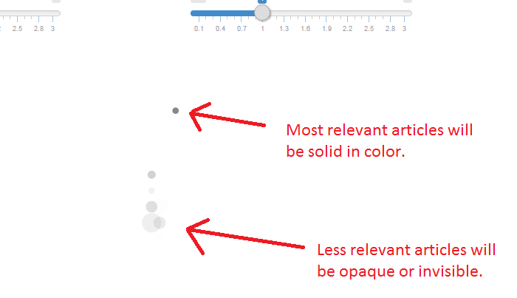

1. To start a new search, select the RStudio browser window and click on the “Open in Browser” button as shown in step 3. You may have multiple searches active at the same time in different browser tabs and all tabs will retain functionality. To close the application, simply close the RStudio browser window.

