Binary Clock
Tom Aarts
Pi4j id:taartspi

Design document describing the LED PCF8575 connections, and the Java implementation that drives the clock.
Note: there are two PCF8575 IC used in this design. This IC is used as it can provide the current flow to directly control the LED. Alternative IC like the MCP23017 with less current capability would require a PNP transistor in the circuit.

Table of Contents
Hardware 2
Single LED wiring 2
LED Anode/Cathode 3
LED assignment 4
Overall LED connections 5
PCF8575 Connections 7
Java 9

Hardware

Single LED wiring
The following documents the connections for a single LED

- VDC
+3.3 VDC
MCP23017
+5 VDC
C
E
B
1500 ohm
330 ohm
LED

LED Anode/Cathode

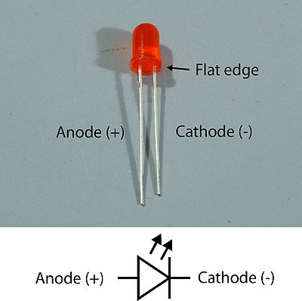

LED assignment

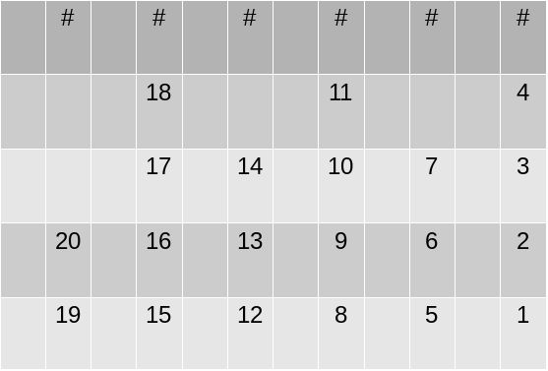
---- Hours ----
--- Minutes ---
--- Seconds ---

Overall LED connections
Higher level view of the twenty LED connections
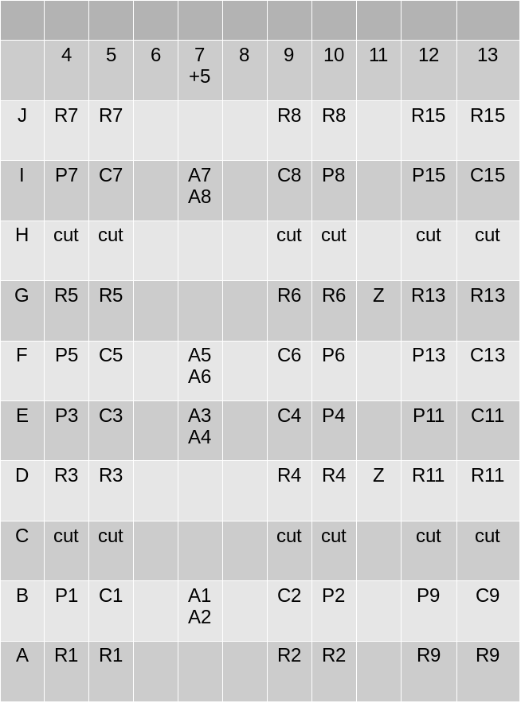
A anode, C cathode, R resistor, P post, Z colon
.
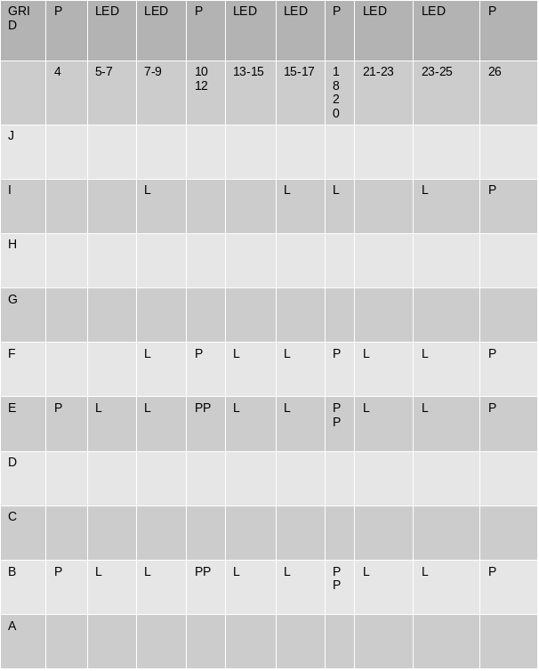
Chart list columns for each LED pair and column of the interconnect pin.
L LED, P interconnect pin.

PCF8575 Connections
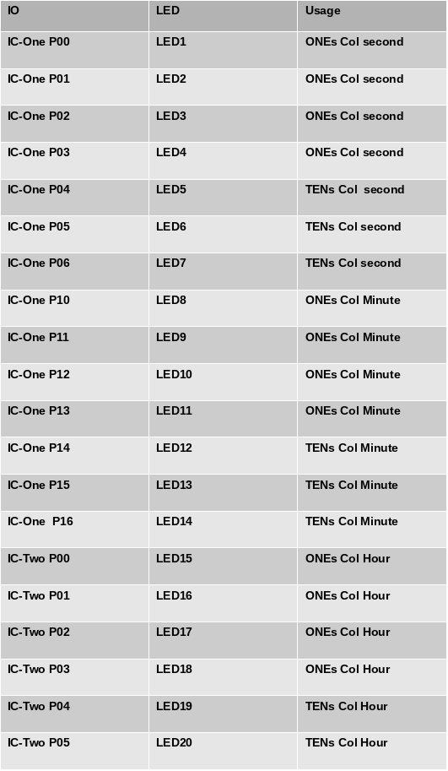
PCF8575 Pin to LED

Java
See project https://github.com/taartspi/pi4j-device-tca9548
Source: src/main/java/com/pi4j/devices/binaryClock/BinaryClock.java

