CT Image Annotation Tool

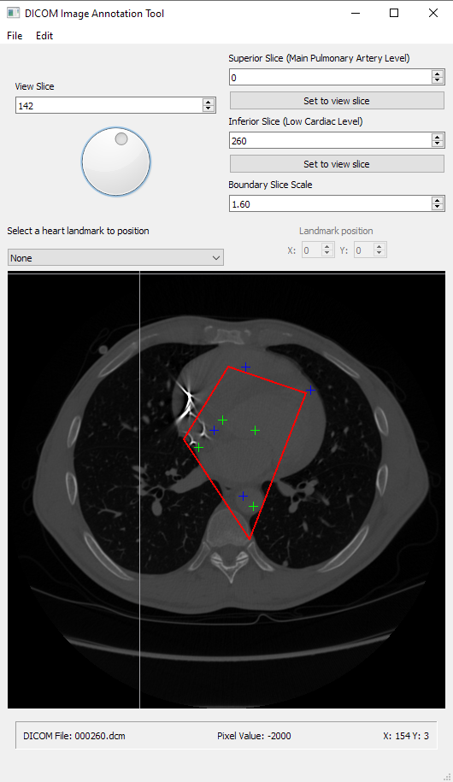

Table of Contents

Introduction and How To Run 3

1. Opening Data 3

1.1 Opening a DICOM Folder 3

1.2 Importing Existing Annotation Files 4

2. Browsing CT Images 4

2.1 Changing the View Slice 4

2.2 View Slice Markers and Data 5

3. Annotating CT Images 6

3.1 General Concepts 6

3.2 Setting Superior & Inferior Slices 7

3.3 Positioning Heart Landmarks 8

3.4 Scaling Slice Crop Boundaries 9

3.6 Exporting Annotation Files 9

4. Batch Operations & 3D Arrays 10

4.1 Batch Exporting and Normalizing 3D Arrays 10

4.2 Batch Masking 3D Arrays 11

# Introduction and How To Run

The CT Image Annotation Tool provides an interface to annotate axial cross sectional CT images stored in the DICOM data format with key heart landmarks, and to then export those annotations as files. It also provides an interface to then read directories of annotation files and batch export the annotation files to normalized 3D NumPy array files for use in a convolutional neural network (CNN) machine learning system. The tool provides a variety of ways to annotate images along with helpful data that enables the user to make more informed annotation decisions.

The annotation tool is run by executing the **CTImageAnnotationTool.py** Python code file in the project directory. Keep in mind this requires all dependency packages for the project, including *but not limited to* PyQt5, NumPy, OpenCV, Matplotlib, and SciKit.

# 1. Opening Data

## 1.1 Opening a DICOM Folder

In order to start annotating a CT Image, you first need to select a directory of cross sectional DICOM files to read data from. To do this, click the **Select Image Directory** button in the **File** menu.

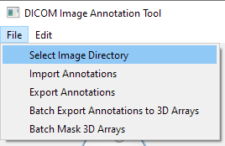

This will open a file dialog prompting you to select a directory to read DICOM data from.

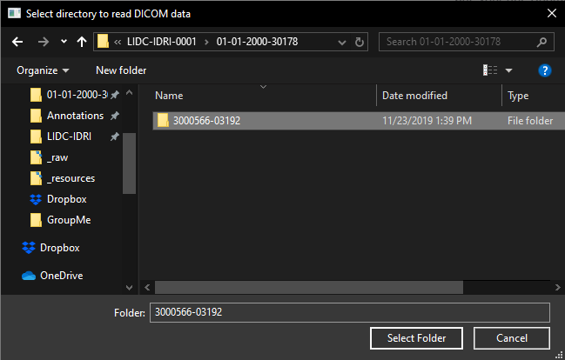

When you have selected a directory, click Select Folder, and if the directory contains more than one cross sectional DICOM file, you will see the a view slice image appear in the annotation tool UI indicating that a cross sectional image has been loaded with default annotations from the DICOM files read from the directory you selected. If the required DICOM data is not in the directory, an error popup will appear.

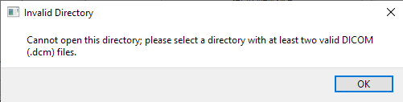

## 1.2 Importing Existing Annotation Files

If you already have exported annotation files, you can import them using the **Import Annotations** button in the **File** menu.

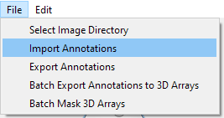

This will attempt to load a cross sectional image from the directory path stored in the annotation file with the annotations specified in the same file. Keep in mind that for this to work, you must have the appropriate DICOM data in a directory at the absolute path specified in the annotation file you are trying to open; be careful with loading annotation files created on other machines.

# 2. Browsing CT Images

## 2.1 Changing the View Slice

When a cross sectional CT image has been loaded, either by opening a DICOM folder or importing an existing annotation file, the first (topmost) slice in the cross sectional image will be shown as the view slice preview image, along with information for that slice in the view slice data widget below the view slice image.

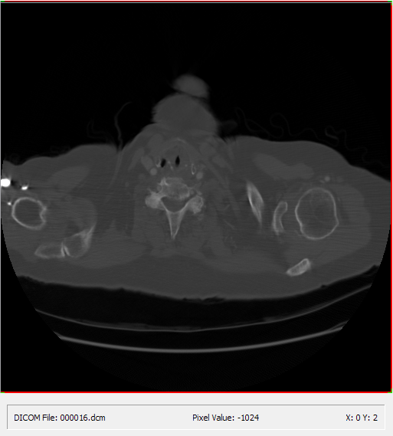

You can change the view slice using three different methods:

1. Change the value of the spin box in the **View Slice** tool widget (shown below)
2. Adjust the dial in the **View Slice** tool widget (shown below)
3. With your mouse cursor on the view slice preview image itself, scroll your mouse wheel

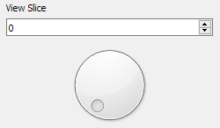

## 2.2 View Slice Markers and Data

There are several markers and labels shown on the view slice preview image and in the view slice data widget that all provide crucial information about the current user annotations and view slice. These are labeled in the diagram below.

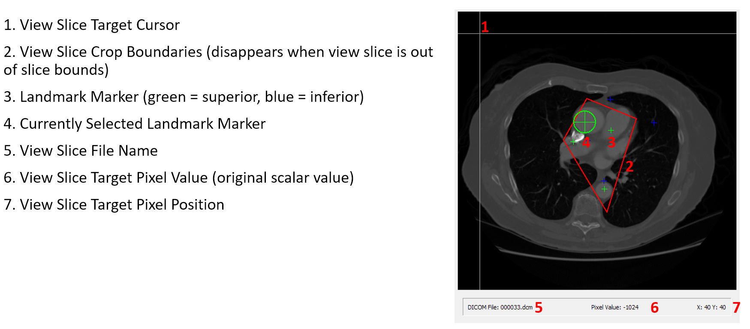

The View Slice Target cursor replaces your standard mouse cursor when you are dragging your mouse over the view slice preview image. It provides a more useful visualization for landmark placement than a basic mouse cursor.

The View Slice Crop Boundaries box shows you the slice crop boundaries for the current view slice. If the current view slice is out of bounds of the crop boundary slices (above the superior slice or below the inferior slice), this box will not appear.

The Landmark Markers show heart landmarks that aren’t currently selected for placement. Superior landmarks are marked green, and inferior landmarks are marked blue (heart landmarks and superior vs. inferior are discussed more in Section 3).

The Currently Selected Landmark Marker looks like a Landmark Marker but is larger and has a circle around it. It indicates the currently selected heart landmark for positioning. If no heart landmark is selected for positioning, no landmark will have this marker. This marker takes on the color that the landmark would have with a normal Landmark Marker (green for superior, blue for inferior).

The View Slice File Name indicates the file name of the DICOM file stored in the directory from which the cross sectional CT image was read corresponding to the view slice.

The View Slice Target Pixel Value indicates the raw scalar value in the DICOM file for the current slice at the pixel of the view slice preview image that the View Slice Target cursor is over.

The View Slice Target Pixel Position indicates the XY position of the pixel of the view slice preview image that the View Slice Target cursor is over.

# 3. Annotating CT Images

## 3.1 General Concepts

There are eight heart landmarks that need to be set for each cross sectional CT image, four on a superior (top) crop boundary slice, and four on an inferior (bottom) crop boundary slice.

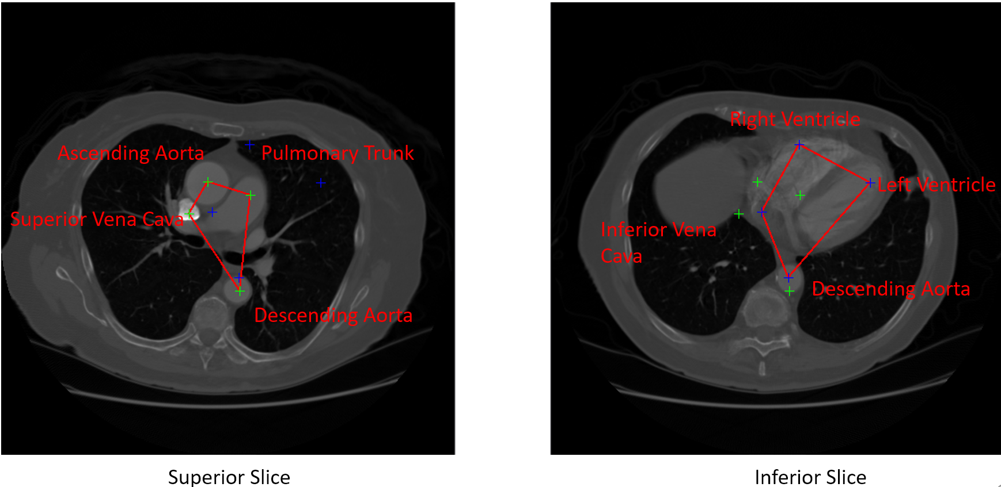

These landmarks define the crop boundaries for each slice; the crop boundaries for slices between the superior and inferior slices are linearly interpolated between the boundaries for superior and inferior slice based on the given slice’s distance from each.

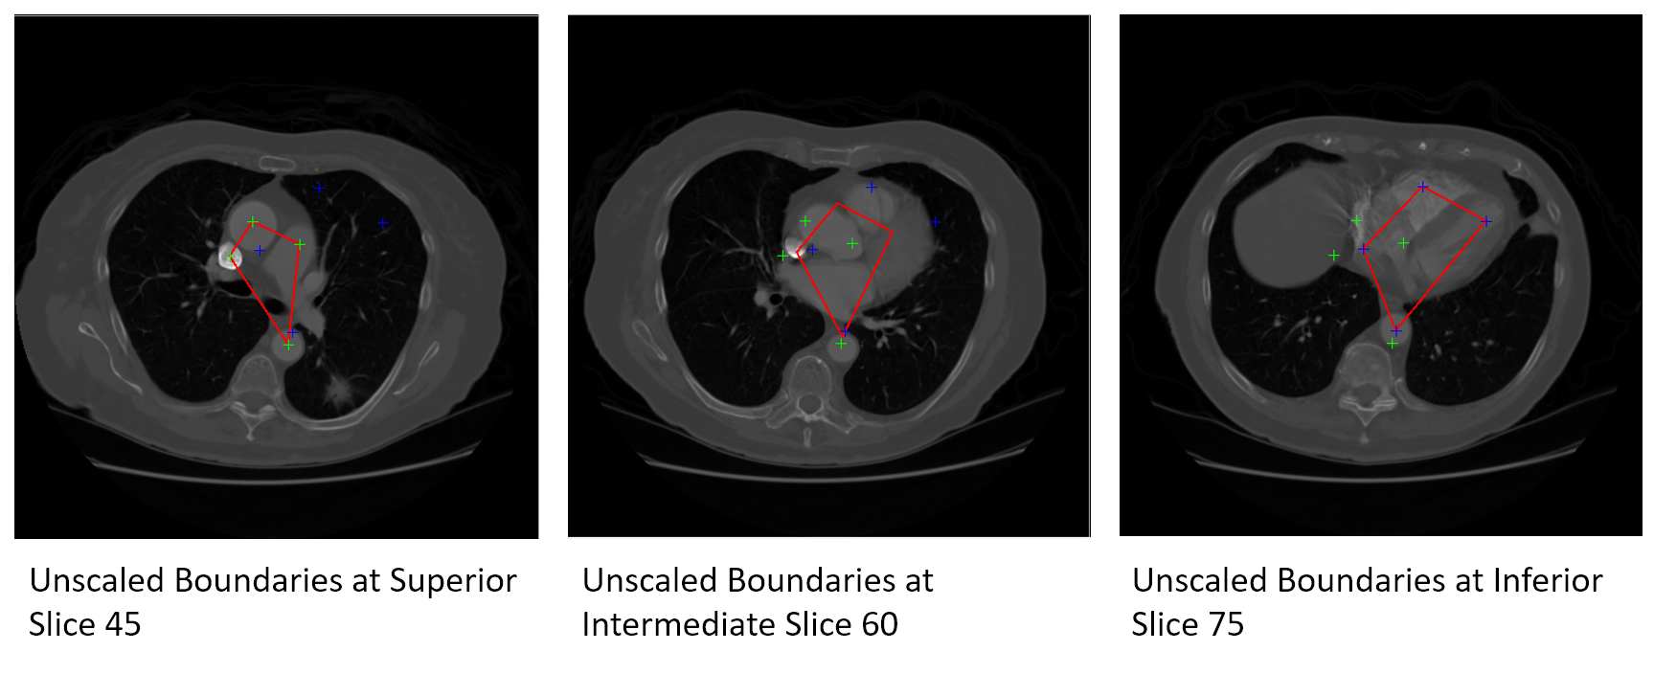

When the cross sectional image is cropped and normalized using the annotations, the part of the cross sectional image that will be left over is the space inside the crop boundaries for each slice between the superior and inferior slice (inclusive).

## 3.2 Setting Superior & Inferior Slices

The superior slice must always be less than the inferior slice, and the inferior slice greater than the superior slice. The superior and inferior slices can be set using two different methods:

1. Directly change the value in the **Superior Slice (Main Pulmonary Artery Level)** and **Inferior Slice (Low Cardiac Level)** spin boxes
2. Press the **Set to view slice** buttons below either spin box to set the respective crop boundary slice to equal the current view slice (this will modify the other crop boundary slice if this is out of bounds)

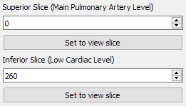

If the slices in the CT Image happen to be in reverse order (this has been observed in some CT images), you can click the **Reverse Slices** button in the **Edit** menu, and this will instantly reverse the slice order in the cross sectional image with no effect on any annotations or other settings.

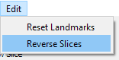

## 3.3 Positioning Heart Landmarks

To select a heart landmark to position, you must choose an item from the **Select a heart landmark to position** combo box.

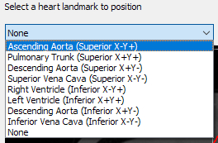

Once you’ve selected a heart landmark, the **Landmark position** widget will be enabled.



Then, you can position the landmark one of two ways:

1. Directly adjust the values in the **Landmark position** widget
2. Click somewhere on the view slice preview image with your left mouse button to set the landmark at the position on the image where you clicked. You can refer to the view slice data widget below the preview image for the precise XY coordinates at your cursor location. Remember you can hold your left mouse button and drag the landmark around as well.

You should be able to see the Currently Selected Landmark marker on the view slice preview image move around as you position the landmark. If the view slice is inside the crop slice boundaries, you should see the View Slice Crop Boundaries box change as well.

If you want to reset your heart landmarks to their default position, you can click the **Reset Landmarks** button in the **Edit** menu.

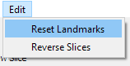

## 3.4 Scaling Slice Crop Boundaries

Often, the slice crop boundaries need to be wider than just the path around the interpolated heart landmark positions. This is because just cropping around the heart landmark positions omits some important arteries. Thus, you must scale the slice crop boundaries up by a scale factor. Using the **Boundary Slice Scale** spin box, you can set a scale factor that scales each slice crop boundary up or down by the scale factor, where 1.0 performs no scaling.

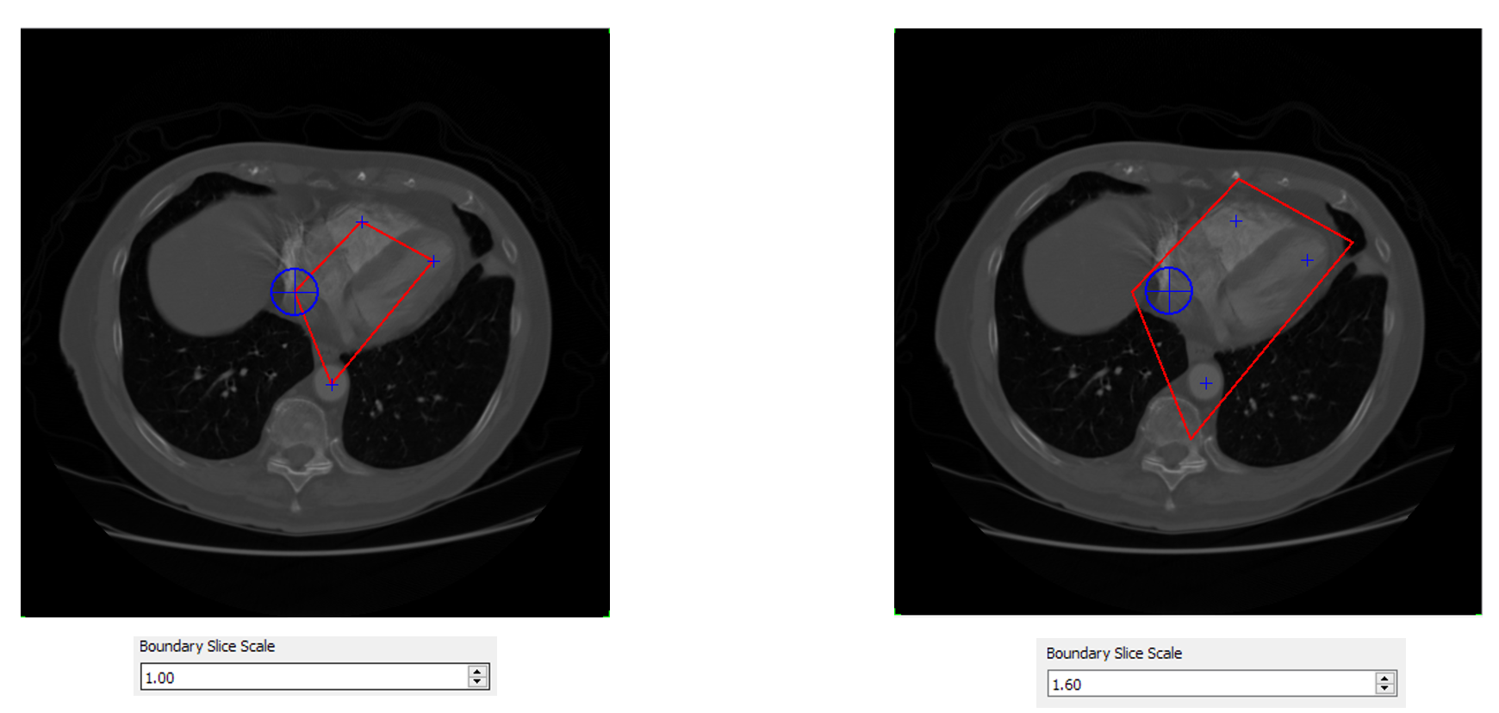

## 3.6 Exporting Annotation Files

Once you’re done annotating a cross sectional CT image, you can export your annotations by clicking the **Export Annotations** button in the **File** menu.

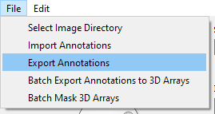

This will open a file dialog prompting you to choose a directory in which to save your annotations. Each annotation file is prefixed with the patient ID for the cross sectional image annotated and has a *.annotations* extension and contains the following data in JSON format:

* The absolute path to the directory containing the DICOM data for the cross sectional CT image
* The superior and inferior slice indices
* The heart landmark positions
* The slice crop boundary scale factor

Keep in mind this means that for an annotation file to be useful, the DICOM files need to be in the same absolute location that they were in when the annotation file was created.

# 4. Batch Operations & 3D Arrays

## 4.1 Batch Exporting and Normalizing 3D Arrays

Once you’ve built up a directory of annotation files, you can then use the annotation tool to batch export normalized 3D array files (in .npy format) from the data in the annotation files. To do this, click the **Batch Export Annotations to 3D Arrays** button in the **File** menu. This will open a file dialog prompting you to select a directory to scan for annotation files (these must have the extension *.annotations*).

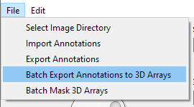

After a directory is selected, for each annotation file found in that directory, two .npy 3D array file will be exported to the same directory, one for affine normalization, and one for projection normalization. The 3D array files will be prefixed with the same patient ID as the annotation file used to create them, and suffixed with _affine and _projection respectively. This process will take a long time, especially with many annotation files (in which case it can take hours). While the UI will lock up during this process, the Python terminal will print helpful statements indicating the progress of the exports.

Each 3D array file will be normalized to have the dimensions 256x256x256 pixels, and will have pixel values converted to Hounsfield units form the original DICOM pixel data. If the 3D array is affine normalized, it will preserve the shape of the original cross sectional image at the expense of black space around the crop bounds for each slice. On the other hand, if the file is projection normalized, all space in the array will contain relevant data in Hounsfield units, but the shape of the image features will be warped from the original cross sectional image. Below are examples of each method for the same cross sectional image slice.

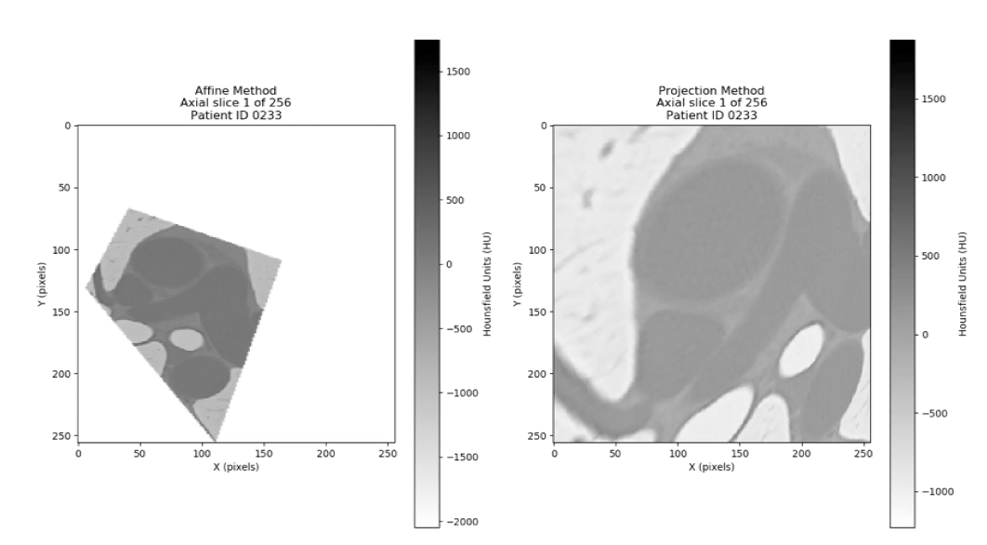

## 4.2 Batch Masking 3D Arrays

After exporting 3D arrays, you may want to mask them for improved machine learning performance. This creates a mask using erosion and dilation for each slice and applies it to the image data for said slice, which enhances heart features while removing unwanted lung features. You can do this by clicking the **Batch Mask 3D Arrays** button in the **File** menu, which will open a file dialog prompting you to select a directory of 3D arrays. For each 3D array file, a new masked array file with a _masked suffix will be created. Like with batch exporting the original 3D arrays from annotation files, this will take a long time, but print statements in the terminal have been added to indicate progress.

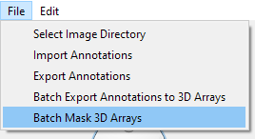

Below is an example of how masking works.

