Team1 Advanced Computer Vision evaluation tutorial in Windows

# First of All

* 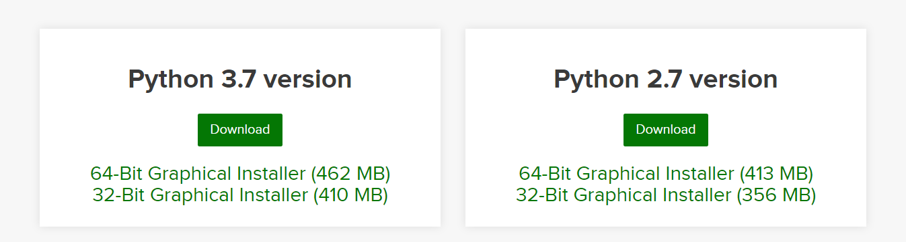Install Anaconda3 (python3.7) <https://www.anaconda.com/distribution/>.
* Create a new folder under a path of your choice and name it Project. (e.g. E:\ Project).
* cd into the Project directory. Clone/Download our github repository <https://drive.google.com/file/d/1CmRXBzu2vuJOLgYvSWH-gTF79YiRhW-h/view?usp=sharing> to the Project folder.
* Extract it’s contents inside the Project folder.
* 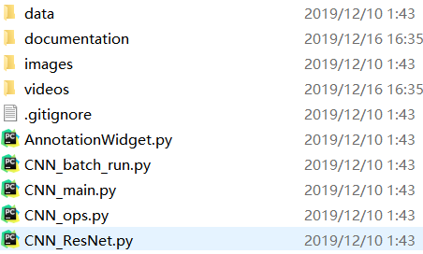You should now have a single folder named ACVProject-master under your Project folder, which contains code and another files as such:

#### Create a new Conda virtual environment (Optional)

* Open a new Anaconda/Command Prompt window
* cd into the ACVProject-master directory.
* Type the following command:

conda create -n Med3D pip python=3.6

* The above will create a new virtual environment with name Med3D
* Now lets activate the newly created virtual environment by running the following in the Anaconda Promt window:

Activate Med3D

* Once you have activated your virtual environment, the name of the environment should be displayed within brackets at the beggining of your cmd path specifier, e.g.:
* Type the following command:

pip install -r requirements_win.txt

pip install keras

* Install Pycharm <https://www.jetbrains.com/pycharm/download/#section=windows>
* 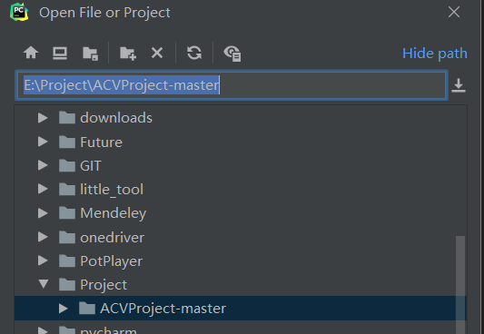Click File=>Open choose ACVProject-master directory.
* 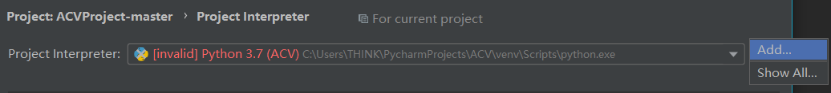Click File=>settings=>Project:ACVProject-master=>Project interpreter=>add
* 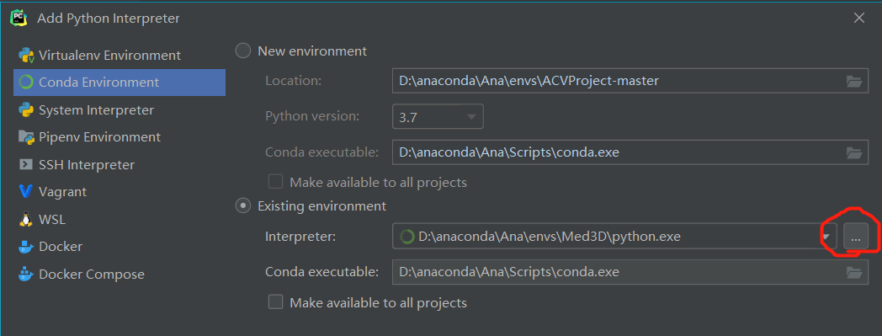Click Conda Environment=>Exsting environment=>…
* 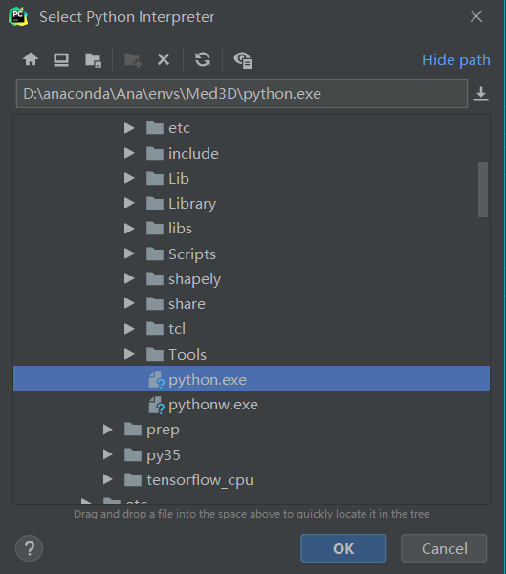Choose path to where you install anaconda\envs\Med3D\python.exe
* Click OK=>OK
* 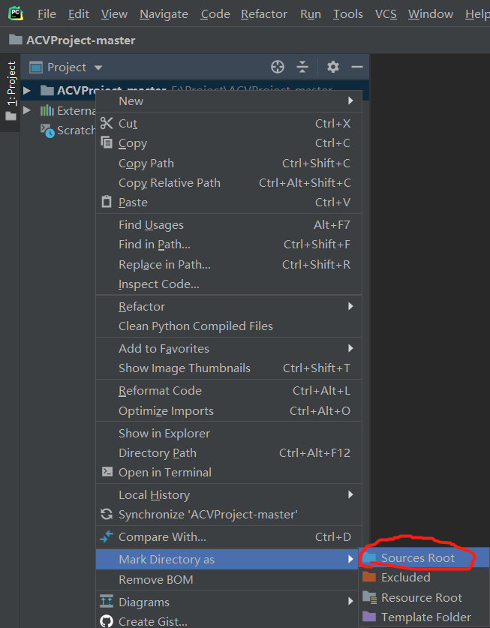Right click ACVProject folder and set it as source folder.
* 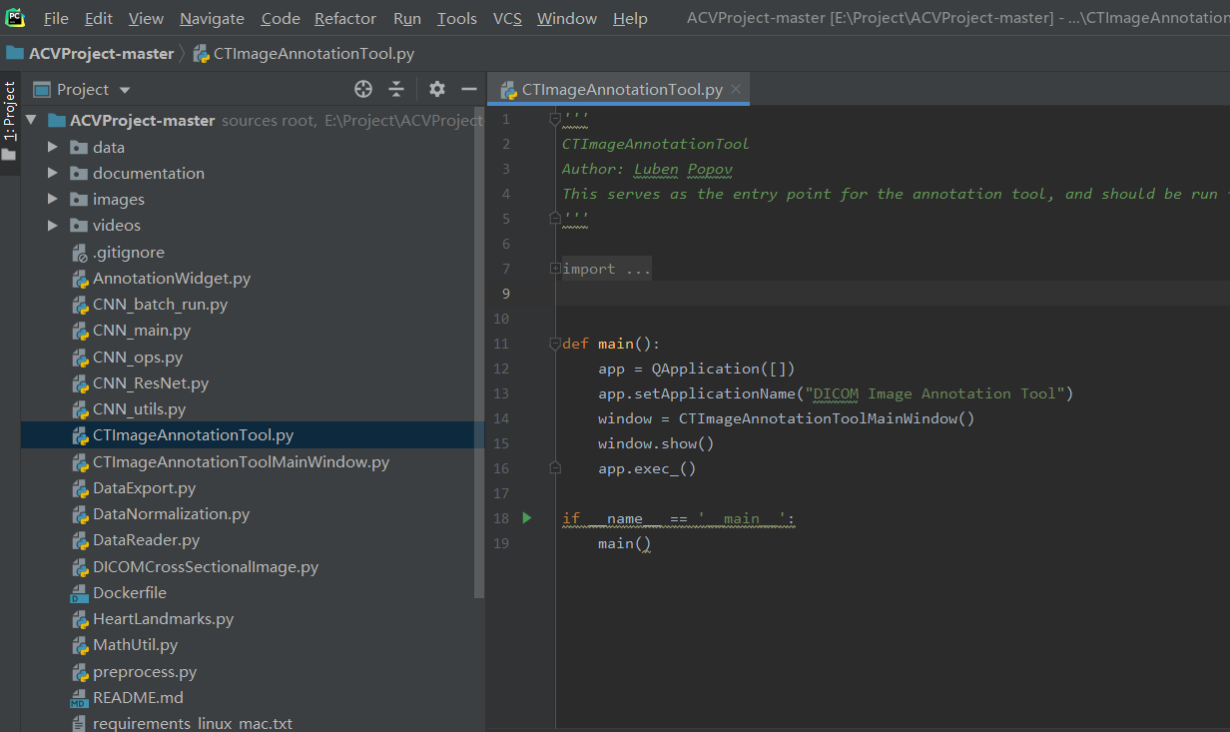Now Open CTImageAnnotationTool.py and run this script with Alt+Shift+F10
* 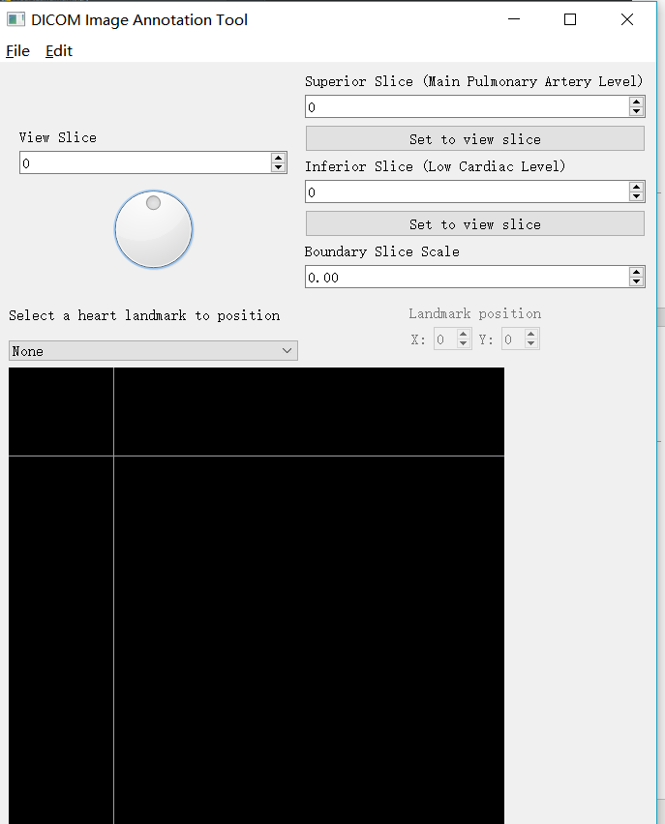Now you should open this annotation tool like below:
* For annotation tool using please check E:\Project\ACVProject-master\documentation\CTImageAnnotationToolManual.pdf
* Download dataset with this google drive link to the E:\Project: <https://uofh-my.sharepoint.com/:f:/g/personal/taburt_cougarnet_uh_edu/EiZNY6eYAINBkJFTpeIjkzYBrS9p03lG64a_DcJW3GPZGw>
* Extract it’s contents inside the E:\Project folder.
* You should now have folder as following:

E:

├─ ACVProject-master

└─ ACV_project_Team1_F19

* For dataset and CNN framework description please check E:\Project\ACVProject-master\documentation\Med3DResNetManual.pdf
* Open a new Anaconda/Command Prompt window
* cd into the ACVProject-master directory.
* Add two line code in the *CNN_utils.py*

Import csv

Import numpy as np

* Change the *CNN_utils.py* 108 line code from

MIN_HU, MAX_HU = update_hu_range(test_image_temp, MIN_HU, MAX_HU)

* To

MIN_HU, MAX_HU = Visualization.update_hu_range(test_image_temp, MIN_HU, MAX_HU)

* Type the following command:

python CNN_main.py --phase train --dataset ACV --res_n 18 --work_path E:/Project/ACV_project_Team1_F19/ --train_test_ratio 70_30 --batch_size 40 --lr 0.1 --data_type projection --n_axial_channels=4 --epoch 25