**AGILE PROJECT SPRINT 2**

**CLINICAL MANAGEMENT SYSTEM**

**WIREFRAMES**

**GROUP 3**

**Due: 09 December, 2018**

**Members**

**Aman, Semir - 101142654**

**Chaudhry, Ayusha - 100968449**

**Naguit, Sir Angel - 101152749**

**Victa, Francis Bertholet - 101159185**

**Yang, Maria Lilian - 101151657**

**Table of Contents**

1. **General Views3**
2. **Receptionist Views** **6**
3. **Doctor Views** **12**
4. **Nurse Views16**
5. **Manager Views** **19**
6. General Views
   1. Login Page

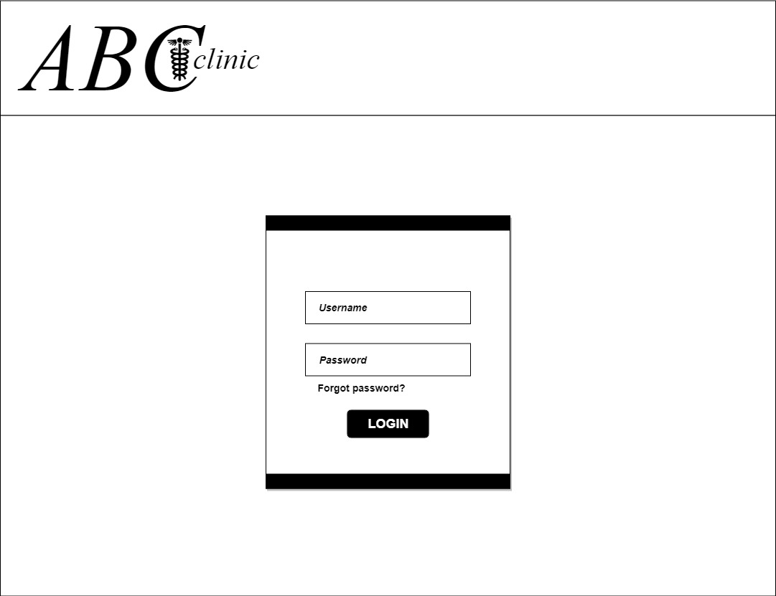

* 1. Messages View

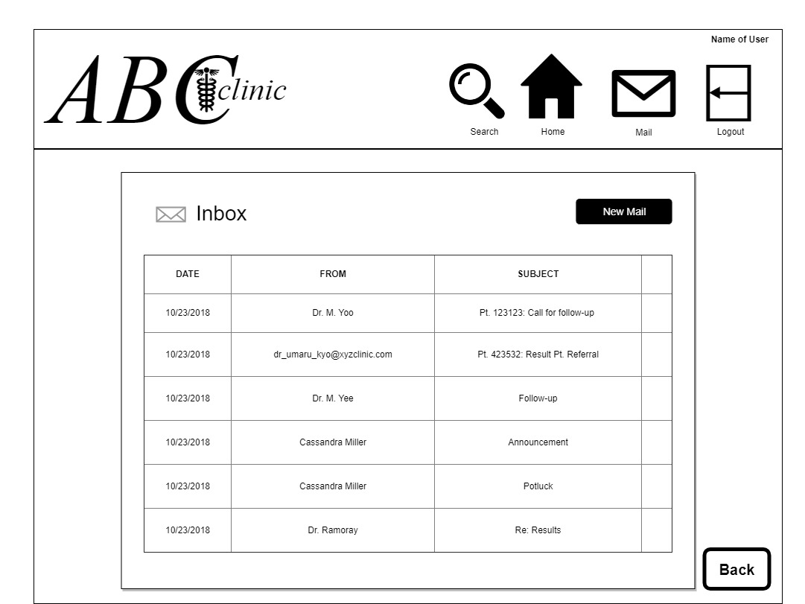

* 1. New Message View

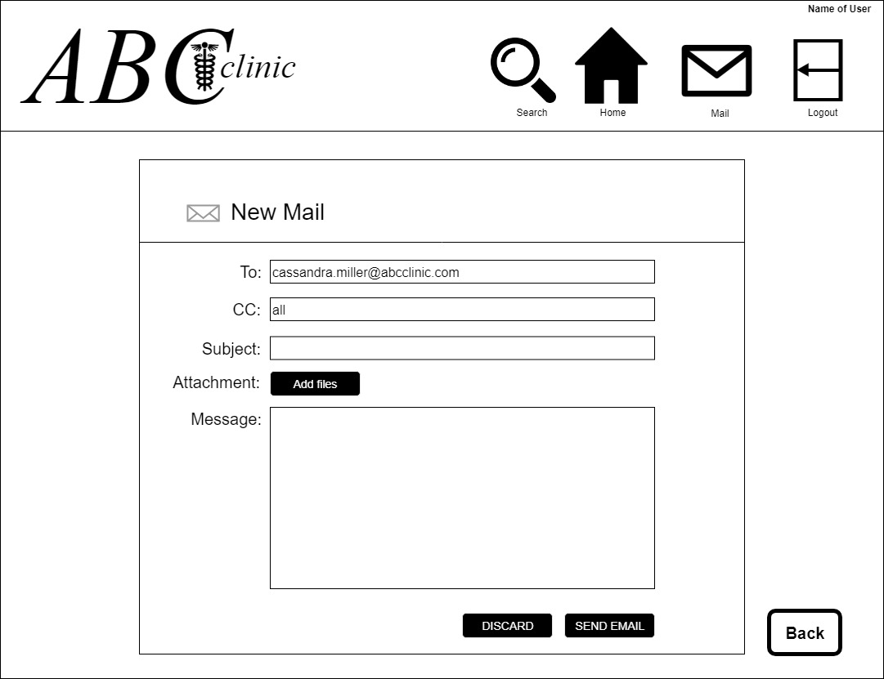

1. Receptionist
   1. Receptionist Search

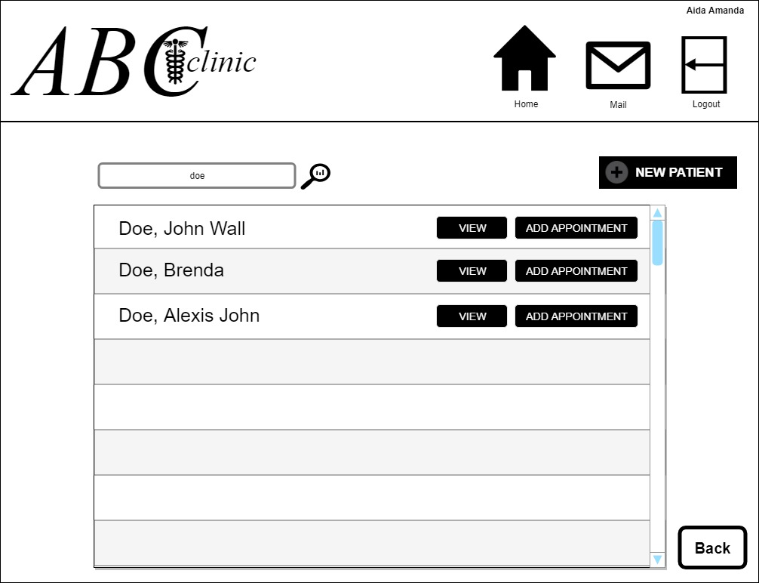

* 1. Receptionist View Patient

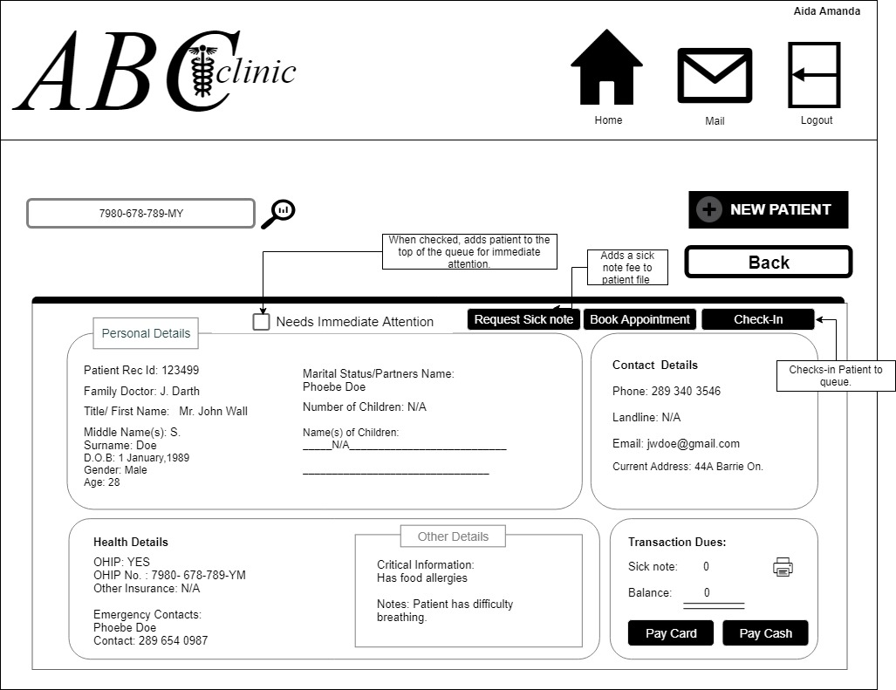

* 1. Receptionist Add New Patient

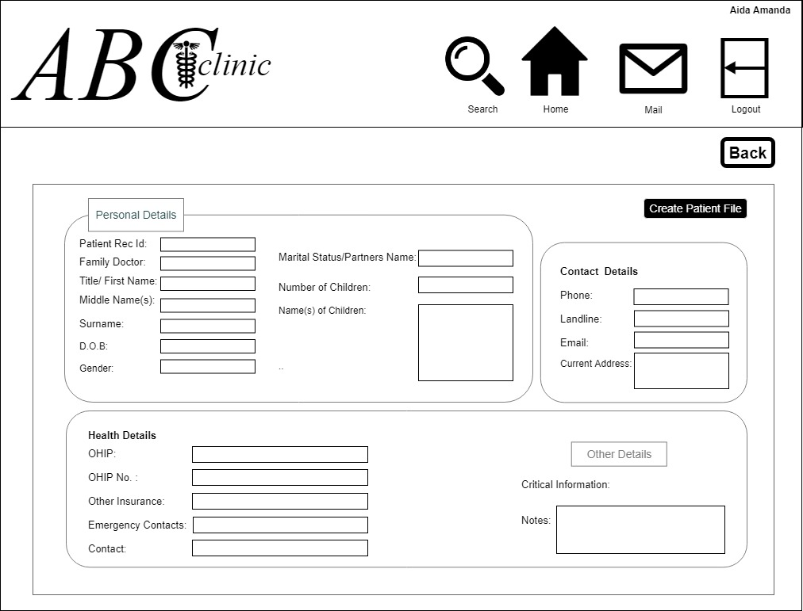

* 1. Receptionist Appointment Page

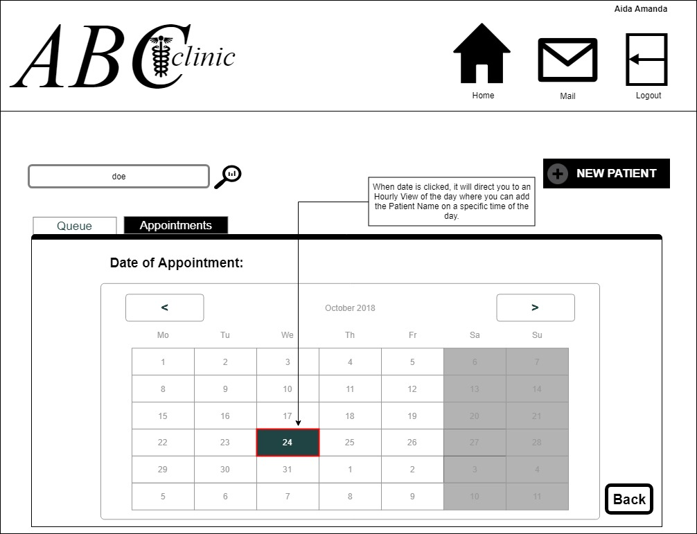

* 1. Receptionist Daily Appointment View

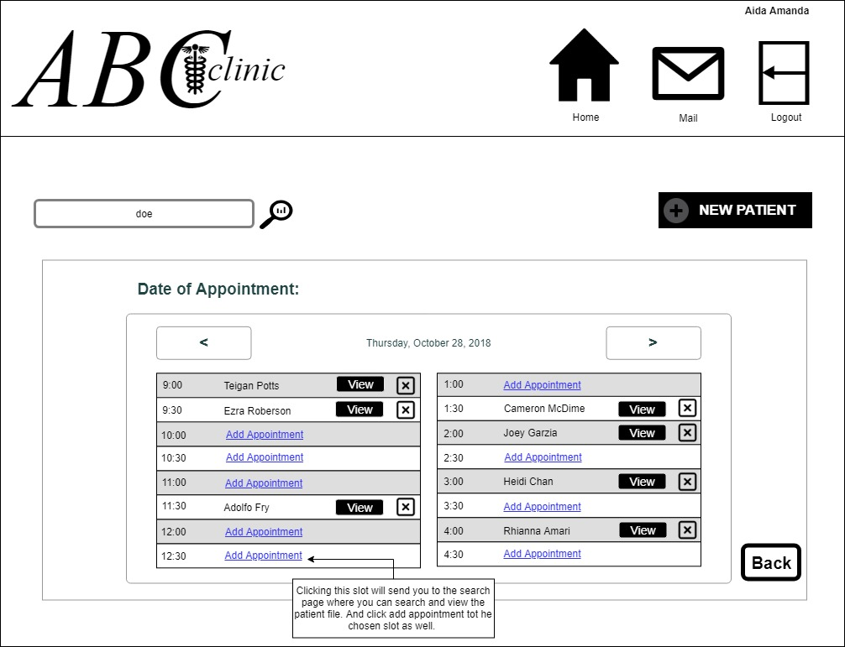

* 1. Receptionist Queue List View

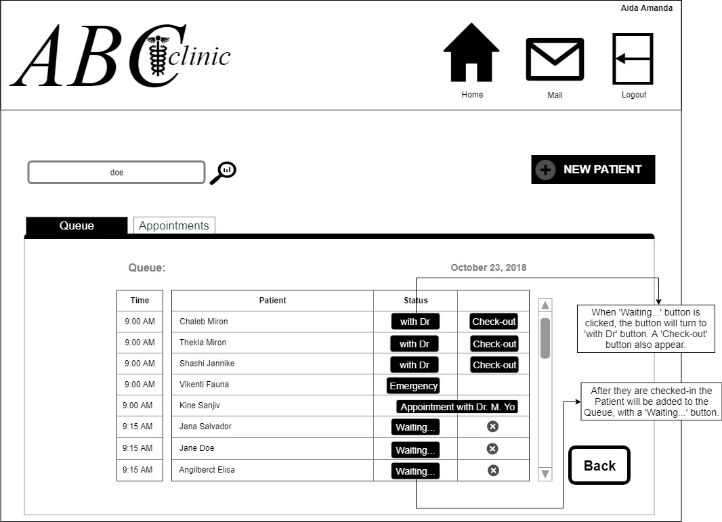

1. Doctor View
   1. View Patient

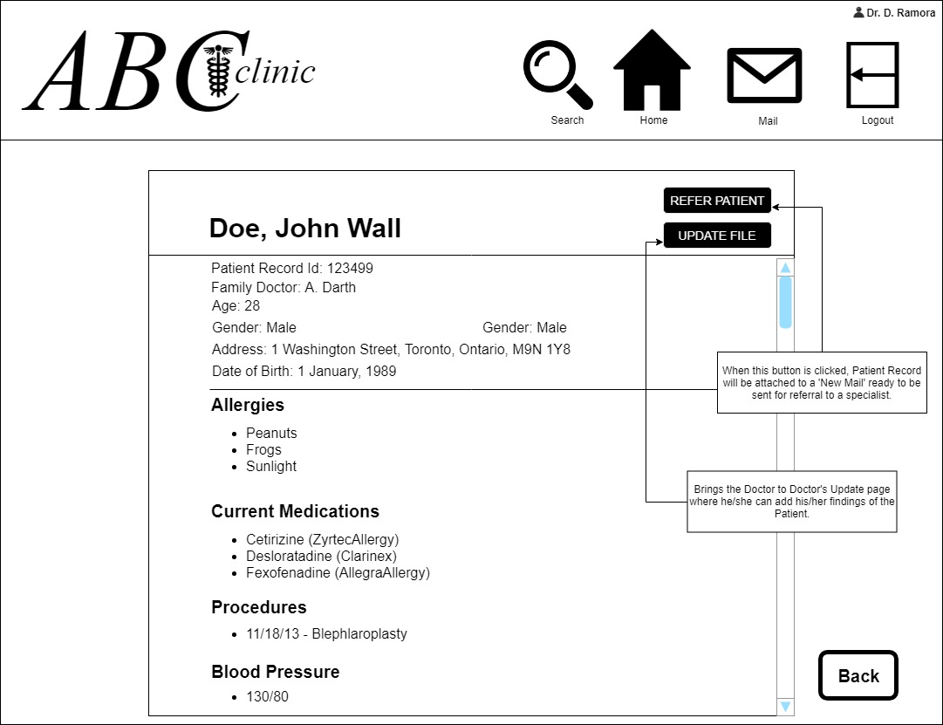

* 1. Refer to Specialist

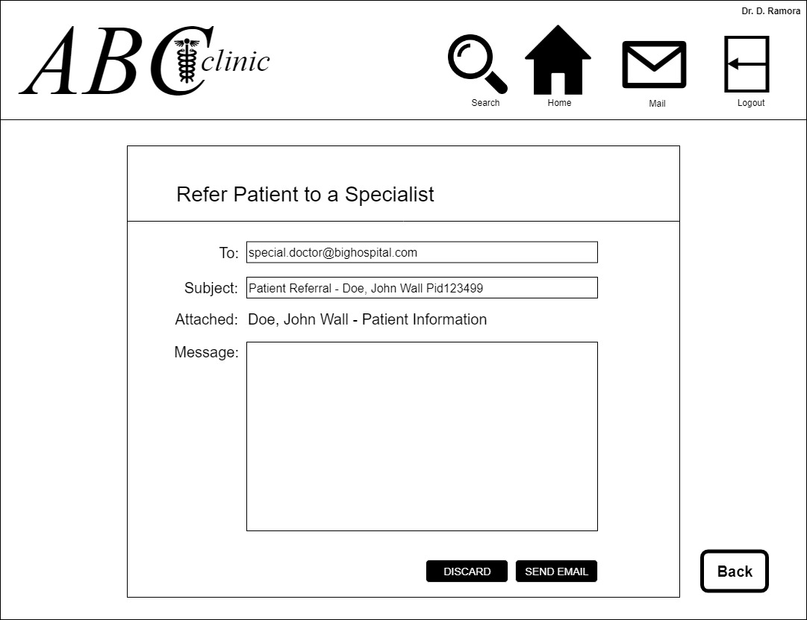

* 1. Search

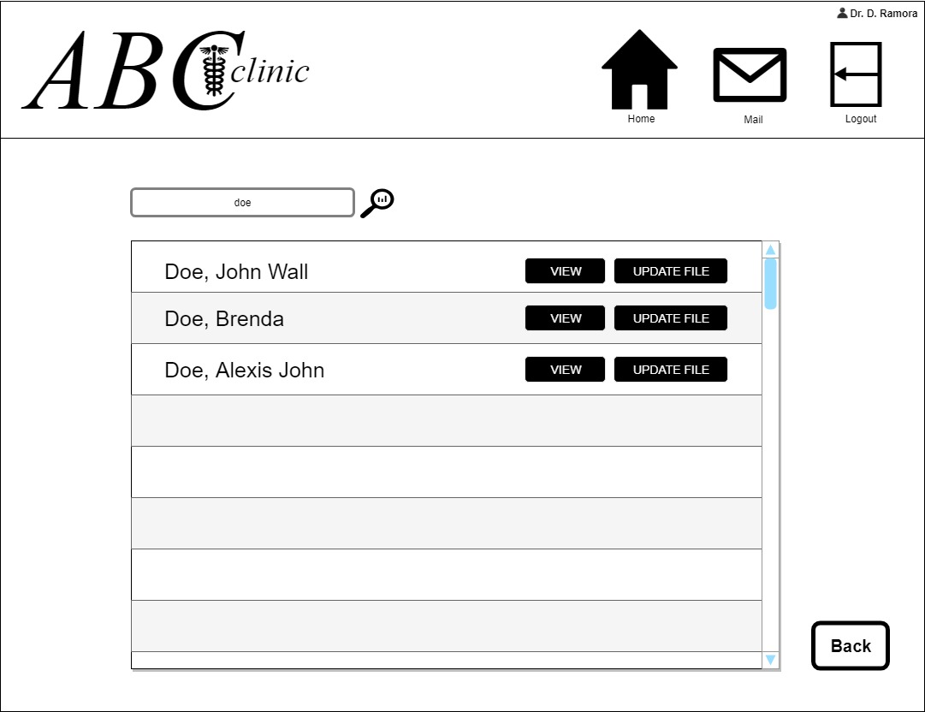

* 1. Update File

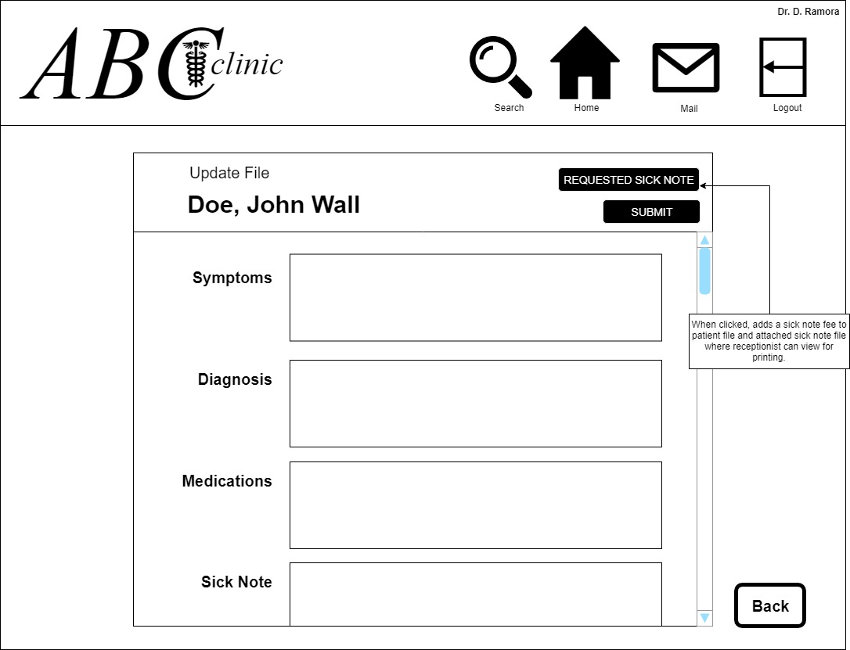

1. Nurse
   1. Search

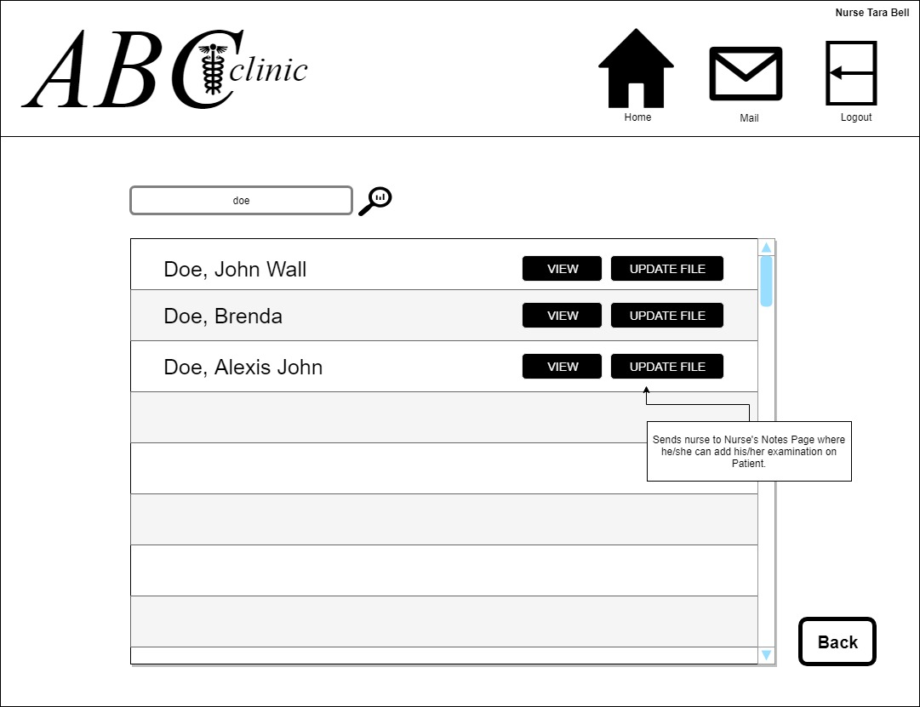

* 1. View Patient

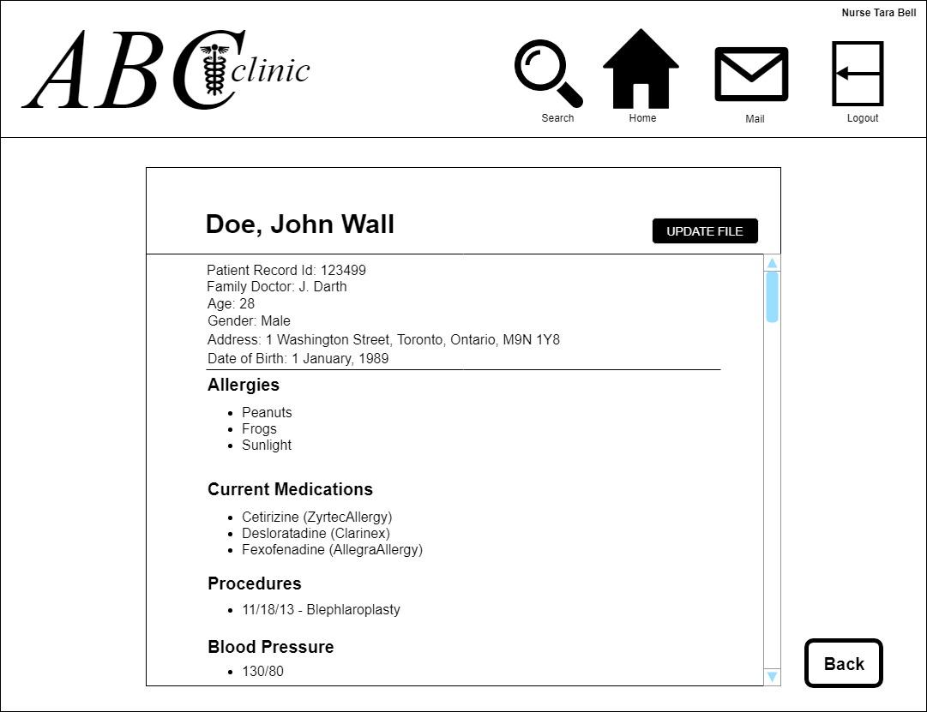

* 1. Update Patient File

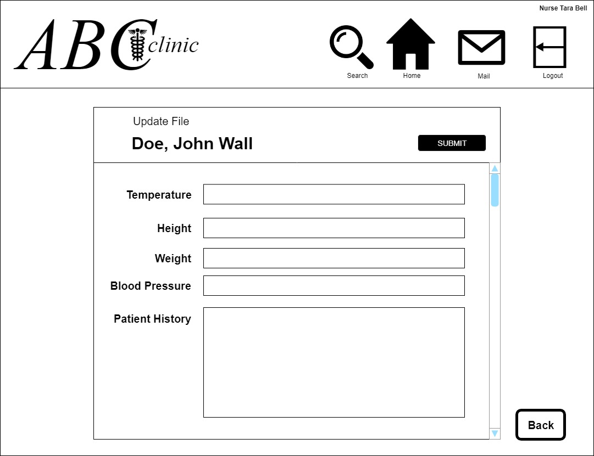

1. Manager
   1. Schedule View

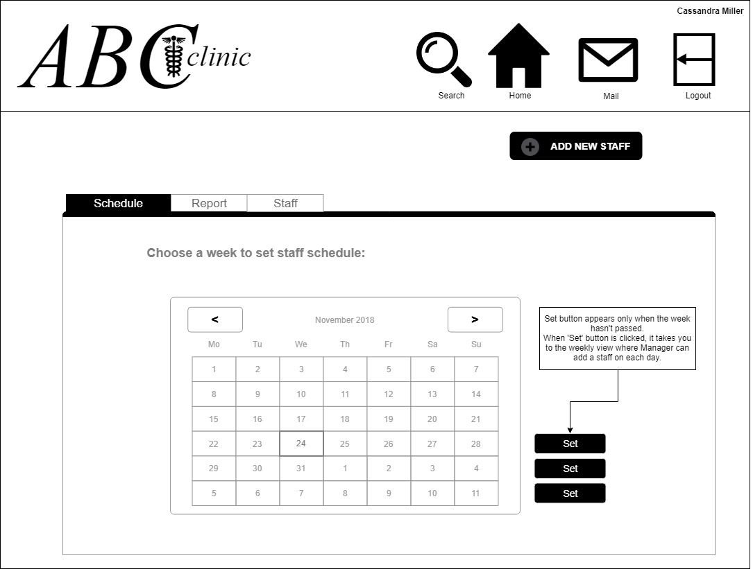

* 1. Schedule Staff View

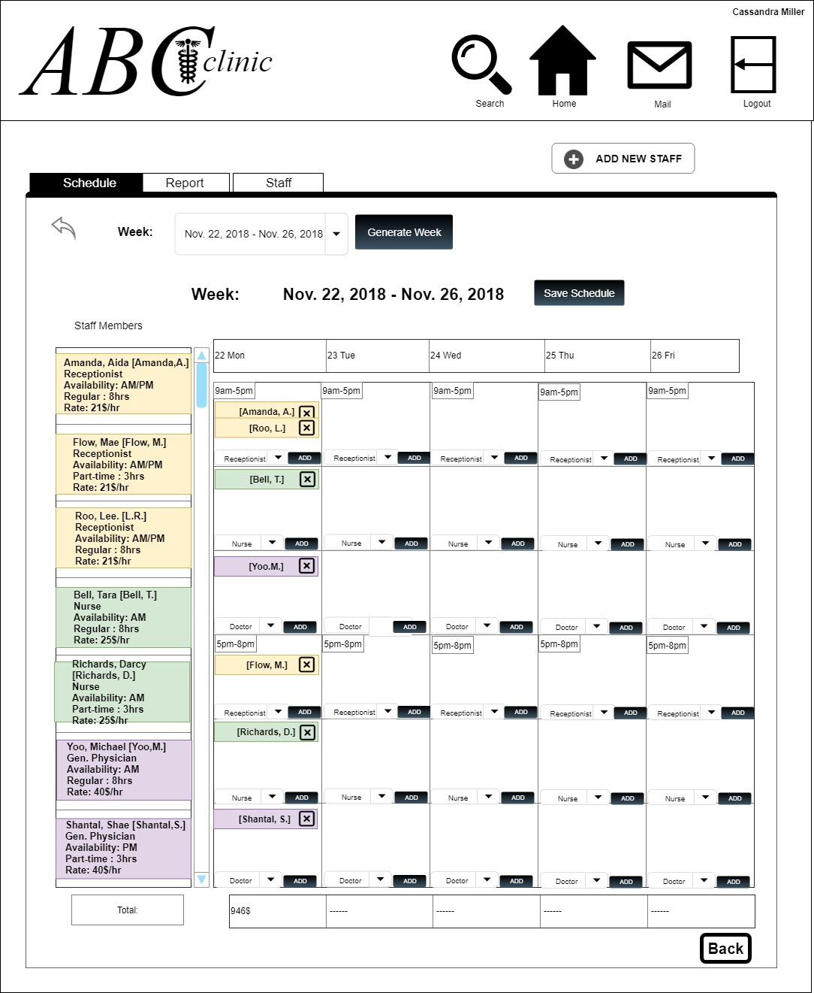

* 1. Create Reports View

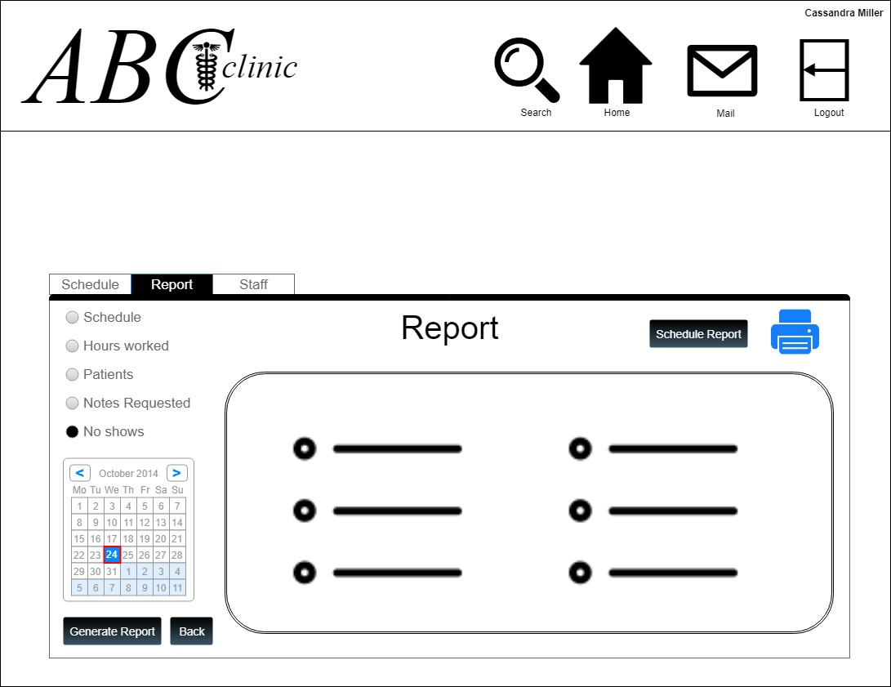

* 1. Generate Report View

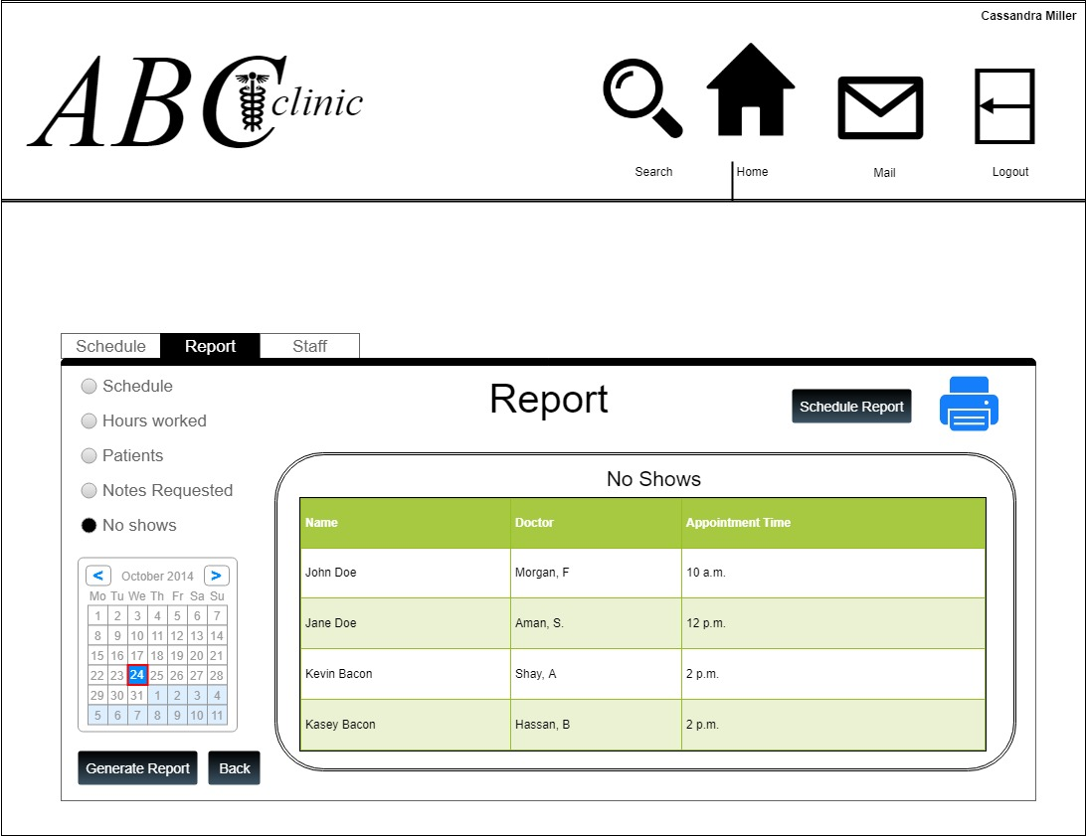

* 1. Schedule Reports View

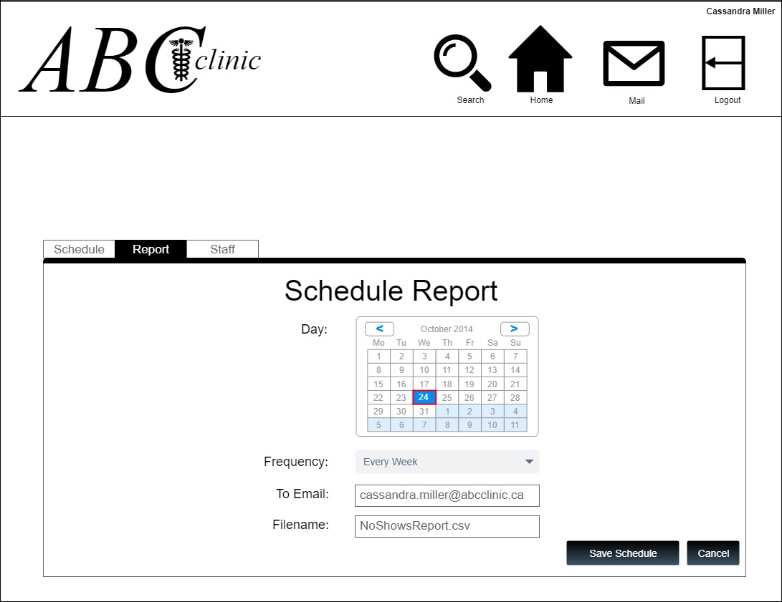

* 1. Add Staff View

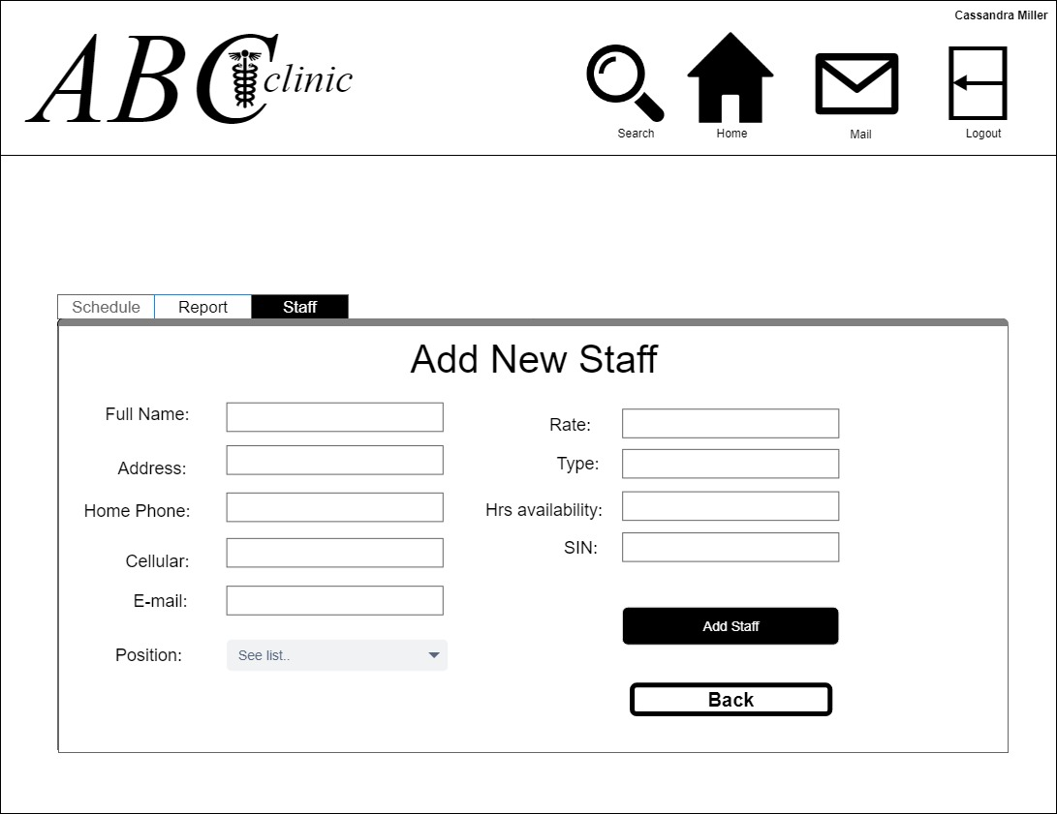

* 1. View Staff

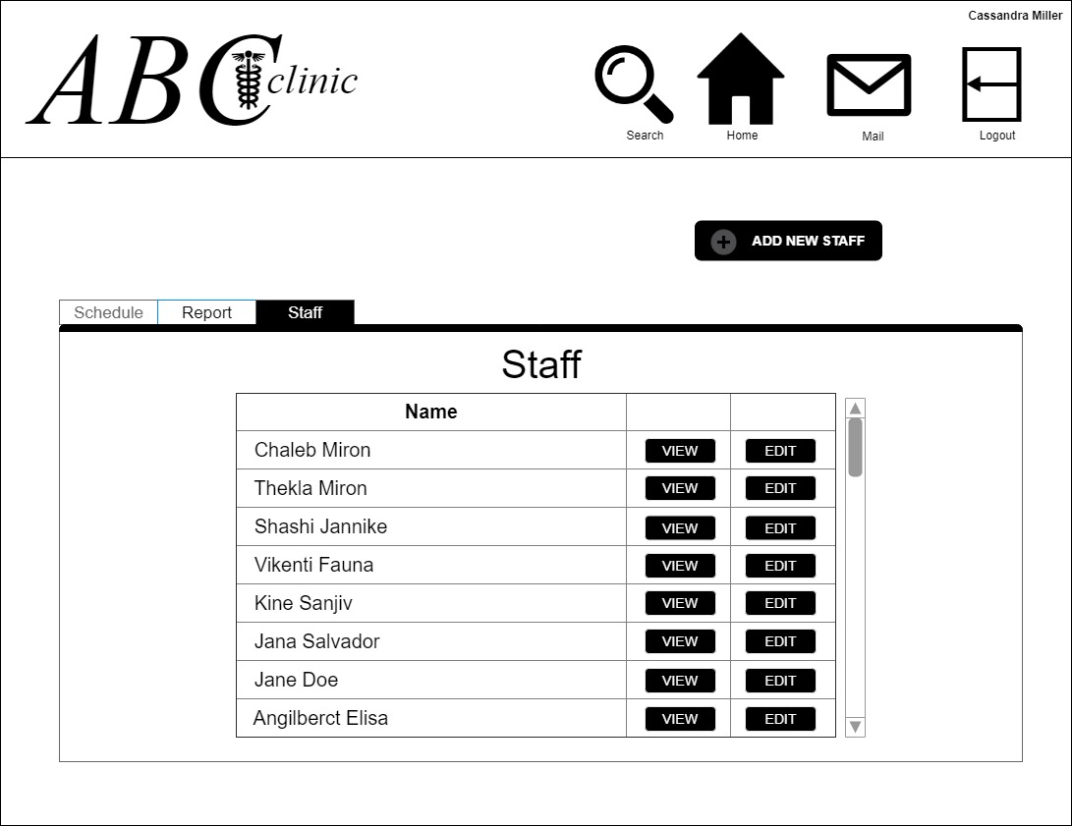

* 1. View Staff

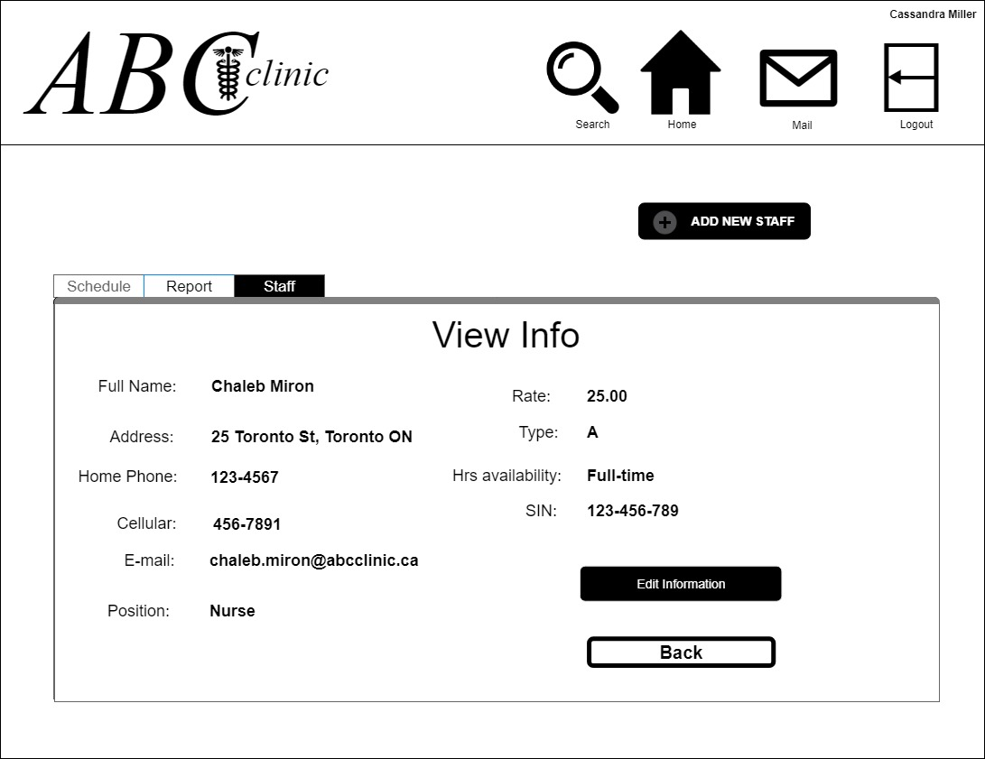

* 1. Edit Staff View

