Week 1 – Screen 1 - Screenshot 1
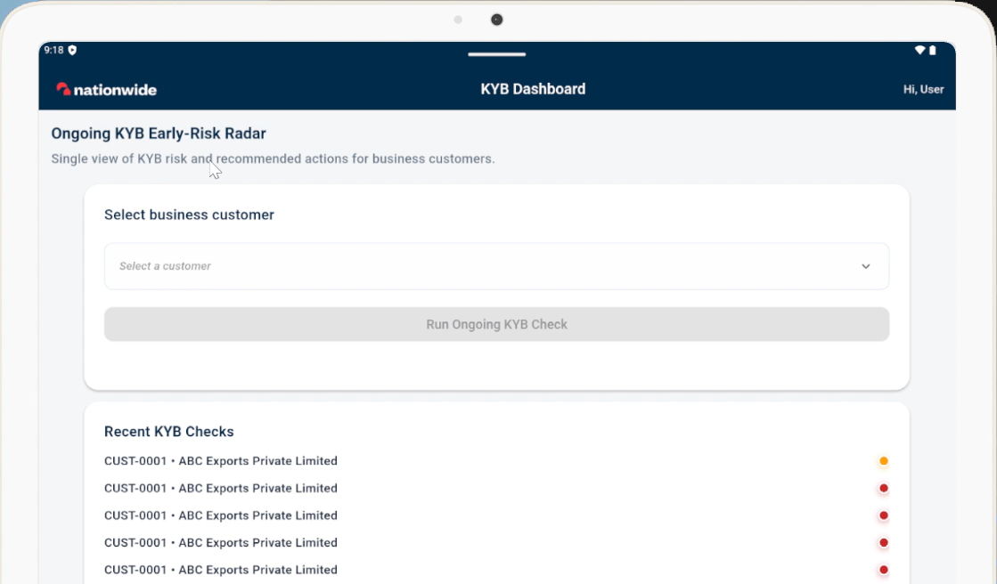
Week 1 – Screen 1 - Screenshot 2
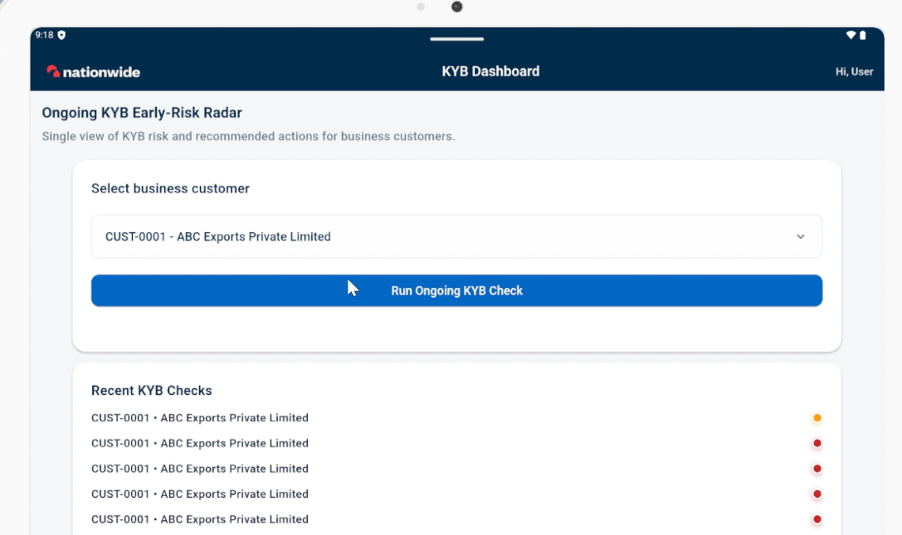
Week 1 – Screen 1 - Screenshot 3
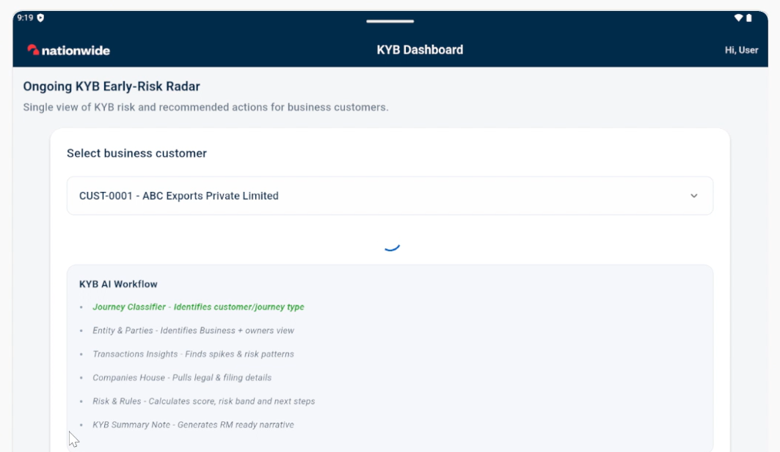

Week 2 – Screen 2 - Tab 1 – Screenshot 1
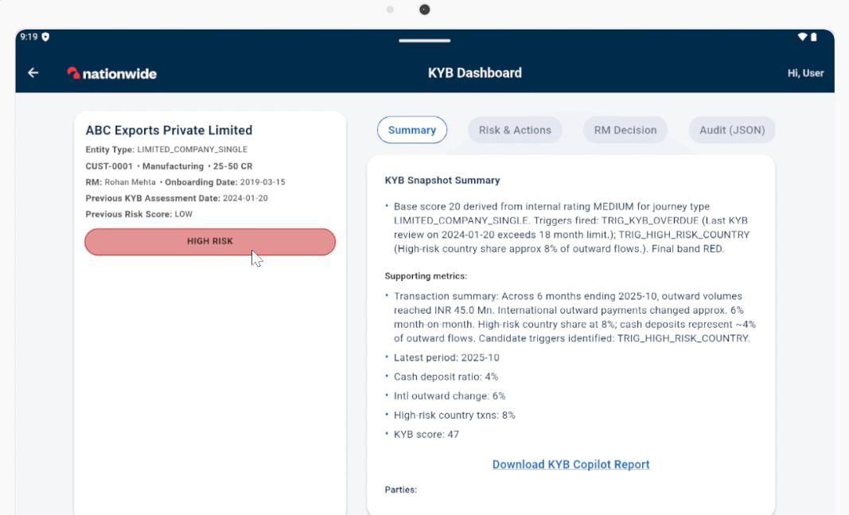
Week 2 – Screen 2 - Tab 1 – Screenshot 2
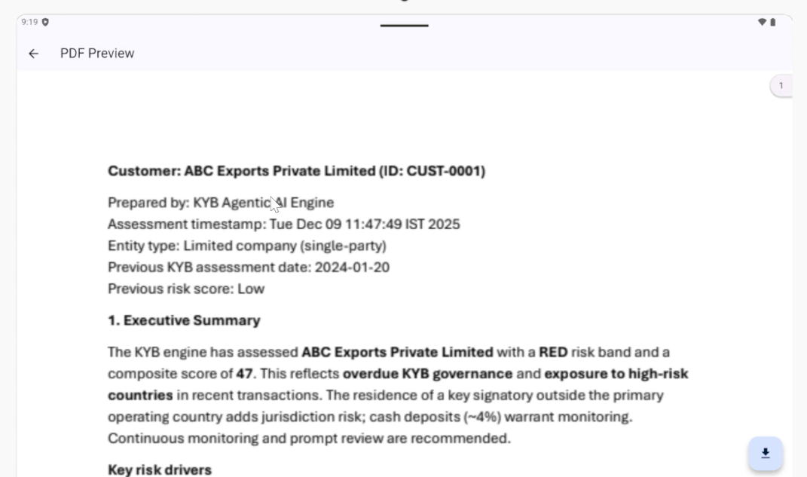
Week 2 – Screen 2 - Tab 1 – Screenshot 3
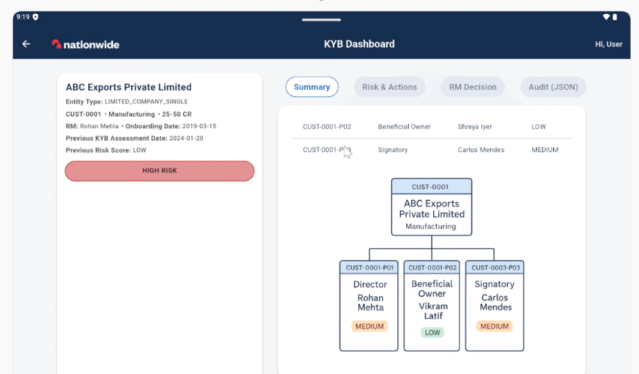
Week 2 – Screen 2 - Tab 2 – Screenshot 1
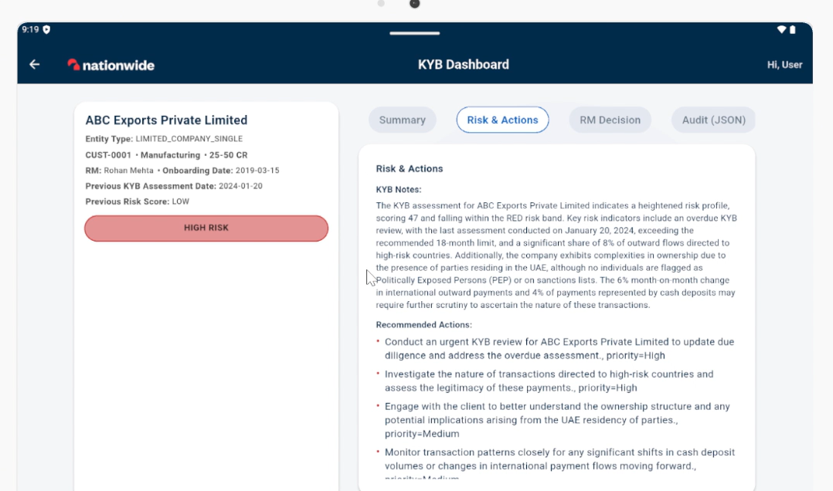
Week 3 – Screen 2 - Tab 3 – Screenshot 1
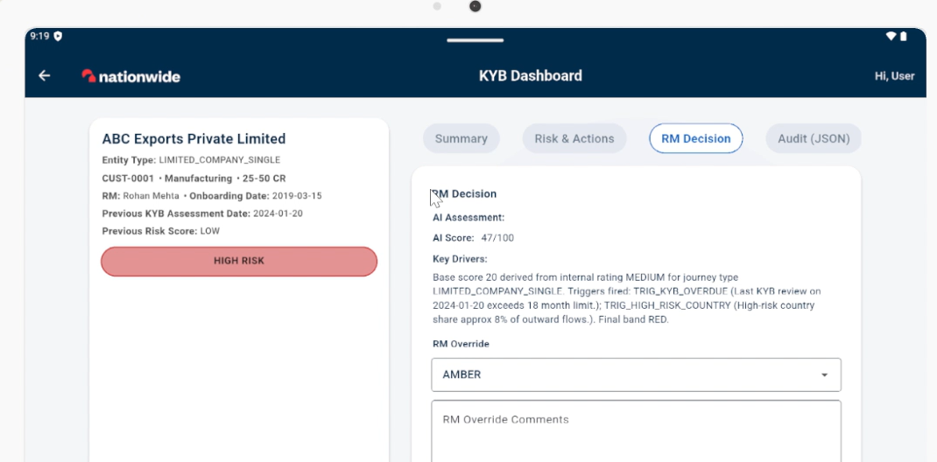
Week 3 – Screen 2 - Tab 3 – Screenshot 2
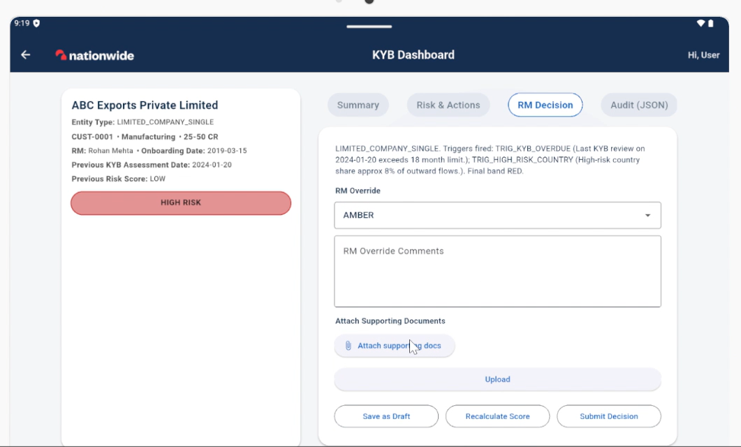
Week 3 – Screen 2 - Tab 4 – Screenshot 1
