Paddle Controller Requirements

Thomas Abdallah, Summer 2018

Contents

1.0 Introduction and Definitions 2

1.1 Acronyms 2

1.2 Coordinate System 2

1.3 Paddle Controller Interfaces 2

2.0 Global Stakeholder Requirements 3

3.0 System Requirements 3

4.0 Hardware Requirements 3

5.0 Software Requirements 3

# Introduction

## 1.1 Acronyms and Definitions

Table 1 – Acronyms and Definitions

|  |  |
| --- | --- |
| Acronym | Definition |
| PC | Paddle Controller – electromechanical system responsible for controlling the air hockey paddle. Includes embedded hardware, software, and electromechanical system. |
| uC | Microcontroller – Embedded controller interfacing with the PC expansion board.  Also known as “Axeman”. |
| PCE | Paddle Controller Expansion – Electronics interface between uC and PC I/O. |
| MC | Master Controller – External controller communicating with PC over CAN |

## 1.2 Coordinate System

Figure 1 shows the coordinate system for the Paddle Controller.

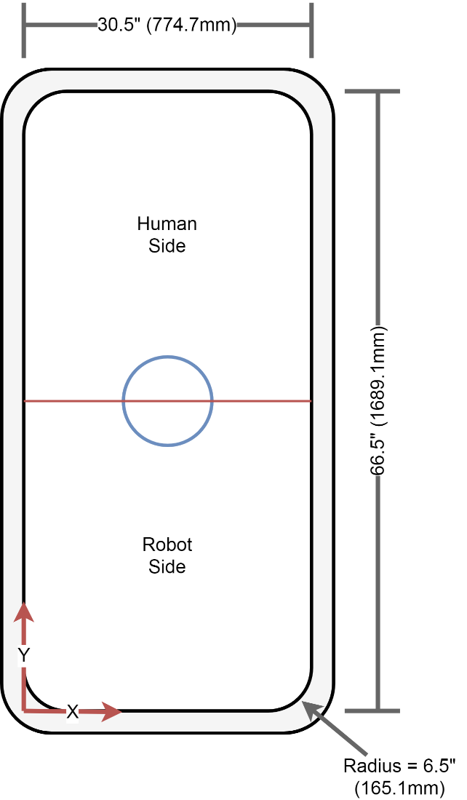

Figure 1 - Paddle Controller Coordinate System

## 1.3 Paddle Controller I/O

The Paddle Controller shall interface with the transducers and actuators listed in Table 2.

Table 2 - Paddle Controller I/O

|  |  |  |
| --- | --- | --- |
| Interface Name | Interface Type | Description |
| 1 – Motor_X | Output | X-Axis DC Motor |
| 2 – Motor_Y_1 | Output | Y-Axis Left DC Motor |
| 3 – Motor_Y_2 | Output | Y-Axis Right DC Motor |
| 4 – Encoder_X | Input | X-Axis Motor Encoder |
| 5 – Encoder_Y_1 | Input | Y-Axis Left Motor Encoder |
| 6 – Encoder_Y_2 | Input | Y-Axis Right Motor Encoder |
| 7 – Light_Screen_1 | Input | Light Screen 1 |
| 8 – Light_Screen_2 | Input | Light Screen 2 |
| 9 – Light_Screen_3 | Input | Light Screen 3 |
| 10 – Light_Screen_4 | Input | Light Screen 4 |
| 11 – Goal_Sensor_1 | Input | Goal sensor – robot side |
| 12 – Goal_Sensor_2 | Input | Goal sensor – human side |
| 13 – Goal_Light_1 | Output | Goal light – robot side |
| 14 – Goal_Light_2 | Output | Goal light – human side |
| 15 – Mode_Switch | Input | 2 position mode switch |
| 16 – Y_Pos_Button | Input | Push button for manual control |
| 17 – Y_Neg_Button | Input | Push button for manual control |
| 18 – X_Pos_Button | Input | Push button for manual control |
| 19 – X_Neg_Button | Input | Push button for manual control |
| 20 – X_Limit_1_Switch | Input | X-Axis hard limit switch 1 |
| 21 – X_Limit_2_Switch | Input | X-Axis hard limit switch 2 |
| 22 – X_Home_Switch | Input | X-Axis home position limit switch |
| 23 – Y_Limit_1_Switch_L | Input | Y-Axis left hard limit switch 1 |
| 24 – Y_Limit_2_Switch_L | Input | Y-Axis left hard limit switch 2 |
| 25 – Y_Home_Switch_L | Input | Y-Axis left home position limit switch |
| 26 – Y_Limit_1_Switch_R | Input | Y-Axis right hard limit switch 1 |
| 27 – Y_Limit_2_Switch_R | Input | Y-Axis right hard limit switch 2 |
| 28 – Y_Home_Switch_R | Input | Y-Axis right home position limit switch |
| 29 – Reset | Input | Paddle Controller reset switch |
| 30 – uC_Power_In | Input | Power input for microcontroller |
| 31 – 24V_Power_In | Input | Power input for paddle controller electronics |

# System Requirements

* 1. PC shall be capable of defending against pucks travelling at a top speed of 9 metres per second on a table with dimensions 30.5” x 66.5”.
  2. PC shall be capable of tracking paddle position in X & Y directions to within +/- 5mm.
  3. PC shall be capable of reporting paddle position and speed to MC.
  4. PC shall be capable of moving the paddle to a specified position when commanded by MC.
  5. PC shall be capable of moving the paddle manually using push-button inputs.
  6. PC shall be capable of limiting paddle speed when commanded by MC.
  7. PC shall include the following safety features:
     1. A mechanism to manually remove power from the PC.
     2. A mechanism to stop paddle movement when end of travel is reached.
     3. A mechanism to stop paddle movement if excessive resistance is encountered.
     4. A mechanism to detect intrusions into the robots operating area and stop paddle movement if an intrusion is detected.
     5. A mechanism to shield users from rotating components and pinch-points. Capable of detecting when a puck enters either net and reporting goal to external controller

# Hardware Requirements

* 1. An emergency stop shall be mounted in an easily accessible location that removes all electrical power from the PC when pressed.
  2. Electrical power shall be removed from the DC motors when end of travel is reached.
  3. A mechanical device shall be implemented to remove energy from the moving paddle when end of travel is reached.
  4. Paddle movement shall be stopped when an overload condition is detected. Example: Obstruction on playing surface preventing paddle from moving freely.
  5. Sensors (light screens) shall detect any intrusion into the robots operating area. Paddle movement shall be stopped when an intrusion is detected.
  6. PC shall include mechanical shielding on rotating components and potential pinch-points.

# Software Requirements

* 1. PC shall