Scaling

266 Color Images(Dataset)

(10000 pixel*10000 pixel)

266 Color Images

(224 pixel*224 pixel)

3002 Input Color Images

(224 pixel*224 pixel)

Augmentation

Training Set(1847)~60%

Validation Set(637)~20%

Testing Set(518)~20%

* VGG16 Network has been used after data alteration.

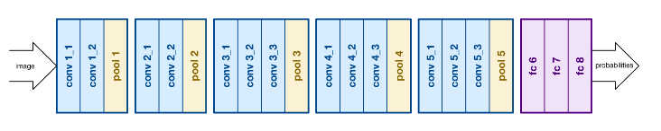

* VGG16 is a deep convolutional network for object recognition, image localization and baseline Feature extraction. VGG16 has 16 convolutional layers. It takes an image with dimensions of 224x224x3 and gives an output of 512 features vector.
* Since, the variable of interest is just one value. We started to add few more layers to the 512 features vector and started to observe the accuracy and error for trained data, validation data and test data.
* Initially we have used the train data to train the network above with 6 extra layers containing 512, 256, 128, 64, 32 and finally 1 (value of variable of interest) and observed that the accuracy was high for training set where as low for train data and error was too high for both validation data and test data.

Neural Network Model -1

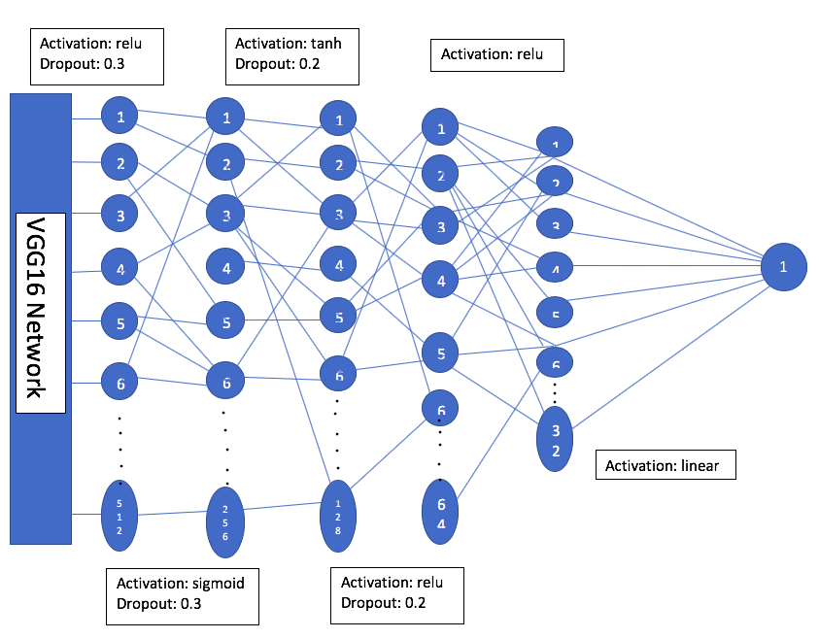

* So, we have changed the number of layers, dropout values, activation functions and the number of neurons in each layer. Following are few of the networks used to find the variables of interest.

Neural Network Model -2

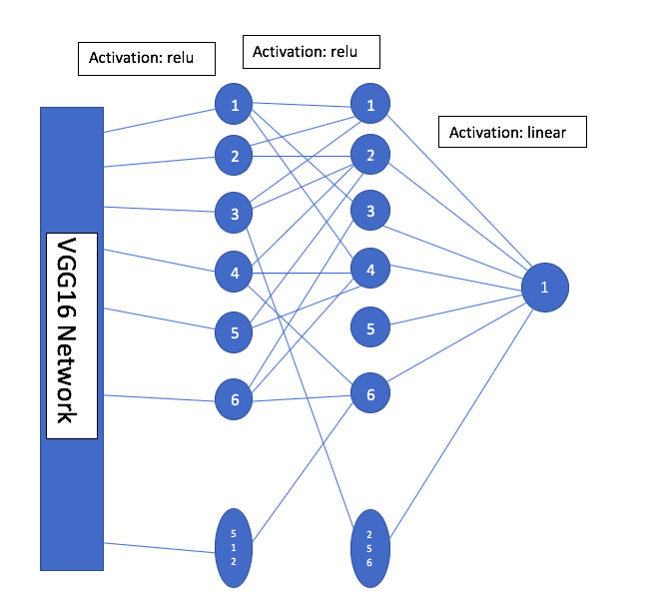

Neural Network Model -3

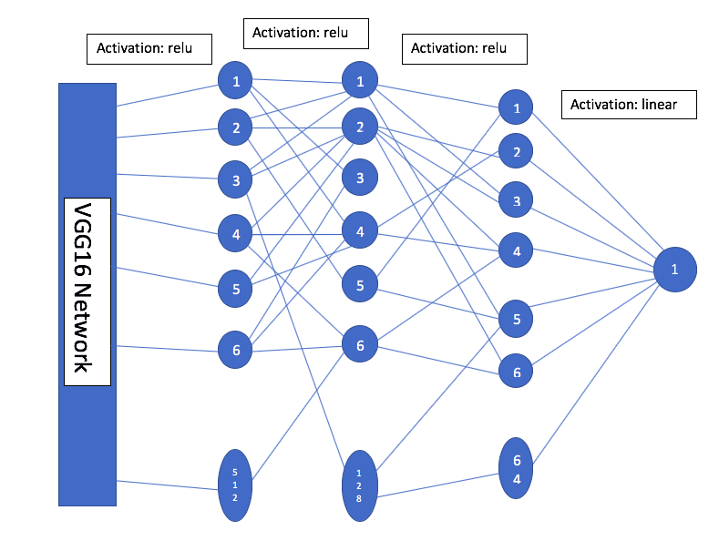

Using different networks in order to train the network by adjusting the weights and to predict the correct values for variables of interest of input samples. The variables of interests that we have worked on are:

1)phe

2)od.harvest

3)dead

4)live

5)cont.max.rate

6)toby.max.od

7)carb.lag

8)bfrac

9)pvd

Note:(The mean squared error for training, validation and testing that has been obtained in each case has been depicted in the tables depicted below:

**Variable**: phe

|  |  |
| --- | --- |
| Errors | Values |
| Mean Squared error for Training | 0.00034870645087192785 |
| Mean Squared error for Validation | 0.005561113104244674 |
| Mean Squared error for Testing | 0.011002254193708478 |

**Variable**: od.harvest

|  |  |
| --- | --- |
| Errors | Values |
| Mean Squared error for Training | 0.0057764621286360025 |
| Mean Squared error for Validation | 0.15355093117724386 |
| Mean Squared error for Testing | 0.21097110887867143 |

**Variable**: dead

|  |  |
| --- | --- |
| Errors | Values |
| Mean Squared error for Training | 0.321205079225 |
| Mean Squared error for Validation | 21.614637671 |
| Mean Squared error for Testing | 13.7954725138 |

**Variable**: bfrac

|  |  |
| --- | --- |
| Errors | Values |
| Mean Squared error for Training | 0.0010053146696927073 |
| Mean Squared error for Validation | 0.009871702635400523 |
| Mean Squared error for Testing | 0.00978040923526273 |

**Variable**: live

|  |  |
| --- | --- |
| Errors | Values |
| Mean Squared error for Training | 12.7374746989 |
| Mean Squared error for Validation | 21.812443708 |
| Mean Squared error for Testing | 87.430079753 |

**Variable**: cont_max_rate

|  |  |
| --- | --- |
| Errors | Values |
| Mean Squared error for Training | 12.7723766428 |
| Mean Squared error for Validation | 39.6228505104 |
| Mean Squared error for Testing | 63.728888855 |

**Variable**: toby.max.od

|  |  |
| --- | --- |
| Errors | Values |
| Mean Squared error for Training | 0.0037947 |
| Mean Squared error for Validation | 0.218014226 |
| Mean Squared error for Testing | 0.14545988 |

**Variable**: carb.lag

|  |  |
| --- | --- |
| Errors | Values |
| Mean Squared error for Training | 0.694854802509 |
| Mean Squared error for Validation | 28.642791224 |
| Mean Squared error for Testing | 51.727614962 |

**Variable**: pvd

|  |  |
| --- | --- |
| Errors | Values |
| Mean Squared error for Training | 0.9260953868006653 |
| Mean Squared error for Validation | 20.284075546863505 |
| Mean Squared error for Testing | 46.53408130071335 |

Of all the variables of interest we obtained high Accuracy for below parameters.

* Bfrac
* cont_max_rate
* phe