**Project Requirements:**

**Language used:** Python 3.6.4

**IDE:** Jupyter Notebook (Installation link - <http://jupyter.org/install>)

**Packages used in Python:** Keras, Tensorflow, PIL, Numpy, openpyxl, os, pandas

**Project Execution Instructions:**

**Testing Models accuracy:**

**Step – 1:** Add Images to **TestingData_ML_Project** sub-folder in **Testing Models** folder.

For testing:

**Step – 2:** Open Testing Models folder.

* Variable **“od.harvest”**
* Open Testing Model_od.harvest.ipynb
* Variable “**bfrac**”
* Open Testing Model_bfrac.ipynb
* Variable “**phe**”
* Open Testing Model_phe.ipynb
* Variable “**pvd**”
* Open Testing Model_pvd.ipynb
* Variable “**Toby.max.od**”
* Testing Model_toby.max.od.ipynb

For testing variables: **Dead/live/carblag/count rate max**:

* Open Testing Model_dead_live_carblag_countratemax.ipynb
* Change parameter in **model.load_weights( )** accordingly.

In the file, go to the following line

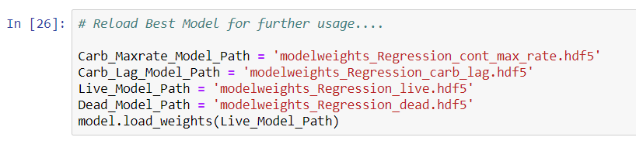

**Note:** Changes should be made only for the variables: “Dead”/”live”/”carblag”/”count rate max” for testing. Apart from these, no other files need any modifications for the testing purpose.

* On executing the complete file, we get the predicted values as follows.

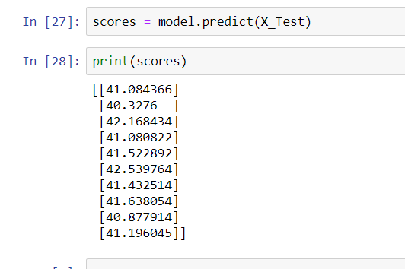

* These are the predicted values for live variable with input of 10 images.