Study on “Robot-Assisted Rehabilitation of Hand Function After Stroke with the HapticKnob and the HandCARE”

Group 06

Goh Him Ling, A0098234Y

Florence Wai Tze Yun, A0101653U

------------------------------------- REPORT BACKBONE -------------------------------------

1. Introduction

* About the Paper
* Robot-assisted Rehabilitation

2. Robot-assisted Rehabilitation

* Importance of Using It
* Benefits

3. About the Experiments

* Introduction
* Experiment 1
  + How is it conducted
  + Results
* Experiment 2
  + How is it conducted
  + Results

4. Experimental Plot Replicate

5. Contributions made to the field of health

6. Issues

7. Challenges

8. Limitations

9. Impacts to the world and our society

10. Conclusion

------------------------------------- END REPORT BACKBONE -------------------------------------

**1. Introduction**

The paper studies how biomechatronics can aid in rehabilitation of specifically the hand function, after patients suffer from stroke and have difficulty in performing activities of daily living (ADL). Biomechatronics is the interdisciplinary study of biology, mechanics, electronics and control. It focuses on the research and design of assistive, therapeutic and diagnostic devices to compensate (partially) for the loss of human physiological functions or to enhance these functions.

The use of biomechatronics in rehabilitation therapies may be addressed simply as robot-assisted rehabilitation (RAR). The purpose of using RAR provides mechanical assistance, or in worse cases, support to the patients while they perform various dictated tasks during the therapy process. While RAR benefits patients with movement disorders by administering task-orientated motor training on themselves, the computerized devices enable healthcare data scientists to be able to quantify these movement related variables and enable meaning out of these data collected, for both diagnosis and clinical assessment.

**1.1 About Using Robot-Assisted Rehabilitation**

There is an increasing need to use RAR in current times as technology improves, moving the healthcare field forward and better it for the society. With increasing stroke population, there is a rising need for the numbers and meta-data of the stroke patients to be analyzed carefully. The surge urges people to come up with better and more efficient ways to handle with therapy and limited therapists. With RAR, the paper claims that the robots are easily combined with other rehabilitation technologies such as virtual reality and haptic technology*, and is relatively a more useful tool to study motor control.

(Footnote: Haptics , is the technology of adding the sensation of touch and feeling to computers)

Benefits are listed as such:

As such, biosensors on these devices are used to detect the movements and intentions of the the user in what they want to do.

**2. Robot-Assisted Rehabilitation**

**2.1 Importance of Robot-Assisted Rehabilitation**

Based on research, there is an increasing stroke population nowadays and the number is still growing. The growing demand has outweighed the capability in training and producing adequate therapists on time.

The robots can be easily combined with other rehabilitation technologies, such as virtual-reality and haptic technology in order to not only meeting the growing demand, but also to make the rehabilitation process more interactive and speed up the process of rehabilitation as compared to conventional therapy.

Apart from that, Robot-Assisted Rehabilitation process can serve as a tool in studying motor control as well. The data collected during the rehabilitation process can be clustered and processed to learn human motor movements for further improvements.

**2.2 Benefits of Robot-Assisted Rehabilitation**

RAR is useful in increasing the intensity of therapy at affordable costs, which offers other advantages as well, such as good repeatability. Repetitive movement therapy has been observed to produce positive clinical outcomes by several studies. In addition to high intensity, practicing movements that are task-oriented and functionally meaningful to the patient can result in better motor outcomes than that of conventional therapeutic techniques. This type of therapy, however, is labor intensive and time consuming. But with the use of programmable robotic devices, some of the aspects of this therapy can be automated to relieve some burden off the therapist and expanding their ability to provide more efficient service.

Besides, RAR allows precisely controllable assistance and resistance during movements and enables objective and quantifiable measures of subject performance. Objective measures of subject performance with good sensitivity are very important for the therapy process. These measures will not only enable us to keep track of a subject’s progress during therapy but will also be useful in evaluating the efficacy of newly developed therapy techniques.

In addition, robots can be easily combined with other rehabilitation technologies such as virtual-reality and haptic technology. This is especially effective in increasing training motivations of the patients.

**3. Experiments**

**3.1 Introduction**

The two robots being used for experiments are HapticKnob (figure 1) and HandCARE (figure 2). These robots are end-effector robots, which are comparatively mechanically simpler, easier to use and more compact than usual exoskeleton robots.

HapticKnob’s main function is to train grasping in coordination with pronation and supination of the forearm. While for HandCARE, it is mainly used to train the independent movement or isometric force training of each finger.

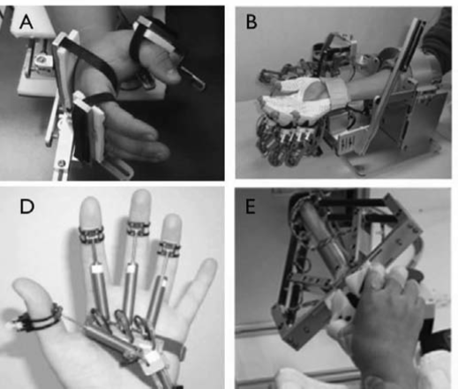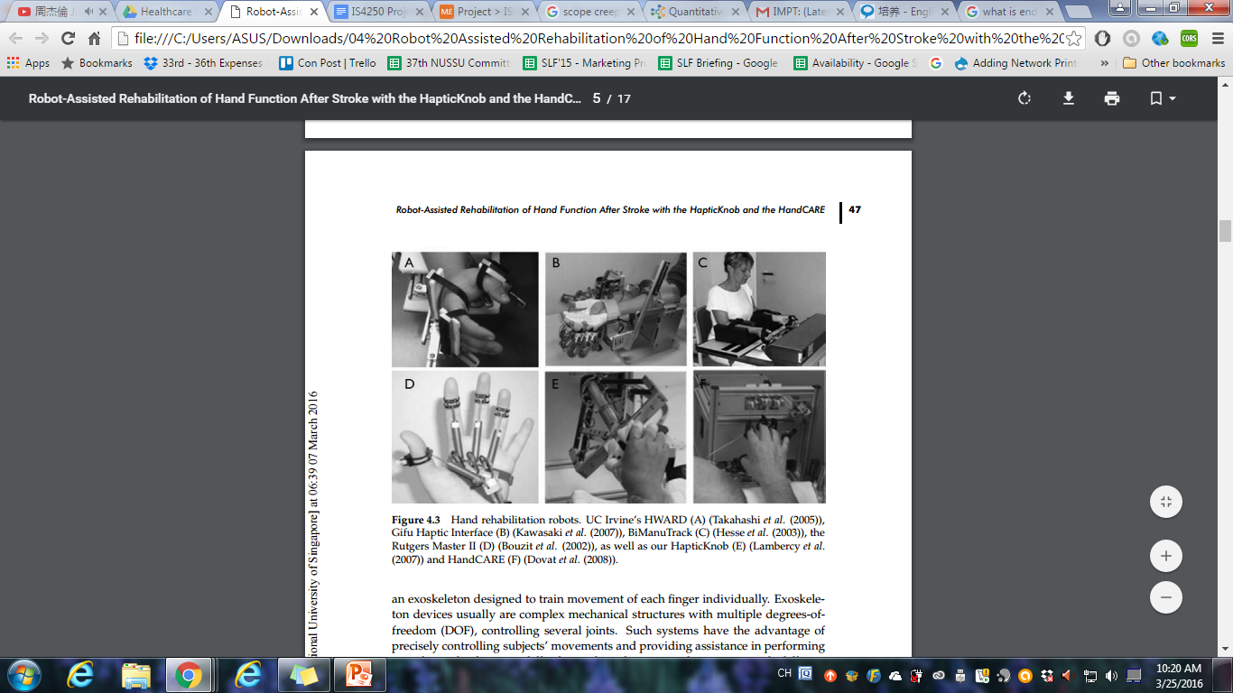

*Figure 1: HapticKnob Figure 2: HandCARE*

4 subjects were selected for the experiments, with several criterion:

* 43-83 years of age
* Right-handed
* Suffered from right hemiparesis
* Able to move right arm and hand, but have difficulties in performing many typical ADL (Activities of daily living)

Subjects went through a 8-week rehabilitation therapy with a 40-minutes session twice a week. Each session was being splitted into 20 minutes of training with HapticKnob and another 20 minutes with HandCARe.

**3.2 Experiment 1**

**3.2.1 How it was conducted**

The first experiment was being carried out with the assistance of HapticKnob. The main purpose was to train forearm pronation and supination movement. Subjects were required to undergo the simulation of turning a doorknob, with the help of HapticKnob through applying a resistive load. The first movement was always supination, starting from the rest position of the forearm, and followed by the movement of full pronation.

Image was displayed on the computer screen connected to the robot. The image orientation will change following the movement of the subject’s forearm. Once the target, eg. supination, was reached, the image on the monitor was reoriented to require an identical returning movement in pronation for realignment.

**3.2.2 Results**

In average, the time required to perform the twisting movements significantly decreased

for both supination (−25%) and pronation (−13%), while the coordination between forces applied by thumb and fingers increases.

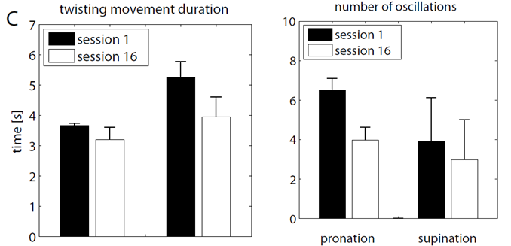

**3.3 Experiment 2**

**3.3.1 How it was conducted**

The experiment was conducted with the subject’s fingers being maintained in a fixed position by the HandCARE. Letters were then being selected by isometrically applying a certain amount of force with a specific finger, i.e. Active Finger (AF), and by minimizing the force applied by the other fingers, i.e. Non- Active Fingers (NAF). The training was focused on the tripod thumbindex-middle as these fingers are most commonly used in ADL. One stroke subject with limited finger impairment performed this exercise during the entire 8 weeks of therapy.

**3.3.2 Results**

After the trainings, the number of successful trials (i.e. correctly selected letter) increased for these three fingers (+16% for the thumb, +28% for the index, and +29% for the middle finger). The time to perform a successful trial was also significantly reduced (−45%), which indicates that the subject felt more comfortable with the exercise and was able to better control forces generated by these fingers. This suggests that an intense isometric force training promotes recovery of finger function.

Data was obtained with comparison of fingertip force of stroke patient P3 (female, 83 years old and 6 years post-stroke) between the beginning (figure 3), the middle (figure 4) and the end (figure 5) of the trainings. From the results, it is proven that the force applied by the NAF tends to decrease with training when the index finger produces force.

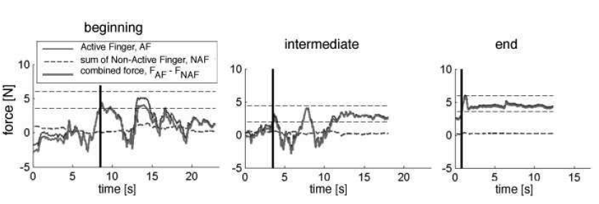

*Figure 3 Figure 4 Figure 5*

**3.4 Overall Result**

Robot-assisted training has proven to be resulted in direct benefits in ADL for the four subjects, and in a reduction of their impairments. A mean improvement of +1.05 stages (+25%) was observed in the 4 patients who participated to the pilot study.

In addition, patients reported improvement in their daily activities at home. They felt more secure in grasping and manipulating objects, more skillful in fine motor tasks, such as manipulating buttons or handwriting, and started to use their impaired hand more, which we believe is crucial for further improvement.

**4. Experimental Plot Replicate**

***Coming soon...***

**5. Contributions made to the field of health**

One of the main contributions is the robots help to improve hand motor function and force control significantly through different trainings, like grasping, precision grip and fractionation. Other than hand function, it also trains elbow and shoulder during the process, as these two components are needed to stabilize the arm during the trainings. By producing visible improvements, it helps patients to regain their confidence in their motor abilities as well.

Besides, these end-effector based robots provide more freedom and comfort during training, compared to exoskeleton robots, as patients do not have to wear the complex device over their arms.

In addition, it decreases the complexity and cost of the robotic systems. HapticKnob and HandCARE are comparatively less complex in terms of their structures compared to exoskeleton robots. When the complexity is lower, it means that it will be easier for patients to learn and operate with the device.

Lastly, it will help to solve the problem that repetitive task-oriented therapy can be labour intensive and time consuming to both the patients and therapists. With these devices, patients will be able to carry out the trainings at home with minimal control from the therapist remotely.

**6. Issues**

In order for the program to produce significant improvements, long period of active participation is needed from the patients. This is a huge issue as continuous and effective motivation is needed in order to keep the patients going.

Besides, in general, most of the stroke patients are typically older. They might not be tech savvy and may feel fatigue easily. Special designs with interesting features will be needed in order to overcome these issues.

**7. Challenges**

There are a few challenges that HapticKnob and HandCARE need to address in order to promote a wider usage when it goes public.

First challenge will be how to cultivate strong initial motivation and promote public acceptance for the robots. As most of the stroke patients are typically older, and they might find it hard in accepting a machine-controlled device to replace the traditional human-based therapy.

The next challenge is how sophisticated or how easy the user interface and visual feedback should be, as older people might not be as tech savvy or familiar with gamification as expected.

Third challenge is to improve on the ease of implementation. Ideal case will be the public are able to set up the device with minimal or without any help from the therapist or technician.

The last challenge is concern with the capability and ability to mass produce these robots and meet the market demand on time.

**8. Limitations**

Nothing is perfect and the same goes to HapticKnob and HandCARE. There are few limitations bounded with the devices, and one of the most critical ones is certain degree of remaining motor function is still needed in order for the robotic rehabilitation to be effective.

Secondly, the training movements are limited by passive guidance from therapist. In other words, patients will only train based on the instructions given by the therapist. Only limited activities will be carried out and hence, it might not be fully practical in dealing with all kinds of real life activities.

Besides, HapticKnob and HandCARE are not applicable to patients with neurological disorder, such as Tremor and Apraxia.

Lastly, the experiments were carried out in relatively short periods. Hence, there remains uncertainty that the improvements may decrease gradually when time goes on, and hence, full recover of hand function will remain as a dream.

**9. Impacts to the world and our society**

In general, HapticKnob and HandCARE are great inventions that will be producing impactful effects to the society. They can be used as a tool for studying motor control by analysing the patterns and data reflected on the computer that is being connected to the robots. The data will be useful in revising a more sophisticated solution to improve therapy outcome.

In addition, it is comparatively much easier to mass produce the robots than experienced therapists in order to meet the increasing demand of therapy due to escalating population of stroke patients.

Last but not least, the devices have overturned the past perceptions that rehabilitation therapy is boring and painful. By integrating interactive features into the devices, it helps to relieve the stress of the patients when undergoing therapy activities. One of the examples will be for HapticKnob, patients can personally select pictures, like family photo, and the image will be used in the twisting training. When patient twist his hand, the orientation of the image will be changed as well, and eventually reaches the right orientation when the target is reached.

**10. Conclusion**

In summary, hand function, such as precision control and power grip, plays a very crucial role in enhancing the quality of our daily life.

HapticKnob and HandCARE are end-effector approach that will be useful in helping stroke survivors in regaining their lost hand function to a certain degree. They provide more freedom and comfort to the patients compared to exoskeleton products, as well as reduce the complexity and cost of the robotic system. However, limitations still exist, such as, a certain degree of hand function is required in order for the rehabilitation to be effective.

From the experiments, the robots were safe to use and deemed to be well accepted by the patients. However, due to the small sample size of the experiments, it is not justifiable that these robots will be receiving the similar level of acceptance from the public, especially from the elderly.

However, it is proven that these devices will be contributing significantly in enriching the user experience. Intensive and repetitive training program is the basis for improvement, however, it can be very tiring. By providing interactive features, it helps to constantly motivate the user to continue with the training in a more fun environment.

Last but not least, despite the robots were only used for pilot tests, the invention represents a good kick start in the effort of engaging simple rehabilitation robot as standard therapy and assessment tool in the future.