README

・environment
lubbuntu 16.10, MongoDB:3.2.19, Tomcat:8.5, eclipse:Oxygen.1 Release (4.7.1)
・MVC model
M: MongoBeans.java
V&C: MongoController(Update, Insert, Delete, Search).java and MongoShowViewing.java and MongoShowRank.java and showGraph.jsp
Processing: MongoProcessing(Update, Insert, Delete, Search)
DBConnect: MongoDB.java
WebPage: index.html

・How to use this Web applicationo.

At first, you need to execute “/WebContent/WEB-INF/index.html” with Tomcat.(I used Tomcat version8.5).

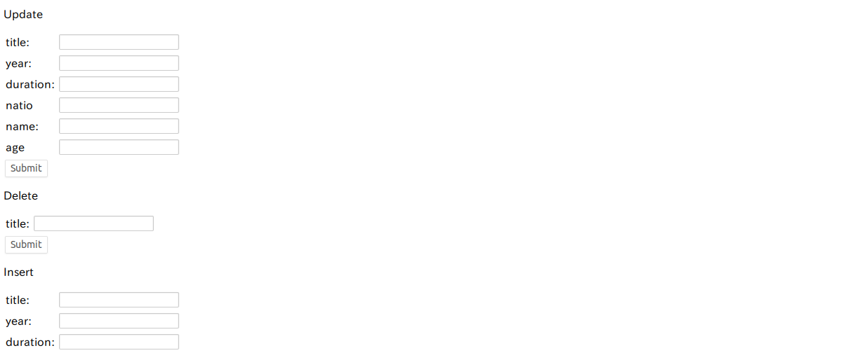
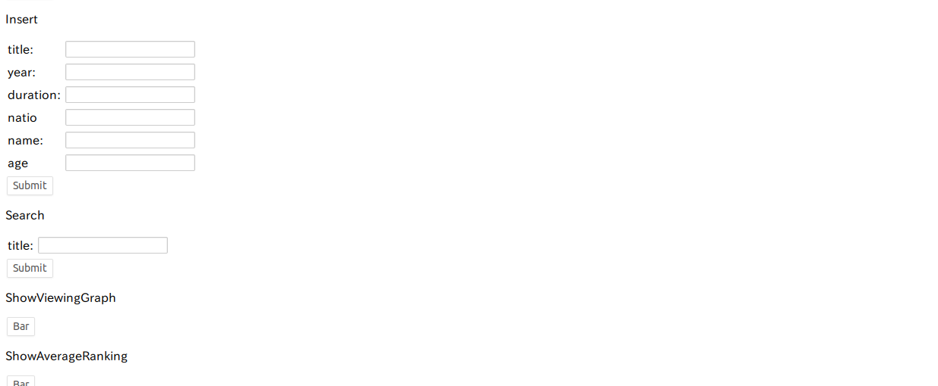

Then you can find this Screen.

1. Update
For instance, you will change the movie of japon. The data changed before is below.

You need to put an information that you want to change like below and submit.
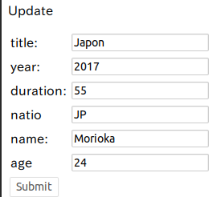

Then you will get an information like below.

2.Delete
You need to put a title title that you want to delete and submit, then you can delete the film.
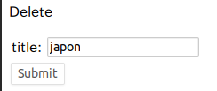

3. Update

You need to put an information that you want to add to the data base and submit.
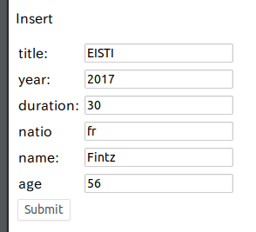

Then you will see like this line at the bottom.

4. Search

You need to put a title that you want to search like below and submit.
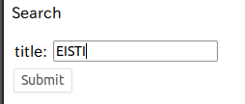

Then you can get a screen like below.

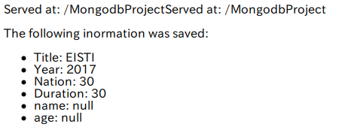

If you do search, the view number of the film will be increased.
This view number is used for “Display the number of views per movie (Bar chart)” and “Display the average ranking per movie”.

5. Display the number of views per movie (Bar chart)
You need to submit the button of Bar like below.
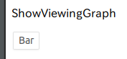

Then you can get a graph like below.
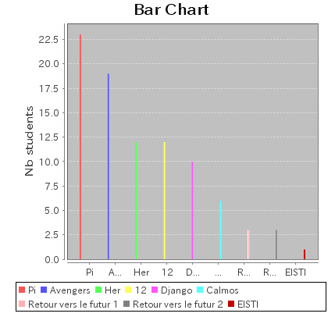

6. Display the average ranking per movie
You need to push a button of submit to calculate a average ranking like below.
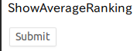

Then you can get an average ranking like below.

