libname stocks "C:\Users\akalia3\Downloads";

**proc** **contents** data=stocks.annualreports varnum;

**run**;

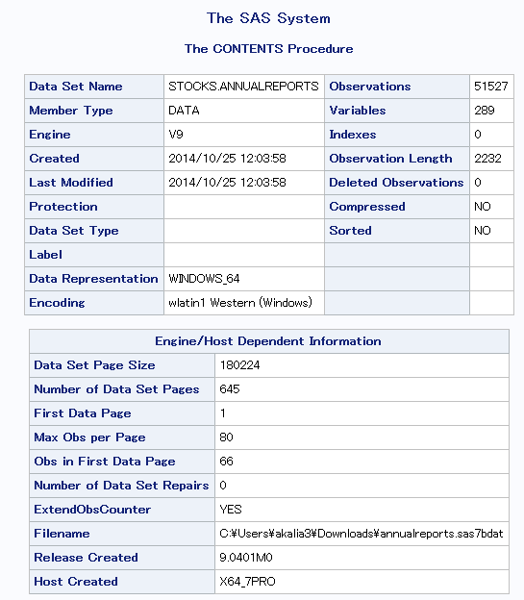

**proc** **freq** data=stocks.annualreports;

table IndFinancialYearEnd;

**run**;

**data** work.AnnualReports;

set stocks.AnnualReports;

FiscalYearDate=datepart(IndFinancialYearEnd);

FiscalYear=Year(FiscalYearDate);

**run**;

**proc** **freq** data=work.annualreports;

table FiscalYear;

**run**;

**data** work.No2014;

set work.AnnualReports;

if FiscalYearDate<**"01Jan2014"d**;

**run**;

**proc** **freq** data=work.no2014;

tables FiscalYear;

**run**;

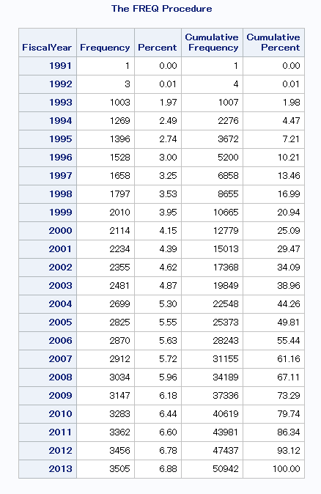

**proc** **freq** data=No2014;

table sector*industry/list missing missprint;

**run**;

**data** Mycompanies;

set work.No2014;

if sector="Consumer Servic" and Industry="Other Consumer Servic";

**run**;

**proc** **freq** data=mycompanies order=freq;

title "No of Annual Report Records by Name";

table name;

**run**;

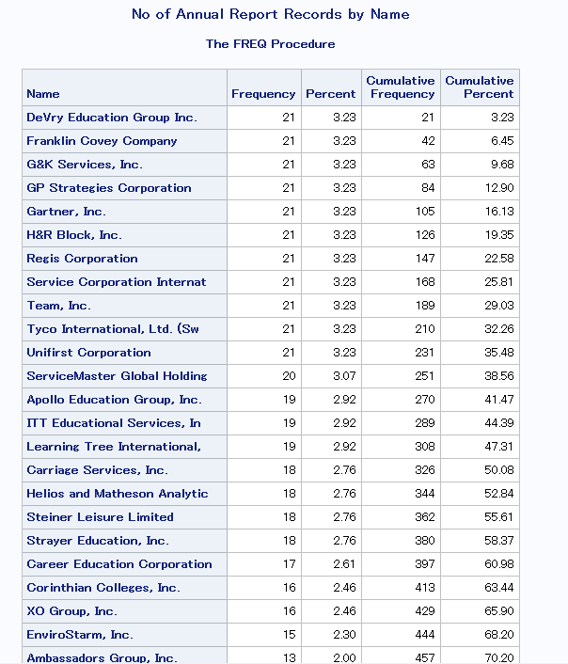

**proc** **freq** data=mycompanies ;

title "Counts of Symbol by Name--Detect Duplicates";

table symbol*name/list missing missprint;

**run**;

**proc** **sort** nodupkey data=Mycompanies;

by name FiscalYear;

**run**;

**proc** **freq** data=mycompanies ;

title "Counts of Symbol by Name--Detect Duplicates";

table symbol*name/list missing missprint;

**run**;

title;

**data** Mycompanies;

set Mycompanies;

NameCompressed=compress(Name, " #.(),;&-");

**run**;

**proc** **freq** data=mycompanies order=freq;

tables namecompressed/list out=CompanyCounts;

**run**;

**data** WithBinaries;

set Mycompanies;

if namecompressed="DeVryEducationGroupInc" then DeVryEducationGroupInc=**1**;

else DeVryEducationGroupInc=**0**;

if namecompressed="FranklinCoveyCompany" then FranklinCoveyCompany=**1**;

else FranklinCoveyCompany=**0**;

if namecompressed="GKServicesInc" then GKServicesInc=**1**;

else GKServicesInc=**0**;

if namecompressed="GPStrategiesCorporation" then GPStrategiesCorporation=**1**;

else GPStrategiesCorporation=**0**;

**run**;

**proc** **freq** data=WithBinaries order=freq;

tables Name*DeVryEducationGroupInc*FranklinCoveyCompany*GKServicesInc*GPStrategiesCorporation/list missing missprint;

**run**;

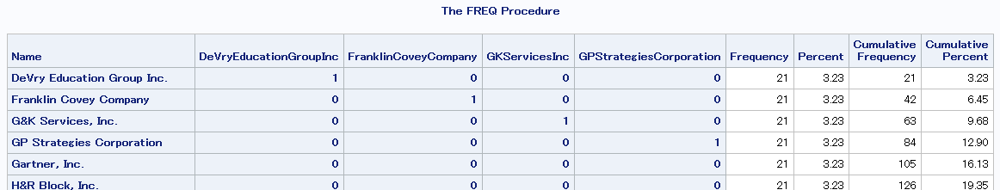

**data** ForAnova;

set WithBinaries;

if DeVryEducationGroupInc=**1** or FranklinCoveyCompany=**1** or GKServicesInc=**1** or GPStrategiesCorporation=**1**;

**run**;

**data** ConvertMetric;

set ForAnova;

PriceSToInd=input(PriceSalesToIndustry,**8.**);

**run**;

**proc** **means** data=convertmetric;

class symbol;

var PriceStoInd;

**run**;

**proc** **anova** data=convertmetric;

class symbol;

model PriceStoInd=symbol;

means symbol/snk;

**run**;

**quit**;

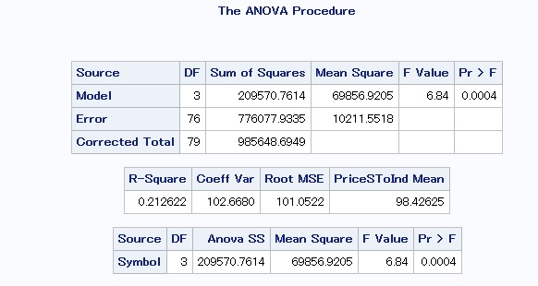

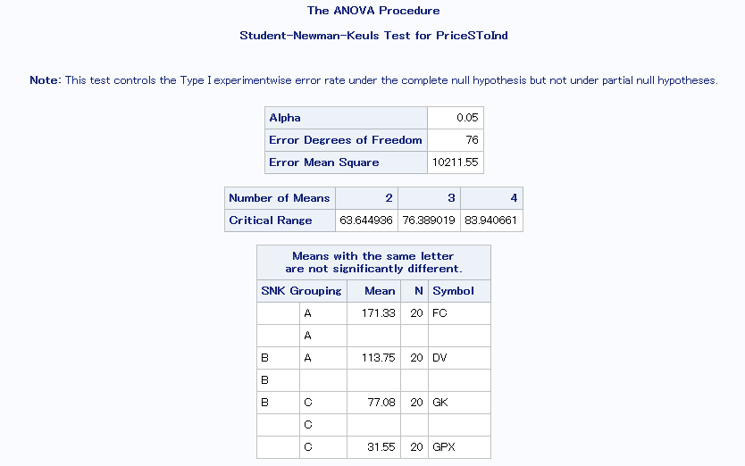

**Ho: There is no significant difference in mean of Price Sales to Industry for companies**

**Ho: µDeVryEducationGroupInc=µFranklinCoveyCompany=µGKServicesInc=µGPStrategiesCorporation**

**Ha: There is significant difference in mean of Price Sales to Industry for at least one company**

**The p-value for the ANOVA test is 0.0004. We would therefore reject Ho for any standard alpha (1%, 5%, or 10%). We therefore conclude that a statistically significant difference does exist for price sales to industry in each company.**

Student-Newman-Keuls Test detects statistically significant differences in Price Sales to Industry between companies in group A and C. But there is no adequate significant differences between group A and B or Group B and C.

**proc** **sort** nodupkey data=mycompanies;

by symbol;

**run**;

**data** work.optionsfile;

set stocks.optionsfile (rename=(underlying=Symbol));

if **"01Mar2014"d**<=expdate<=**"30Nov2014"d**;

**run**;

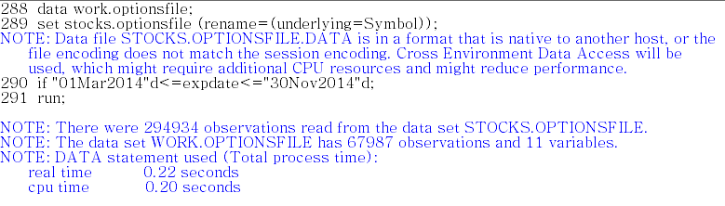

**proc** **sort** data=optionsfile;

by symbol expdate strike;

**run**;

**data** myoptions;

merge mycompanies(in=OnCompanies keep=symbol)

work.optionsfile(in=OnOptions)

;

by Symbol;

if OnCompanies and OnOptions;

**run**;

**proc** **freq** data=myoptions;

table Symbol;

**run**;

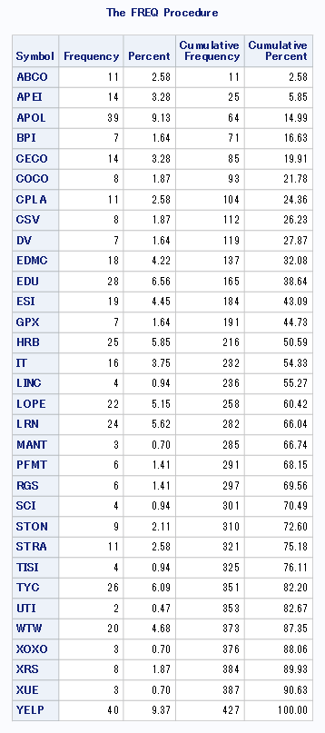

**proc** **means** data=myoptions;

class Symbol type;

var strike;

**run**;

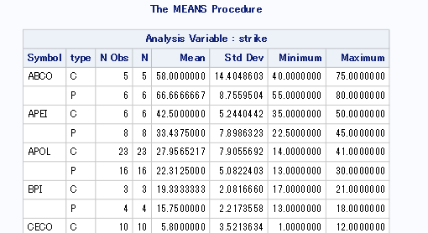

**proc** **summary** data=myoptions nway;

class symbol type;

var strike;

output out=OptionStrikes mean=;

**run**;

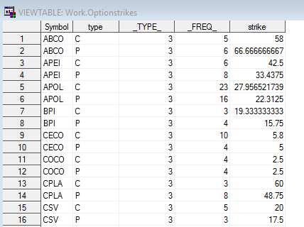

**data** work.prices;

set stocks.pricesrevised;

year=year(date);

**run**;

**proc** **means** data=work.prices n nmiss min;

class year;

var date;

**run**;

**proc** **summary** data=work.prices nway;

class year;

var date;

output out=FirstTradingDayPerYear min=;

**run**;

**proc** **print** data=FirstTradingDayPerYear;

**run**;

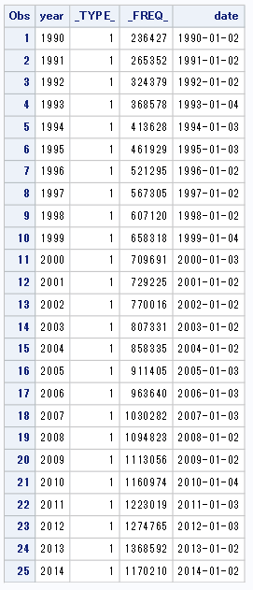

**data** MyFirstTradingDay;

set stocks.pricesrevised;

if date=**"03Jan2012"d**;

**run**;

**proc** **sort** data=MyFirstTradingDay;

by tic;

**run;**

**data** MyPriceFirstTradingDay;

merge Mycompanies (in=OnCompanies keep=symbol)

MyFirstTradingDay (in=onprices rename=(tic=symbol));

by Symbol;

if OnCompanies and onprices;

**run**;

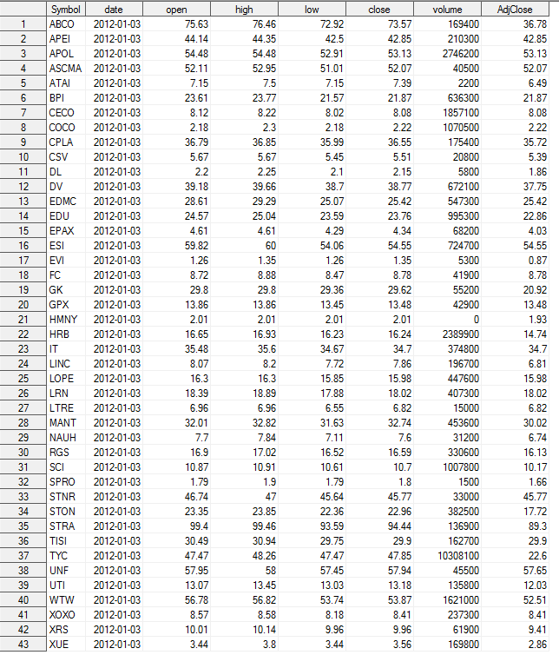

**data** work.DivFile;

set stocks.DivFile;

where Date ge **"01Jan2010"d**;

rename tic=Symbol;

**run**;

**data** MyDividends;

merge MyPriceFirstTradingDay (in=onprice)

Divfile (in=ondiv);

by symbol;

if onprice and ondiv;

**run**;

**proc** **summary** data=MyDividends nway;

class symbol adjclose;

var DivAmount;

output out=Divsum sum=;

**run**;

**data** DivCalc;

format DivYield percent8.1;

set DivSum;

DivYield=DivAmount/Adjclose;

**run**;

**proc** **print** data=DivCalc;

**run**;

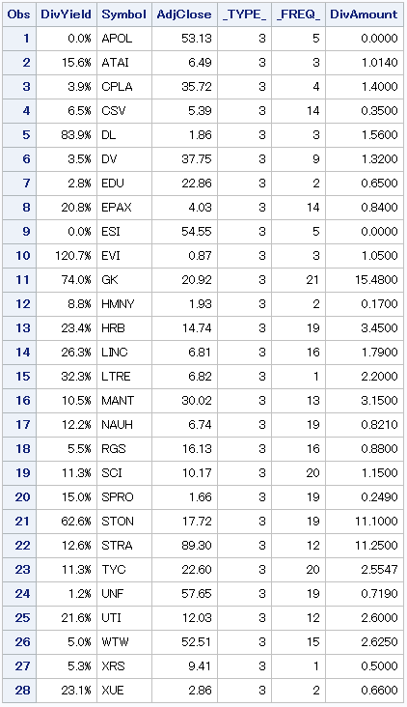

**data** work.splits (drop=date rename=(splitdate=date));

set stocks.splits;

splitdate = input(date,YYMMDD10.);

format splitdate YYMMDD10.;

rename tic=Symbol;

**run**;

**data** Mysplits;

merge Mycompanies (in=oncompanies keep=symbol)

splits (in=onsplits);

by symbol;

if oncompanies and onsplits

and date ge **"01Jan1988"d**;

**run**;

**proc** **summary** data=Mysplits nway;

class symbol;

var split;

output out=Splitminmax (drop=_type_) min=splitmin max=splitmax;

**run**;

**proc** **print** data=Splitminmax;

**run**;

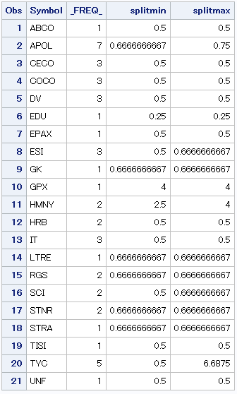

**data** Onepersymbolstart;

merge mycompanies (in=onbase keep=symbol)

splitminmax (in=onsplits)

divcalc (in=ondiv);

by symbol;

if onbase;

**run**;

**proc** **freq** data=myoptions;

table symbol /out=optionscount (drop=percent rename=(count=optionscount));

**run**;

**proc** **transpose** data=optionstrikes (drop=_type_ _freq_)

out=optionstransposed prefix=strikeprice_;

by symbol;

id type;

var strike;

**run**;

**proc** **print** data=optionstransposed;

**run**;

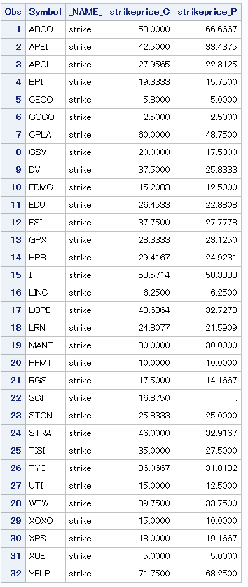

**data** Onepersymbolround2;

merge mycompanies (in=onbase keep=symbol)

splitminmax (in=onsplits rename=(_freq_=splitcount))

divcalc (in=ondiv drop=_type_ _freq_ adjclose)

optionscount (in=onoptions)

optionstransposed (in=optionsprices drop=_NAME_)

;

by symbol;

if onbase;

**run**;

options label;

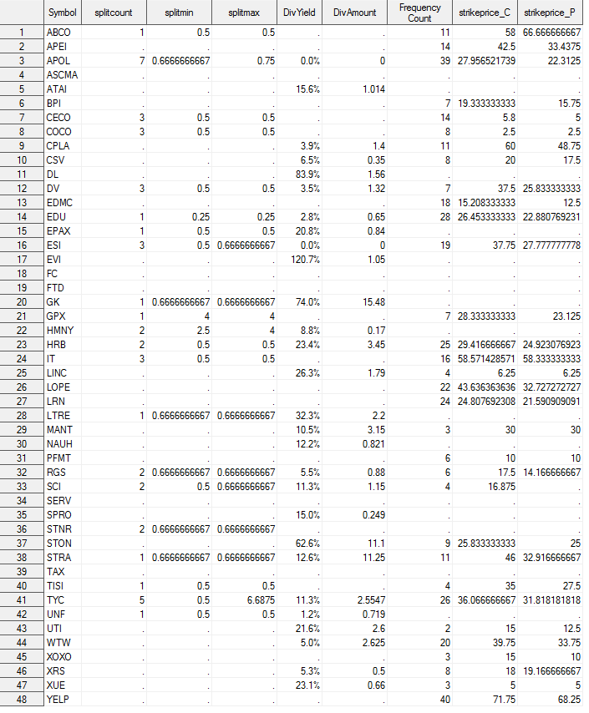

**data** onepersymbolnoblanks;

set Onepersymbolround2;

format strikeprice_C strikeprice_P **8.2**;

array numbervars _numeric_;

do over numbervars;

if numbervars=**.** then numbervars=**0**;

end;

**run**;

**proc** **print** data=onepersymbolnoblanks;

**run**;

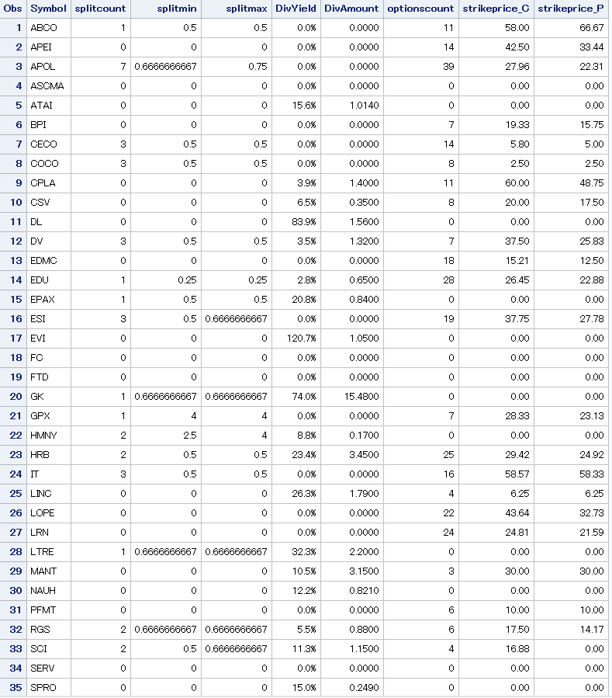

**data** onepersymbolnoblanks;

set Onepersymbolround2;

format strikeprice_C strikeprice_P **8.2**;

array BlankToZero splitcount divyield divamount optionscount;

do over BlankToZero;

if BlankToZero=**.** then BlankToZero=**0**;

end;

**run**;

**proc** **print** data=onepersymbolnoblanks;

**run**;

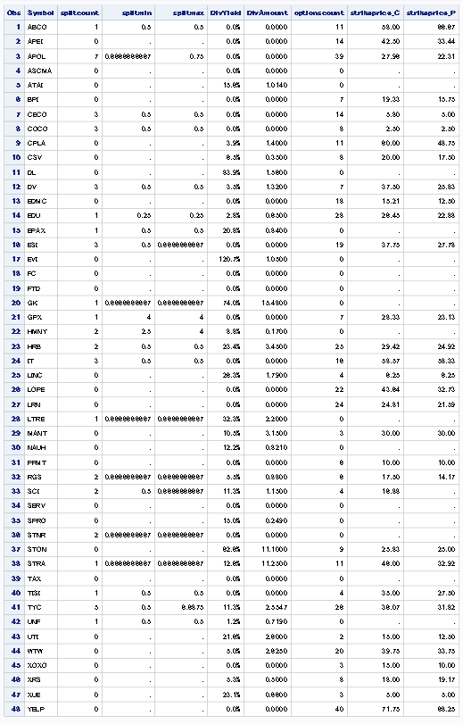

**Little Book Method**

**data** Mycompany;

set stocks.annualreports;

format InfoAvailDate YYMMDD10.;

where sector="Consumer Servic" and Industry="Other Consumer Servic";

fiscalyeardate=datepart(IndFinancialYearEnd);

FiscalYear=Year(FiscalYearDate);

InfoAvailDate=input(IndDatePrelimLoaded,YYMMDD10.);

**run**;

**Proc** **sort** data=Mycompany nodupkey;

by symbol Indfinancialyearend;

**run**;

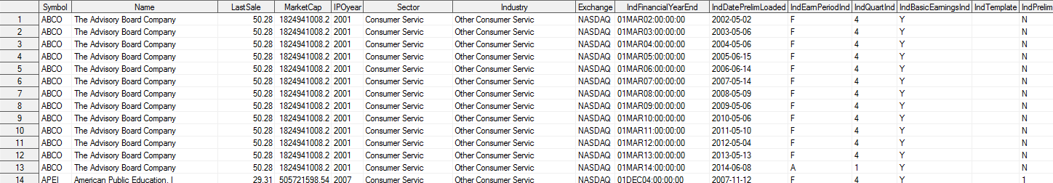

**data** report2009;

set mycompany (keep=fiscalyear ebit bstotalcurrentliabilities bsltdebt bsminorintliab bsprefstockeq

bscash bsnetfixedass bswc symbol infoavaildate bssharesoutcommon);

where fiscalyear=**2009**;

returnoncapital=ebit/(bsnetfixedass+bswc);

**run**;

**proc** **rank** data=report2009 out=report2009ROC descending;

var returnoncapital;

ranks rankroc;

**run**;

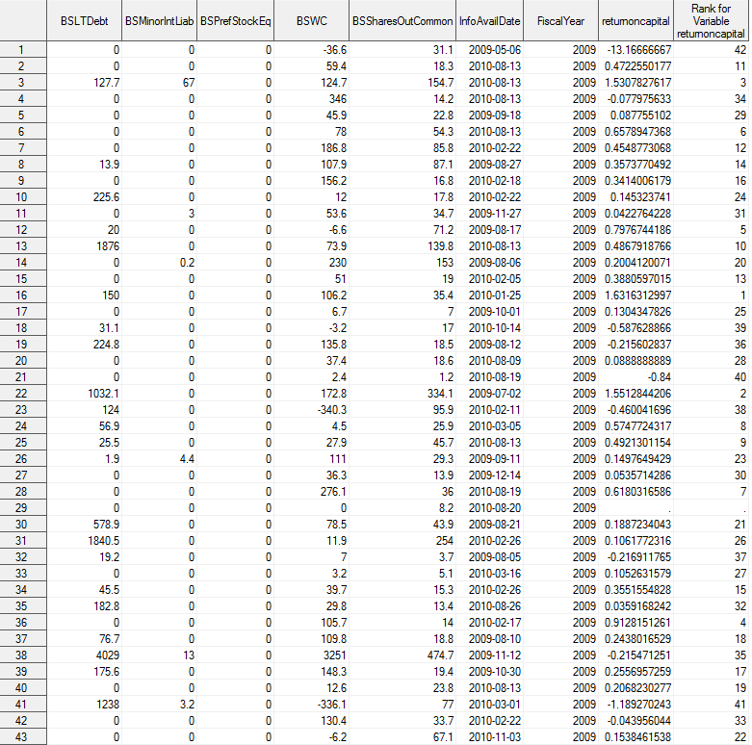

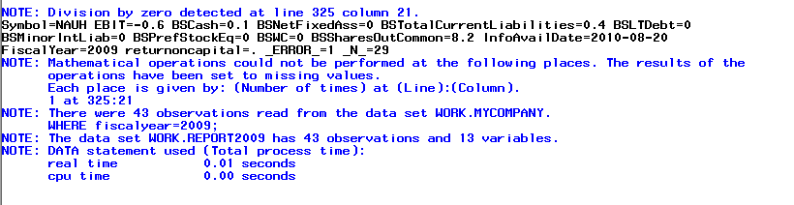

**data** GetPrices;

merge report2009roc (in=onbase)

stocks.pricesrevised (in=onprices rename=(tic=symbol) keep=tic date close adjclose);

by symbol;

if onbase and date=InfoAvailDate;

**run**;

**proc** **freq** data=getprices;

tables symbol;

title "GetPrices";

**run**;

title;

**data** GetPrices2;

merge report2009roc (in=onbase)

stocks.pricesrevised (in=onprices rename=(tic=symbol) keep=tic date close adjclose);

by symbol;

if onbase and InfoAvailDate<=date<=InfoAvailDate+**5**;

**run**;

**proc** **freq** data=getprices2;

tables symbol;

title "GetPrices2";

**run**;

title;

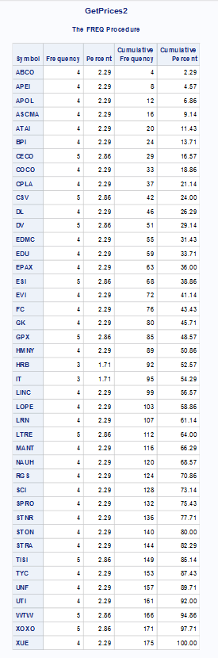

**data** getpricesfirst;

set getprices2;

by symbol date;

if first.symbol;

**run**;

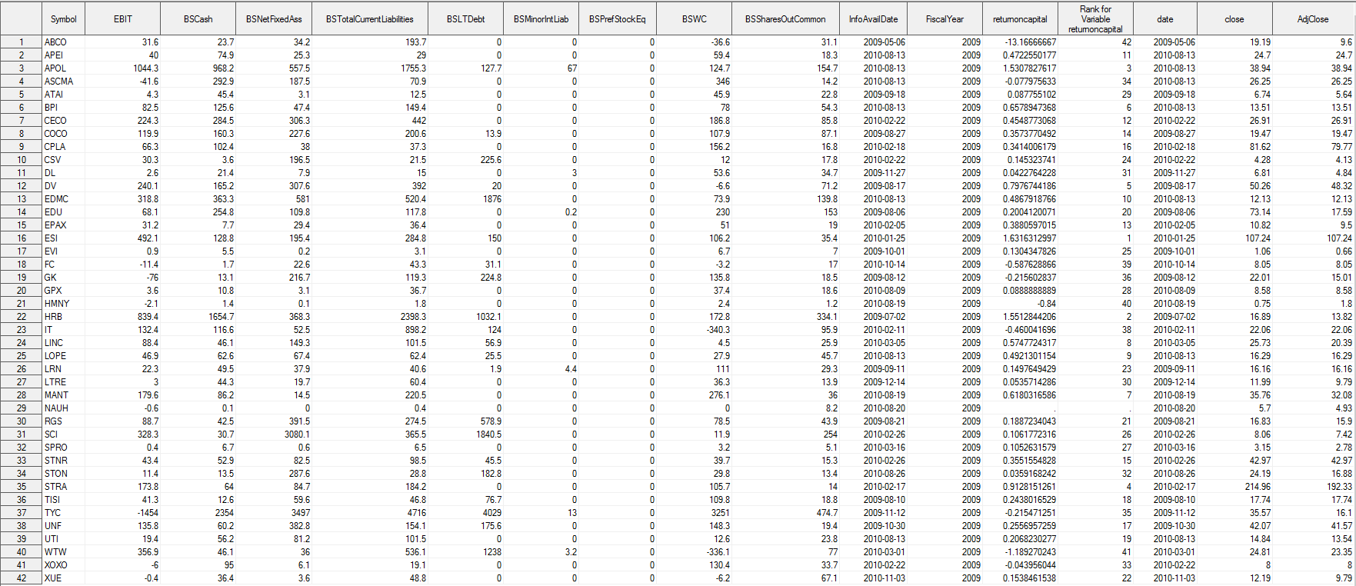

**data** EarningsYield;

set getpricesfirst;

marketcap=close*bssharesoutcommon;

earningsYield=ebit/(marketcap+bstotalcurrentliabilities+bsltdebt+bsminorintliab+bsprefstockeq-bscash);

**run**;

**proc** **rank** data=EarningsYield out=EYandROCRank descending;

var earningsyield;

ranks rankEY;

**run**;

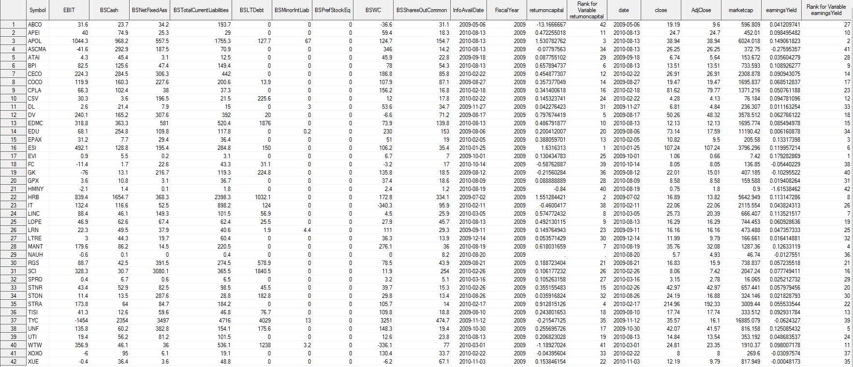

**proc** **plot** data=EYandROCRank;

plot RankEY*RankROC=''$symbol;

**run**;

**quit**;

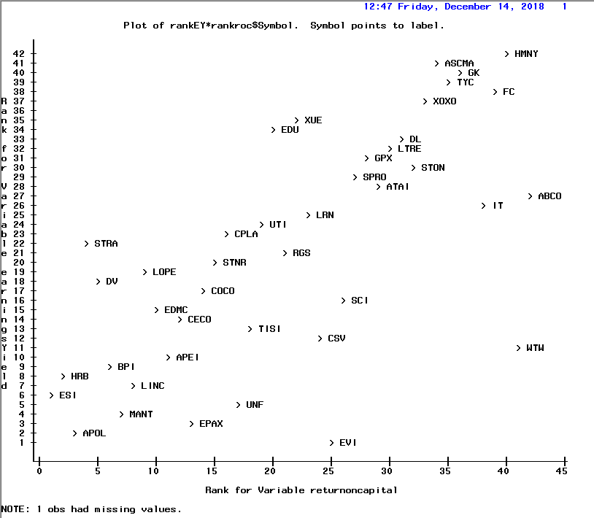

**data** AvgRank;

set EYandrocrank;

Avgrank=(rankey+rankroc)/**2**;

**run**;

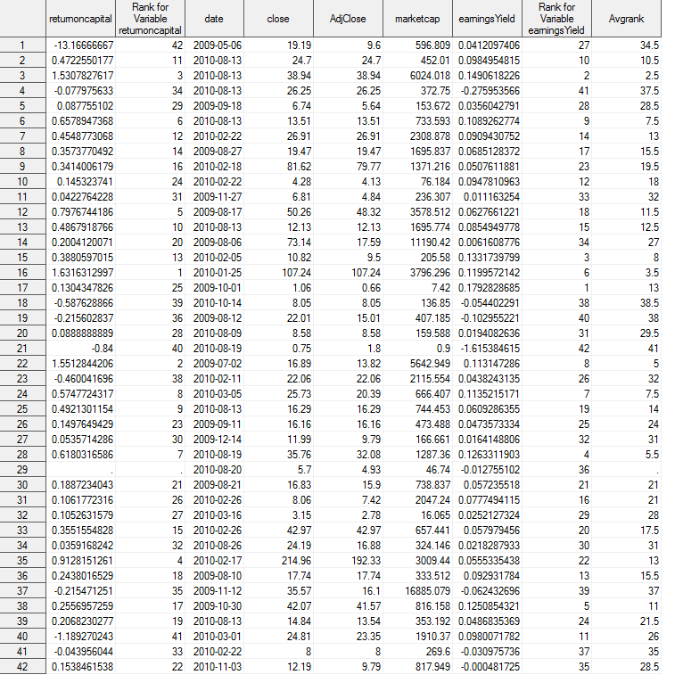

**data** Mycompaniesoneyearlater (keep=symbol fiscalyear infoavaildate);

set stocks.annualreports;

format InfoAvailDate YYMMDD10.;

where sector="Consumer Servic" and Industry="Other Consumer Servic";

fiscalyeardate=datepart(IndFinancialYearEnd);

FiscalYear=Year(FiscalYearDate);

InfoAvailDate=input(IndDatePrelimLoaded,YYMMDD10.);

if fiscalyear=**2010**;

**run**;

**data** Oneyearlaterwithprice;

merge Mycompaniesoneyearlater (in=oncompanies)

stocks.pricesrevised (in=onprices rename=(tic=symbol adjclose=lateradjclose) keep=tic date close adjclose);

by symbol;

if InfoAvailDate-**5**<=date<=InfoAvailDate-**1**;

**run**;

**data** pricebeforenextreport;

set Oneyearlaterwithprice;

by symbol date;

if last.symbol;

**run**;

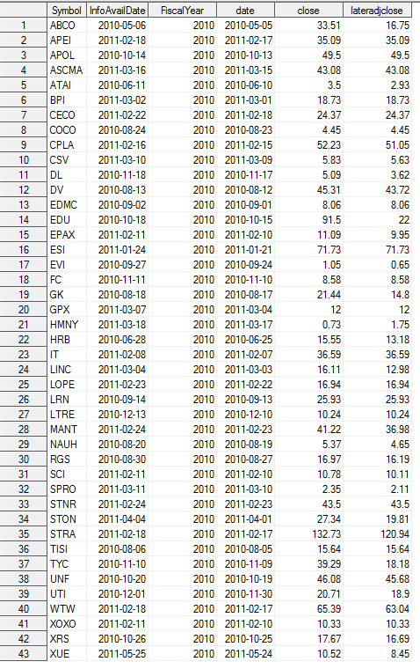

**data** evalbeforenextreport;

merge avgrank (in=onbase)

pricebeforenextreport (in=onnext);

by symbol;

if onbase;

return=(lateradjclose-adjclose)/adjclose;

**run**;

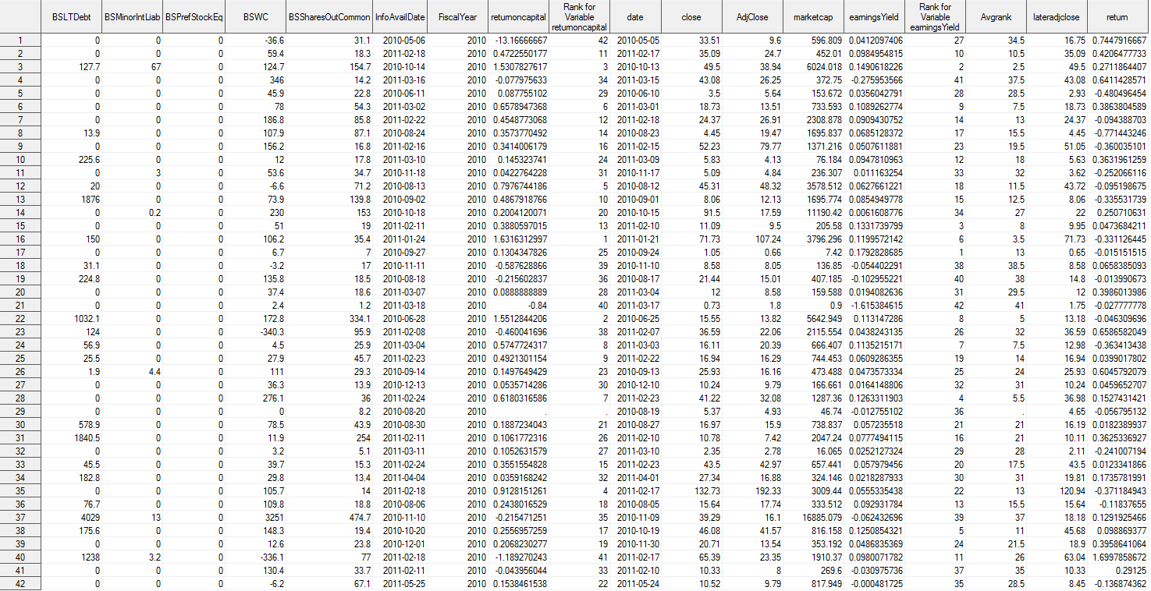

**proc** **plot** data=evalbeforenextreport;

plot return*avgrank=''$symbol;

**run**;

**quit**;

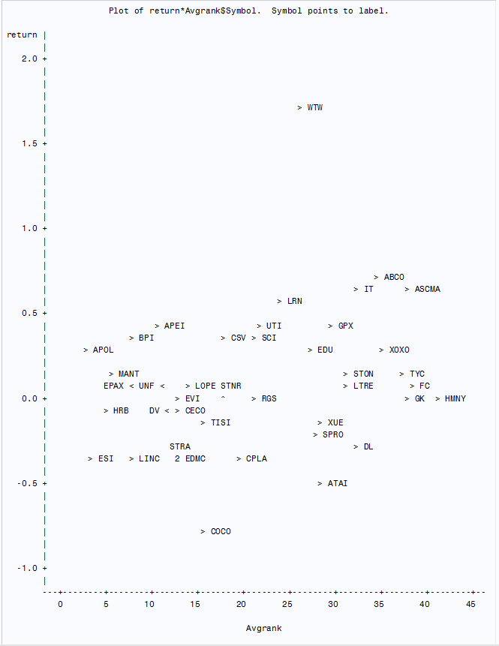

**data** muchlaterprice (keep=tic adjclose rename=(tic=symbol adjclose=adjclose2014));

set stocks.pricesrevised;

if date=**"02Jan2014"d**;

**run**;

**data** LaterReturn;

merge EvalBeforeNextReport (in=onbase)

muchlaterprice (in=onlater)

;

by symbol;

if onbase;

return2014=(adjclose2014-adjclose)/adjclose;

**run**;

**proc** **plot** data=laterreturn;

plot return2014*avgrank=''$symbol;

**run**;

**quit**;

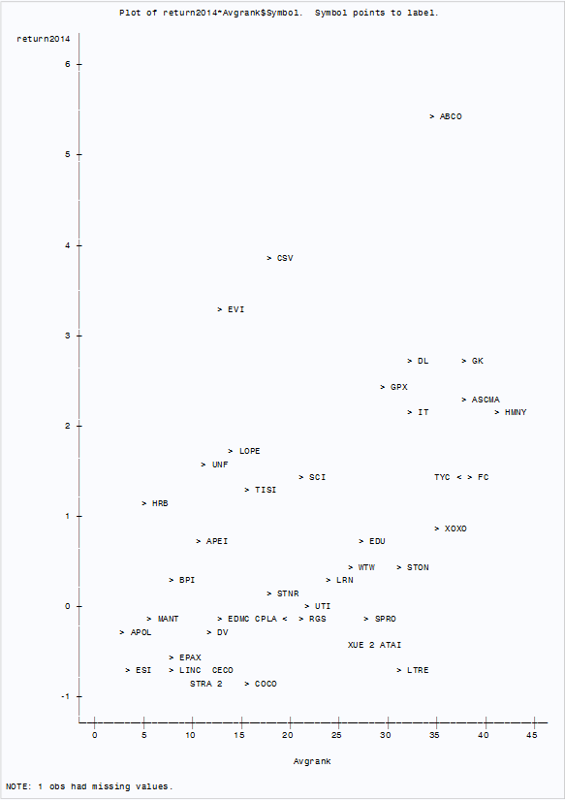

**proc** **reg** data=laterreturn;

model return2014=avgrank;

**run**;

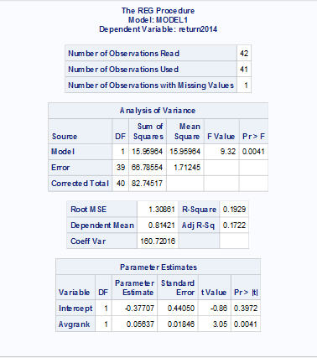

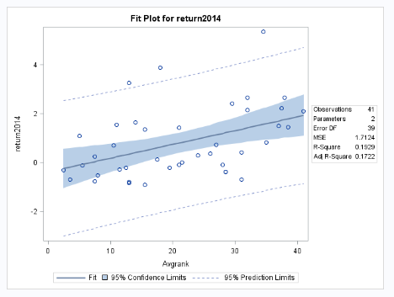

**proc** **reg** data=laterreturn;

model return=avgrank;

**run**;

**quit**;

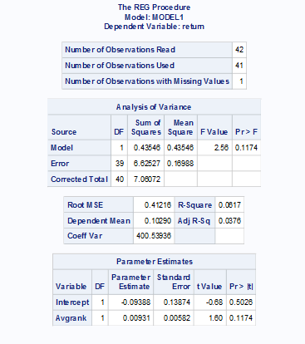

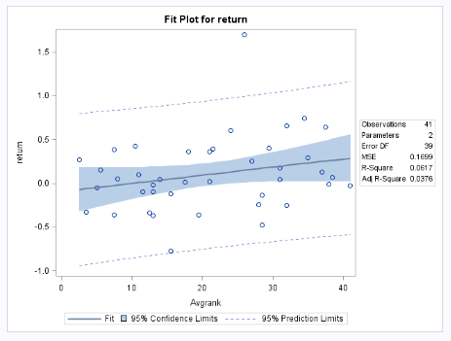

**Synopsis**

The top companies with higher return on capital are ITT Educational Services, In, H&R Block, Inc. and Apollo Education Group, Inc. The top companies with higher earning yield are EnviroStarm, Inc., Apollo Education Group, Inc. and Ambassadors Group, Inc. Based on little book that beats the market, by combining both return on capital and earnings yield, the top companies with best returns are ITT Educational Services, In, H&R Block, Inc., Apollo Education Group, Inc., Bridgepoint Education, Inc., Lincoln Educational Services and ManTech International Corporation.

For one year return in 2010, Apollo Education Group, Inc. has the better return for top ranks. But for return in 2014, H&R Block, Inc. has the higher return for better ranks.

Based on linear regression, Average rank for return on year 2014 has small positive slope with good statistical significance for all three confidence intervals (1%, 5%, 10%) and has an adjusted R square value of 17%. Though average rank for return on one year has small positive slope it does not have good statistical significance and has a low adjusted R square value of 3%. Average rank for return on year 2014 has more predictive power than the one year returns, but it is limited.