Experiment No.: 02

- Title: Use var, let, const, and demonstrate basic features like template literals and destructuring, build a billing calculator with user input.
- Software/Tools Required: HTML, VS Code.
- Theory: JavaScript is a scripting language used to make web pages interactive and dynamic. It allows developers to perform calculations, validate user input, display messages, and manipulate webpage content. In this experiment, a Billing Calculator is developed using JavaScript. The program accepts user inputs such as customer name, product name, quantity, and price per item through dialog boxes (prompt()). It then calculates the total bill and displays a formatted billing receipt on the webpage. The program demonstrates the following JavaScript features:
- var – Used to declare function-scoped variables. It can be redeclared and updated.
- let – Used to declare block-scoped variables. It can be updated but not redeclared within the same scope.
- const – Used to declare constants whose values cannot be reassigned.
- Template Literals – Enclosed within backticks (`), they allow embedding variables directly into strings using ${} for easier string formatting.
- Destructuring – A feature that extracts values from arrays or objects into separate variables, making the code cleaner and more readable.
- Output:

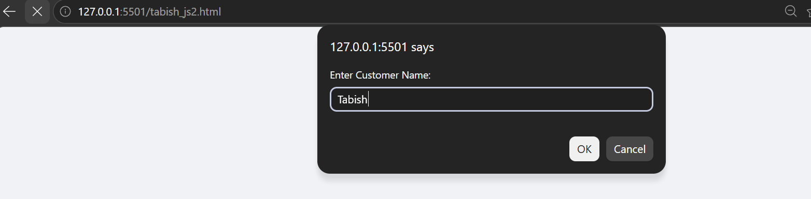
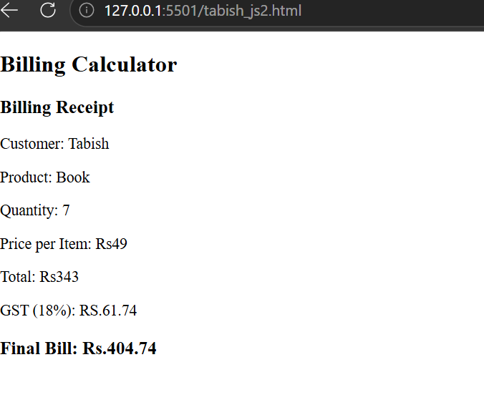

Case Study No.: 2
1. Case Study Title: Develop a webpage for an online shopping website using HTML,CSS,HTML5, and calculate bills
Program Code:
<!DOCTYPE html>
<html lang="en">
<head>
<meta charset="UTF-8">
<meta name="viewport" content="width=device-width, initial-scale=1.0">
<title>Online Shopping Store</title>

<style>
*{
margin:0;
padding:0;
box-sizing:border-box;
font-family:Arial, Helvetica, sans-serif;
}

body{
background:#eef4ff;
}

header{
background:linear-gradient(90deg,#4f46e5,#06b6d4);
color:white;
padding:20px;
text-align:center;
}

nav{
background:#1e293b;
padding:15px;
text-align:center;
}

nav a{
color:white;
text-decoration:none;
margin:20px;
font-weight:bold;
}

nav a:hover{
color:#38bdf8;
}

section{
width:90%;
margin:auto;
padding:30px;
}

.products{
display:flex;
justify-content:space-around;
flex-wrap:wrap;
gap:20px;
}

.card{
background:white;
width:250px;
padding:20px;
border-radius:12px;
box-shadow:0 5px 15px rgba(0,0,0,.2);
text-align:center;
}

.card img{
width:180px;
height:180px;
object-fit:cover;
}

.card h3{
color:#1e3a8a;
margin:10px 0;
}

.price{
color:#059669;
font-size:22px;
font-weight:bold;
}

input{
width:80px;
padding:8px;
margin-top:10px;
}

button{
margin-top:15px;
padding:10px 20px;
background:#4f46e5;
color:white;
border:none;
border-radius:6px;
cursor:pointer;
font-size:16px;
}

button:hover{
background:#3730a3;
}

.bill{
margin-top:40px;
background:white;
padding:25px;
border-radius:10px;
box-shadow:0 5px 15px rgba(0,0,0,.2);
}

footer{
margin-top:40px;
background:#1e293b;
color:white;
text-align:center;
padding:15px;
}
</style>
</head>

<body>

<header>
<h1>🛒 Trendy Online Shopping Store</h1>
<p>Best Deals | Best Prices</p>
</header>

<nav>
<a href="#">Home</a>
<a href="#">Products</a>
<a href="#">Offers</a>
<a href="#">Contact</a>
</nav>

<section>

<div class="products">

<div class="card">

<h3>Laptop</h3>
<p class="price">₹50000</p>
Quantity<br>
<input type="number" id="lap" value="0" min="0">
</div>

<div class="card">

<h3>Smart Phone</h3>
<p class="price">₹20000</p>
Quantity<br>
<input type="number" id="phone" value="0" min="0">
</div>

<div class="card">

<h3>Headphones</h3>
<p class="price">₹3000</p>
Quantity<br>
<input type="number" id="head" value="0" min="0">
</div>

</div>

<center>
<button onclick="bill()">Calculate Bill</button>
</center>

<div class="bill">
<h2>Bill Details</h2>
<h3 id="output"></h3>
</div>

</section>

<footer>
<p>© 2026 Trendy Online Shopping Store | Designed by Tabish Mansoori</p>
</footer>

<script>

function bill(){

let laptop=50000;
let phone=20000;
let head=3000;

let q1=parseInt(document.getElementById("lap").value)||0;
let q2=parseInt(document.getElementById("phone").value)||0;
let q3=parseInt(document.getElementById("head").value)||0;

let total=(q1*laptop)+(q2*phone)+(q3*head);

let gst=total*0.18;

let finalBill=total+gst;

document.getElementById("output").innerHTML=
`
Laptop : ₹${q1*laptop}<br><br>
Phone : ₹${q2*phone}<br><br>
Headphones : ₹${q3*head}<br><br>

Subtotal : ₹${total}<br><br>
GST (18%) : ₹${gst.toFixed(2)}<br><br>

<b style="color:green;font-size:25px;">
Grand Total : ₹${finalBill.toFixed(2)}
</b>
`;

}

</script>

</body>
</html>

Output
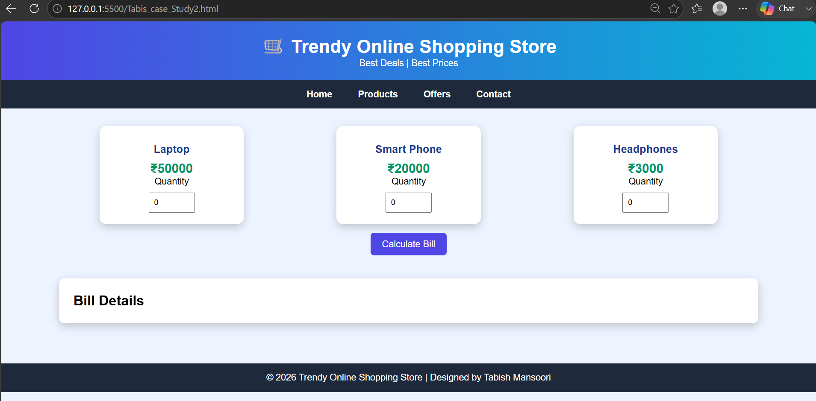

- Result/Conclusion: The Billing Calculator was successfully implemented using JavaScript. The program accepts user input, performs the billing calculation, and displays the receipt correctly. It successfully demonstrates the use of var, let, const, template literals, and destructuring while providing a simple and interactive billing application.

