Experiment No.: 01

Title: Demonstrate inline, internal, and external JavaScript; use console methods; create a webpage showing user info and a welcome message.

Software/Tools Required: HTML, VS Code.

Theory: HTML (HyperText Markup Language) is the standard language used to create web pages. It provides the basic structure of a webpage using elements such as headings, paragraphs, images, lists, tables, and buttons. CSS (Cascading Style Sheets) is used to style the webpage. It controls the layout, colors, fonts, spacing, and overall appearance of the webpage. In this program, an "About Me" webpage is created using HTML and CSS. The webpage contains a profile picture, personal information, skills, education details, and a contact button. CSS is used to improve the appearance by adding colors, spacing, borders, and alignment.

Output: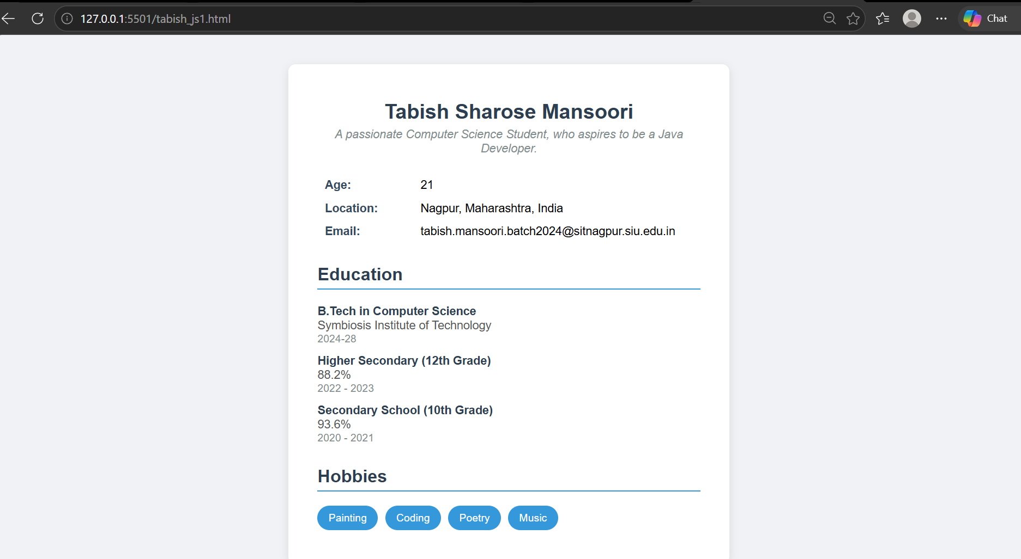

Case Study Program Code:

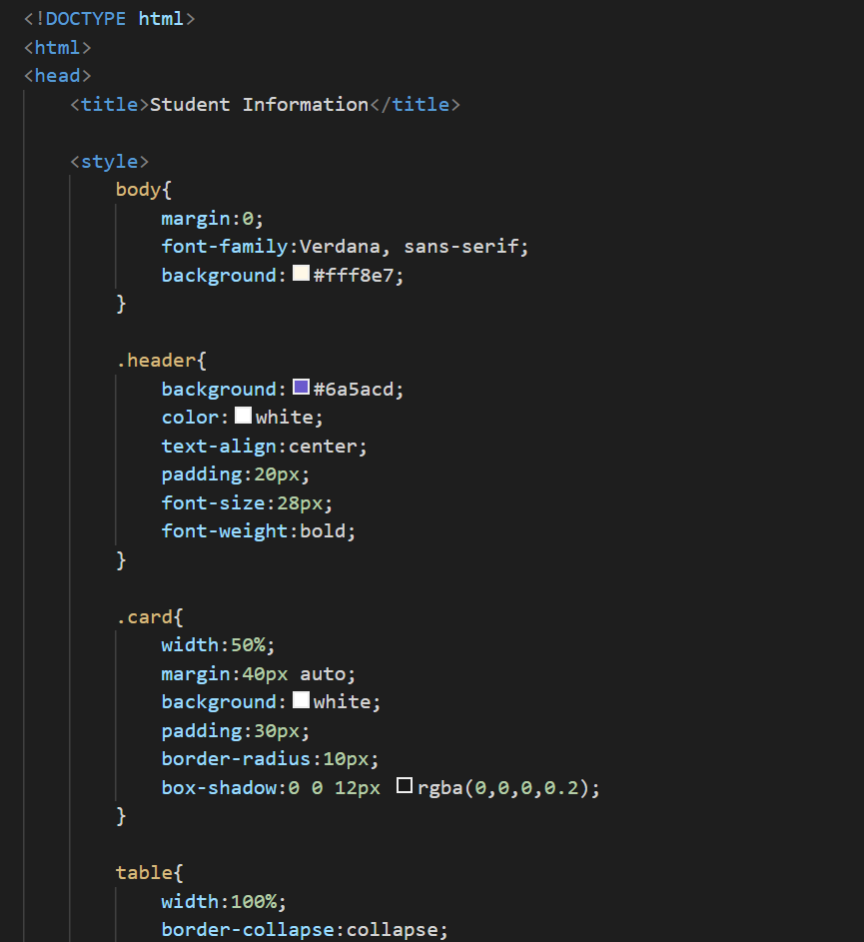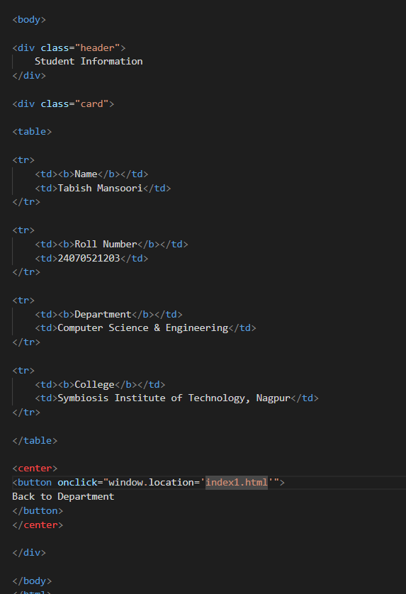

Output:

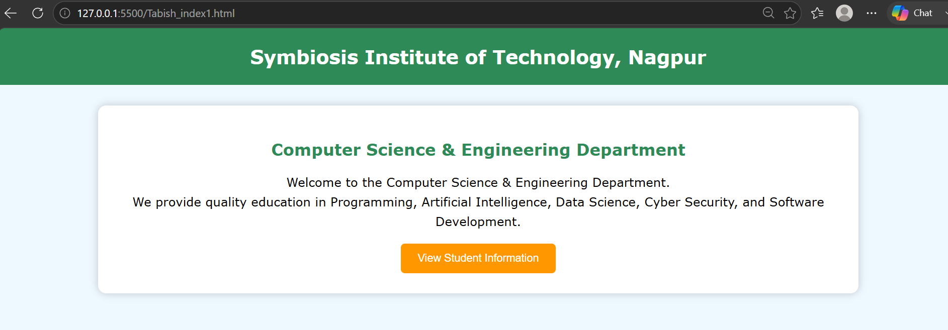

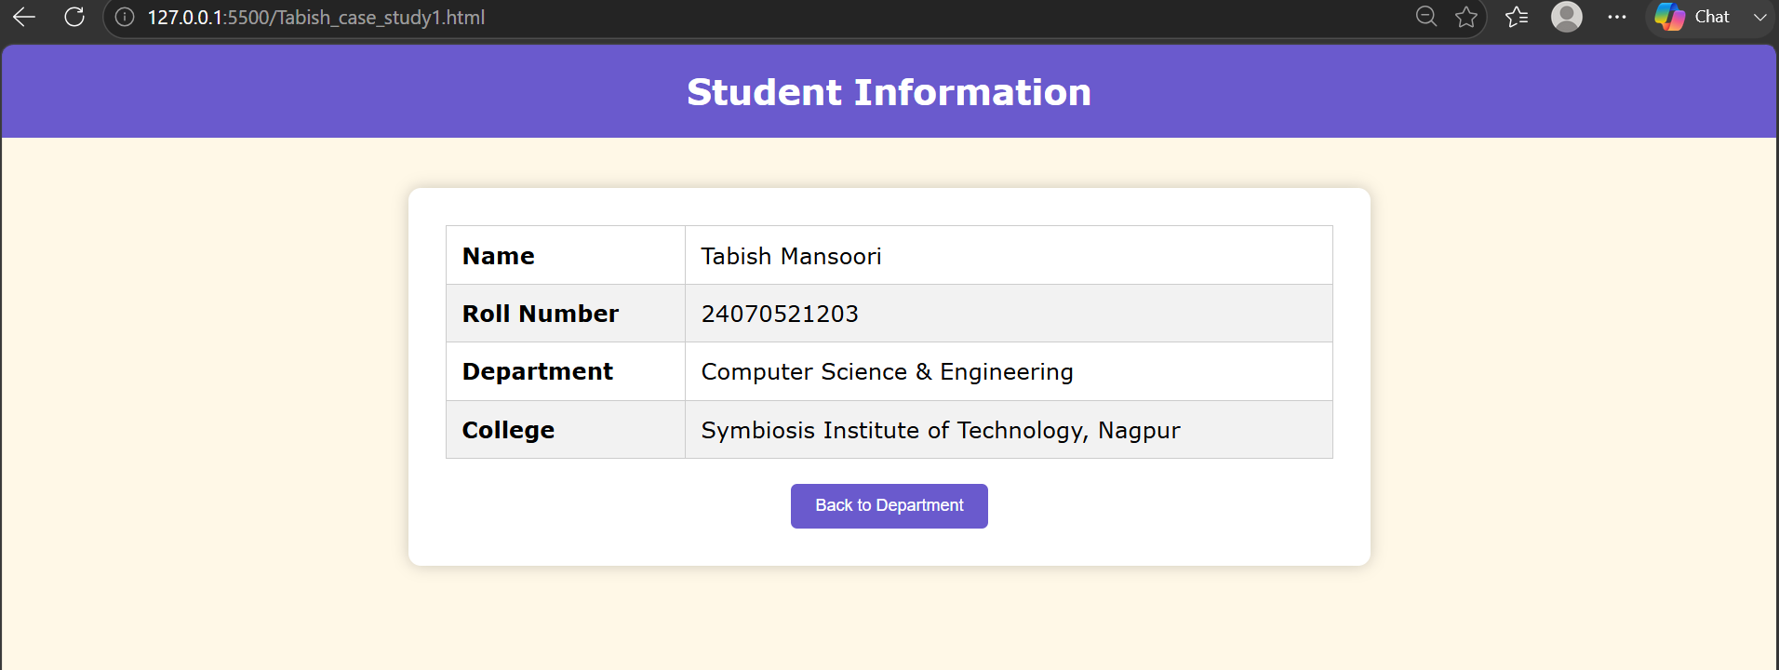
Result/Conclusion: The "About Me" webpage was successfully created using HTML and CSS. The webpage displays personal information in a well-organized and visually appealing format. This practical demonstrates the basic use of HTML for webpage structure and layout.

