Experiment No.: 03

Title: Implement control structures and form validation; create a grading system based on user-entered marks.

Software/Tools Required: HTML, VS Code.

Theory: This experiment demonstrates the use of control structures (if-else statements) and form validation in JavaScript. The user enters marks through an HTML form, and the program checks whether the input is valid (between 0 and 100). Based on the entered marks, the program determines the student's grade using conditional statements and displays the result dynamically on the webpage. This experiment helps in understanding decision-making, input validation, and user interaction in web development.

Output:

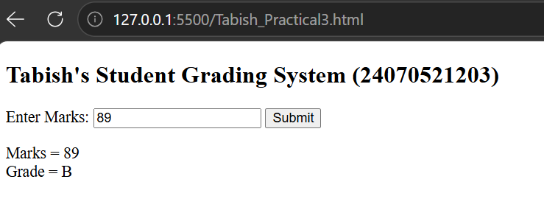

Case Study Program Code:
<!DOCTYPE html>
<html lang="en">
<head>
<meta charset="UTF-8">
<meta name="viewport" content="width=device-width, initial-scale=1.0">
<title>Scholarship Eligibility Checker</title>

<style>
*{
margin:0;
padding:0;
box-sizing:border-box;
font-family:Arial, Helvetica, sans-serif;
}

body{
background:#eef2f7;
display:flex;
justify-content:center;
align-items:center;
height:100vh;
}

.container{
width:400px;
background:#ffffff;
padding:30px;
border-radius:12px;
box-shadow:0 8px 20px rgba(0,0,0,0.15);
text-align:center;
}

h1{
color:#1f3b73;
margin-bottom:10px;
}

p{
color:#555;
margin-bottom:20px;
}

input{
width:100%;
padding:12px;
font-size:16px;
border:1px solid #bfc9d9;
border-radius:6px;
margin-bottom:20px;
}

button{
width:100%;
padding:12px;
background:#1f3b73;
color:white;
border:none;
border-radius:6px;
font-size:16px;
cursor:pointer;
}

button:hover{
background:#294d8b;
}

.result{
margin-top:20px;
padding:15px;
background:#f4f7fb;
border-left:5px solid #1f3b73;
border-radius:6px;
font-size:18px;
font-weight:bold;
color:#1f3b73;
}
</style>

</head>
<body>

<div class="container">

<h1>Scholarship Eligibility</h1>

<p>Enter Student Marks (0 - 100)</p>

<input type="number" id="marks" min="0" max="100" placeholder="Enter Marks">

<button onclick="checkScholarship()">
Check Eligibility
</button>

<div class="result" id="result">
Result will appear here.
</div>

</div>

<script>

function checkScholarship(){

let marks=parseInt(document.getElementById("marks").value);
let category="";

if(isNaN(marks) || marks<0 || marks>100){
category="Please enter valid marks between 0 and 100.";
}
else if(marks<50){
category="Not Eligible";
}
else if(marks<=69){
category="Bronze Scholarship";
}
else if(marks<=84){
category="Silver Scholarship";
}
else if(marks<=94){
category="Gold Scholarship";
}
else{
category="Platinum Scholarship";
}

document.getElementById("result").innerHTML=category;

}

</script>

</body>
</html>

Output:


Result/Conclusion:
The grading system successfully accepted the user's marks, validated the input, and displayed the correct grade according to the predefined grading criteria. This experiment helped in understanding how form validation ensures valid user input and how control structures (if-else statements) are used to make decisions and generate appropriate output in a web application.

