Experiment No.: 04

1. Title: Implement control structures and form validation; create a grading system based on user-entered marks.

2. Software/Tools Required: HTML, VS Code.

3. Theory: JavaScript provides different types of functions, such as function declarations, function expressions, and arrow functions, to perform reusable tasks efficiently. Variable scope controls where variables can be accessed and includes global, function, and block scope. A closure is a feature in which an inner function remembers and accesses variables from its outer function even after the outer function has finished execution. JavaScript also supports exception handling through the try-catch statement, which helps detect and manage runtime errors without stopping the program. In this practical, these concepts are applied to develop a palindrome checker, which verifies whether a given string or number reads the same forwards and backwards, demonstrating the practical use of functions, scope, closures, and error handling.

4. Output:
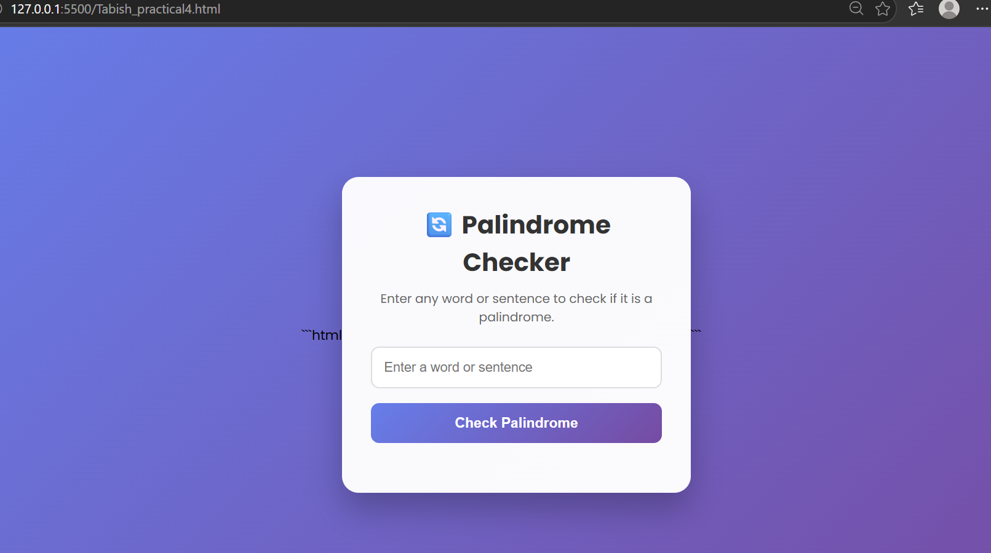
CASE STUDY-04: ATM Card PIN Verification Using JavaScript
Functions 1.Aim: To verify whether an ATM PIN is a palindrome using JavaScript functions and demonstrate function declaration, function expression, arrow function, and scope.
Program Source Code:
<!DOCTYPE html>
<html lang="en">
<head>
<meta charset="UTF-8">
<meta name="viewport" content="width=device-width, initial-scale=1.0">
<title>ATM PIN Verification</title>

<style>

*{
margin:0;
padding:0;
box-sizing:border-box;
font-family:Arial, Helvetica, sans-serif;
}

body{
display:flex;
justify-content:center;
align-items:center;
height:100vh;
background:linear-gradient(135deg,#4338ca,#0f766e);
}

.container{
width:380px;
background:white;
padding:35px;
border-radius:18px;
text-align:center;
box-shadow:0 12px 30px rgba(0,0,0,0.3);
}

.logo{
width:70px;
height:70px;
background:linear-gradient(135deg,#14b8a6,#4338ca);
color:white;
font-size:28px;
font-weight:bold;
display:flex;
justify-content:center;
align-items:center;
margin:auto;
border-radius:15px;
}

h1{
margin-top:18px;
color:#312e81;
font-size:30px;
}

p{
margin:10px 0 25px;
color:#666;
}

input{
width:100%;
padding:14px;
font-size:20px;
text-align:center;
border:2px solid #14b8a6;
border-radius:10px;
outline:none;
}

input:focus{
border-color:#4338ca;
}

button{
width:100%;
margin-top:25px;
padding:14px;
background:#4338ca;
color:white;
border:none;
border-radius:10px;
font-size:18px;
cursor:pointer;
transition:.3s;
}

button:hover{
background:#312e81;
}

.result{
margin-top:25px;
padding:18px;
border-radius:10px;
display:none;
}

.success{
background:#dcfce7;
border:2px solid #22c55e;
color:#166534;
}

.error{
background:#fee2e2;
border:2px solid #ef4444;
color:#991b1b;
}

.footer{
margin-top:20px;
color:#666;
font-size:14px;
}

</style>
</head>

<body>

<div class="container">

<div class="logo">ATM</div>

<h1>ATM PIN Verification</h1>

<p>Enter your ATM PIN</p>

<input type="password" id="pin" maxlength="6" placeholder="Enter PIN">

<button onclick="verifyPIN()">Verify PIN</button>

<div id="result" class="result"></div>

<div class="footer">
XYZ Bank Security System
</div>

</div>

<script>

function verifyPIN(){

let pin=document.getElementById("pin").value;
let result=document.getElementById("result");

if(pin==""){
result.style.display="block";
result.className="result error";
result.innerHTML="⚠ Please enter your PIN.";
return;
}

let reverse=pin.split("").reverse().join("");

if(pin===reverse){

result.style.display="block";
result.className="result success";

result.innerHTML=
"<h2>✔ PIN Verified</h2>" +
"<br><b>Bank :</b> XYZ Bank" +
"<br><br><b>PIN :</b> "+pin+
"<br><br>🎉 Your PIN is a <b>Palindrome</b>.";

}
else{

result.style.display="block";
result.className="result error";

result.innerHTML=
"<h2>✖ PIN Verified</h2>" +
"<br><br><b>PIN :</b> "+pin+
"<br><br>Your PIN is <b>Not a Palindrome</b>.";

}

}

</script>

</body>
</html>

Output:
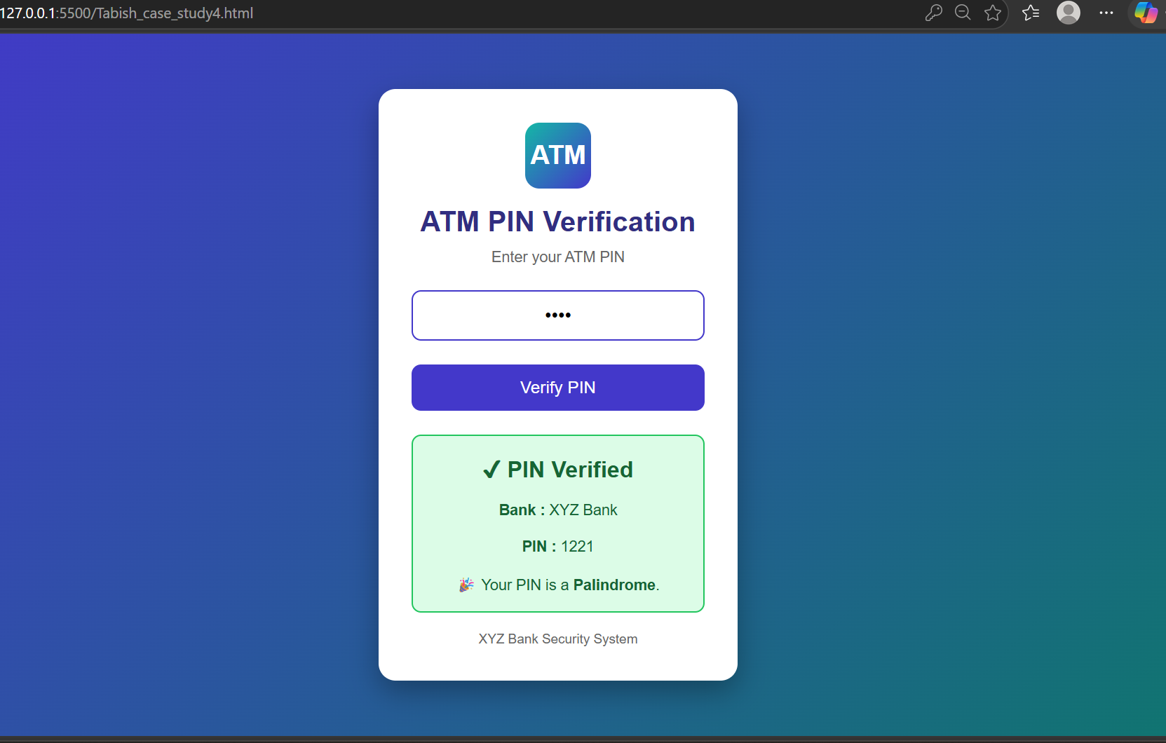
5. Result: The program was executed successfully. It demonstrated different types of JavaScript functions, variable scope, closures, and exception handling using trycatch. The palindrome checker correctly identified whether the given input was a palindrome or not

