

Experiment No.: 04

- Title: Implement control structures and form validation; create a grading system based on user-entered marks.

- Software/Tools Required: HTML, VS Code.

- Theory: JavaScript provides different types of functions, such as function declarations, function expressions, and arrow functions, to perform reusable tasks efficiently. Variable scope controls where variables can be accessed and includes global, function, and block scope. A closure is a feature in which an inner function remembers and accesses variables from its outer function even after the outer function has finished execution. JavaScript also supports exception handling through the try-catch statement, which helps detect and manage runtime errors without stopping the program. In this practical, these concepts are applied to develop a palindrome checker, which verifies whether a given string or number reads the same forwards and backwards, demonstrating the practical use of functions, scope, closures, and error handling.

- Output:

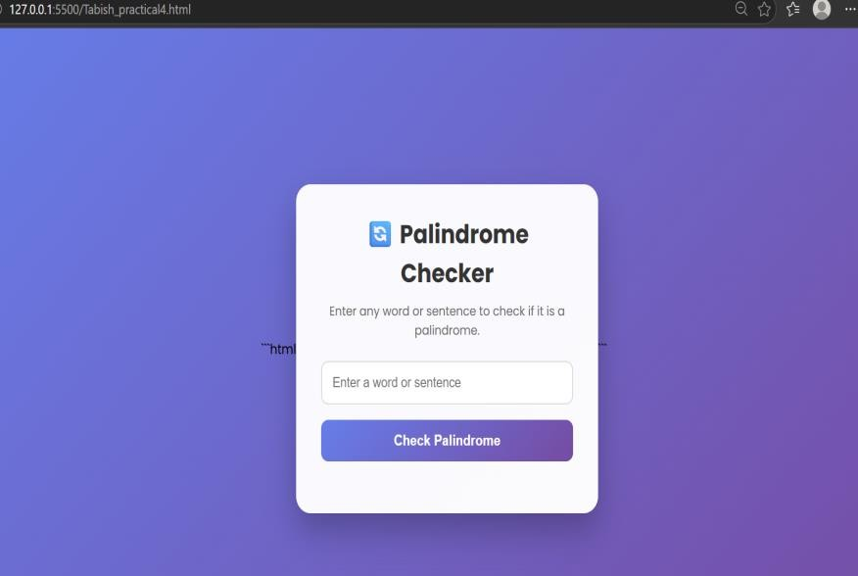
CASE STUDY-04: ATM Card PIN Verification Using JavaScript Functions 1.Aim: To verify whether an ATM PIN is a palindrome using JavaScript functions and demonstrate function declaration, function expression, arrow function, and scope.

Program Source Code:
<!DOCTYPE html>
<html lang="en">
<head>
<meta charset="UTF-8">
<meta name="viewport" content="width=device-width, initial-scale=1.0">
<title>ATM PIN Verification</title>

<style>

*{
margin:0; padding:0;
box-sizing:border-box;
font-family:Arial, Helvetica, sans-serif;
}

body{
display:flex;
justify-content:center; align-items:center; height:100vh;
background:linear-gradient(135deg,#4338ca,#0f766e);
}

.container{
width:380px; background:white; padding:35px; border-radius:18px; text-align:center;
box-shadow:0 12px 30px rgba(0,0,0,0.3);
}

.logo{
width:70px; height:70px;
background:linear-gradient(135deg,#14b8a6,#4338ca); color:white;
font-size:28px; font-weight:bold; display:flex;
justify-content:center; align-items:center; margin:auto;
border-radius:15px;
}

h1{

}

margin-top:18px; color:#312e81; font-size:30px;

p{
margin:10px 0 25px; color:#666;
}

input{
width:100%; padding:14px; font-size:20px;
text-align:center; border:2px solid #14b8a6; border-radius:10px; outline:none;

}

input:focus{
border-color:#4338ca;
}

button{
width:100%; margin-top:25px; padding:14px;
background:#4338ca; color:white; border:none; border-radius:10px; font-size:18px; cursor:pointer; transition:.3s;
}

button:hover{
background:#312e81;
}

.result{
margin-top:25px; padding:18px; border-radius:10px; display:none;
}

.success{
background:#dcfce7; border:2px solid #22c55e; color:#166534;
}

.error{
background:#fee2e2; border:2px solid #ef4444; color:#991b1b;
}

.footer{

margin-top:20px; color:#666; font-size:14px;
}

</style>
</head>

<body>

<div class="container">

<div class="logo">ATM</div>

<h1>ATM PIN Verification</h1>

<p>Enter your ATM PIN</p>

<input type="password" id="pin" maxlength="6" placeholder="Enter PIN">

<button onclick="verifyPIN()">Verify PIN</button>

<div id="result" class="result"></div>

<div class="footer"> XYZ Bank Security System
</div>

</div>

<script>

function verifyPIN(){

let pin=document.getElementById("pin").value; let result=document.getElementById("result");

if(pin==""){
result.style.display="block"; result.className="result error";
result.innerHTML="⚠ Please enter your PIN.";
return;
}

let reverse=pin.split("").reverse().join("");

if(pin===reverse){

result.style.display="block"; result.className="result success";

result.innerHTML=
"<h2>✔ PIN Verified</h2>" + "<br><b>Bank :</b> XYZ Bank" + "<br><br><b>PIN :</b> "+pin+
"<br><br>◻ Your PIN is a <b>Palindrome</b>.";

}
else{

result.style.display="block"; result.className="result error";

result.innerHTML=
"<h2>✖ PIN Verified</h2>" + "<br><br><b>PIN :</b> "+pin+
"<br><br>Your PIN is <b>Not a Palindrome</b>.";

}

}

</script>

</body>
</html>

Output:

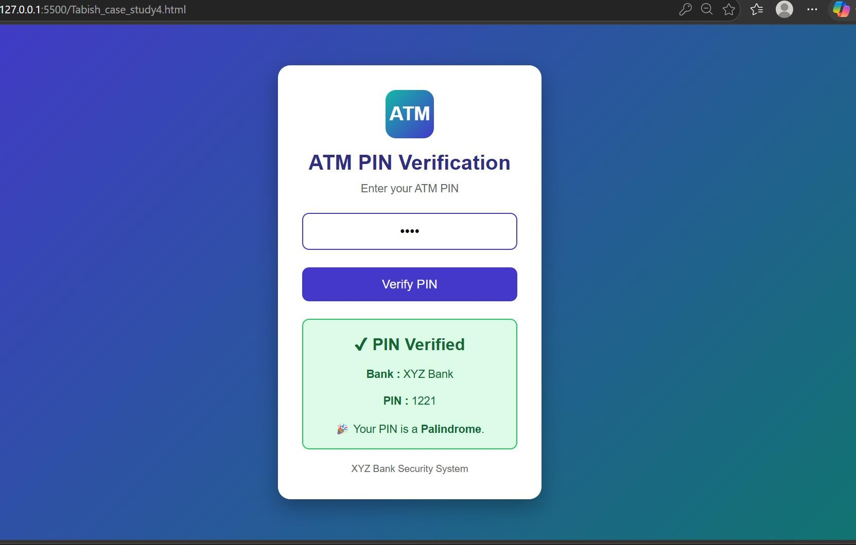

- Result: The program was executed successfully. It demonstrated different types of JavaScript functions, variable scope, closures, and exception handling using trycatch. The palindrome checker correctly identified whether the given input was a palindrome or not

Experiment No.: 03

Title: Implement control structures and form validation; create a grading system based on user-entered marks.

Software/Tools Required: HTML, VS Code.

Theory: This experiment demonstrates the use of control structures (if-else statements) and form validation in JavaScript. The user enters marks through an HTML form, and the program checks whether the input is valid (between 0 and 100). Based on the entered marks, the program determines the student's grade using conditional statements and displays the result dynamically on the webpage. This experiment helps in understanding decision-making, input validation, and user interaction in web development.

Output:
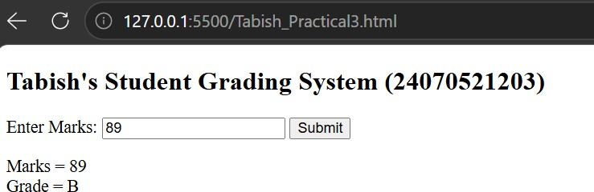

Case Study Program Code:
<!DOCTYPE html>
<html lang="en">
<head>
<meta charset="UTF-8">
<meta name="viewport" content="width=device-width, initial-scale=1.0">
<title>Scholarship Eligibility Checker</title>

<style>
*{
margin:0; padding:0;
box-sizing:border-box;
font-family:Arial, Helvetica, sans-serif;
}

body{
background:#eef2f7; display:flex;
justify-content:center; align-items:center; height:100vh;
}

.container{
width:400px; background:#ffffff; padding:30px; border-radius:12px;
box-shadow:0 8px 20px rgba(0,0,0,0.15); text-align:center;
}

h1{

}

color:#1f3b73; margin-bottom:10px;

p{
color:#555;
margin-bottom:20px;
}

input{
width:100%; padding:12px; font-size:16px;
border:1px solid #bfc9d9; border-radius:6px; margin-bottom:20px;
}

button{
width:100%; padding:12px; background:#1f3b73; color:white; border:none; border-radius:6px; font-size:16px; cursor:pointer;
}

button:hover{
background:#294d8b;
}

.result{
margin-top:20px; padding:15px; background:#f4f7fb;
border-left:5px solid #1f3b73; border-radius:6px;
font-size:18px; font-weight:bold; color:#1f3b73;
}
</style>

</head>
<body>

<div class="container">

<h1>Scholarship Eligibility</h1>

<p>Enter Student Marks (0 - 100)</p>

<input type="number" id="marks" min="0" max="100" placeholder="Enter Marks">

<button onclick="checkScholarship()"> Check Eligibility
</button>

<div class="result" id="result"> Result will appear here.
</div>

</div>

<script>

function checkScholarship(){

let marks=parseInt(document.getElementById("marks").value); let category="";

if(isNaN(marks) || marks<0 || marks>100){
category="Please enter valid marks between 0 and 100.";
}
else if(marks<50){ category="Not Eligible";
}
else if(marks<=69){ category="Bronze Scholarship";
}
else if(marks<=84){ category="Silver Scholarship";
}
else if(marks<=94){ category="Gold Scholarship";
}
else{
category="Platinum Scholarship";
}

document.getElementById("result").innerHTML=category;

}

</script>

</body>
</html>

Output:


Result/Conclusion:

The grading system successfully accepted the user's marks, validated the input, and displayed the correct grade according to the predefined grading criteria. This experiment helped in understanding how form validation ensures valid user input and how control structures (if-else statements) are used to make decisions and generate appropriate output in a web application.



Experiment No.: 02

- Title: Use var, let, const, and demonstrate basic features like template literals and destructuring, build a billing calculator with user input.

- Software/Tools Required: HTML, VS Code.

- Theory: JavaScript is a scripting language used to make web pages interactive and dynamic. It allows developers to perform calculations, validate user input, display messages, and manipulate webpage content. In this experiment, a Billing Calculator is developed using JavaScript. The program accepts user inputs such as customer name,
product name, quantity, and price per item through dialog boxes (prompt()). It then calculates the total bill and displays a formatted billing receipt on the webpage. The program demonstrates the following JavaScript features:
  - var – Used to declare function-scoped variables. It can be redeclared and updated.

  - let – Used to declare block-scoped variables. It can be updated but not redeclared within the same scope.
  - const – Used to declare constants whose values cannot be reassigned.

  - Template Literals – Enclosed within backticks (`), they allow embedding variables directly into strings using ${} for easier string formatting.
  - Destructuring – A feature that extracts values from arrays or objects into separate variables, making the code cleaner and more readable.

- Output:

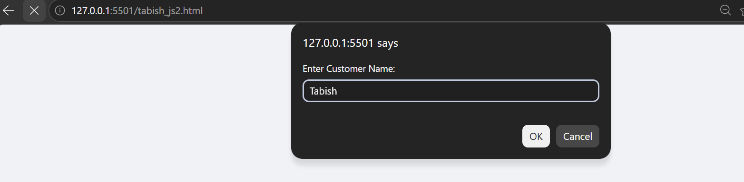
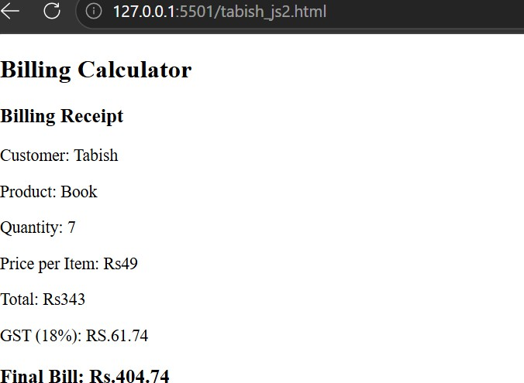

Case Study No.: 2
1. Case Study Title: Develop a webpage for an online shopping website using HTML,CSS,HTML5, and calculate bills

Program Code:
<!DOCTYPE html>

<html lang="en">

<head>

<meta charset="UTF-8">

<meta name="viewport" content="width=device-width, initial-scale=1.0">

<title>Online Shopping Store</title>

<style>

*{

margin:0;

padding:0;

box-sizing:border-box;

font-family:Arial, Helvetica, sans-serif;

}

body{

background:#eef4ff;

}

header{

background:linear-gradient(90deg,#4f46e5,#06b6d4);

color:white;

padding:20px;

text-align:center;

}

nav{

background:#1e293b;

padding:15px;

text-align:center;

}

nav a{

color:white;

text-decoration:none;

margin:20px;

font-weight:bold;

}

nav a:hover{

color:#38bdf8;

}

section{

width:90%;

margin:auto;

padding:30px;

}

.products{

display:flex;

justify-content:space-around;

flex-wrap:wrap;

gap:20px;

}

.card{

background:white;

width:250px;

padding:20px;

border-radius:12px;

box-shadow:0 5px 15px rgba(0,0,0,.2);

text-align:center;

}

.card img{

width:180px;

height:180px;

object-fit:cover;

}

.card h3{

color:#1e3a8a;

margin:10px 0;

}

.price{

color:#059669;

font-size:22px;

font-weight:bold;

}

input{

width:80px;

padding:8px;

margin-top:10px;

}

button{

margin-top:15px;

padding:10px 20px;

background:#4f46e5;

color:white;

border:none;

border-radius:6px;

cursor:pointer;

font-size:16px;

}

button:hover{

background:#3730a3;

}

.bill{

margin-top:40px;

background:white;

padding:25px;

border-radius:10px;

box-shadow:0 5px 15px rgba(0,0,0,.2);

}

footer{

margin-top:40px;

background:#1e293b;

color:white;

text-align:center;

padding:15px;

}

</style>

</head>

<body>

<header>

<h1>◻ Trendy Online Shopping Store</h1>

<p>Best Deals | Best Prices</p>

</header>

<nav>

<a href="#">Home</a>

<a href="#">Products</a>

<a href="#">Offers</a>

<a href="#">Contact</a>

</nav>

<section>

<div class="products">

<div class="card">

<h3>Laptop</h3>

<p class="price">₹50000</p>

Quantity<br>

<input type="number" id="lap" value="0" min="0">

</div>

<div class="card">

<h3>Smart Phone</h3>

<p class="price">₹20000</p>

Quantity<br>

<input type="number" id="phone" value="0" min="0">

</div>

<div class="card">

<h3>Headphones</h3>

<p class="price">₹3000</p>

Quantity<br>

<input type="number" id="head" value="0" min="0">

</div>

</div>

<center>

<button onclick="bill()">Calculate Bill</button>

</center>

<div class="bill">

<h2>Bill Details</h2>

<h3 id="output"></h3>

</div>

</section>

<footer>

<p>© 2026 Trendy Online Shopping Store | Designed by Tabish Mansoori</p>

</footer>

<script>

function bill(){

let laptop=50000;

let phone=20000;

let head=3000;

let q1=parseInt(document.getElementById("lap").value)||0;

let q2=parseInt(document.getElementById("phone").value)||0;

let q3=parseInt(document.getElementById("head").value)||0;

let total=(q1*laptop)+(q2*phone)+(q3*head);

let gst=total*0.18;

let finalBill=total+gst;

document.getElementById("output").innerHTML=

`

Laptop : ₹${q1*laptop}<br><br>

Phone : ₹${q2*phone}<br><br>

Headphones : ₹${q3*head}<br><br>

Subtotal : ₹${total}<br><br>

GST (18%) : ₹${gst.toFixed(2)}<br><br>

<b style="color:green;font-size:25px;">

Grand Total : ₹${finalBill.toFixed(2)}

</b>

`;

}

</script>

</body>

</html>

Output
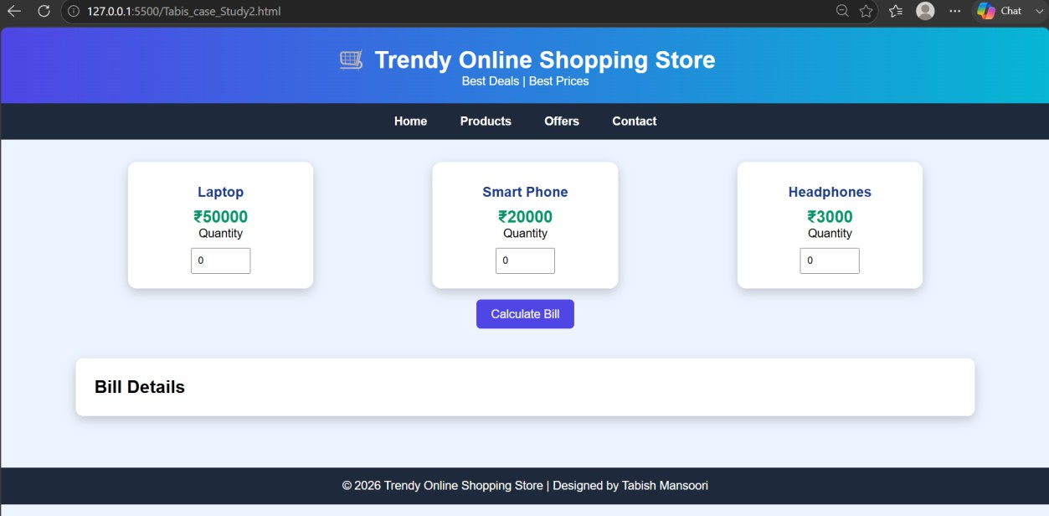

5. Result/Conclusion: The Billing Calculator was successfully implemented using JavaScript. The program accepts user input, performs the billing calculation, and displays the receipt correctly. It successfully demonstrates the use of var, let, const, template literals, and destructuring while providing a simple and interactive billing application.

Experiment No.: 01

Title: Demonstrate inline, internal, and external JavaScript; use console methods; create a webpage showing user info and a welcome message.

Software/Tools Required: HTML, VS Code.

Theory: HTML (HyperText Markup Language) is the standard language used to create web pages. It provides the basic structure of a webpage using elements such as headings, paragraphs, images, lists, tables, and buttons. CSS (Cascading Style Sheets) is used to style the webpage. It controls the layout, colors, fonts, spacing, and overall appearance of the webpage. In this program, an "About Me" webpage is created using HTML and CSS. The webpage contains a profile picture, personal information, skills, education details, and a contact button. CSS is used to improve the appearance by adding colors, spacing, borders, and alignment.

Output:


Case Study Program Code:
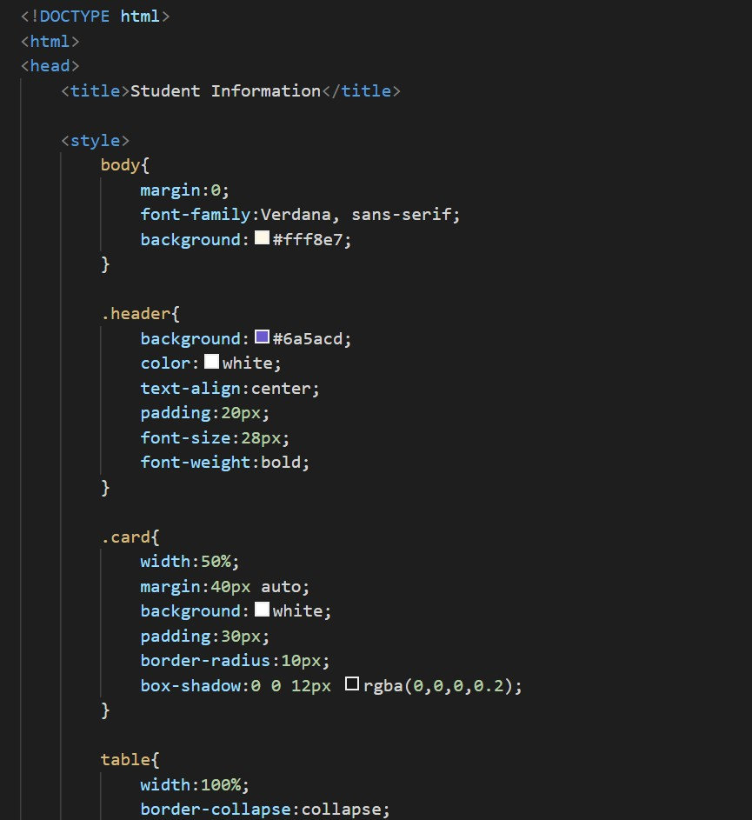

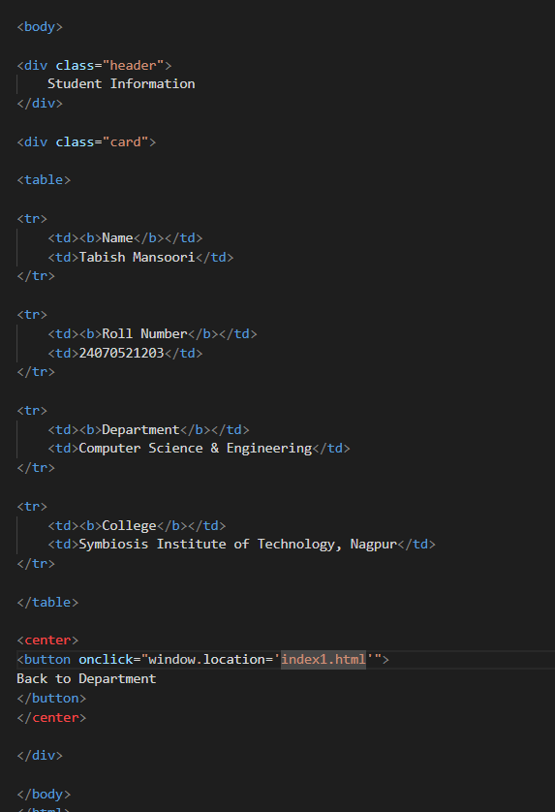

Output:
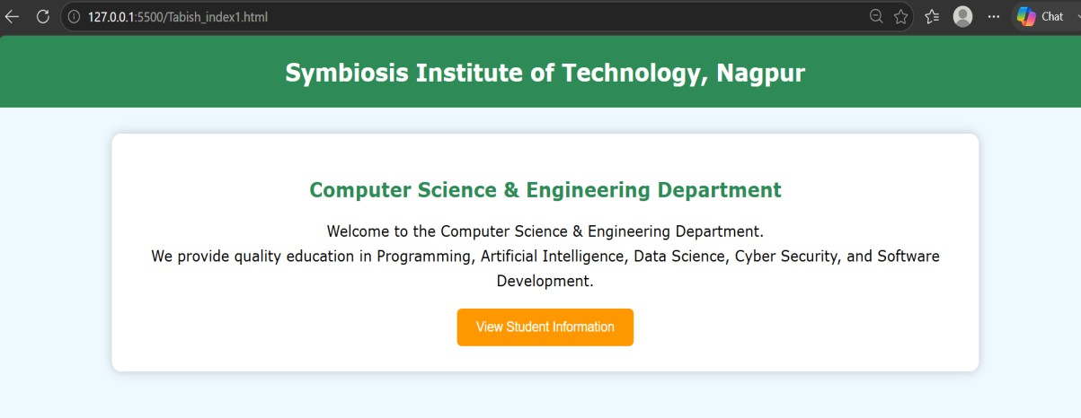
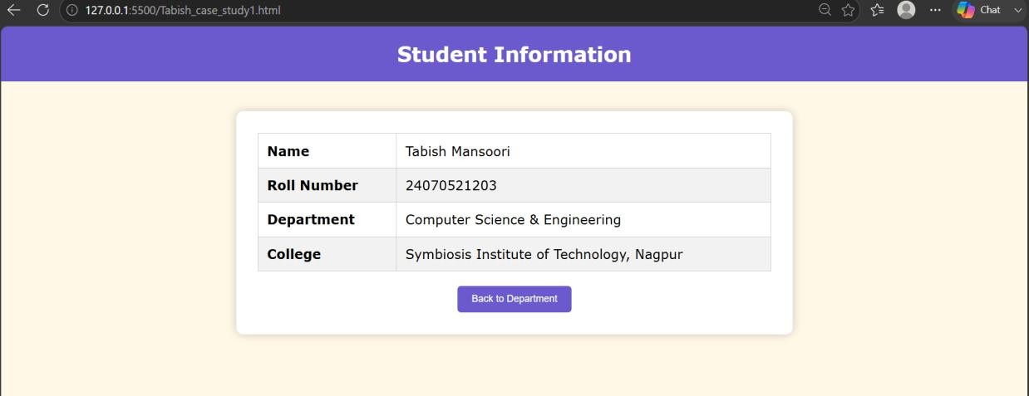

Result/Conclusion: The "About Me" webpage was successfully created using HTML and CSS. The webpage displays personal information in a well-organized and visually appealing format. This practical demonstrates the basic use of HTML for webpage structure and layout.

Experiment No.: 07

- Title: Perform DOM traversal and updates; develop a to-do list app with add, edit, and delete features.

- Software/Tools Required: HTML, VS Code.

- Theory: DOM (Document Object Model) represents an HTML page as a tree of elements. JavaScript uses the DOM to access, traverse, create, update, and delete HTML elements dynamically.
In this experiment, DOM methods and event handling are used to develop a To-Do List application. The user can enter a task and add it to the list. Each task contains Edit and Delete options. The Edit option modifies the task, while Delete removes it from the DOM.
Key methods used: getElementById(), querySelector(), createElement(), appendChild(), textContent, and remove().

To-Do List Application
A to-do list is a simple application that demonstrates DOM manipulation and event handling. The user enters a task and clicks Add to create a new list item. Each task can have Edit and Delete buttons.
Working Logic:
- Take the task entered by the user from the input field.
- Create a new <li> element using JavaScript.
- Add the task text and Edit/Delete buttons to the list.
- The Edit button allows the user to modify the existing task.
- The Delete button removes the task from the DOM.
- DOM methods are used to dynamically update the to-do list.

- Output:

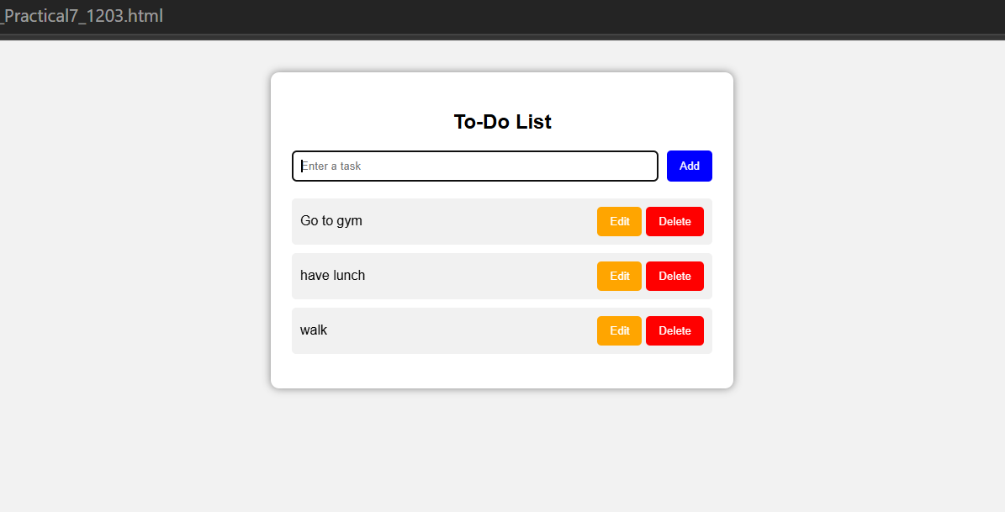

5.Conclusion: Thus, the experiment successfully demonstrates DOM traversal and dynamic DOM updates using JavaScript. A functional to-do list application was developed with Add, Edit, and Delete operations. This experiment helps in understanding how JavaScript interacts with HTML elements and dynamically changes webpage content based on user actions.

CASE STUDY
AIM: To Demonstrate the Events Handling in JavaScript
a) Access and manipulate form elements using JavaScript.
b) Validate user input (e.g. email, empty fields).
c) Use various form events (submit, change, focus).
Case Study:-
Create the following HTML form and use required JavaScript and events in a given form.

Code: 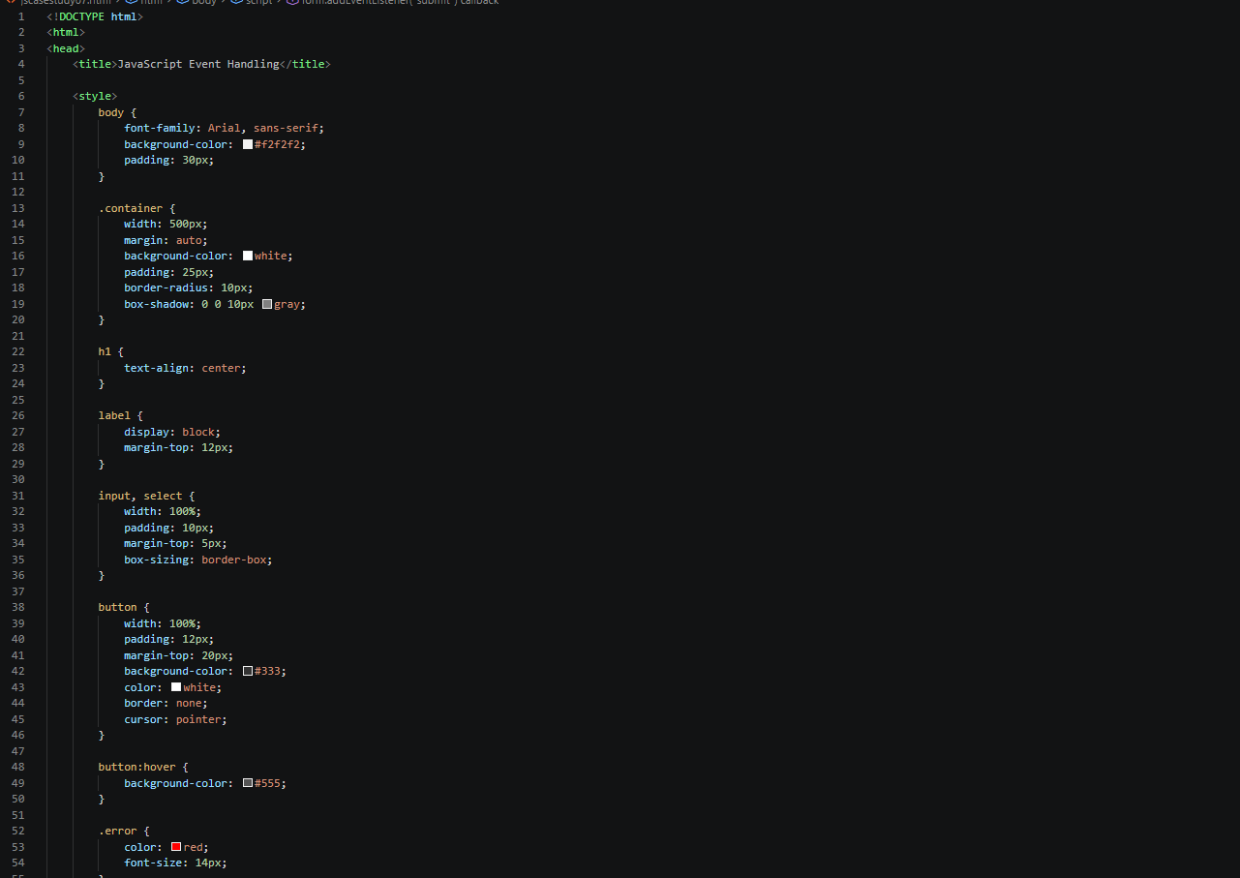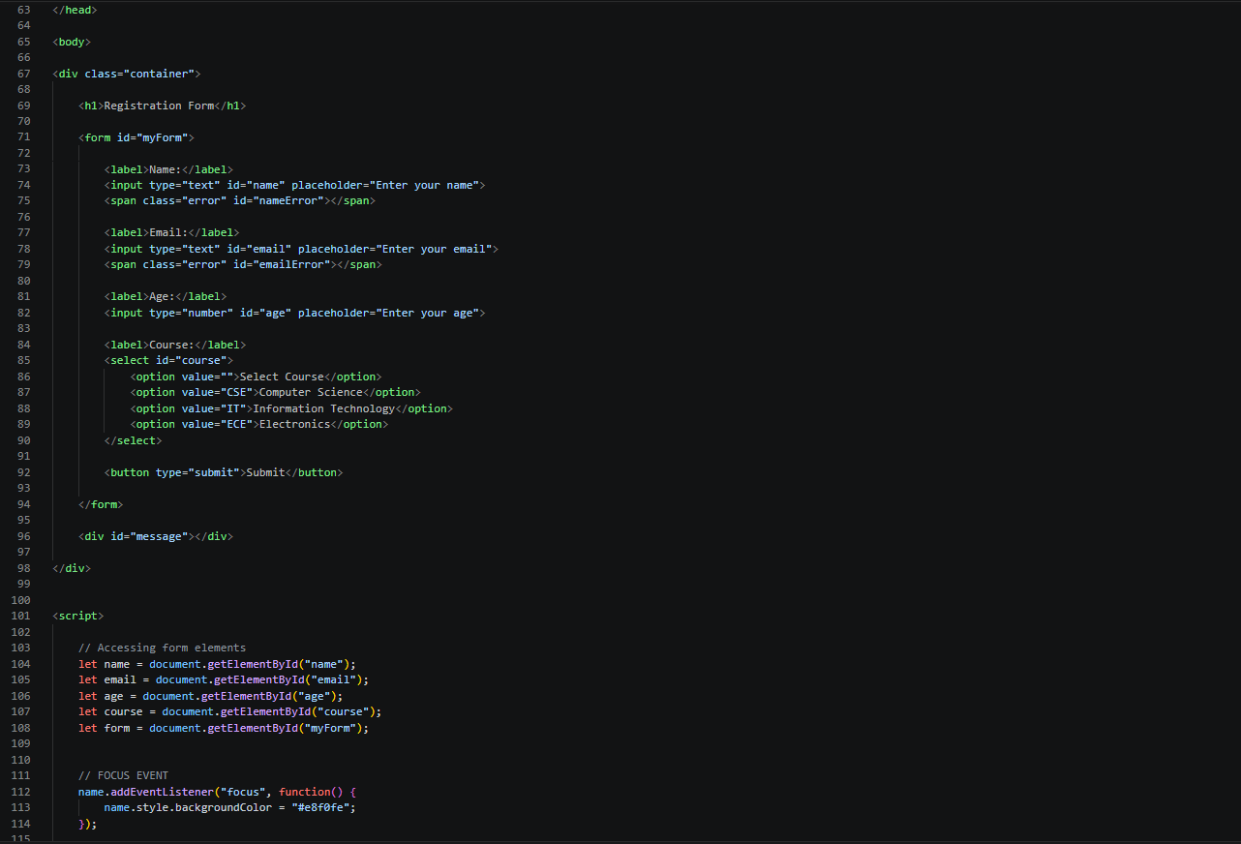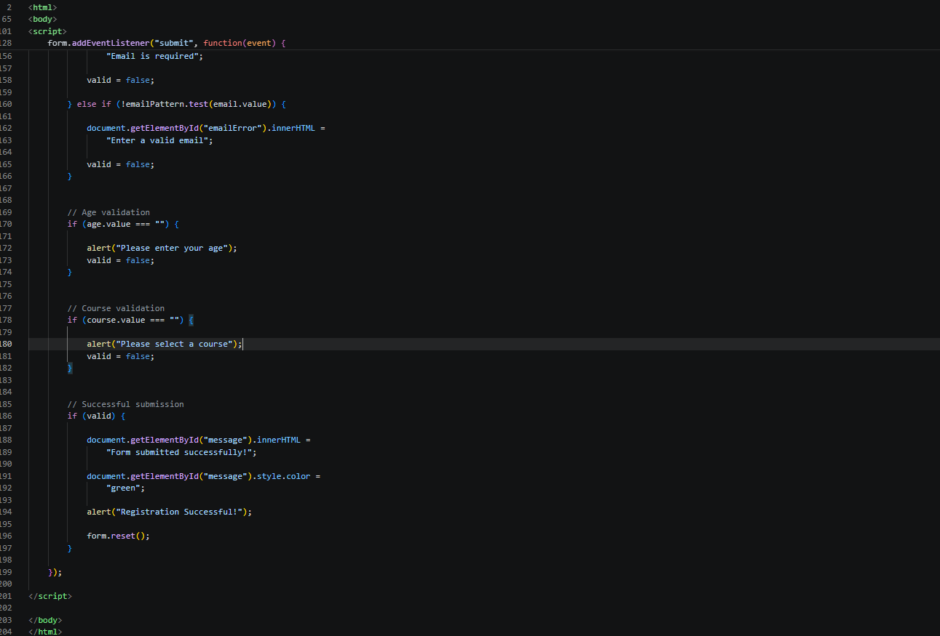

Output:
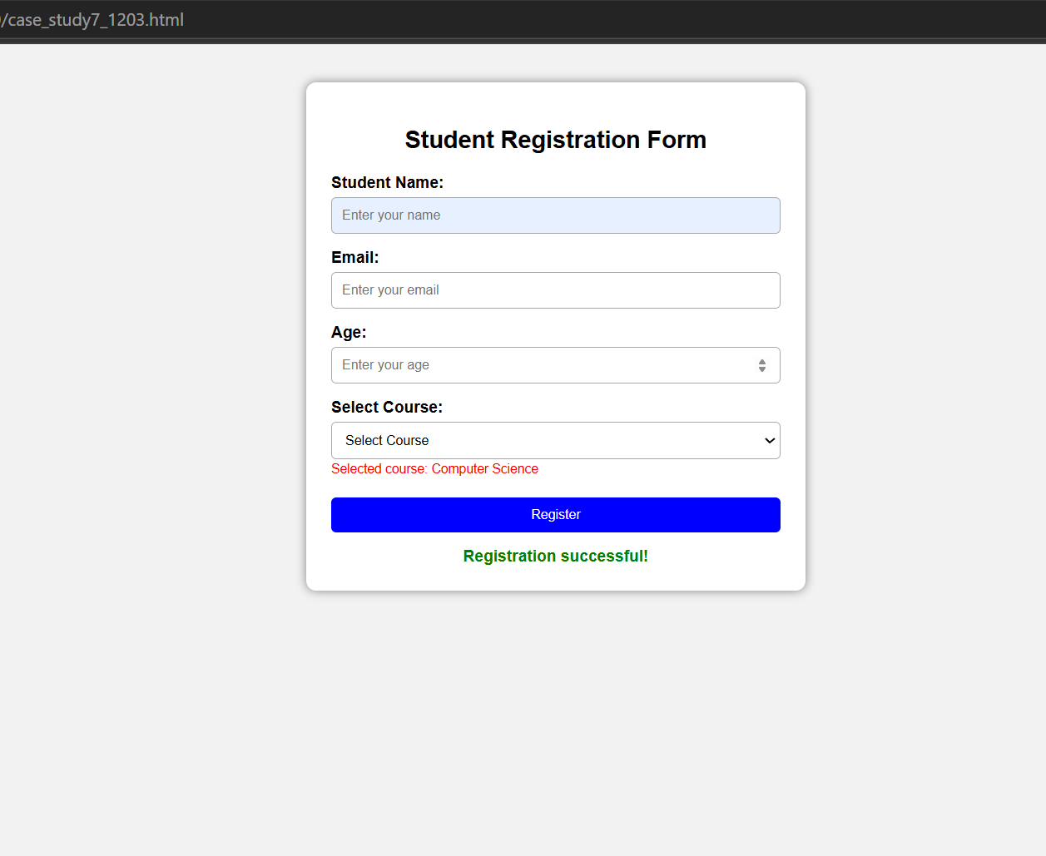

Result: Thus, the experiment successfully demonstrates DOM traversal and dynamic DOM updates using JavaScript. A functional to-do list application was developed with Add, Edit, and Delete operations. This experiment helps in understanding how JavaScript interacts with HTML elements and dynamically changes webpage content based on user actions.

Experiment No.: 08

- Title: Access and validate form fields using events; design a gym admission form with live input checks.

- Software/Tools Required: HTML, VS Code.

- Theory: JavaScript is used to access and validate form fields and make web forms interactive. Form elements can be accessed using methods like getElementById() and querySelector().
JavaScript events such as input, blur, change, and submit help detect user actions. Live validation checks the entered information immediately and displays an error message if the data is incorrect or incomplete.
In the Gym Admission Form, fields such as Name, Age, Email, Phone Number, Gender, and Membership Plan can be validated. JavaScript displays suitable error messages when the entered data is invalid and provides feedback immediately. This improves user experience and prevents incorrect or incomplete data from being submitted.

Key features:
- Access form elements using JavaScript DOM methods.
- Handle user actions using events.
- Perform live input validation.
- Display error messages dynamically.
- Prevent form submission when invalid data is entered.
- Ensure that required fields are properly filled.

- Output:

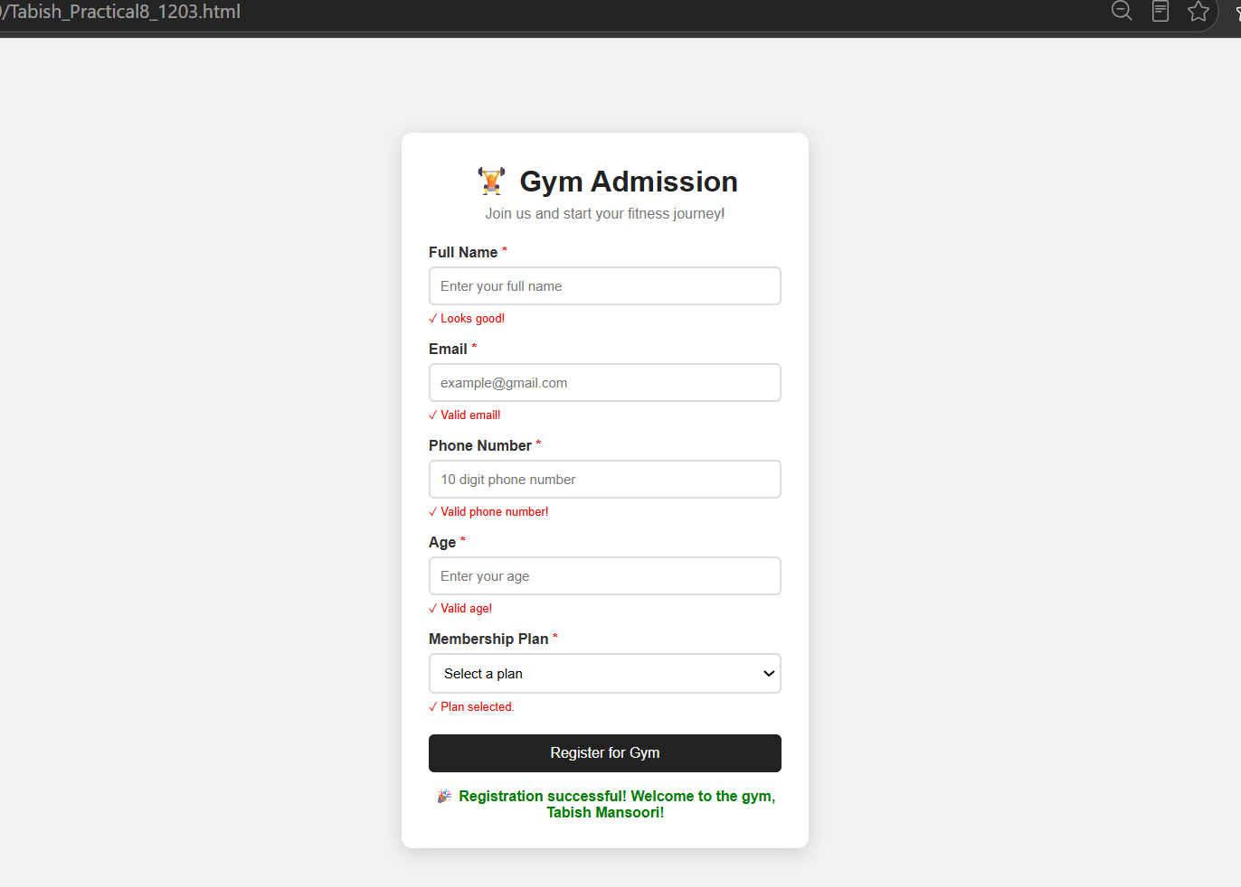

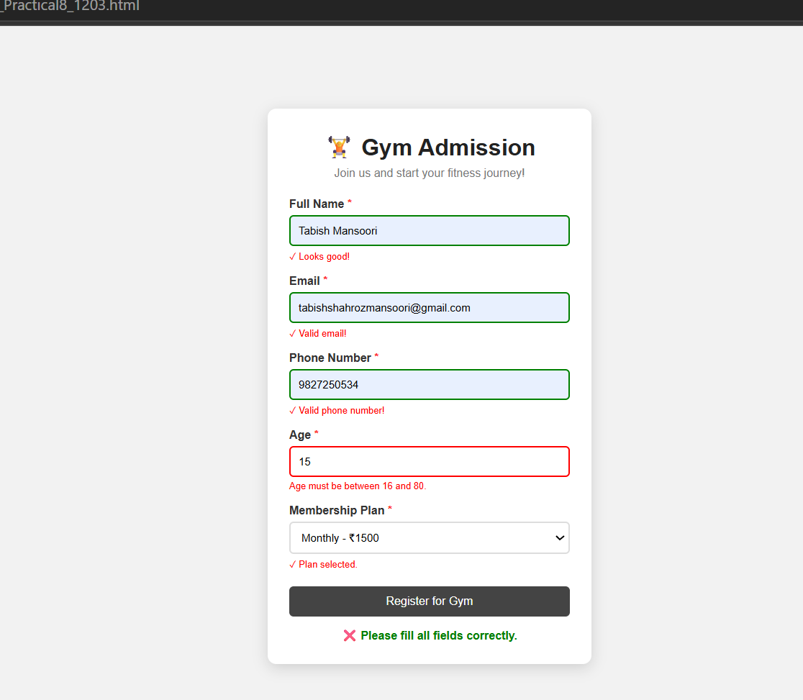
CASE STUDY

AIM: To design an Online Job Application Form using HTML, CSS, and JavaScript with real-time form validation, ensuring that the entered details are valid before submission.
Code: 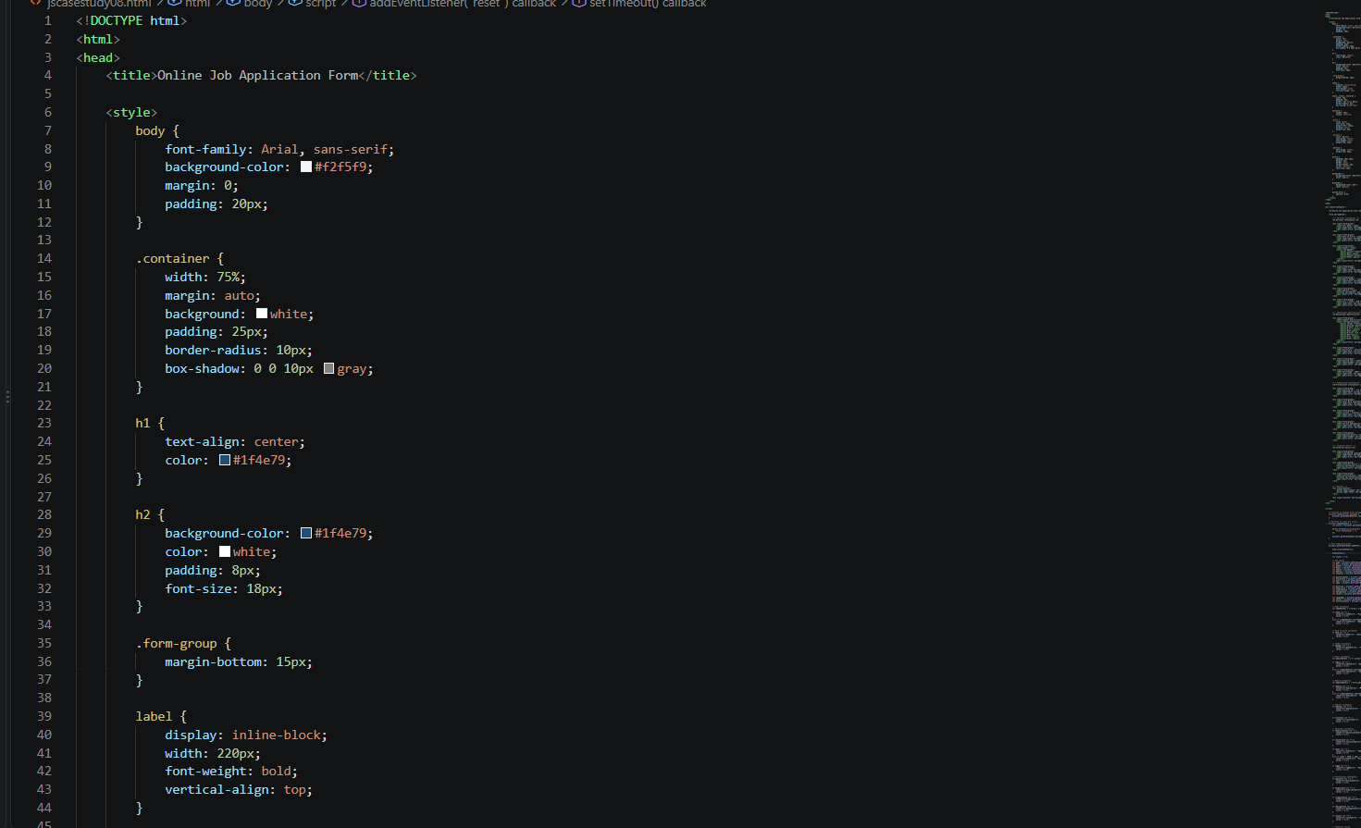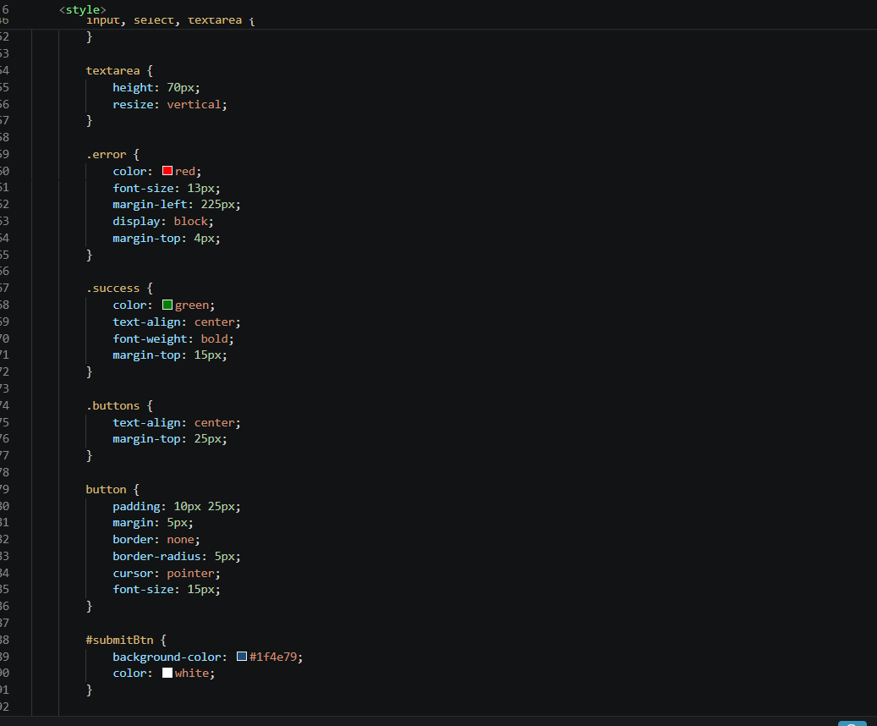

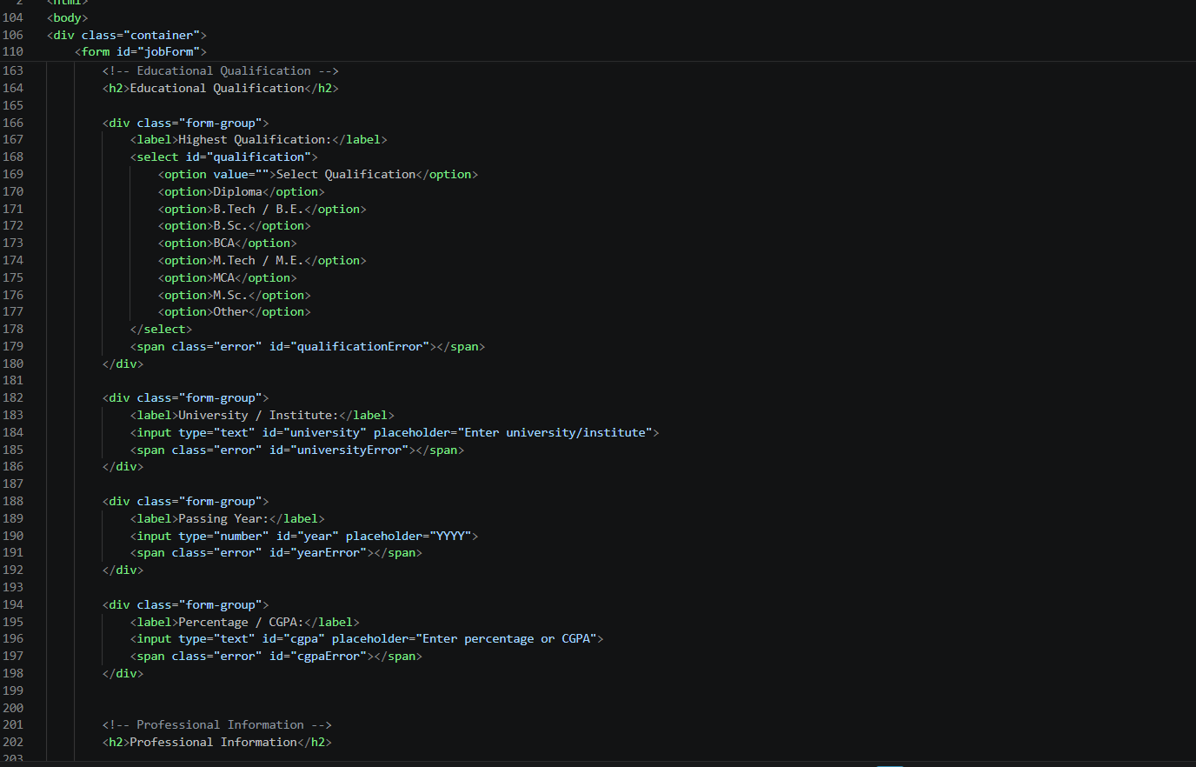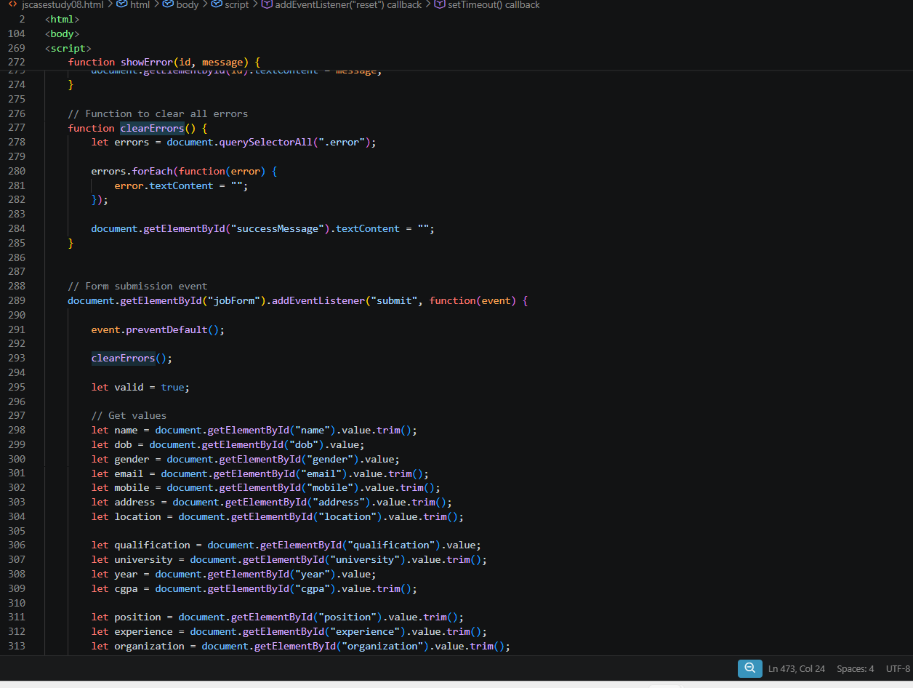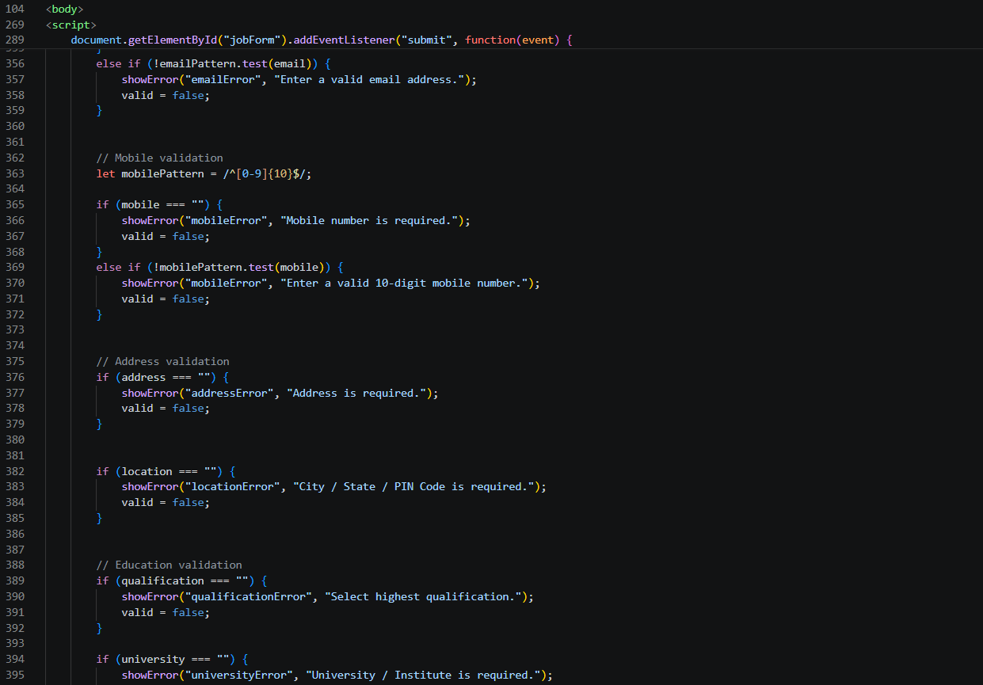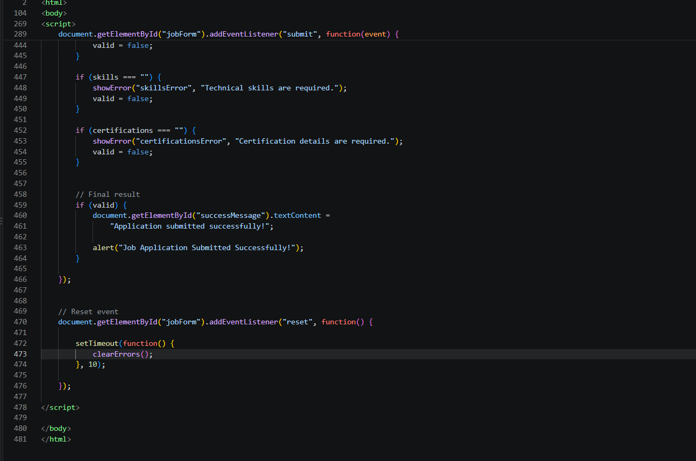

Output:

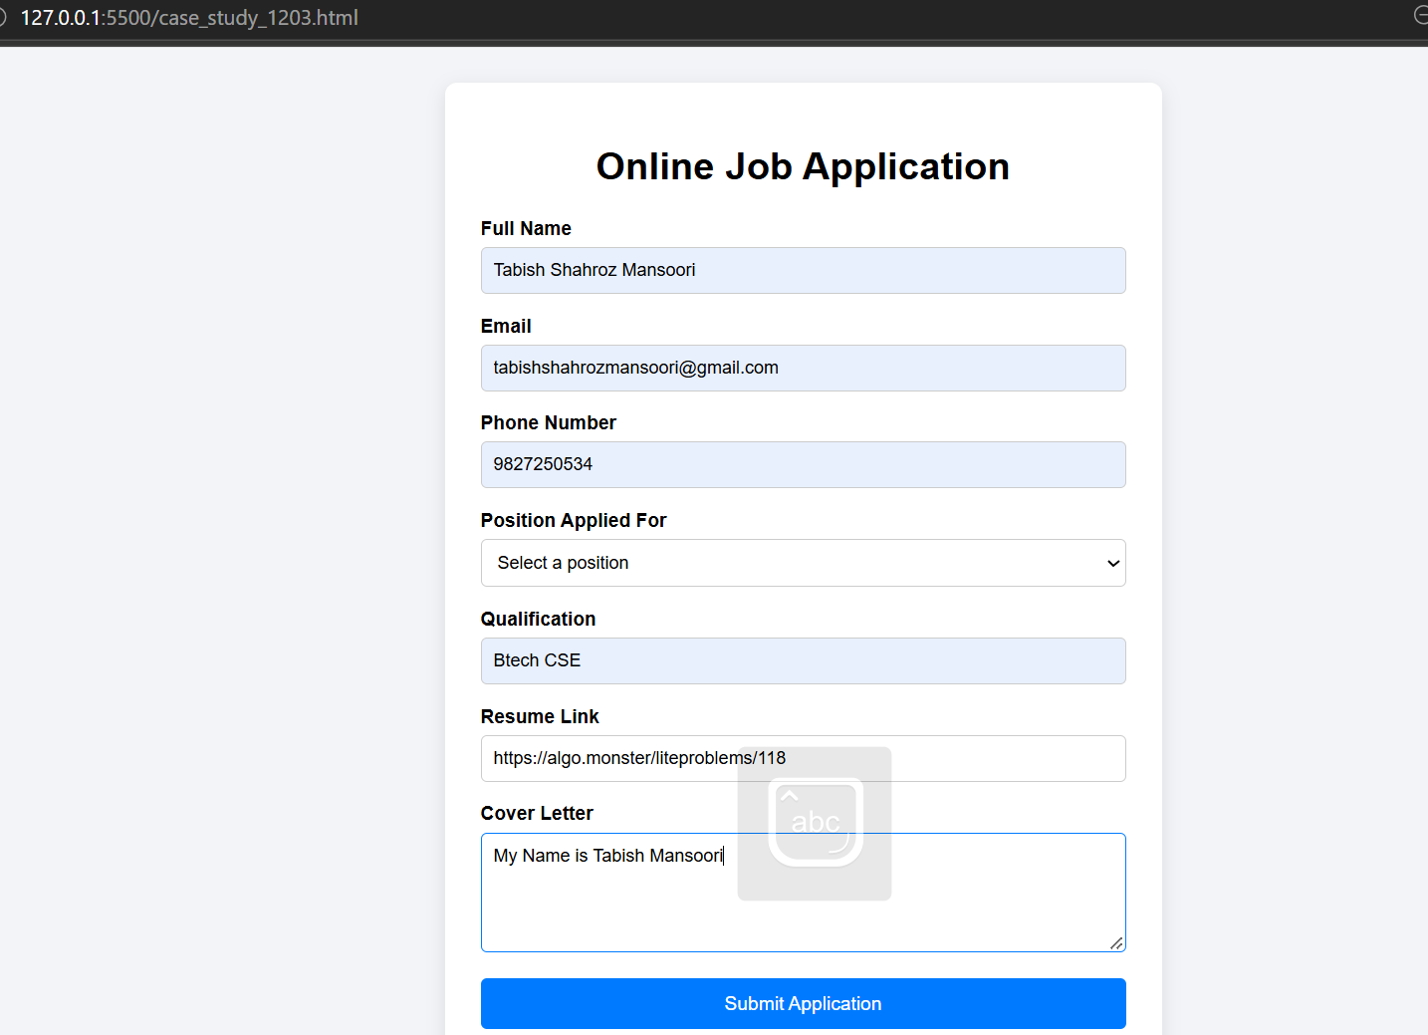

Result: Thus, an Online Job Application Form was successfully developed using HTML, CSS, and JavaScript. JavaScript validation ensures that incorrect or incomplete information is detected before submission, making the form more reliable, user-friendly, and interactive.

Experiment No.: 06

- Title: Use String functions and regex for email validation,data extraction and text analysis.

- Software/Tools Required: HTML, VS Code.

- Theory: JavaScript string functions and Regular Expressions (Regex) are used for text processing, pattern matching, and data validation. String methods such as length, toUpperCase(), toLowerCase(), substring(), replace(), and split() help manipulate and analyze text data. Regex provides a powerful way to search, match, and validate patterns in strings.
In this practical, regex is used to validate email addresses by checking their format, while string functions are used for data extraction and text analysis, such as counting words, finding specific text, and replacing or extracting information from a string.

- Output:

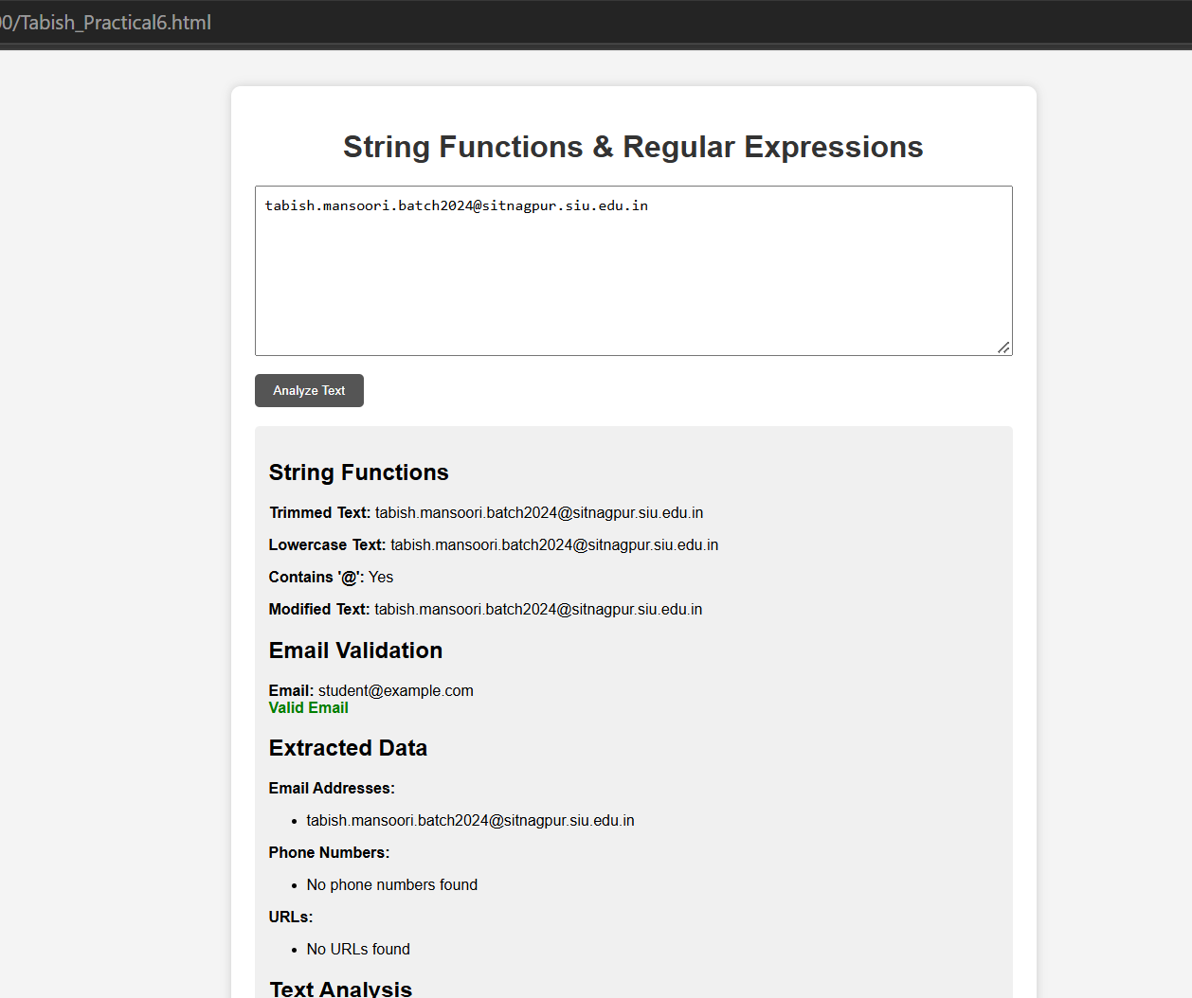

5.Result: Successfully implemented email validation, data extraction, and text analysis using JavaScript string functions and Regular Expressions (Regex). The program correctly validates email formats, extracts required data, and performs text processing operations efficiently.

CASE STUDY
AIM: To perform various String operations using Java Script.
a) To perform Basics of string.
b) Work with strings: substring(), indexOf(), split(), replace().
Case Study :-
- Write a program to reverse a string.
- WAP to count the number of vowels in a paragraph.

Code:
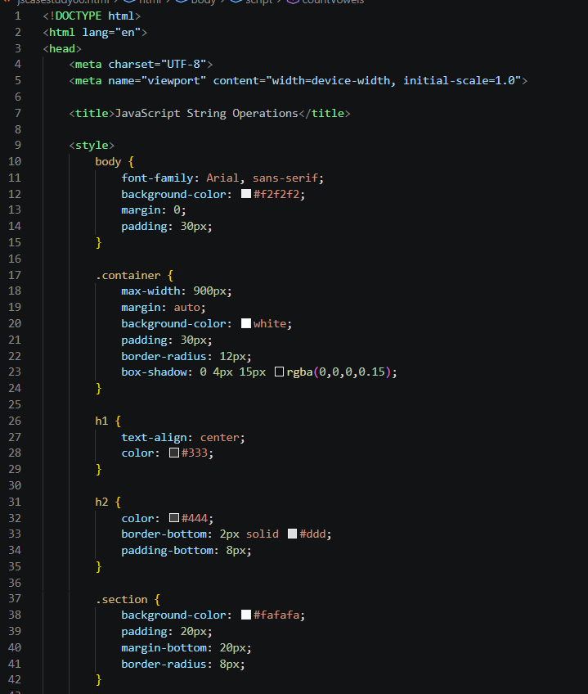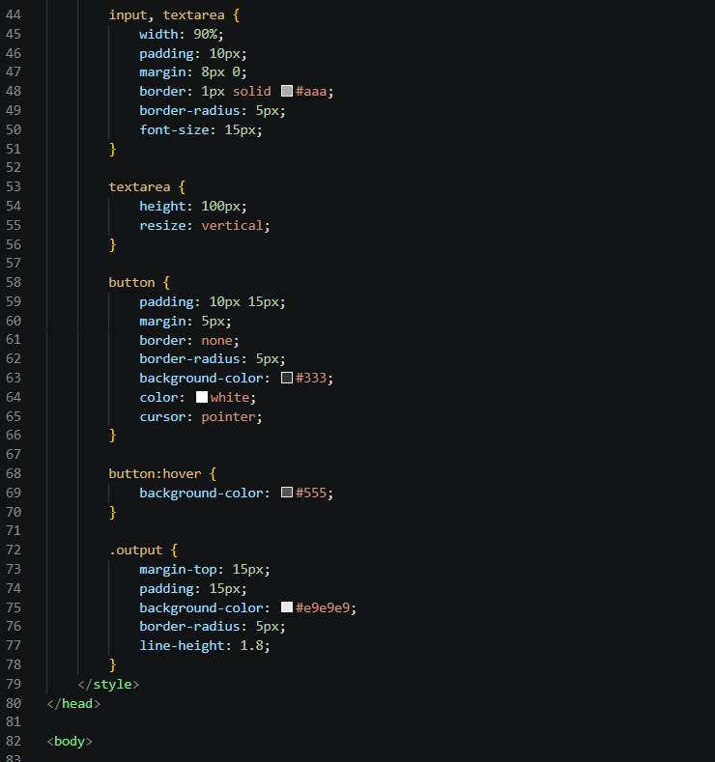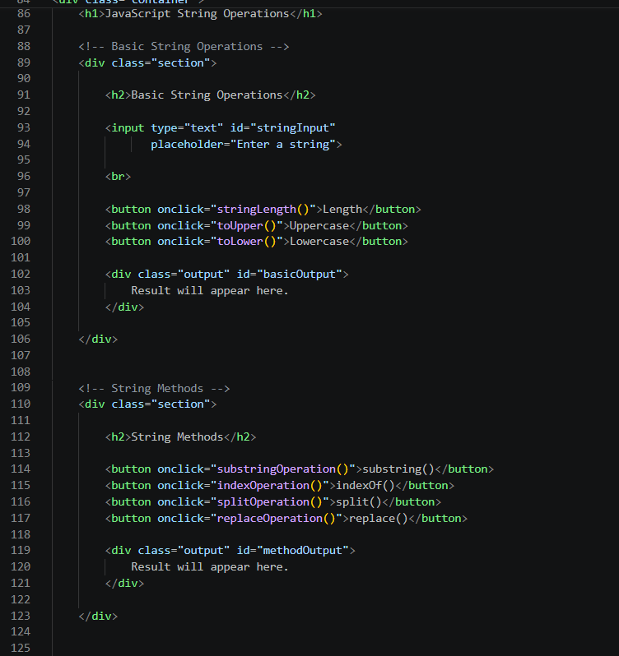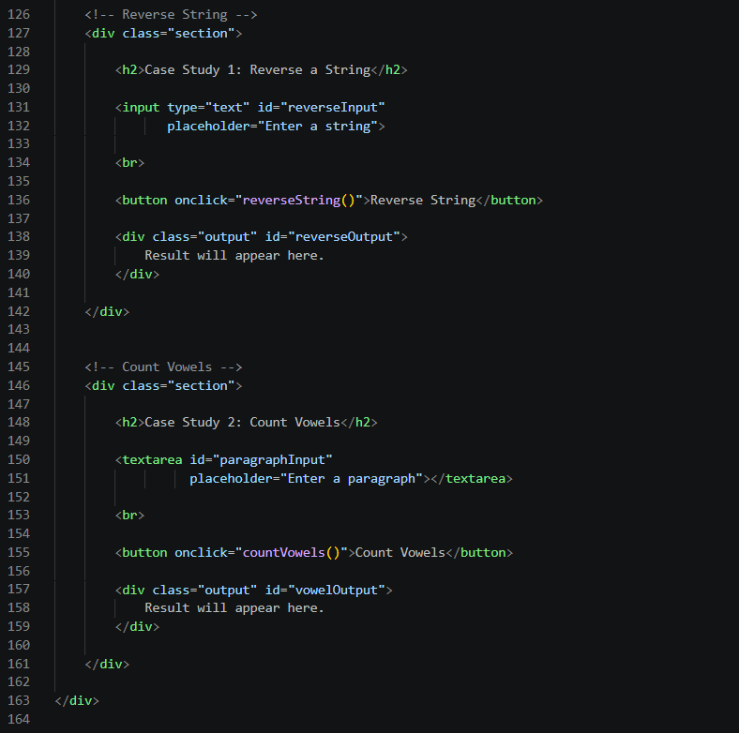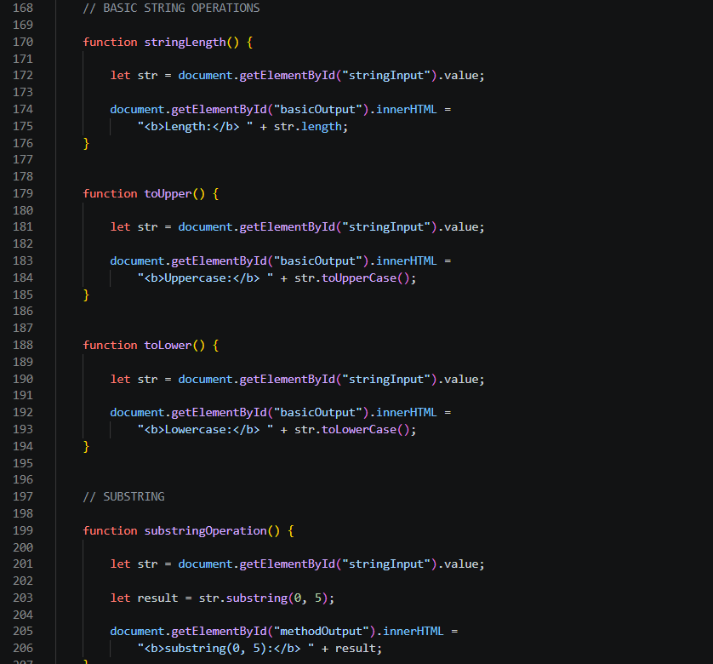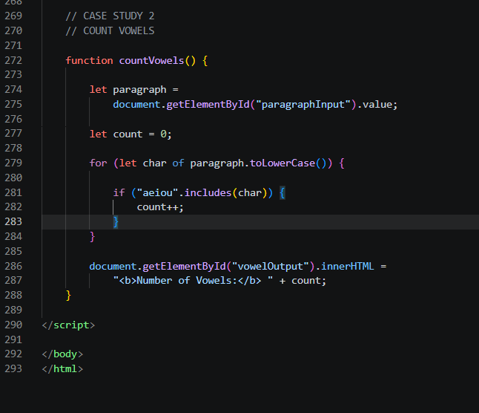

Output:
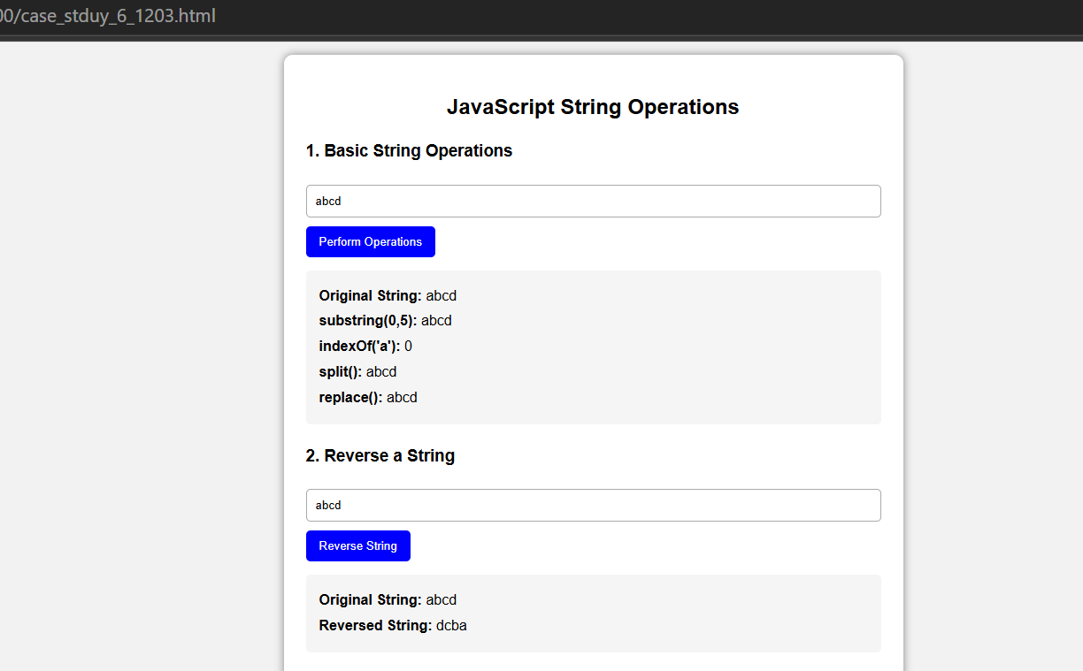

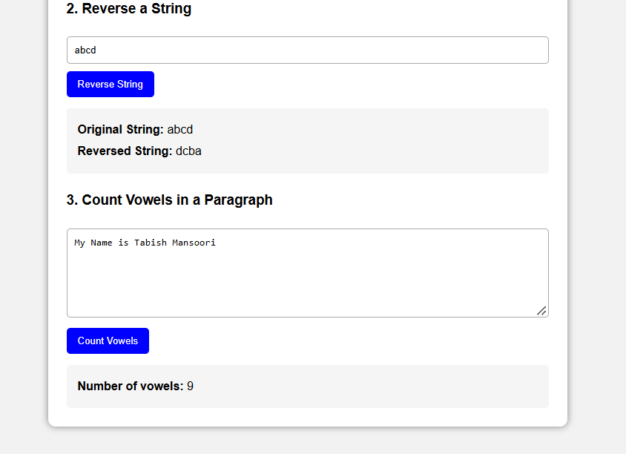

Conclusion: Thus, we successfully performed various String operations in JavaScript such as substring(), indexOf(), split(), and replace(). We also implemented programs to reverse a string and count the number of vowels in a paragraph, gaining a better understanding of JavaScript string manipulation and loops.

Experiment No.: 05

- Title: Apply array methods and object handling; create a cart total calculator with discount logic.

- Software/Tools Required: HTML, VS Code.

- Theory: JavaScript arrays are used to store multiple values, while objects store data in key-value pairs. Array methods like map (), filter (), and reduce () are useful for processing and calculating data. In a shopping cart, each product is represented as an object containing its name, price, and quantity. The reduce () method is used to calculate the total cart value. Based on the total amount, discount conditions are applied using conditional statements, and the final payable amount is calculated.

- Output:

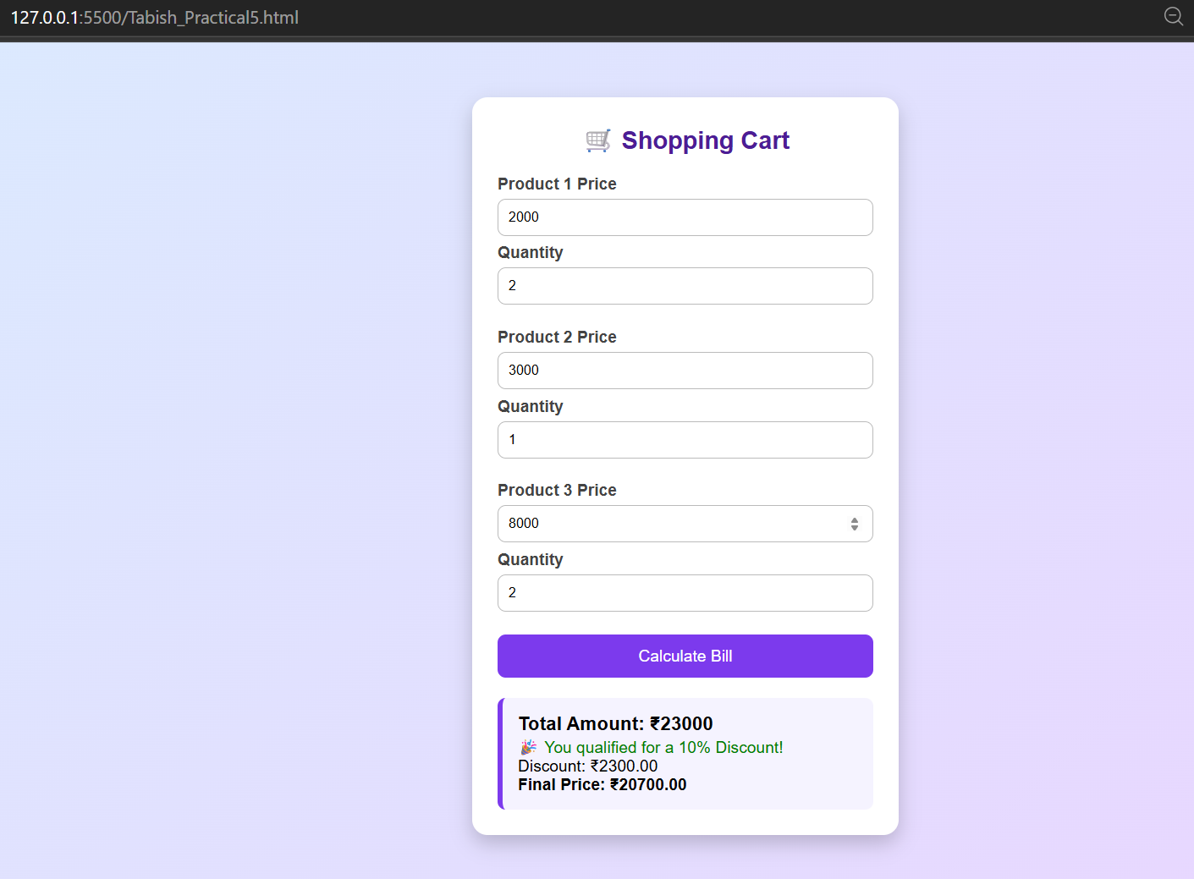

5.Result/Conclusion: The cart total calculator was successfully implemented using JavaScript arrays, objects, array methods, and conditional discount logic. The program calculates the total price, applies the appropriate discount, and displays the final amount to be paid.

CASE STUDY

To study the functioning of Arrays and Loops in Java Script
a) Create and manipulate arrays: push, pop, shift, unshift, splice, slice.
b) Use array methods: map(), filter(), reduce(), forEach().
CaseStudy:-
Create an array of numbers and find the maximum and minimum value.

Code:

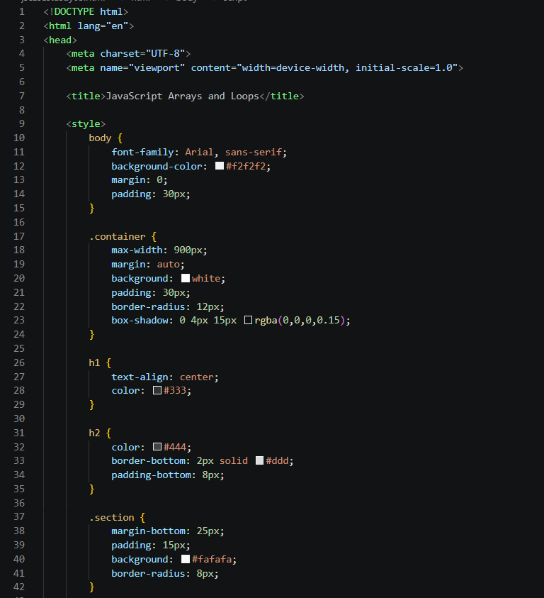

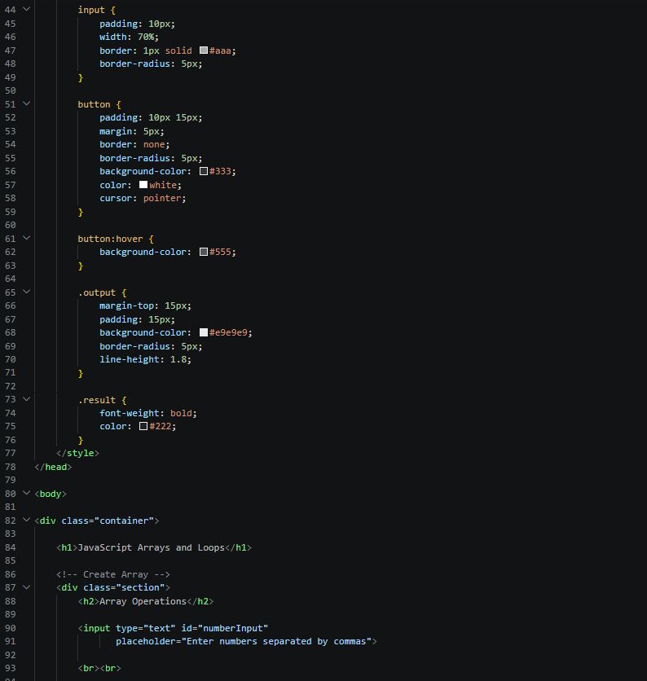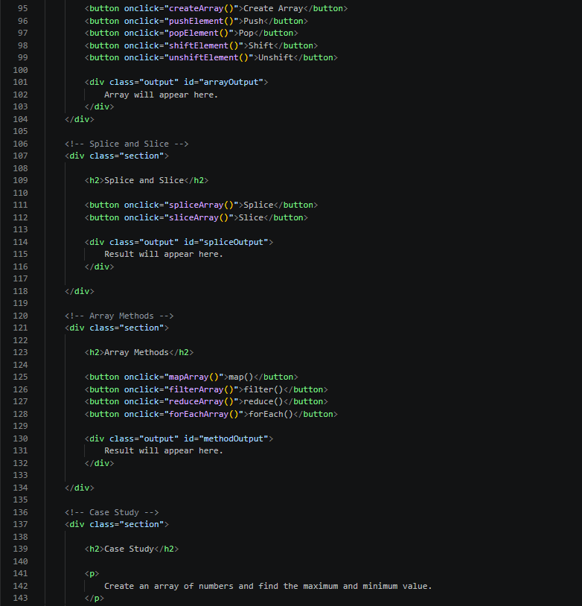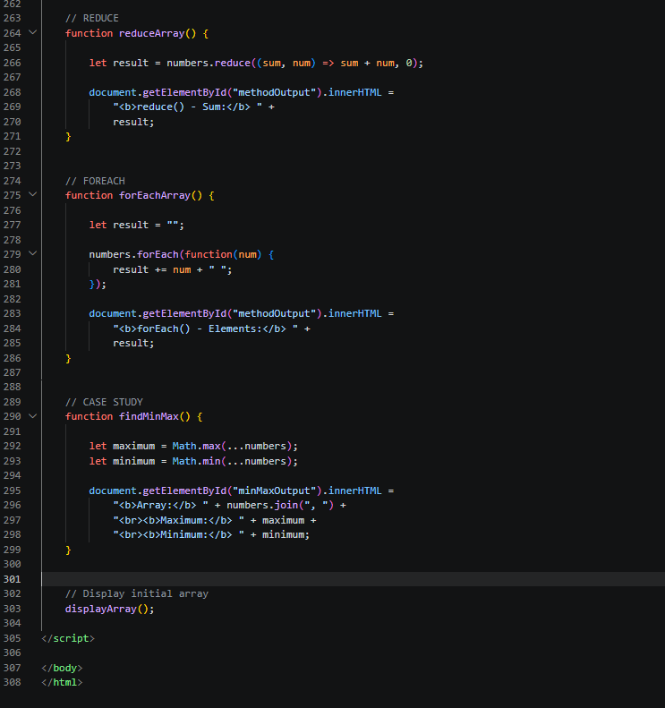
OUTPUT:
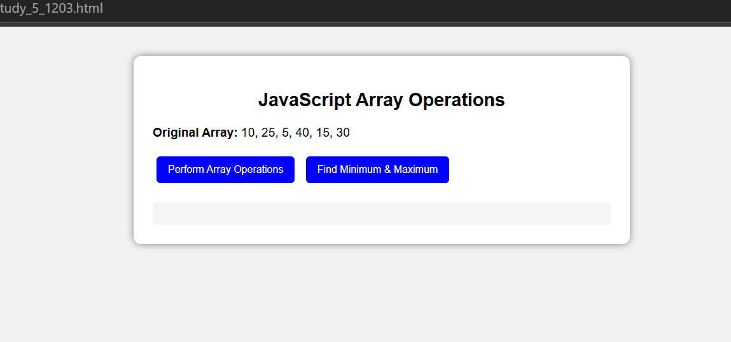
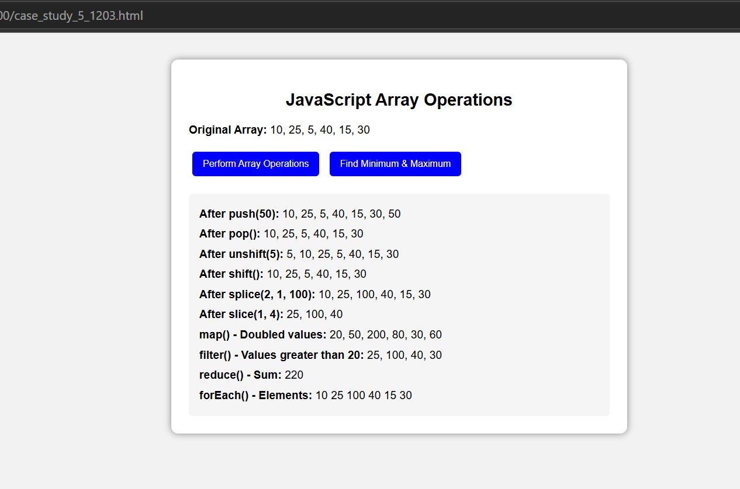

Result/Conclusion: The cart total calculator was successfully implemented using JavaScript arrays, objects, array methods, and conditional discount logic. The program calculates the total price, applies the appropriate discount, and displays the final amount to be paid.

