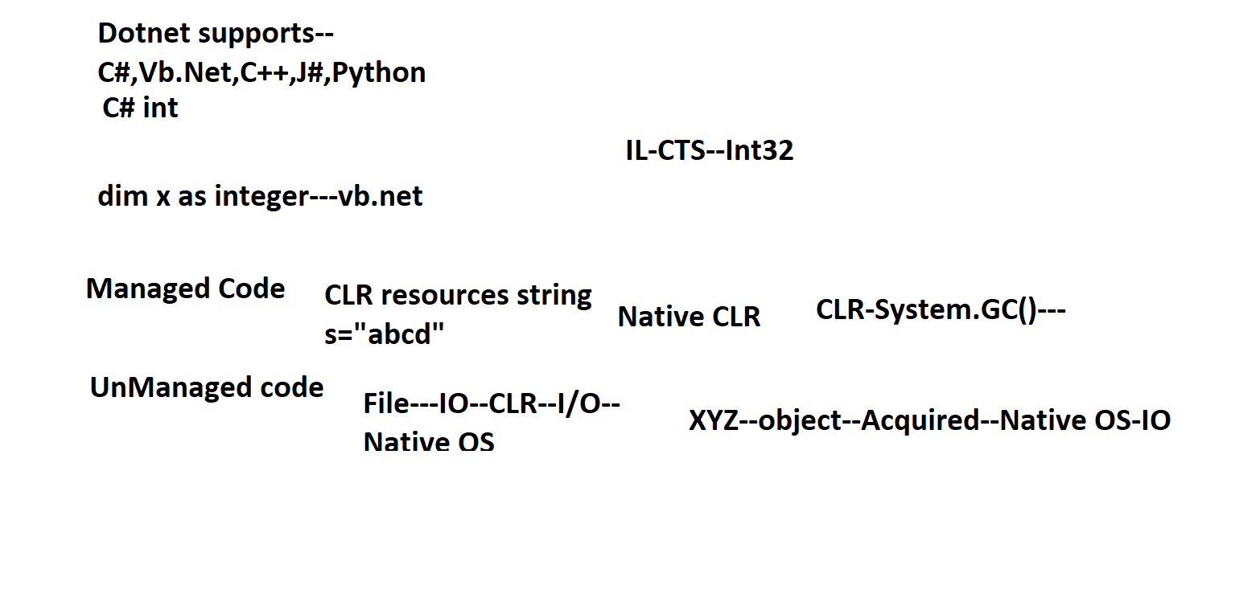

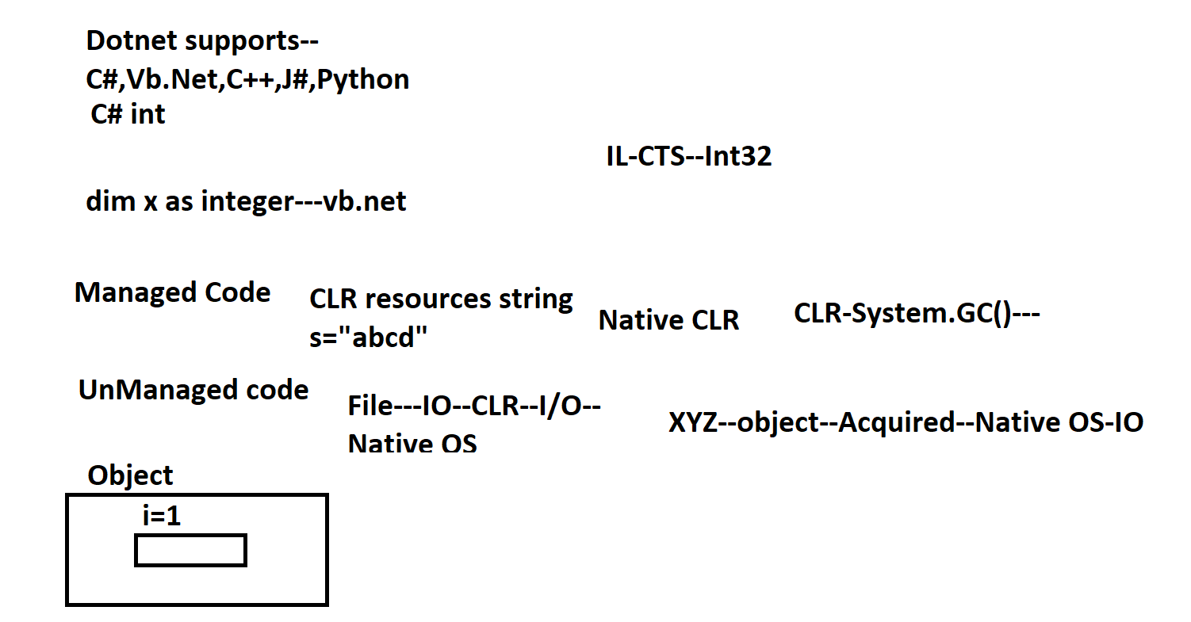

New A()—Object new A()—

1.Single Father--Child

2.Multilevel –Grandfather—Father--Child

3.Multiple—Father xxxxxxx Mother:Child

**C# don’t have multiple inheritance---**

Overloading—False polymorphism--

Overriding—True Polymorphism

Limitation---Homogeneous—

C#--Object—C# object---C#

C# --Object----Java –Object---

Distributed Programming Industry –app-1—app-2

Maketrip—C#--customernam—amount deduct---

----SOA---Services---API--

PaymentGateway---SBI-HFDC---Java

