Hackathon Theme*: | Healthcare
Project Title*: | MetaboliQ AI
Team Name*: | Mavericks |  | Team Size* (1-4): | 4
Institution Name*: | AISSMS Institute of Information Technology, Pune
City/Town*: | Pune |  | State*: | Maharashtra
Team Lead Full Name*: | Tabish Ali Ansari |  | Team Lead Email ID*: | tabish.ansari@aissmsioit.org
Team Lead Department*: | AI&DS |  | Team Lead Phone*: | 9607080527
Student 2 Full Name: | Khushal Sharma |  | Student 2 Email ID: | khushal088sharma@gmail.com
Student 2 Department: | AI&DS |  | Student 2 Phone: | 8983171744
Student 3 Full Name: | Aditya Pawar |  | Student 3 Email ID: | aditya.narsing@aissmsioit.org
Student 3 Department: | AI&DS |  | Student 3 Phone: | 9322411273
Student 4 Full Name: | Kashish Wani |  | Student 4 Email ID: | kashishwani7@gmail.com
Student 4 Department: | Instrumentation |  | Student 4 Phone: | 7972232930
Faculty Mentor Name: | - |  | Mentor Email ID: | -
Mentor Department: | - |  | Mentor Phone: | -

Project Abstract / Overview—
MetaboliQ AI is an AI-driven healthcare solution targeting diabetes awareness and predicting its occurrences. Comprising of an NLP chatbot and four other functionalities:
1. Project the number of diabetic patients in a population based on demographics.
2. Predict individual diabetes risk based on lifestyle.
3. Classify the type of diabetes using medical reports.
4. Predict gestational diabetes in women.
By leveraging Machine Learning models, MetaboliQ AI empowers individuals, hospitals, and governments with actionable insights for preparedness to counter this chronic disease and simultaneously raise awareness to reduce health risks.

Keywords—
Precaution is better than Cure!
AI in Healthcare, Diabetes Awareness, Diabetes Prediction, NLP Chatbot, Decision Tree Classifier, Random Forest Classifier, Population Health Analysis, Gestational Diabetes, Predictive Analytics, Chronic Disease Management, Medical Reports Analysis, Healthcare Preparedness.

PROBLEM STATEMENT

Diabetes is a proliferating global health problem, with over 830 million people suffering worldwide, the majority living in low-and middle-income countries. Early detection and awareness are important to prevent kidney failure, stroke and heart diseases. Present healthcare technology struggles to predict, classify and manage diabetes cases due to limited resources and large number of patients. MetaboliQ AI addresses this gap through AI-driven healthcare to analyse demographics, lifestyle data and medical reports. By empowering individuals, hospitals and governments; MetaboliQ AI aims at raising awareness among the younger tech-savvy generation and to predict the occurrence of this chronic disease in a given population.

SOLUTION DESCRIPTION
MetaboliQ AI is an AI tool which simplifies analysis, prediction and management of diabetes. The tool consists of a chatbot for user education and four predictive functionalities catering to different user types such as individuals, diabetic patients, pregnant women and hospitals. The Machine Learning models provide actionable insights for early detection, precautionary diagnostics and resource planning.
- Population-level diabetes prediction using demographic data
- Individual risk assessment through lifestyle analysis with a Decision Tree Classifier.
- Diabetes type classification via medical reports using a Random Forest Classifier.
- Gestational diabetes prediction for women using Decision Tree Classifier.
The core innovation lies in integrating predictive analytics with accessible tools, enabling governments, hospitals, and individuals to combat diabetes effectively and proactively.

TECHNICAL ARCHITECTURE
MetaboliQ AI employs a modular architecture integrating AI models with intuitive user interfaces:
ML Algorithms and AI technologies used are:
- NLP Chatbot: Utilizes Natural Language Processing techniques with pre-trained transformers (e.g., BERT) for answering user queries.
- Diabetic Cases Projection: Linear regression and population analysis.
- Lifestyle-Based Risk Assessment: Decision Tree Classifier for individual diabetes risk prediction.
- Diabetes Type Classification: Random Forest Classifier trained on medical data to predict the type of diabetes.
- Gestational Diabetes Prediction: Decision Tree Classifier for assessing pregnancy-related diabetes risk.
Front-End tech-stack includes:
- HTML.
- CSS.
- JavaScript.
- Python Flask.
Programming Languages & Tools:
- Languages: Python for machine learning, model development & integration and deployment.
- Frameworks/Libraries: Scikit-learn, Pandas, NumPy, Flask for backend APIs, NLTK and Transformers for NLP.
Datasets:
- NLP Chatbot: https://huggingface.co/datasets/abdelhakimDZ/diabetes_QA_dataset
https://huggingface.co/datasets/abdelhakimDZ/diabetes_QA_dataset_origin
- Diabetic Cases Projection: Synthetic Dataset.
- Lifestyle-Based Risk Assessment: https://www.kaggle.com/datasets/alexteboul/diabetes-health-indicators-dataset/data
- Diabetes Type Classification: https://www.kaggle.com/datasets/ankitbatra1210/diabetes-dataset/data
- Gestational Diabetes Prediction: https://www.kaggle.com/datasets/rasooljader/gestational-diabetes

INTEL TECHNOLOGY USED
Optimized Libraries Used:
- Intel oneAPI Data Analytics Library (oneDAL): Accelerated performance for training and inference of Decision Tree and Random Forest classifiers.
- Intel Math Kernel Library (MKL): Enhanced performance of numerical computations for regression and data preprocessing.
Frameworks Used:
- TensorFlow with Intel Optimizations: Accelerates the NLP model for the chatbot.
- Scikit-learn (optimized for Intel hardware): Builds and evaluates predictive models like Decision Trees and Random Forest Classifiers.
Toolkits Used:
Intel Distribution of OpenVINO Toolkit: Streamlined deployment of machine learning models on Intel hardware for real-time prediction tasks.
Hardware Used:
Intel-based Workstations/Laptops: Development and testing of models.
Intel AI DevCloud: Enabled access to scalable compute resources for training, fine-tuning, and testing models efficiently.
Pre-trained Models and Platforms:
Hugging Face Models: Leveraged transformer models like BERT for chatbot NLP tasks, optimized using Intel Neural Compressor.
Intel Tiber Cloud:
For requesting resources necessary to execute the Machine Learning algorithms and for coding.

SOCIAL, ECOLOGICAL & ECONOMIC IMPACT
- Social Impact: MetaboliQ AI raises awareness about diabetes, enabling early detection and prevention, improving quality of life, and reducing healthcare disparities.
- Economic Impact: By predicting and managing diabetes cases, the project reduces healthcare costs for governments and individuals, minimizes losses from diabetes-related complications, and optimizes resource allocation in hospitals and clinics.
- Ecological Impact: The digital and AI-driven approach eliminates the need for extensive paper-based health records and reports, promoting sustainability.
At scale, MetaboliQ AI fosters a healthier population, reduces the economic burden of chronic diseases, and aligns with global goals for sustainable healthcare systems.

EXISTING ECOSYSTEM INTEGRATION

- MetaboliQ AI seamlessly integrates with existing healthcare and government systems by providing APIs for interoperability with hospital management systems and public health databases.
- Governments can use its population-level predictions to allocate resources and plan campaigns for diabetes awareness and prevention.
- Corporations can adopt it for employee wellness programs, reducing healthcare costs and enhancing productivity.
- Community clinics and NGOs can leverage the chatbot for diabetes education and early diagnosis.
- By bridging gaps in the current ecosystem, MetaboliQ AI ensures widespread adoption, improved healthcare delivery, and a unified approach to combating diabetes at local, regional, and national levels.

APPLICATION OF THE SOLUTION
MetaboliQ AI offers versatile applications across healthcare sectors:
- Public Health: Governments use population-level predictions for planning diabetes awareness campaigns, resource allocation, and policymaking.
- Clinical Settings: Hospitals and clinics adopt the solution for early diagnosis, patient risk assessment, and personalized care plans.
- Corporate Wellness: Companies integrate the chatbot to promote employee health through lifestyle-based risk assessments.
- Community Outreach: NGOs and local health programs deploy the chatbot for educating underserved populations about diabetes prevention.
By addressing diverse usage scenarios, MetaboliQ AI enhances diabetes management, reduces healthcare burdens, and fosters a healthier society.

FUTURE POTENTIAL & SCALABILITY

MetaboliQ AI is highly scalable, with modular architecture enabling seamless integration into healthcare ecosystems worldwide. Its cloud-based deployment ensures accessibility across diverse geographies, while the chatbot's multilingual capabilities make it adaptable for global populations. The solution has vast market potential in preventive healthcare, corporate wellness, and public health sectors, appealing to governments, insurers, and tech-driven healthcare providers. Socially, it fosters early diabetes detection and management, reducing the burden of complications and enhancing quality of life. Future enhancements include IoT integration for real-time health monitoring and expansion to address other chronic diseases, solidifying its role as a comprehensive healthcare solution.

DEMO VIDEO LINK
https://youtu.be/sxvw4tzdTpY

CODE SUBMISSION LINK
https://github.com/tabishaliansari/MetaboliQ-AI

REFERENCES/RESEARCH ARTICLES

Alhussan, Amel Ali, et al. "Classification of Diabetes Using Feature Selection and Hybrid Al-Biruni Earth Radius and Dipper Throated Optimization." Diagnostics, vol. 13, no. 12, 2023, p. 2038.
https://doi.org/10.3390/diagnostics13122038

Aishwarya Mujumdar, et al. “Diabetes Prediction using Machine Learning Algorithms.” Procedia Computer Science
Volume 165, 2019, Pages 292-299.
https://doi.org/10.1016/j.procs.2020.01.047

Orlando Iparraguirre-Villanueva, et al. “Application of Machine Learning Models for Early Detection and Accurate Classification of Type 2 Diabetes.” Diagnostics (Basel). 2023 Jul 15;13(14):2383.
https://doi.org/10.3390/diagnostics13142383

International Diabetes Federation (IDF):
https://idf.org/about-diabetes/diabetes-facts-figures/

Architecture Diagram for MetaboliQ AI

View this image better at: https://github.com/tabishaliansari/MetaboliQ-AI/blob/main/Architecture-Map/architecture_diagram.png

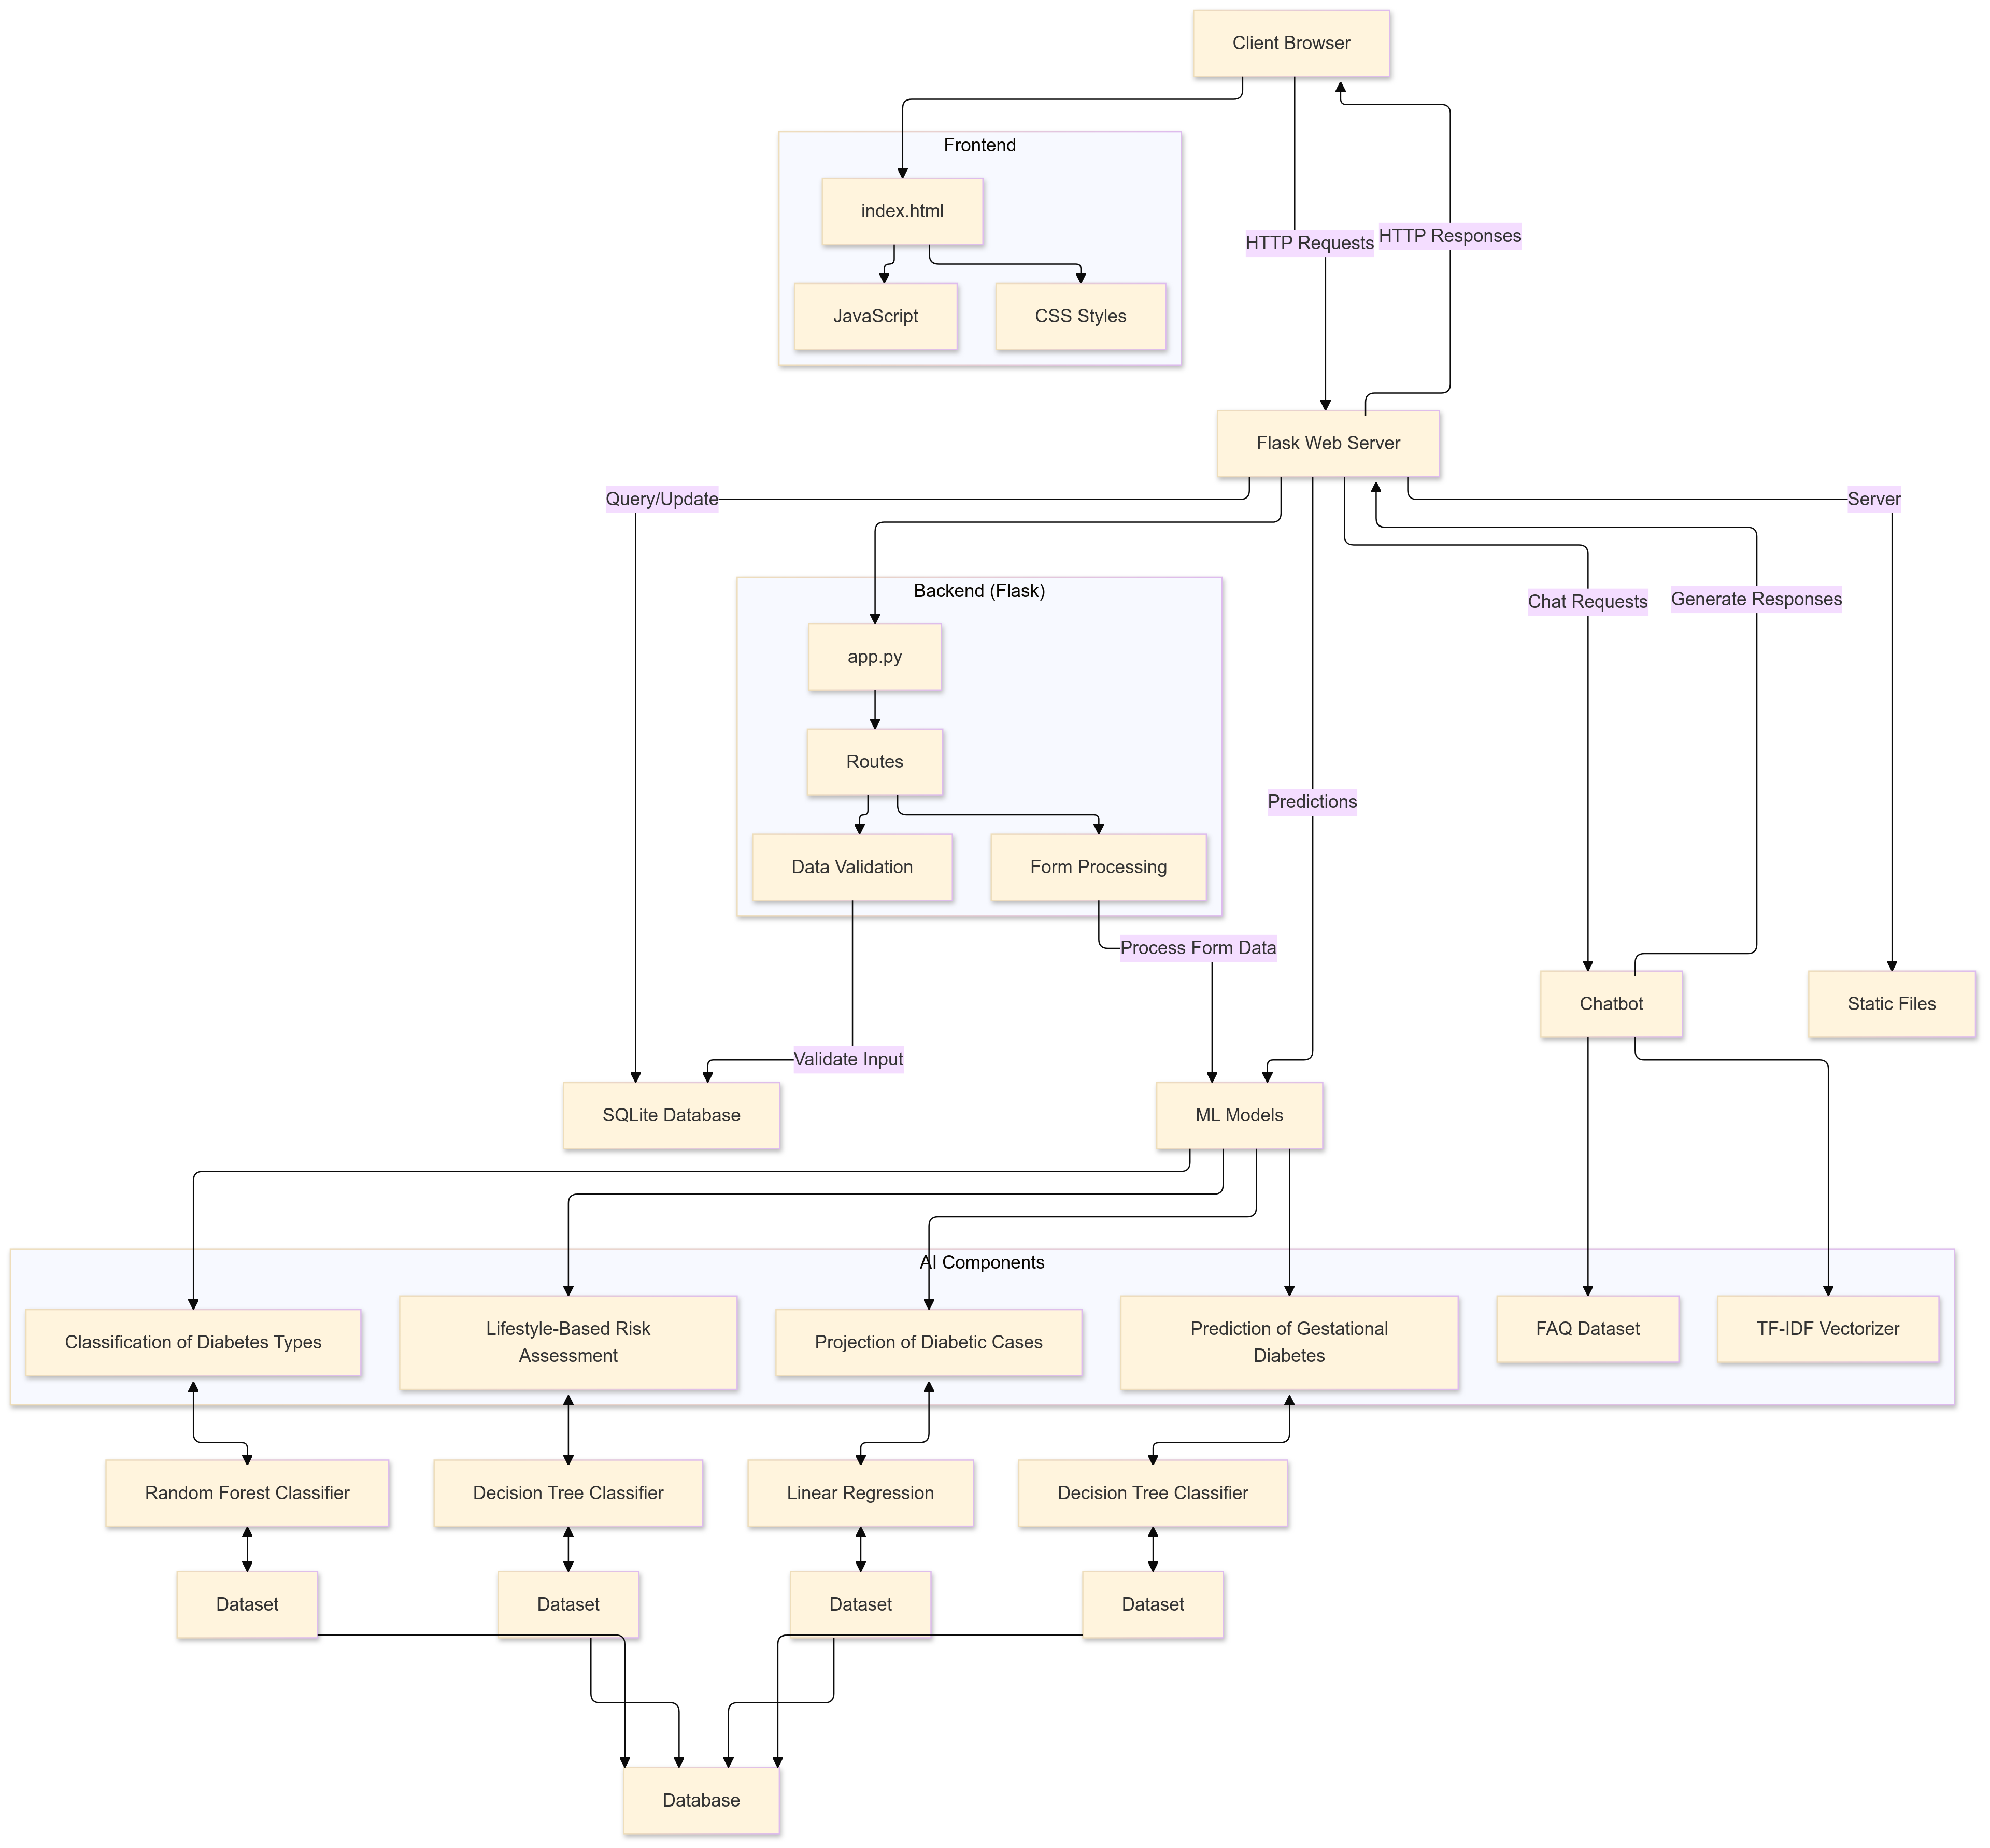

~ Team Mavericks

