**Assignment (1 ) D.B.M.S**

**Mohd Maaz (GU13L0080) M.C.A**

**INSERTION**

INSERT INTO .`student` (`id`, `name`, `course`) VALUES (NULL, 'maaz', 'mca'), (NULL, 'usama', 'ba');

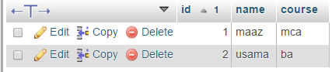

**DELETION**

DELETE FROM ‘student` WHERE `student`.`id` = 2

;

**UPDATION**

UPDATE ‘ student` SET `name` = 'nafess' WHERE `student`.`id` = 1;



**WHERE**

SELECT * FROM `student` WHERE ‘id’ =1 ;



**OR**

SELECT * FROM `student` WHERE course ='mba' or course ='mc

**AND**

SELECT * FROM `student` WHERE name ='maaz' AND course ='bsc'



**BETWEEN**

SELECT * FROM `student` WHERE id BETWEEN 1 AND 8 ;

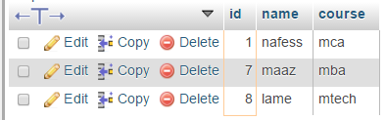

**LIKE**

SELECT * FROM `student` WHERE course LIKE '%c'

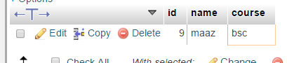

**ORDER BY**

SELECT * FROM `student` ORDER BY id desc

