FIC lab activity 1

Nokia Connecting Robots using Cloud Solutions

|  |  |  |  |
| --- | --- | --- | --- |
|  | | |  |
| Author | Cristian Cosariu, Alexandru Iovanovici, Cosmin Ivan, Lucian Prodan |
| Owner | Nokia Timisoara, Politehnica University of Timisoara |
| Organization | Nokia Romania |
| Approver |  |
| Document ID |  |
| Document location | Public |
|  | |  |
|  | | |  |

Contents

1 Nokia Connecting Robots using Cloud Solutions 3

1.1 Project description 3

1.2 Scope 3

1.3 Teams 3

1.4 Project schema 4

1.5 Technologies & Tools 4

2 HW robot description 5

3 Resources 5

# Nokia Connecting Robots using Cloud Solutions

## Project description

* Control a robot to play a sumo game against another robot or team of robots;
* Use video detection for on field robot movement and control of the ball;
* Assembly/Implement the robots, implement the algorithm to control the ball and robots;
* Define playing tactics.

## Scope

* Use a video streaming solution and send data in Nokia cloud, run the code in the cloud
* Implement the infrastructure (playing field + robots)
* Host / run the control solution in Cloud
* Robots coordination and control algorithm
* Learn to work on a project (subversioning, define specifications, implementation)

## Teams

* Each team must have 2 to 3 students
* Each team must have a name that will be provided to the laboratory responsible
* The team members should come at the same laboratory session in order to work together

## Project schema

Internet

VM (Video processing)

## Technologies & Tools

|  |  |
| --- | --- |
| Arduino boards programing and setting up the system  C:\Users\cosmini\Desktop\arduino.png | Git versioning system  C:\Users\cosmini\Desktop\git.jpg |
| Working with virtual machines  C:\Users\cosmini\Desktop\virtualmachines.png | C++, Open CV  C:\Users\ccosariu\Desktop\openCV.png |
| Eclipse  C:\Users\ccosariu\Desktop\eclipse-426x100.png |  |

# HW robot description

* BetaDo rev. B processing unit, microcontroller: ATmega644P
* plexiglass chassis
* DC motors, 6V, 720rpm
* Rubber wheels 36mm (pereche, 2 bucati)
* Bluetooth JY-H05
* Module ESP8266
* Acumulator 1000mAh
* Communication module 2.4GHZ NRF

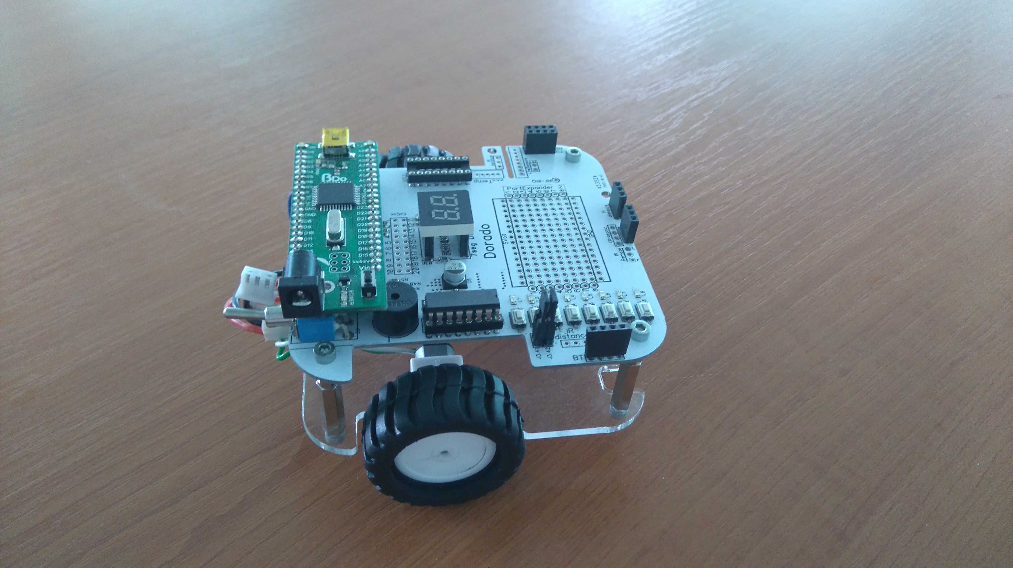

# Resources

<http://robogames.net/rules/all-sumo.php>

<https://www.youtube.com/watch?v=iL8IRF4wQmU>