**Data Visualization – Course Work**

Assignment 5

Task 1: Volume Visualization with Paraview

## Get in touch with ray-casting and isosurfaces.

Create 2 screenshots where you can see the rendering (e.g. a special part of the CT data) as well

as the transfer function.

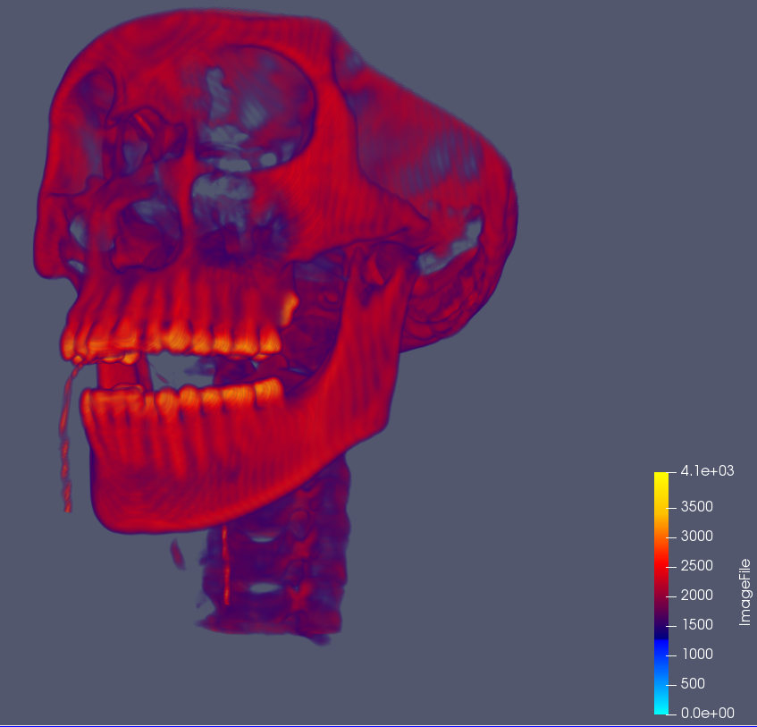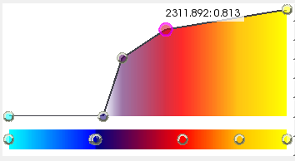

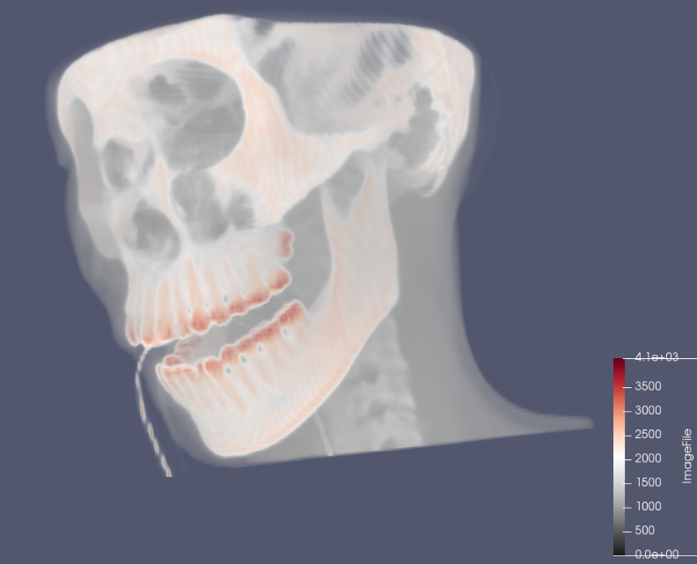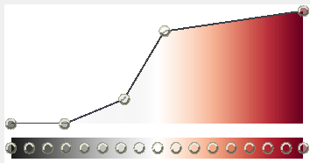

Which part of the body has the highest local change in density? Which filter can you utilize to

solve this question?

*The brain has the highest local change in density. The slice filter can be used.*

What is the density value for bones? Use the contour filter and try to find a good value in order

to produce a clean mesh. Make a screenshot.

1200.

