Tableau – VizAlerts User Guide  
  
Contents

What Is VizAlerts? 2

How do I use it? 2

Simple Alerts 4

Advanced Alerts 5

Walkthrough 6

Important Differences from Simple Alerts 12

Additional Advanced Alert Features 13

Placeholder Objects 14

Advanced Alert Use Cases 15

Tableau Server Monitoring 15

Extract Failure to Refresh Notifications 15

Bulk Mailing 15

Consolidated Emails 15

Dashboard with Hidden Embedded Alert 16

Tips And Tricks 17

Testing an Alert 17

FAQ / Common Issues 18

## What Is VizAlerts?

Since the dawn of time, humans have brought up the needs that they have for various forms of alerting driven by Tableau Server. Some want to know when extract refreshes fail. Others want to know when they succeed. Salespeople want to know when they hit their quota. Still others simply want to make a few tweaks to the existing Subscription functionality, say, by being able to send a report image to a distribution list rather than requiring each individual team member to subscribe separately.

VizAlerts is an email automation platform intended to seamlessly integrate with Tableau Server. The idea behind it is that anyone should be able to easily build, share, and customize pretty much any email automation based on their own Tableau Server viz data.

## How do I use it?

An alert is defined by two things: A View published to Tableau Server, and a subscription to that view on a special, *disabled* Subscription schedule. Let’s take a look at a simple example:

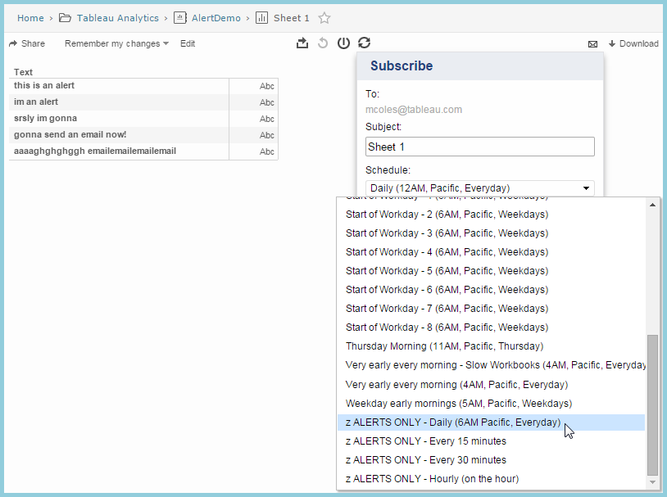

The *view*’s job is to define the criteria for triggering the alert and the content displayed within it. The scheduled *subscription’s* job is to define at what times and how frequently the view is checked to see if an alert should be sent.

VizAlerts functions off of one simple triggering mechanism: The presence of data in your viz. If, when VizAlerts is scheduled to check your viz, it finds that **data is present**, it will trigger the alert. If it finds no data, then nothing happens. Thus, the criteria for when you receive an alert depends solely on what data you’ve connected to, and how you’ve filtered it. Because of this, you have a lot of flexibility in defining your alert.

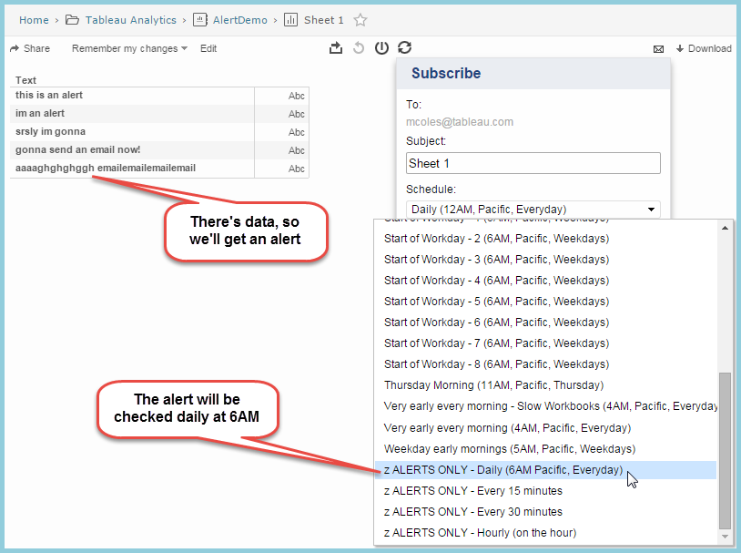

Okay, we’ve got the basic premise down, now we can get to the fun stuff. Namely, what does an alert look like when it hits your inbox? Who does it get sent to?

The answer, just like the answer to every good question, is: “It depends!”

There are two modes of email automation supported by VizAlerts: **Simple Alerts** and **Advanced Alerts**.

## Simple Alerts

True to its name, this is the simplest and easiest form of alerting. Anyone with “view” permissions to a View on Tableau Server can subscribe to it on an Alert schedule, and it will be delivered to them if and only if it is triggered. This means that I could send the URL to the view above to all my co-workers and tell them that if they want to get silly text alerts sent to them at 6AM like I get, they only need subscribe to it on the same schedule.

And here is what the Simple Alert they’d get looks like as an email:

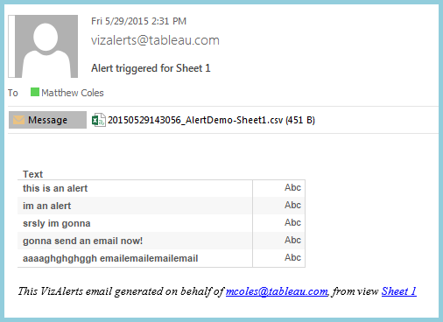

The PNG rendering of the View itself is embedded in the email, and the data from the View is attached in CSV format. The image is linked back to the View on Tableau Server, just as in a Subscription. The CSV is simply there to provide additional information that might not be exposed visually, and to provide a static historical record of what caused the alert to be triggered (by the time you open your email and click the link to investigate, the data behind the View may have changed).

**So wait**—what if someone picked a View that wasn’t designed to be an Alert, and subscribed to it on a custom Alerts schedule? What would happen?

The answer is: A Subscription, effectively. Except they’d also get the CSV data attached to the email.

There are a few other important things to know about Simple Alerts:

* VizAlerts will **impersonate** the Subscriber when it checks for viz data from the View they subscribed to. Therefore, any user filters set up that are based on who is viewing the viz will apply as if the Subscriber had pulled the view up manually in a browser. This provides an easy way for one person to author an Alert that will be triggered at different times depending on who subscribed to it, if so desired.
* If a user creates a Customized View from your original Alert view, they can subscribe to it if they like, and VizAlerts will process it just like any other Alert. This provides additional flexibility if individuals want to tweak specific criteria to trigger their alerts.

All this Simple Alert stuff is well and good, but maybe “simple” isn’t a word that describes you. Maybe you’re more the *power user* type. In that case, please proceed to:

## Advanced Alerts

Advanced Alerts are triggered in the same way that Simple Alerts are, but they allow you extremely granular control over **what** you send to **whom**. They work on the following principle:

“For every row of data in the viz, send an email with properties and content based on the data in each field”

What tells VizAlerts that an given alert is an Advanced Alert from a Simple Alert is the presence of a field named “ Email Action *” in the viz with a value of 1. In addition the properties of an email sent by an Advanced Alert are generated by **specific calculated fields** in the View you subscribe to.   
Each of the following properties for the email has its value mapped from the viz data in accordance with the corresponding field name:

|  |  |  |  |
| --- | --- | --- | --- |
| **Email Property** | **Field Name (with leading space)** | **Required?** | **Structure** |
| To | Email To * | Yes | Email address(es) separated by commas or semicolons |
| From | Email From ~ |  | Email address |
| CC | Email CC ~ |  | Email address(es) |
| BCC | Email BCC ~ |  | Email address(es) |
| Subject | Email Subject * | Yes | Text |
| Header | Email Header ~ |  | HTML |
| Body | Email Body * | Yes | HTML |
| Footer | Email Footer ~ |  | HTML |

The naming conventions for the fields are a little strange, but there’s a method to their madness. Asterisks (*) represent fields **required** for an Advanced Alert, and the tildes (~) represent **optional** fields. All the fields are prepended with the word “ Email” (**note the preceding space**), mostly for uniqueness and easy sorting in the Dimensions pane. But the most important part to know about Advanced Alerts is that the field names **must** **match these exactly** to be used for email properties. All other fields with different names in your viz will be ignored.

Finally, please note that while VizAlerts supports Unicode characters in general, it cannot send mail to email addresses containing them. If any are detected, an error email will be sent instead.

### Walkthrough

Okay, so let’s say we don’t want to have to tell people to subscribe to our “silly words” alert from the previous example. Instead, we want to just deliver it to their inbox automatically at 6AM every day! Let’s build an Advanced Alert to support that.

First, open the workbook in Tableau Desktop, and let’s duplicate the original sheet into a new one called Advanced Silly Words Alert:  
  
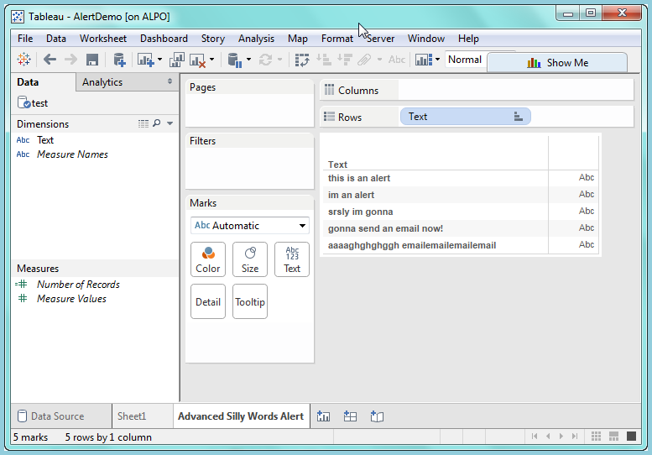

Okay. We have a field called “Text” in there. That’s not useful since it doesn’t map to any email properties. We need the fields to have the proper conventions, just as we saw in the table above. But it’s kind of a pain to have to build all those calculations with the proper names. Thankfully, there’s a faster solution:

Open a connection to a Tableau Server Datasource…

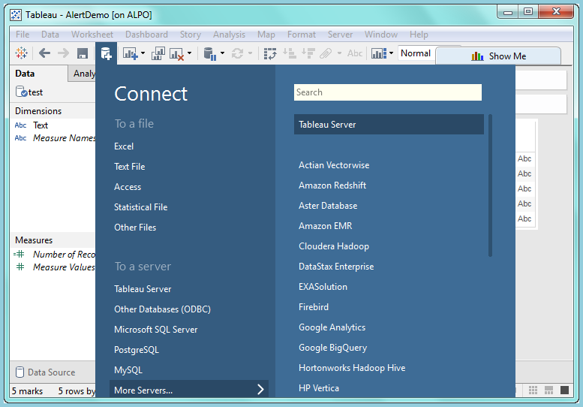

…and connect to the VizAlerts datasource that was presumably published to your Tableau Server instance (If it wasn’t, look for VizAlerts.tdsx in your VizAlerts install folder):

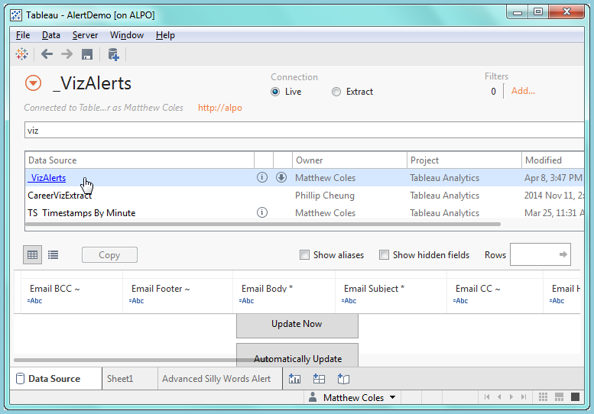

Hey, look at that. It happens to have all the proper fields in it! And each has a comment describing its own usage:

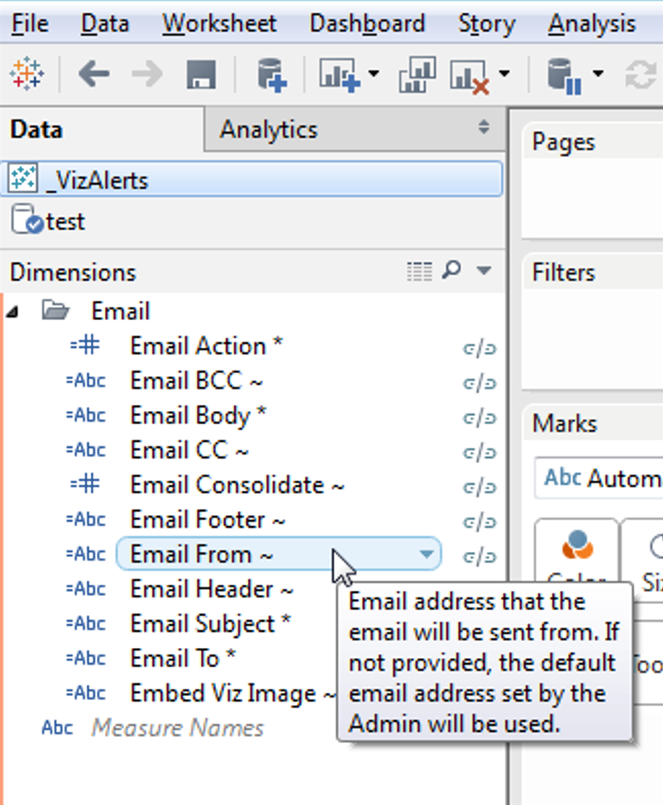

Now, this is just a dummy datasource with one row in it. We *could* get the fields into our viz by blending the data, but that would take a bit of work. A far easier way is to simply copy and paste them into our original data connection. Like so:

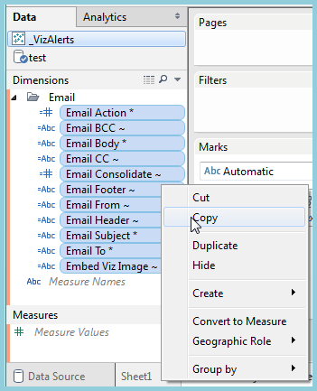 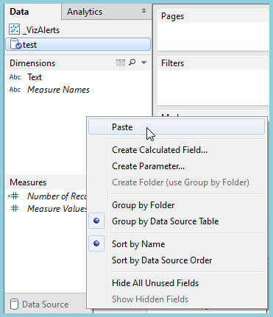

And if we create a nice little folder for them to live in, you get this lovely little setup:

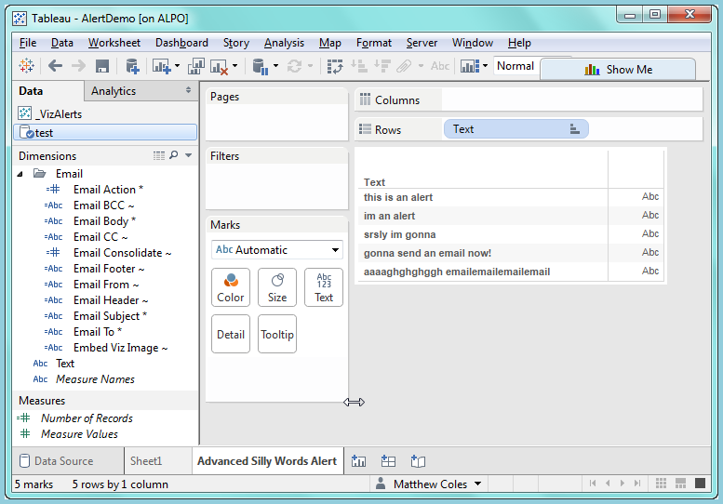

Now, let’s CNTRL-select and drag all the **required** fields out to the Rows shelf to make sure they’re present in our viz (I also re-arranged them in logical order):

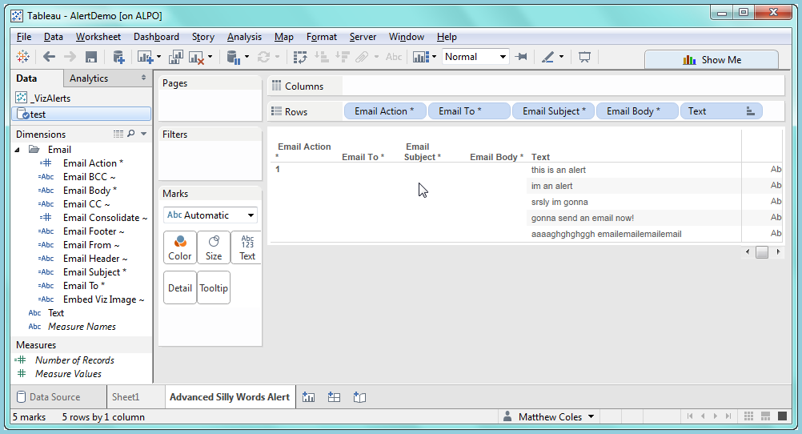

Wait, what’s this “ Email Action *” field about? That doesn’t actually do anything more than tell VizAlerts that this is an Advanced Alert. Because at some point we might want to automate more than just email (hmmm….). So for now, just drag it in and forget about it.

These calculated fields are all intentionally left blank, so that you can fill them in with your own data. To do so, all we need to do is edit them. For this example, we’ll add static string values for the To and Subject fields, but we could just as easily derive those from our data if we had values in there. For the Body, we’ll actually just reference the “text” field directly:

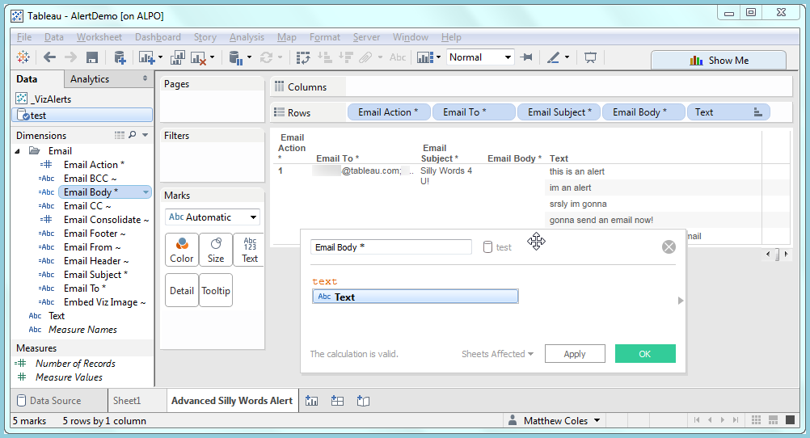

Okay, so after all that work, here’s what we have once we remove the redundant and ignored “text” field from the viz:

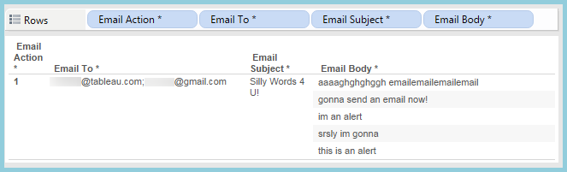

What this means to VizAlerts is: **For every row of data, send one email** to [someone@tableau.com; someone@gmail.com](mailto:someone@tableau.com;%20someone@gmail.com) with the Subject “Silly Words 4 U!” and the Body being the Email Body. Using the above as an example, five emails would be sent to each of the two email addresses.

Now that we’re ready to have this alert run, we need to publish it to Tableau Server and subscribe to it on one of the Alerts schedules, just as we did for the Simple Alert. But now is a good time to mention some of the…

### Important Differences from Simple Alerts

An Advanced Alert is executed via Subscription, just as a Simple Alert is, but with a few key differences:

* **Single Subscriber**: Only the **author** of the Advanced Alert can set up a Subscription to that Advanced Alert. Any other user’s subscription to it will be disregarded. To avoid confusion, it may be useful to limit View permissions on them, so other users cannot subscribe at all.
* **Impersonation**: VizAlerts will use the **author’s** Tableau Server user to generate the content for the Advanced Alert. This means that the author is solely responsible for ensuring that any content being emailed out is appropriate to the intended audience.

The results of the alert we set up hit our inbox like so:

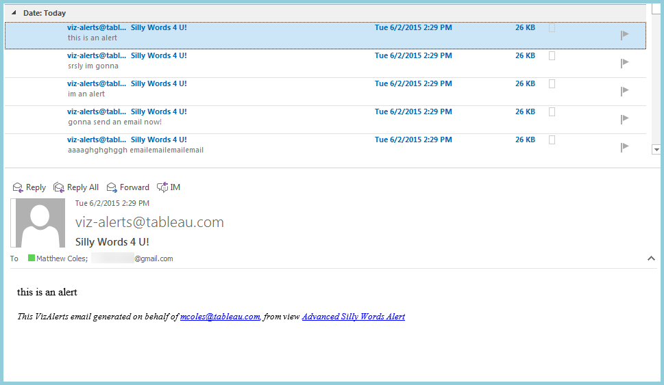

And the same set of emails went to the Gmail address at the same time.

Because all of these email properties are simply calculated fields in Tableau, you can make them conditional rather than a static string. You could, based on the Text field information, send some silly words to the tableau.com address, and others to the gmail.com address, or none at all if you preferred. This allows you to use your data to drive the logic behind who is sent an email, and what it contains.

### Additional Advanced Alert Features

With Advanced Alerts come a few options to allow even more customization in the content sent by the alert. These are enabled by the following fields:

* **Email Body \***This field passes any HTML formatting you include in it into the body of the email you compose, which allows you to customize the look of the content in your email.
* **Email Footer ~ / Email Header ~**These fields allow you add a header and/or footer to the Body of your email, *after* all consolidation has taken place. In fact, they only really make sense to use when you are also using the **Email Consolidate ~** field, since otherwise you could just add the additional info to the **Email Body \*** fielddirectly. Please note that using the **Email Footer ~** field in your viz will *replace* the standard VizAlerts footer that’s automatically appended to alert emails. If you wish to add your own footer, but don’t want to get rid of the standard footer at the bottom, the placeholder text “**VIZALERTS_FOOTER()**” anywhere in your footer data will cause it to be added at that location. See the VizAlerts.tdsx helper datasource for an example.
* **Email Consolidate ~**When this field is present in your view, rather than sending **one email per row** of data, VizAlerts will consolidate the Body field across **multiple rows**, as long as the Subject and **all** recipient fields (To, From, CC, BCC) are the same. Something like this can be very useful if you have information you want to consolidate and send to a user once, rather than bombard them with separate emails for each bit of information. **NOTE** that this field works at the view level, and not at the individual row level—you cannot use it for some rows in your view, but not others. Simply being present in the view, regardless of what value it holds, will enable it for all the data.
* **Embed Viz Image ~**This field doesn’t do anything except to remind you of the value of the VIZ_IMAGE() placeholder text (see Placeholder Objects below for more details).

### Placeholder Objects

Advanced Alerts supports inserting some pre-defined objects in a single alert using placeholder text. At this time VizAlerts supports two:

* **VIZALERTS_FOOTER()**  
  When placed in the “ Email Footer ~” this adds the default VizAlerts footer to the email.
* **VIZ_IMAGE()**  
  This placeholder can be used in the header, body, or footer and will include a PNG image. There are two options for using VIZ_IMAGE():
* VIZ_IMAGE() when called with no argument uses the image of the view that the Advanced Alert originated from.
* VIZ_IMAGE(‘workbookname/viewname’) will render the given workbookname/viewname as a PNG. For example if the URL on Tableau Server is http://myServer/views/SalesData/SalesDashboard then the argument for VIZ_IMAGE would be VIZIMAGE(‘SalesData/SalesDashboard’).  
    
  This option also supports URL Parameters as described in Filter Views Using URL Parameters <http://kb.tableau.com/articles/knowledgebase/view-filters-url>. For example you could use VIZ_IMAGE(‘mySalesData/SalesDashboard/Region=East’) to send only the East data.  
    
  Note that for Advanced Alerts VizAlerts impersonates the viz author so that user must have permissions custom content. Also it is not possible to configure a custom URL to return a viz from a different Site.

## Advanced Alert Use Cases

### Tableau Server Monitoring

Here’s a link to a thread of a number of ways to use VizAlerts for monitoring Tableau Server: <https://community.tableau.com/message/383607#383607>

### Extract Failure to Refresh Notifications

There are multiple ways to set up automated notifications for failure to refresh extracts (the above link has one), here’s another: <https://community.tableau.com/message/465996#465996>

### Bulk Mailing

Using an Advanced Alert with custom URL parameters it is possible to have very fine-grained controls for sending bulk emails from Tableau Server of any view(s) you want. For example a user with the correct permissions could set up a view that had a list of email addresses and body that included custom URL parameters, for example to email out a daily dashboard filtered for certain data:

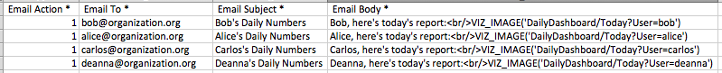

Since the data source could be generated with some simple formulas in Excel, Tableau, or the data source, this offers a lot of flexibility for configuring delivery.

### Consolidated Emails

As noted above there’s an “ Email Consolidate ~” option for Advanced Alerts that will consolidate across the rows in the triggering viz. For example this data would send out one email to Arundhati and automatically include all the images of her direct reports:

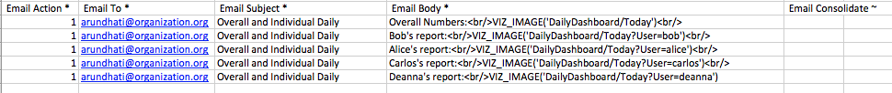

You can also embed multiple VIZ_IMAGE() calls in the header, footer, and/or body. So the same email could be generated using a single (larger) email body:

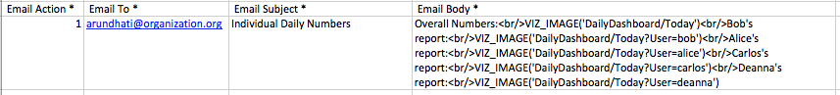

### Dashboard with Hidden Embedded Alert

This is an alternative method to setting up Advanced Alerts for a Tableau dashboard that doesn’t require using custom VIZ_IMAGE() references. There are two important things to know when you set up a Dashboard with a Hidden Embedded Alert:

1. Only one View within the Dashboard can be used to trigger the Alert
2. The triggering View is the one whose name comes first in alphabetical order

Given that, the way to ensure you get what you need out of the Dashboard w/Hidden Embedded Alert is to **embed a specific View that serves as the trigger** for the alert, and name it “-(Dashboard Name) Trigger”, e.g. “-Sales Quota Dashboard Trigger”. The hyphen should ensure it comes first and is therefore used as the trigger.

However, what if you don’t actually want to *display* the trigger view? For Advanced Alerts in particular, you often don’t. To make it invisible, use the Format menu to change text colors to the background of the dashboard and remove borders:

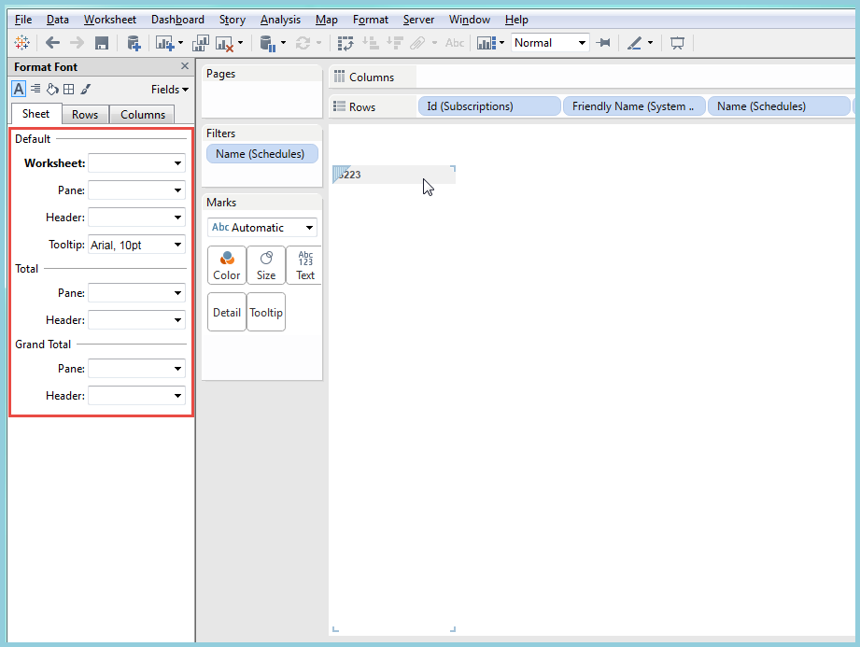

Then, place it in your Dashboard as a “floating” view, and drag the container around it into as small a rectangle as possible. Place it somewhere unobtrusive:

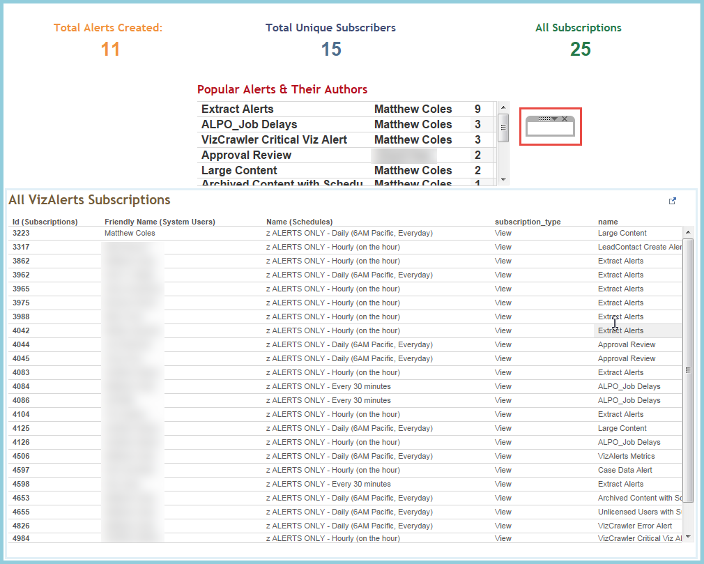

Now, just subscribe to the Dashboard just like any other Alert based on a standard View, and you’re good to go!

## Tips And Tricks

### 

### Testing an Alert

Occasionally, you may wish to test an alert prior to setting it up on a Schedule, as you may not be certain it will execute properly. For Advanced Alerts in particular, testing them first is highly recommended! VizAlerts allows an alert to be tested on a one-off basis without being scheduled through the use of a specific **comment**:

### 

If the owner of the View adds a Comment with the content “**test_alert**” (case insensitive), then the Alert will be tested one time only. If another comment with the same content is added, the Alert will be tested again. Removing the comments, however, will not trigger an additional test. Allow at least three minutes for your alert to show up.

Note that this doesn’t work for Customized Views, only standard Views, and the commenter must also be the owner.

## FAQ / Common Issues

* **I got a failure email instead of an alert!**

When VizAlerts cannot process your alert, by default you and the Administrator are sent a notification email with the details. Issues can range from simple timeouts, permissions issues to datasources, or internal Tableau Server errors. Most commonly, the issue is a timeout. If that’s the case, [improve the speed](http://www.tableau.com/learn/tutorials/on-demand/tableau-server-authoring-performance) of your view! If that’s not possible, work with your Admin to find a way to increase the timeouts your alert runs under.

* **What if I don’t get an alert email when I expect one?**  
  There are a couple of reasons this might occur:
  1. First, ensure that your filter criteria is set up correctly, and that you DID have data in your alert for when it was scheduled to run.
  2. Check to see if your alert was filtered and sent to Junk Mail rather than your Inbox. If it was, make sure to “always allow” mail from the address you received it from in your Junk Mail settings.
  3. If it’s neither of those things, contact your Tableau Server administrator, as they should have received a failure email if your alert truly did not work correctly.
* **How can I avoid getting continual alerts for the same data?**One strategy for this is to use a Relative Date filter against your data. You should set that filter to a span of time that matches the Schedule you subscribed to your Alert on. For example, if you have subscribed to an Alert on a daily schedule, you should set your relative date to show only data for the last 24 hours (or 1440 minutes).
* **I’m getting my Alerts late**Discuss with your Admin, and if they aren’t sure what to do, ask them to read the “FAQ” section of the install_guide.docx file.