
Design Documentation
[GitHub]: https://github.com/tableba/SmartHouse/tree/ali-iot/iot

SmartHouse – IoT

Revision History 1
Design item List 1
Design Item Descriptions 2
D2. Arduino Device Component Design 2
D3. Serial Communication Protocol 3
D4. Interaction Flow – UI Command to Device 4
D5 Fault Handling & Safe Behaviour 5

Revision History

Date | Version | Description | Author
2026-07-17 | 1.0 | Created the initial design documentation for the SmartHouse IoT subsystem. | Ali Daoud
2026-08-22 | 1.1 | Updated design with figures, flow charts, device-state handling, and mock backend implementation. | Ali Daoud

Design item List
Requirement Name | Priority
D1. High-Level Architecture | Essential
D2. Wokwi ESP32 Device Design | Essential
D3. HTTP and JSON Communication | Essential
D4. Device Registration and Heartbeat Flow | Essential
D5. Fault Handling and Safe State Behaviour | Essential

Design Item Descriptions
Description:
The SmartHouse system uses a three-layer architecture:

1. Android Application Layer:
The user views available devices and sends commands through the Android application.

2. Backend Server Layer:
The backend manages users, registered devices, device authentication, heartbeat messages, commands, and device states.

3. IoT Device Layer:
Wokwi ESP32 simulations represent the smart-home devices. The devices communicate with the backend using HTTP requests and JSON data.

Communication flow:
Android Application → Backend Server → Wokwi ESP32 Devices
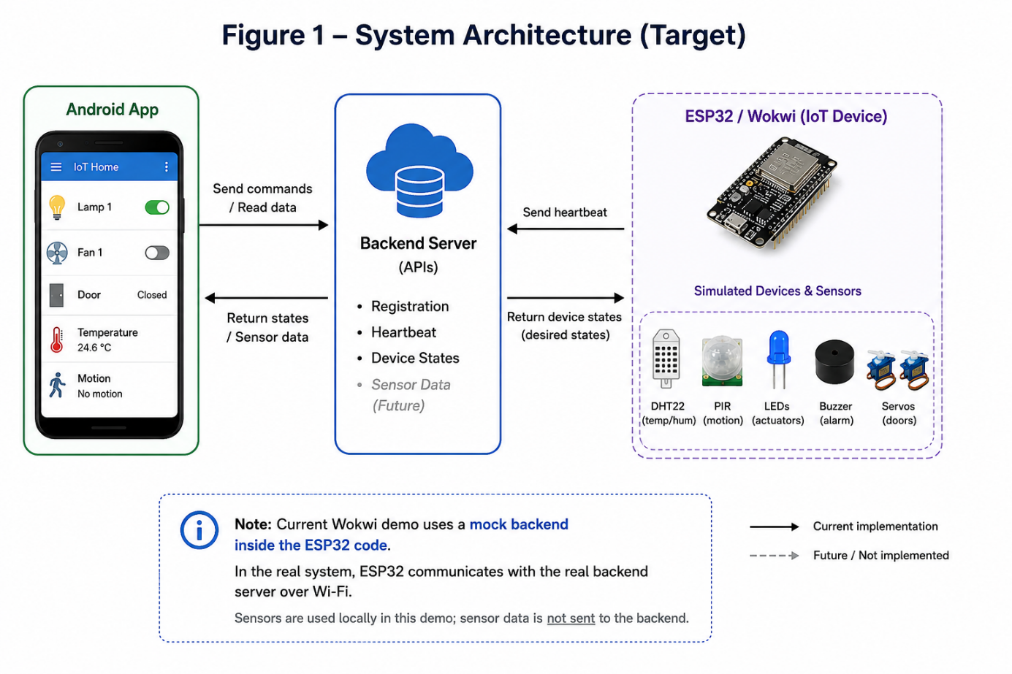

The Android application does not communicate directly with the simulated devices. All communication passes through the backend server.

D2. Arduino Device Component Design
Description:

The IoT subsystem uses Wokwi and ESP32 to simulate smart-home devices without requiring physical hardware.
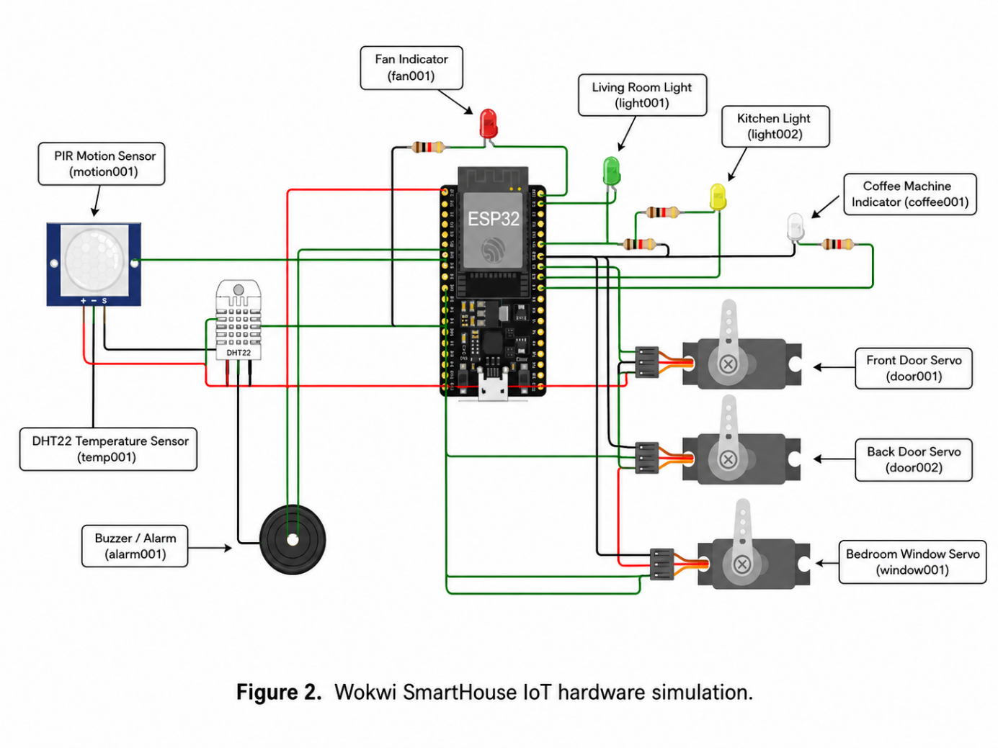

Each simulated device contains:

● A unique device ID

● A device name

● A valid device type

● A device-specific state object

● A secret used for authentication after registration

Supported device types include:

● Light

● Door

● Fan

● Coffee machine

● Temperature sensor

● Motion sensor

● Alarm

● Window

Each device maintains only the state fields relevant to its type. For example, a light may use power and brightness, while a door may use an open state.

The implementation shall keep the backend URL, device information, and authentication data separated from the main device-control logic so that configuration can be updated without changing the complete program.

D3. HTTP and JSON Communication
Description:

The simulated IoT devices communicate with the backend using HTTP requests and JSON-formatted data.

The current backend base URL is:

https://rimmed-crave-lip.ngrok-free.dev/api

Device registration:

POST /devices/register

Example request:

{
"id": "light001",
"name": "Living Room Light",
"type": "light",
"state": {
"power": false,
"brightness": 0
}
}

The backend returns a device secret. This secret shall be stored and used for future device authentication.

Heartbeat:

POST /devices/heartbeat

Example request:

{
"id": "light001",
"secret": "<device_secret>"
}

Each registered device shall send a heartbeat every 30 seconds.

Device states are retrieved through GET /devices/states. The ESP32 checks desired device states every 3 seconds and applies them to the corresponding simulated hardware. In the current Wokwi demonstration, the registration, heartbeat, and device-state endpoints are simulated using a mock backend inside the ESP32 code because the Wokwi Free plan cannot access the local backend through the Private IoT Gateway.

D4. Interaction Flow – UI Command to Device
Description:

The device communication flow begins when a simulated device starts.
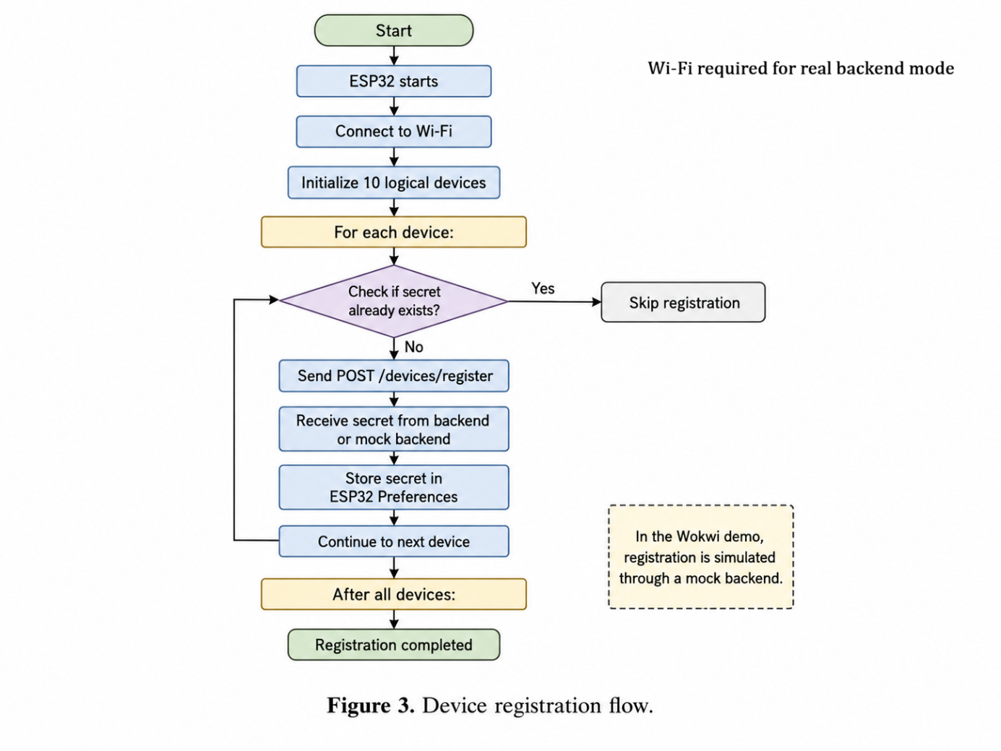

Device Registration Flow:

1. The ESP32 connects to Wokwi Wi-Fi.

2. The device sends its unique ID, name, type, and initial state to the backend registration endpoint.

3. The backend validates the request and returns a unique device secret.

4. The device stores the secret for future authenticated communication.

Heartbeat Flow:

1. The registered device waits 30 seconds.

2. The device sends its ID and secret to the heartbeat endpoint.

3. The backend validates the device secret.

4. If the request is valid, the backend confirms that the heartbeat was received.

5. The device repeats the heartbeat request every 30 seconds.
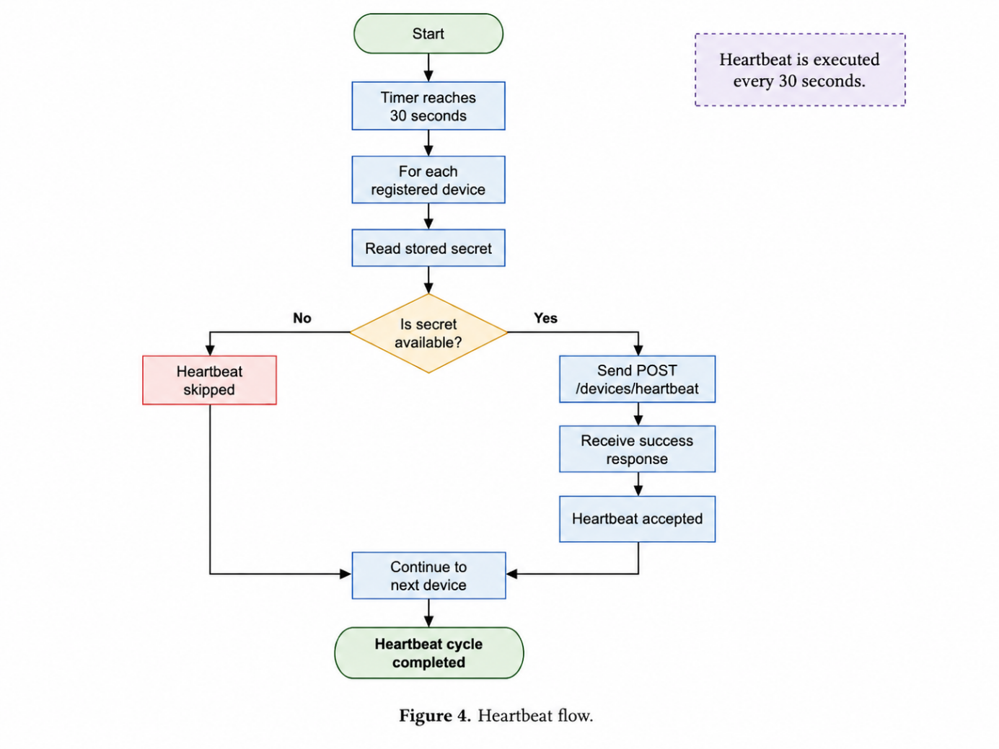

Command Flow:
The Android application sends a command to the backend. The backend stores the desired state for the relevant device. The ESP32 retrieves desired states through GET /devices/states, matches each device by its ID, updates the local state, and applies the state to the simulated Wokwi hardware.
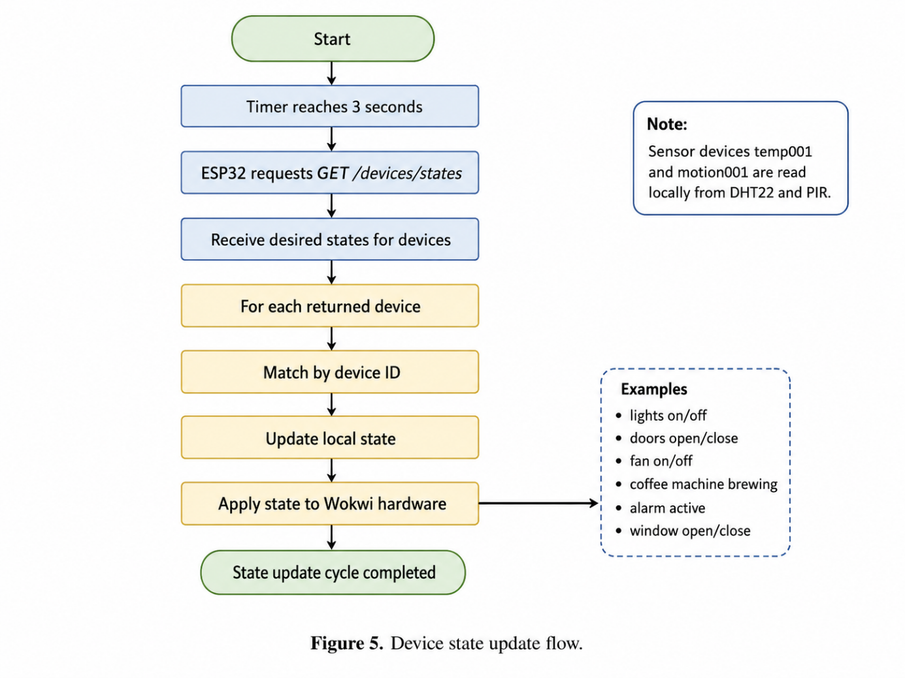

In the current Wokwi demonstration, the backend response is simulated by the mock backend. Reporting sensor states from the ESP32 back to the backend is not currently implemented.

D5 Fault Handling & Safe Behaviour
Description:

The IoT subsystem shall handle communication failures without freezing or crashing.

If Wi-Fi or backend communication is unavailable:

● The device shall preserve its last valid state.

● The device shall retry communication after a delay.

● Invalid or incomplete server responses shall be ignored.

● The device shall not execute commands that cannot be validated.

● Registration and heartbeat errors shall be logged through the serial monitor.

● The backend base URL shall be configurable because the public Ngrok address may change.

● Device secrets shall not be written directly in public source code.

This design reduces the risk of incorrect device behaviour and allows the simulation to recover when communication becomes available again.

