
Supplementary Requirements Documentation

[GitHub]: https://github.com/tableba/SmartHouse/tree/ali-iot/iot

Revision History 1
Supplementary Requirements List 1
Supplementary Requirements Descriptions 2
S1. Backend Interoperability 2
S2. Performance – Response Latency 2
S3. Reliability – Simulation Stability 2
S4. Design Language – UML Standards 2
S5. Fault Handling and State Recovery 3
S6. Multiple Device Support 3
Figures 3
References: 4

SmartHouse – IoT

Revision History

Date | Version | Description | Author
2026-07-27 | 1.0 | Created the initial supplementary requirements for the SmartHouse IoT subsystem. | Ali Daoud

Supplementary Requirements List
Supplementary Requirement Name | Priority
S1. Backend Interoperability | Essential
S2. Performance – Response Latency | Desirable
S3. Reliability – Simulation Stability | Essential
S4. Design Language – UML Standards | Essential
S5. Fault Handling and State Recovery | Essential
S6. Multiple Device Support | Essential

Supplementary Requirements Descriptions

S1. Backend Interoperability

The simulated IoT devices shall communicate with the Android application through the central backend server. Devices shall use HTTP requests and JSON data for registration, authentication, heartbeat messages, commands, and state updates. The Android application shall not communicate directly with the IoT devices.

S2. Performance – Response Latency

Under normal operating conditions, device commands and state updates should be processed within 1000 milliseconds to provide a responsive user experience.

S3. Reliability – Simulation Stability

The Wokwi ESP32 simulation shall operate continuously without freezing or crashing. The IoT subsystem shall maintain consistent device states while multiple simulated devices communicate with the backend.

S4. Design Language – UML Standards

The IoT architecture shall be documented using standardized UML diagrams. The design documentation should include diagrams that describe the system structure and the communication flow between the Android application, backend server, and simulated IoT devices.

S5. Fault Handling and State Recovery

The IoT subsystem shall handle network and backend communication failures without crashing. If communication is unavailable, a device shall preserve its last valid state and attempt communication again later. Invalid or incomplete server responses shall be ignored safely.

S6. Multiple Device Support

The IoT subsystem shall support at least 10 simulated smart-home devices operating simultaneously. Every device shall have a unique ID, name, type, state, and authentication secret. The devices shall be able to register and send heartbeat messages without interfering with one another.

Figures
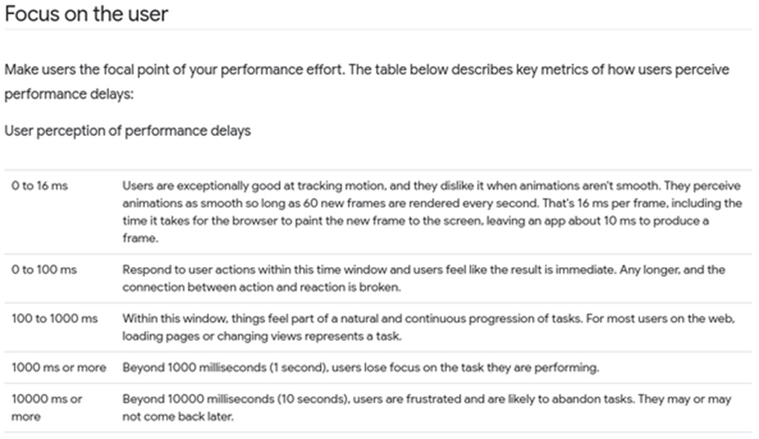
Figure 1: User perception of performance delays [1]

References:

[1] “Measure performance with the RAIL model | Articles,” web.dev. Accessed: Apr. 21, 2026. [Online]. Available: https://web.dev/articles/rail

