
Test Plan Documentation

[GitHub]: https://github.com/tableba/SmartHouse/tree/ali-iot/iot

SmartHouse – IoT

Revision History

Date | Version | Description | Author
2026-07-27 | 1.0 | Created the initial test plan for the SmartHouse IoT subsystem. | Ali Daoud
2026-08-01 | 1.1 | Updated the test statuses after implementing and testing the Wokwi ESP32 simulation. | Ali Daoud
2026-08-14 | 1.2 | Updated test results after mock backend simulation | Ali Daoud
2026-08-22 | 1.3 | Added Wokwi simulation and Serial Monitor screenshots as test evidence. | Ali Daoud

Revision History 1
Test Plan 2

Test Plan
Test Cases

Requirement | Test | Status
R1. Wokwi Device Simulation | Start the ESP32 simulation and verify that all configured devices initialize correctly. | Success
R2. Wi-Fi and Backend Connection | Connect the ESP32 to Wokwi Wi-Fi and verify that it can communicate with the backend URL. | Partially successful – Wi-Fi works. Real backend connection could not be tested because Wokwi Free does not support the required Private IoT Gateway.
R3. Device Registration | Register a device using a unique ID, valid name, type, and initial state. Verify that the backend returns a secret. | Success using mock backend – all 10 devices received simulated status 200 and mock secrets were stored.
R3. Device Registration | Attempt registration using an invalid device type and verify that the request is rejected. | Not tested – mock backend does not validate invalid device types.
R4. Device Secret Authentication | Send an authenticated request using the correct device ID and secret. | Success using mock backend – stored device secrets are used for heartbeat requests.
R4. Device Secret Authentication | Send a request using an invalid secret and verify that it is rejected. | Not tested – mock backend does not perform server-side secret validation.
R5. Device Heartbeat | Verify that each registered device sends a heartbeat every 30 seconds. | Success – all 10 devices send simulated heartbeats every 30 seconds.
R6. Device State Management | Verify that every device stores only state fields relevant to its device type. | Success
R7. Backend Command Handling | Retrieve simulated desired states and verify that the correct simulated devices change state. | Success using mock backend – desired states are retrieved every 3 seconds and applied to the Wokwi hardware.
R8. Device State Reporting | Change a device state and verify that the updated state is reported to the backend. | Blocked – backend endpoint for device state reporting is not available.
R9. Multiple Device Support | Run at least 10 devices with unique IDs and verify that registration and heartbeat communication work independently. | Success using mock backend – 10 logical devices register independently, store secrets, send heartbeats, and receive state updates.

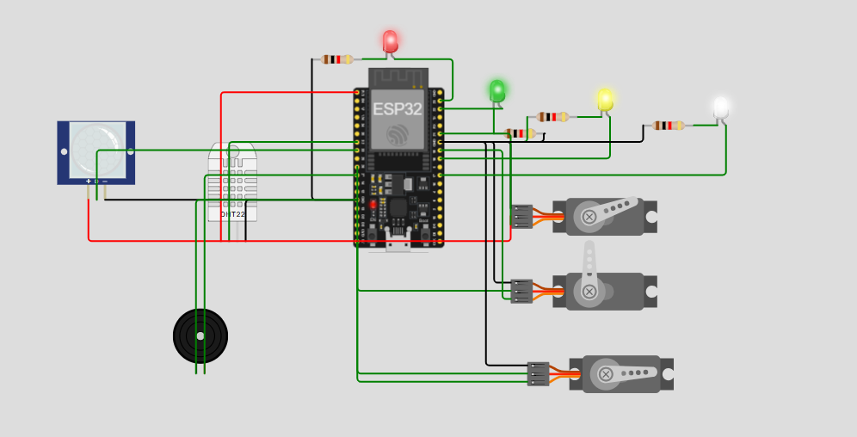
Figure 1. Wokwi simulation showing the ESP32 and connected SmartHouse devices.

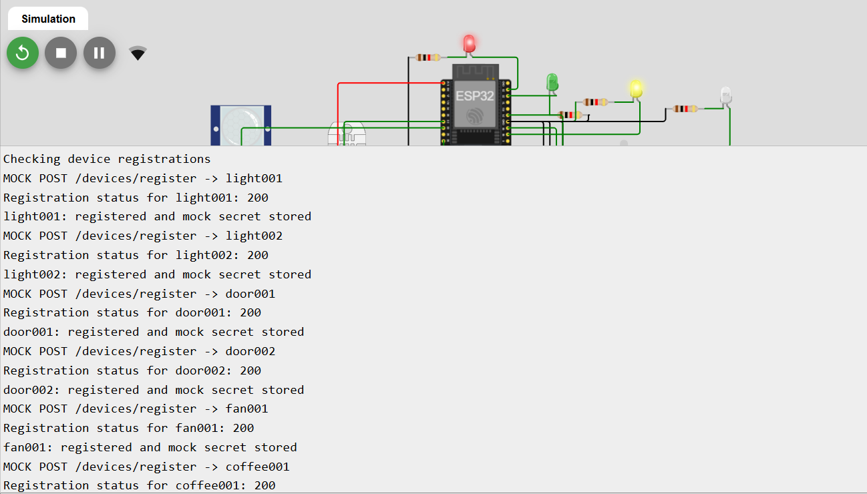
Figure 2. Serial Monitor showing successful mock device registration and stored device secrets.

