PaperTracker
A Gamified Music & Tech Learning Tool

A paper-based music technology game platform, codenamed PaperTracker. Participants use agents that have different functions (random, back and forth, etc.). Interaction is via photo and shape recognition, programming with agents, and drawing shapes. Agents are placed on printed paper tiles with grid/signs printed on.
The platform is web-based; participants join a local network with their mobile phones, which is hosted by an Intel NUC. The server is connected to a large display, which shows all the games in the classroom. The game caters for up to 5 participants.

Team
Radek Rudnicki – Coordination and administration
Lecturer and Major Coordinator, School of Music and Creative Media Production
Jon He – Software and hardware development
Lecturer, School of Music and Creative Media Production
Tristan Bunn – Web development
Interactive Media Lecturer, School of Music and Creative Media Production

Inspiration
Rerum eum voluptatem minus accusamus totam repellat. Et possimus eum id ullam. Et quos dolorem voluptatem nulla ex animi ut. Voluptatibus recusandae similique ex aspernatur.
Quas dolor amet doloremque nobis ab esse a. Ab facilis commodi ducimus consequatur harum. At atque velit et sed et dolor id. Take the digital ideas in these games into the physical world, using augmented reality to fill-in ...

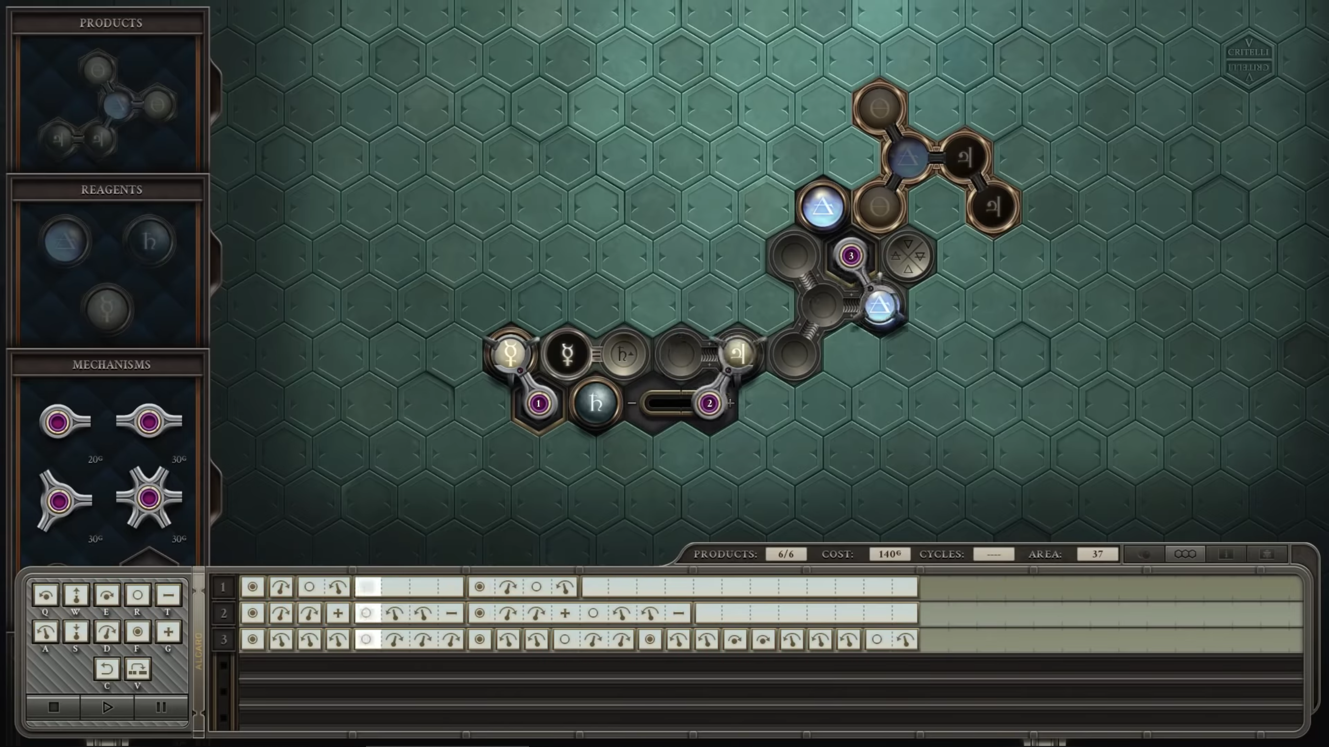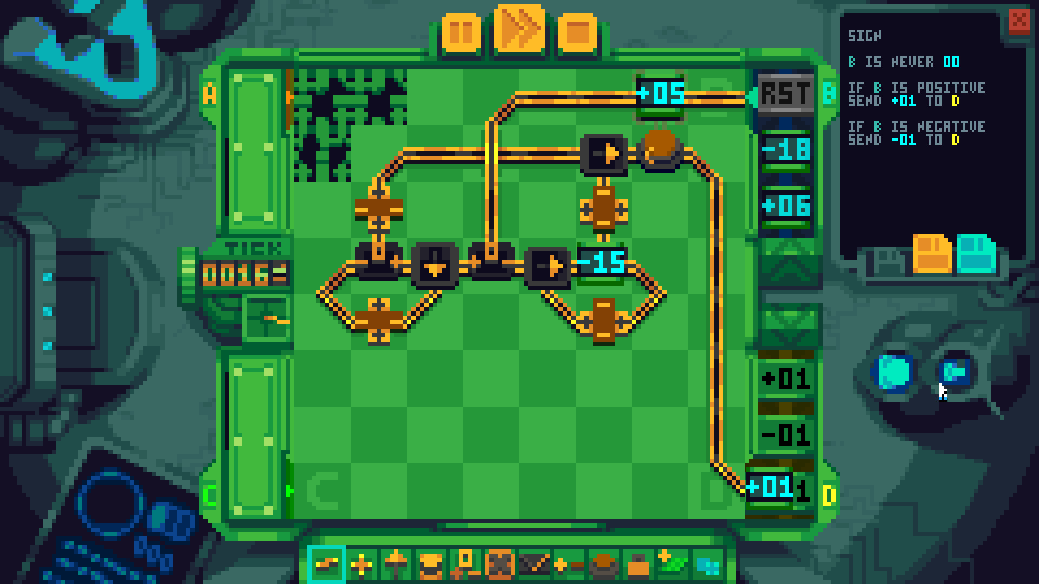
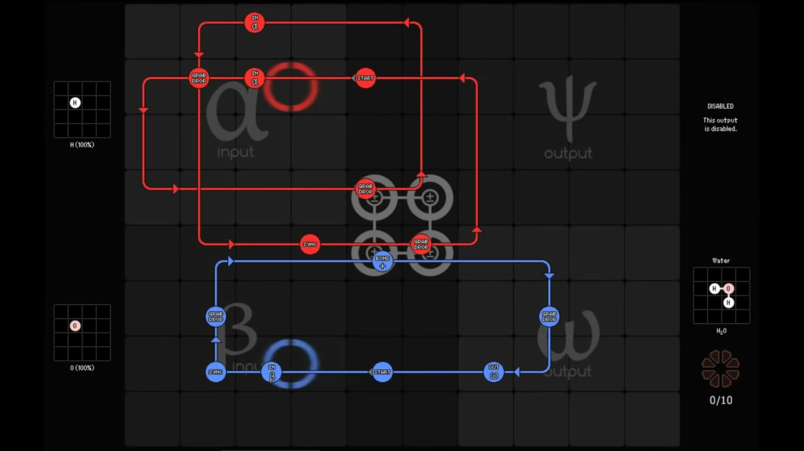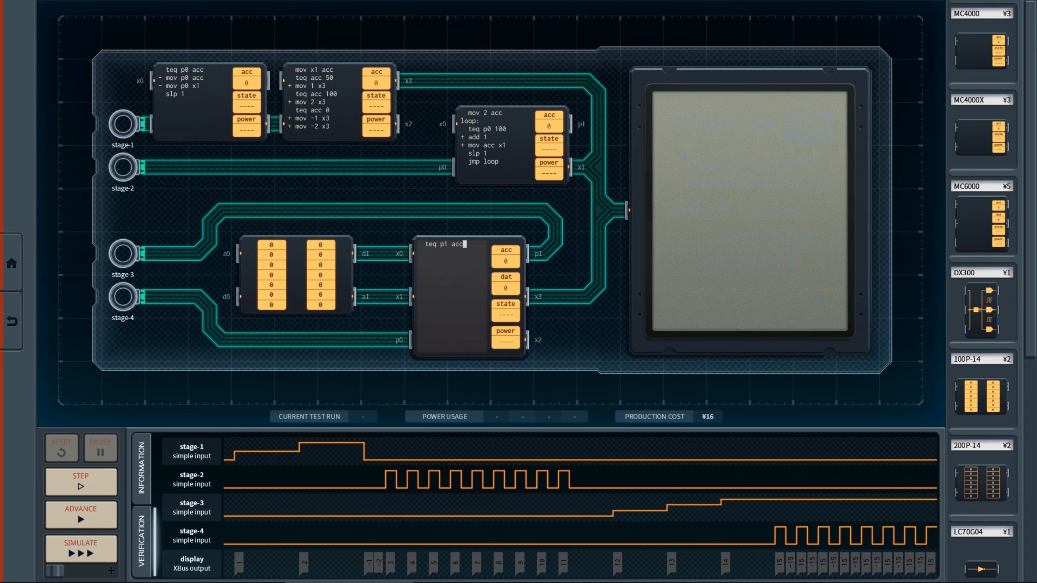
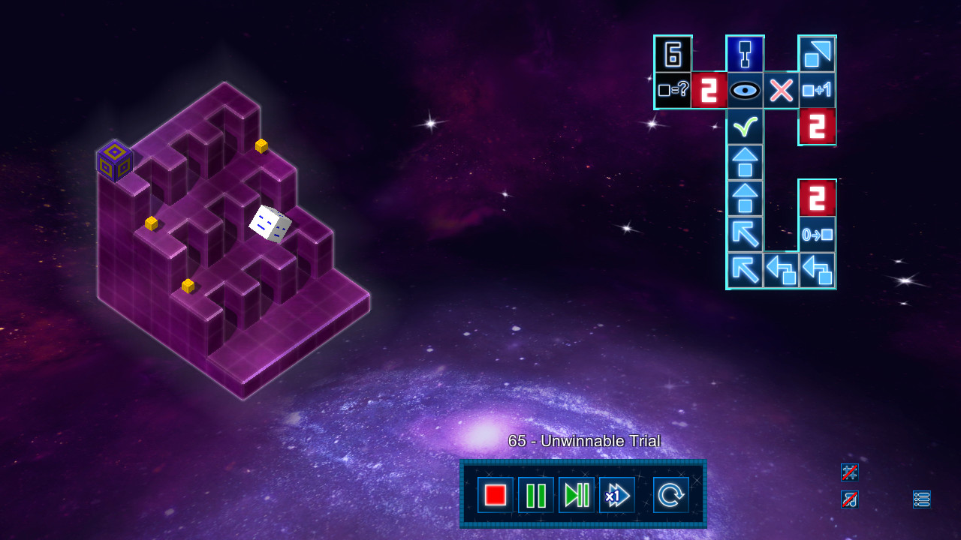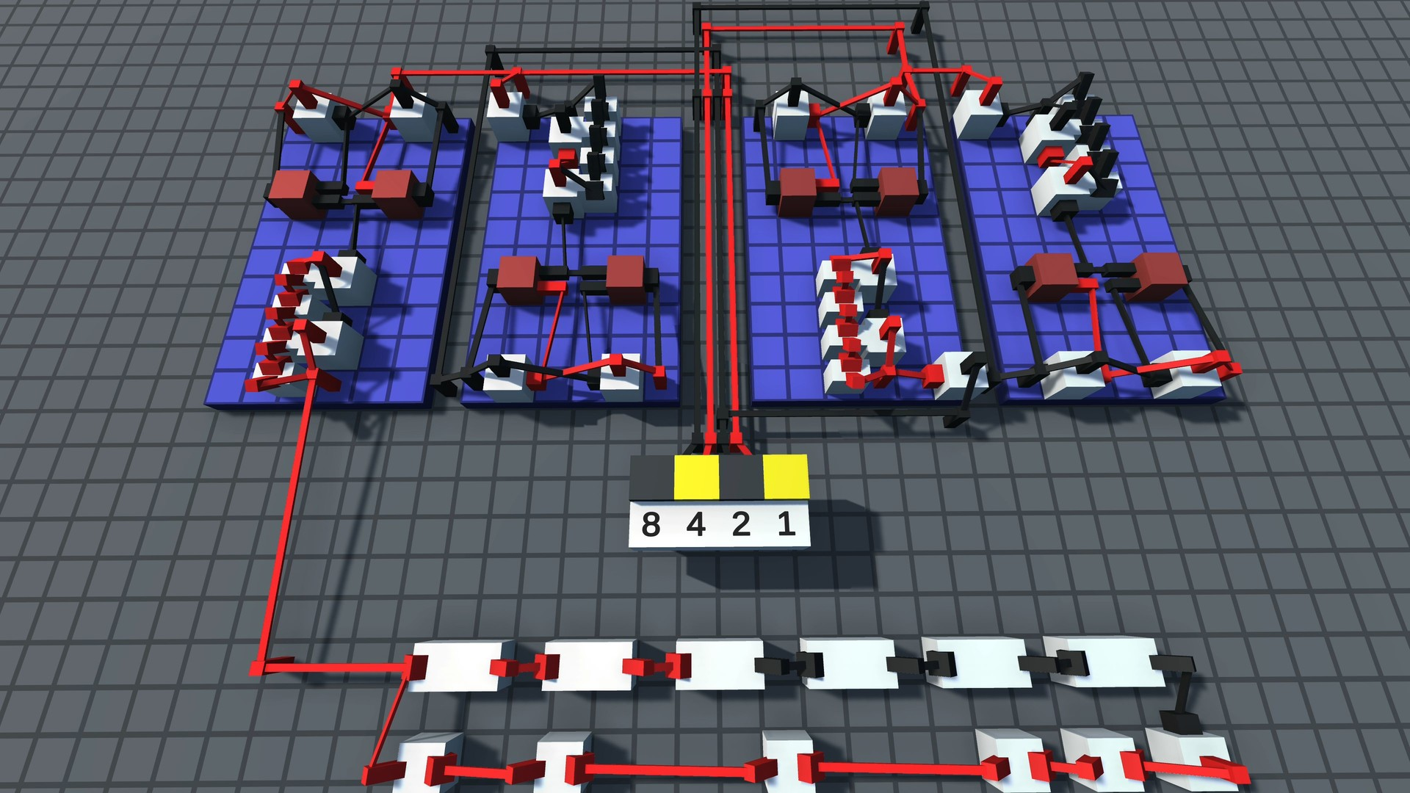
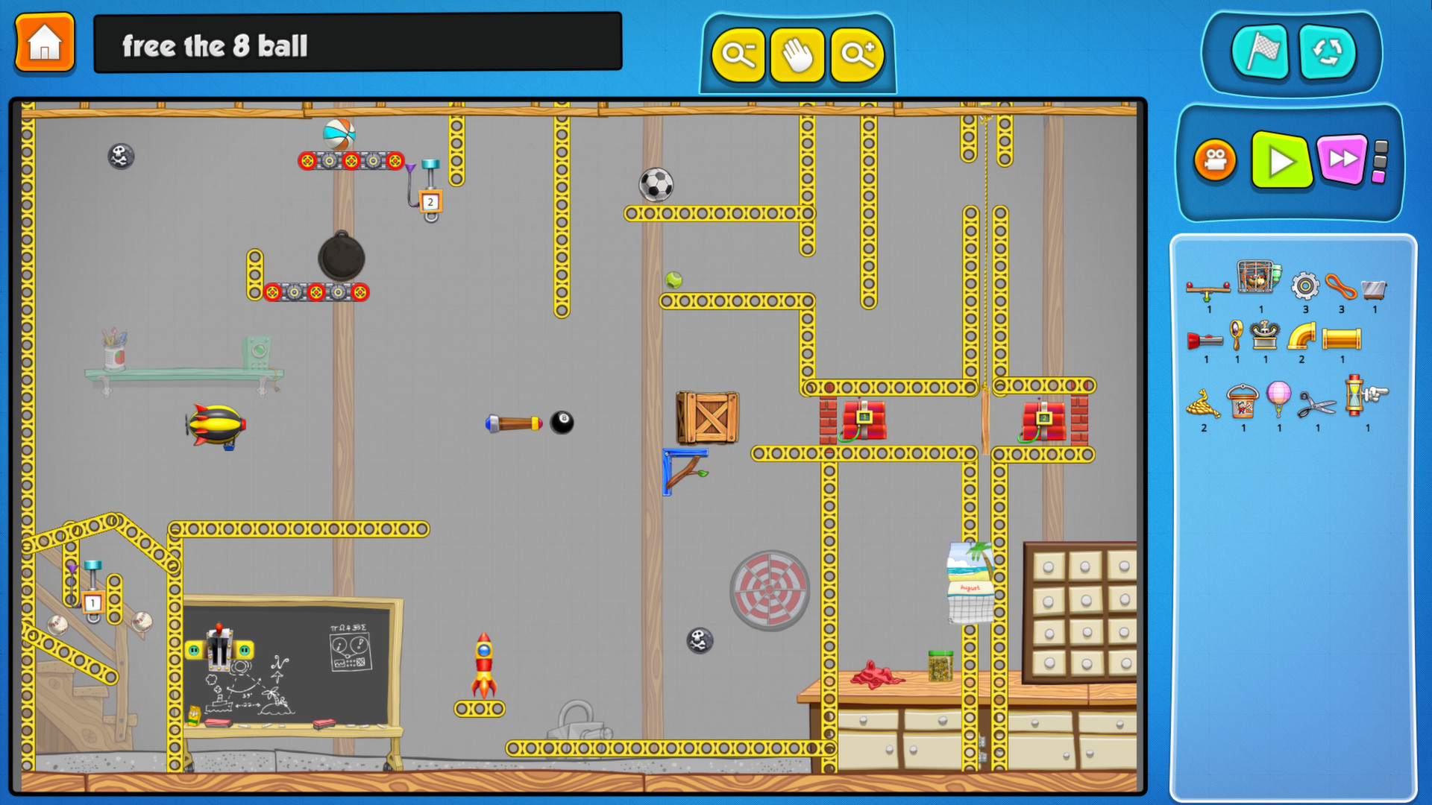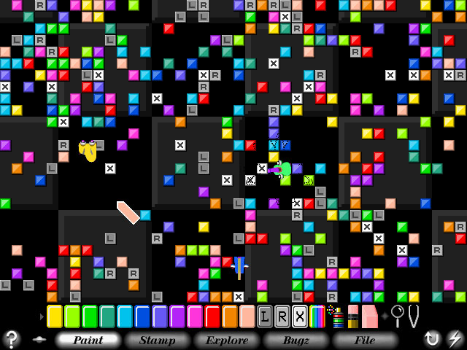
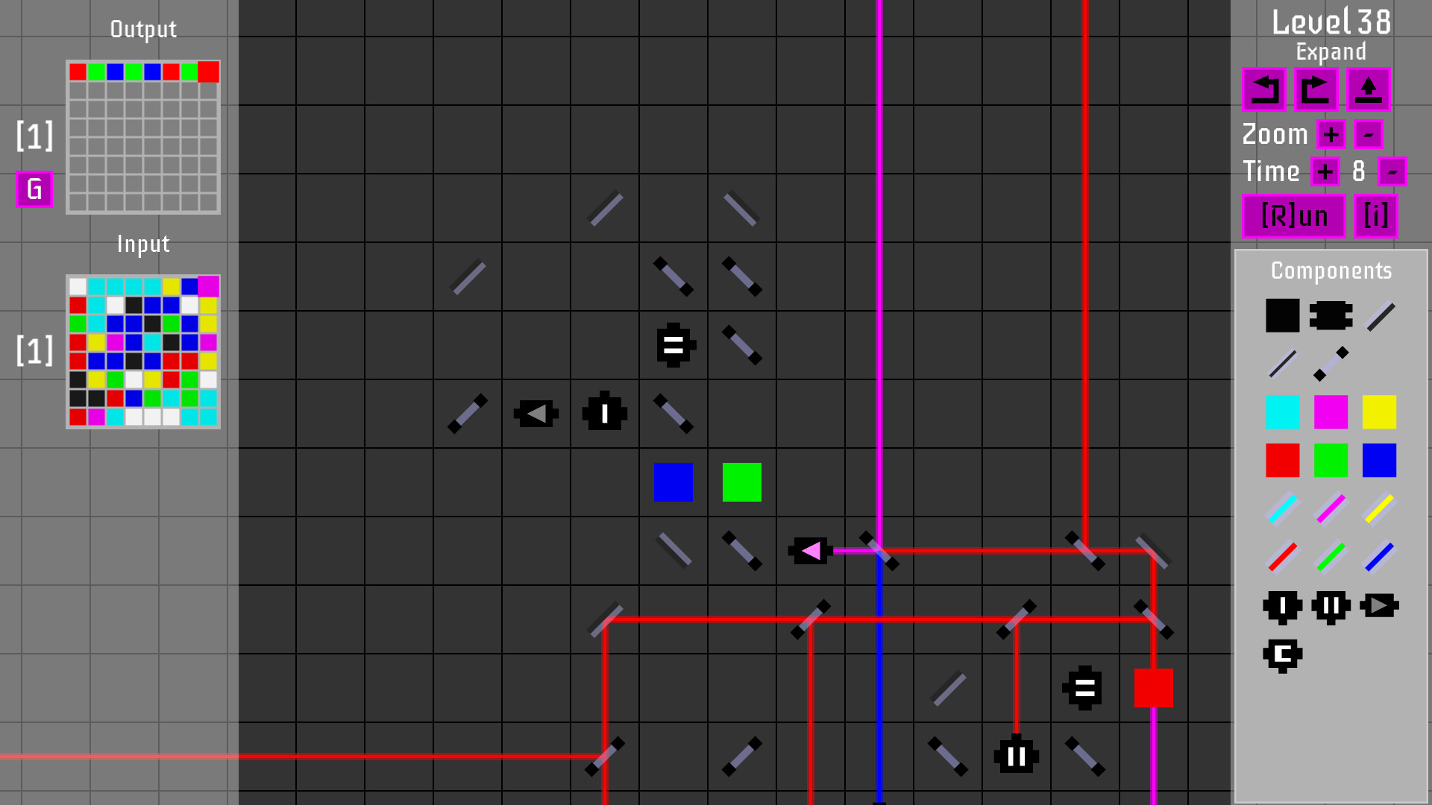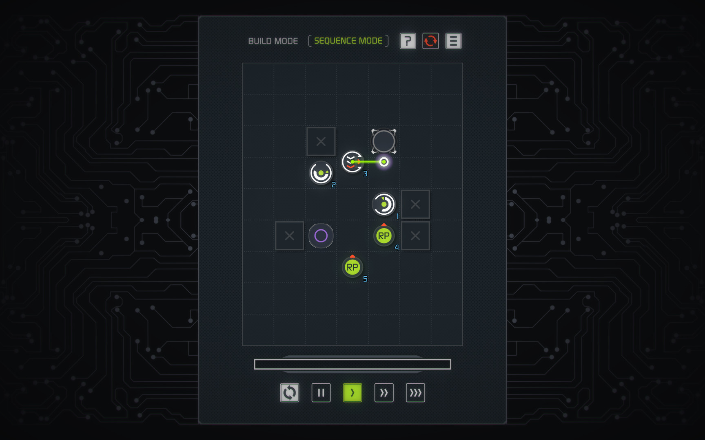
Left-to-right, top-to-bottom: Magnum Opus, Prime Mover, Spacechem, Shenzhen IO, God is a Cube, Logic World, Contraption Maker, SimTunes, Octopticom, The Sequence

