Module [[module|n.n]]: [[module|sub-name]]
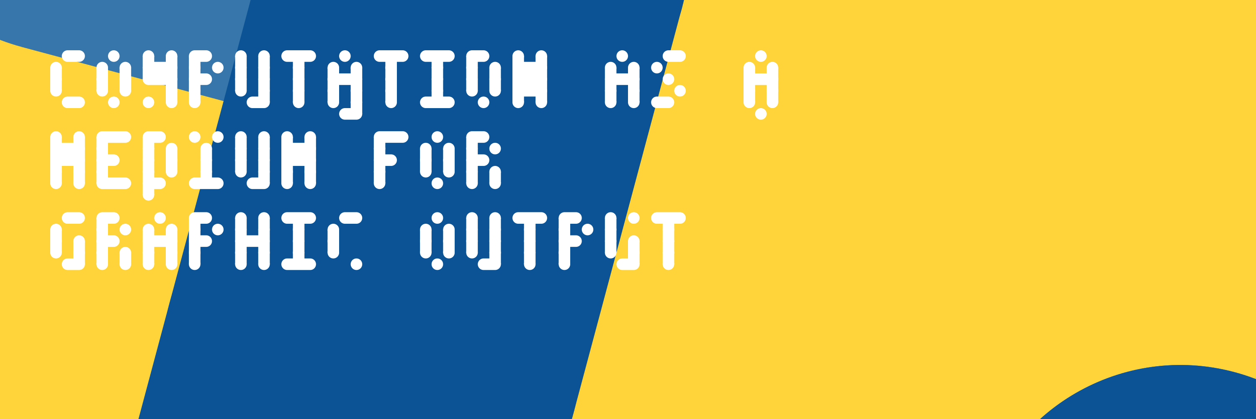
Welcome to Module 1. This module introduces a shift in thinking: from using design software as a tool for producing visual output (i.e. Photoshop or Inkscape) to authoring a system that produces visual output. Rather than clicking and dragging in a graphical interface, you'll write code that describes what should appear on screen. Specifically, you'll use Python to describe everything: shapes, positions, colours, and (later) motion.
This is not a traditional programming course. You're not learning Python for software engineering, per se. You're learning it because it gives you a precise, repeatable, and infinitely flexible way to describe visual outcomes. And, looking further, to combine those techniques with various analytical libraries for data visualisation projects.
[[includes|expectations_module.md]]

Subject Learning Outcomes
This module will help you achieve the following outcomes:
[[outline]].slo.a
[[outline]].slo.b

