

Stackoverflow data
Summary of studies

Wojtek Taisner
Postolovski Dragan

Jan 2019

Brief description
In order to further contribute to and enrich the results and accuracy of our main question investigation, our group has selected three studies to summarize, studies which we deem to be tightly related to our main investigation.

Summary of literature

Study 1:
Understanding the factors for fast answers in technical Q&A websites –
An empirical study of four stack exchange websites
Shaowei Wang, Tse-Hsun Chen, Ahmed E. Hassan
Summary:
This study’s goal is to quantify the time as a variable in the process of getting an answer to a question. The dataset of this study is relatively small when compared to those of the other studies included in this document and it includes 55.853 questions. The study also includes roughly 80.000 questions from three other Stack Exchange websites, but since the questions are distinctly processed, we will ignore all others and only get the results that were produced from analyzing the Stackoverflow questions.
The main approach was to first and foremost structure the inquiries using more than 40 different factories split over 4 dimensions,
- question
- asker
- answer
- answerer.

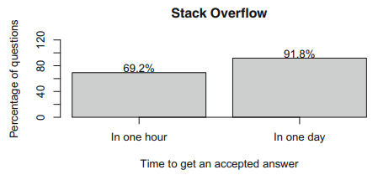

Through case studies, the researchers concluded that there is a strong relation between the factors in the ‘answerer’ dimension and the time needed to get an accepted answer. Moreover, the analysis showed that more than a half of the answered questions had received their accepted answer in less than an hour. The figure above shows a histogram of this conclusion. The study also showed that in general, the longer the question is, the longer it takes for an accepted answer to be posted. Lastly, the study showed that the number of code blocks that the question contained had no significant effect on the time it took to get an accepted answer.

Study 2:
Mining Successful Answers in Stack Overflow
F. Calefato, F. Lanubile, M.C. Marasciulo, N. Novielli
Summary:
This study’s dataset goes more in depth than the sets of the other two analyzed studies. It first uses general metrics such as number of words per answer, score, time elapsed etc. to analyze the data, but it also tries to determine how the language emotion used while writing questions and answers affects the popularity and usefulness of the posts as well.
According to the results of the study, among all of the metrics used to quantify the usefulness of an answer, the most significant affect on the outcome actually had the emotional language the user used while writing. The study shows that answer written with positive sentiment (ex.” Thanks for the feedback! It was a pleasure!”) were more likely to be marked as useful, i.e. be accepted.

Study 3:
Want a Good Answer? Ask a Good Question First!
Yuan Yao, Hanghang Tong, Tao Xie
Summary:
This study’s main objective was to try and analyze the quality of questions and answer that get posted on stackoverflow.

The dataset on which the study worked contained 1.815.140 questions and 3.577.041 answers associated answers.
The key finding of the study was that the quality of an answer is strongly tied and dependent on the quality of the question to which it was posted(depicted in the figure below). The study marks three contributions which are deemed as the highlights of the study. Those are:
- Findings -> while empirically studying the data, the study finds that the score of each post is the primary quality indicator.
- Algorithms -> the study proposes several regression and classification algorithms to predict the quality of questions and answers considering the quantifying numerical scores of each of them, thus differentiating high-quality posts versus low-quality posts.
- Evaluations -> to support the accuracy and effectives of the methods applied, the study extensively evaluated and re-evaluated their results.
