Deep Learning Practice Report

Report Information
Field | Your entry
Student name | Anna Malinovskaia
Assignment | Practice 3 - Diamonds Regression
Date | 30 September 2026

1. Objective
I trained a neural network to predict the price of a diamond from its size, cut, colour and clarity, and checked how good the prediction is. I also made the Dense layers four times wider to see whether a bigger network helps.

2. Setup: Data, Model, and Training
What to describe | Your entry
Data & target | Diamonds dataset from seaborn. 53,940 rows, 9 features, target is the price in dollars. Prices run from $326 to $18,823, the average is $3,933. Split: 32,364 rows for training, 10,788 for validation, 10,788 for test.
Preprocessing | Three features are text: cut, color and clarity. They are not simple categories, they have an order - Ideal is better than Fair, colour D is better than J. So they are coded by that order, from worst to best, and not alphabetically.  Both the features and the price are scaled with StandardScaler. The price is scaled back to dollars before the metrics are calculated, so RMSE and MAE are in dollars.
Model architecture(s) | Baseline (the architecture from regression.py): Dense 64, dropout 0.2, Dense 32, dropout 0.2, Dense 16, Dense 1. All hidden layers use relu, the output is linear. 3,265 parameters.  Tuned: the same shape but four times wider - Dense 256, dropout 0.2, Dense 128, dropout 0.2, Dense 64, Dense 1. 43,777 parameters.  Only the width of the Dense layers was changed. Depth, dropout and everything else stayed the same.
Training configuration | Optimizer Adam, loss MSE, metric MAE, batch size 256, up to 20 epochs. Early stopping with patience 5 and restore of the best weights, plus ReduceLROnPlateau. Learning rate 0.01 for Baseline and Tuned, and 0.001 for the third variant. Hardware: CPU.  Every configuration was trained 5 times from scratch, because one run is not enough - see the results.

3. Results

Regression metrics (Diamonds)
Model | RMSE | MAE | R²
Baseline (64-32-16) | 811 ± 51 | 542 ± 48 | 0.9585 ± 0.0051
Tuned (256-128-64) | 740 ± 62 | 490 ± 39 | 0.9654 ± 0.0056
Tuned, lr 0.001 | 690 ± 44 | 450 ± 25 | 0.9699 ± 0.0038

All numbers in the table are the average of 5 runs with the spread after the sign. The plots below come from the first run of each configuration.
Baseline:
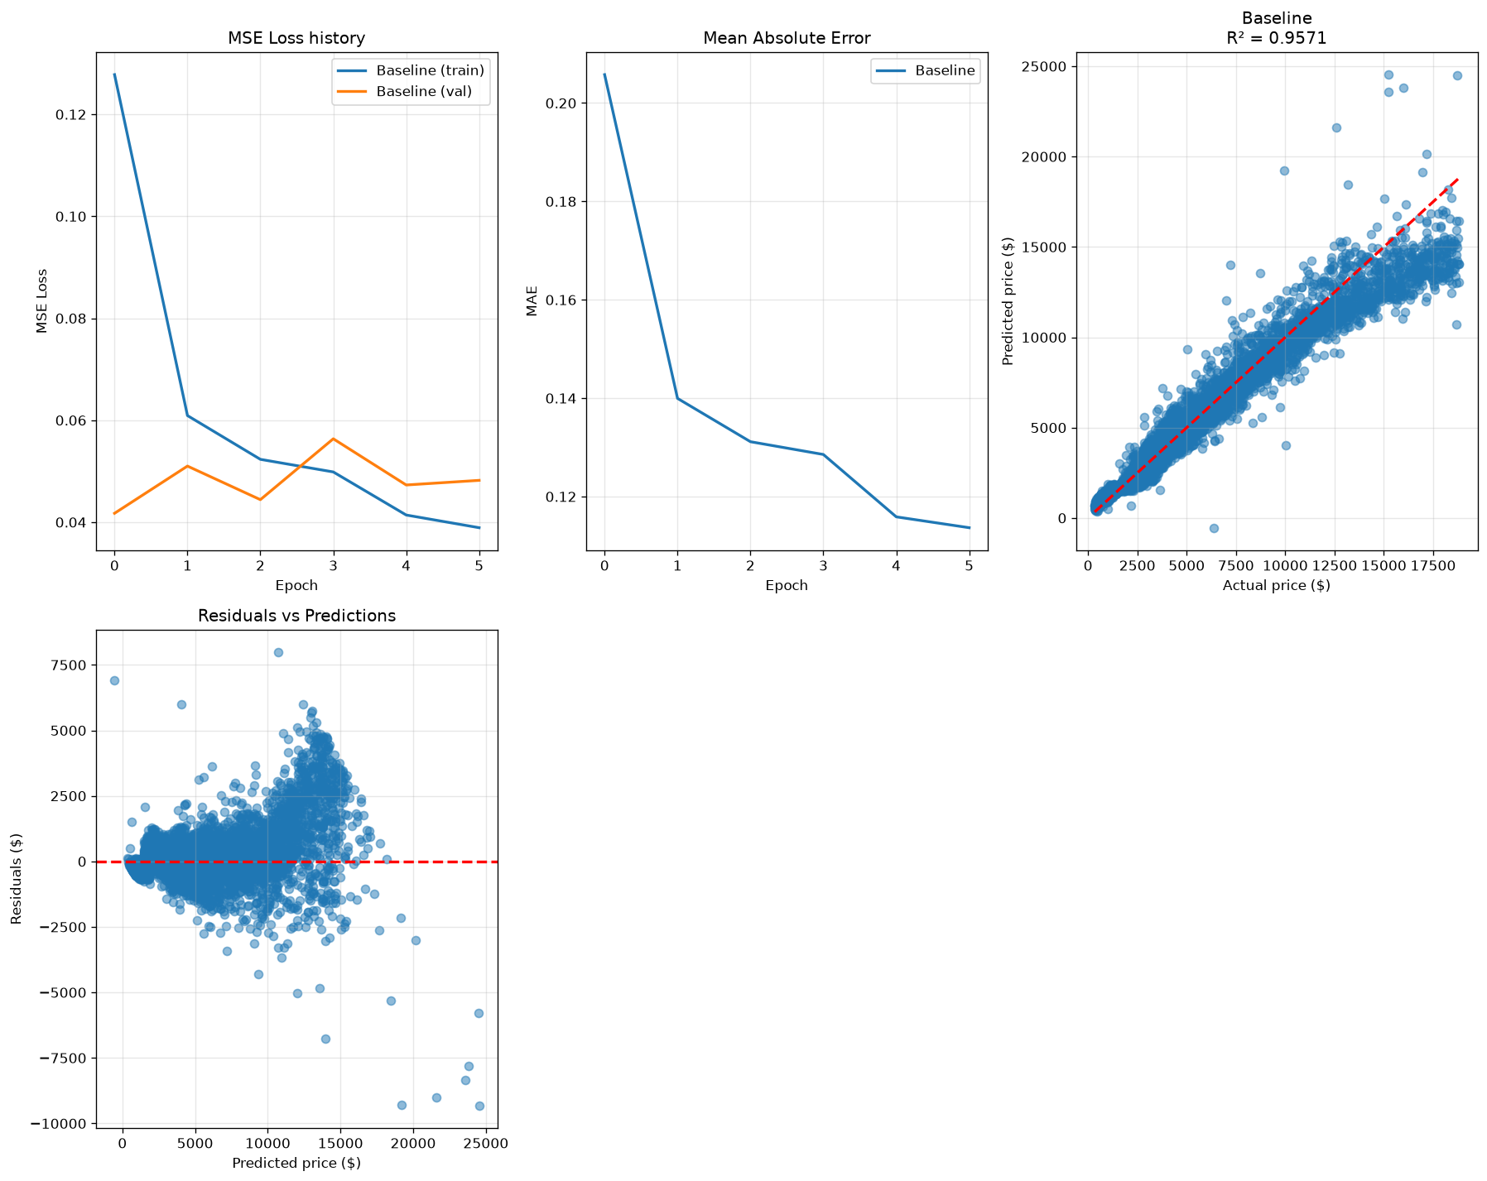
Tuned:
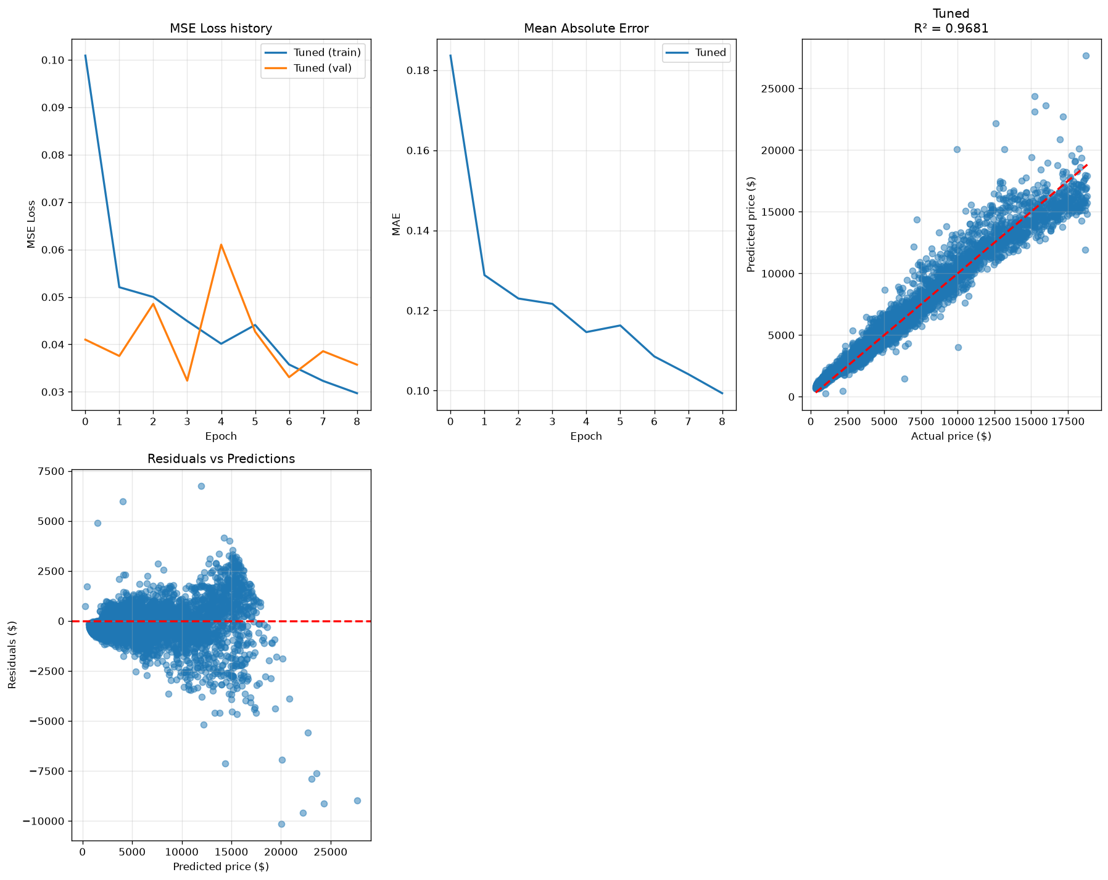
Tuned with learning rate 0.001:
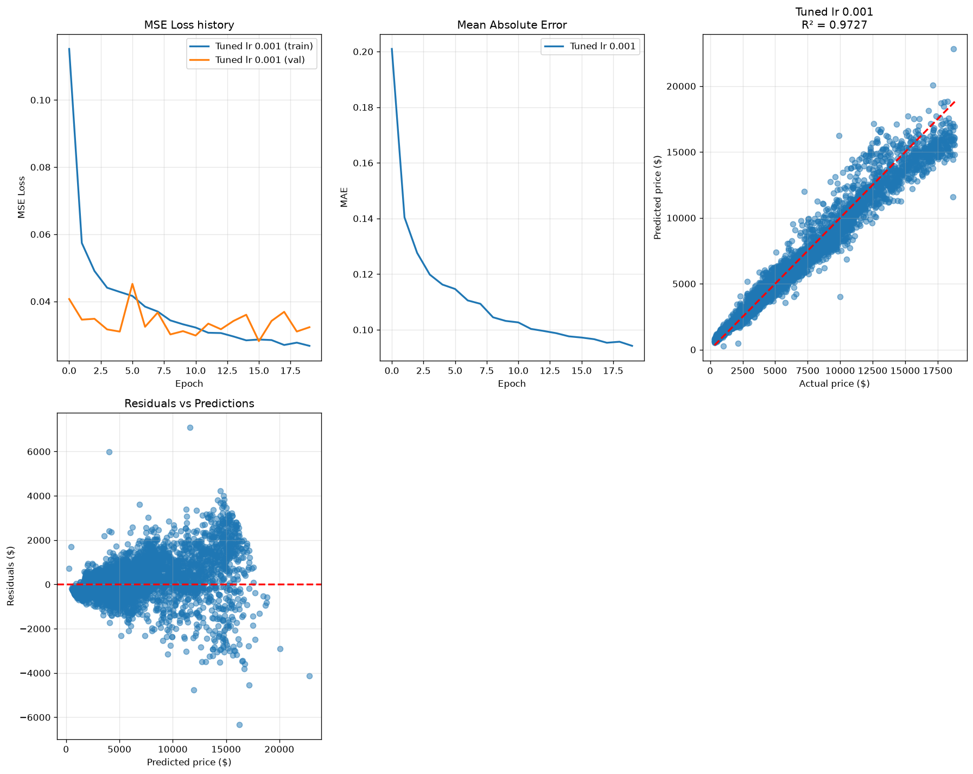
The loss drops fast in the first two or three epochs and then stays flat, so there is no overfitting. The validation curve is not smooth, it jumps from epoch to epoch. With learning rate 0.01 the best epoch was epoch 1 in some runs and epoch 15 in others. With 0.001 the jumps are smaller and the best epoch comes later.
The best result is the wider network with learning rate 0.001: R2 0.9699 against 0.9585 for the baseline, and the average error is $450 instead of $542. One run is not enough to see this. In one of my runs the baseline got 0.9650 and the tuned network 0.9599, so the baseline looked better. Over 5 runs the ranges overlap: 0.9529-0.9650 and 0.9599-0.9736.

4. Error Analysis
The actual-vs-predicted scatter and the residual plot are inside the figures above, in the third and fourth panel of each. The table below shows the average error split by price range.
Price range | Diamonds | Mean price | MAE | MAE as % of price
under $1k | 2961 | $707 | $385 | 55%
$1k-2.5k | 2550 | $1,652 | $239 | 15%
$2.5k-5k | 2400 | $3,707 | $274 | 7%
$5k-10k | 1844 | $6,940 | $550 | 8%
over $10k | 1033 | $13,689 | $1,301 | 10%
In dollars the biggest errors are on expensive diamonds: $1,301 on average above $10,000, against $274 in the middle range. As a share of the price it is the other way round: 55% on diamonds under $1,000 and 10% on expensive ones.
The reason is the loss function. MSE measures the error in dollars and squares it, so errors on expensive diamonds count much more than errors on cheap ones. RMSE is $690 while MAE is $450, and this difference means there are some very large misses.

5. Conclusions
- One run is not enough to compare two architectures. Over 5 runs the baseline gave R2 from 0.9529 to 0.9650 and the tuned network from 0.9599 to 0.9736. The ranges overlap, so one run can show either of them as the winner. In my first attempt it did.
- Making the Dense layers four times wider helps a little: R2 goes from 0.9585 to 0.9654, for 13 times more parameters (3,265 against 43,777). Lowering the learning rate from 0.01 to 0.001 on the same wide network gives more: R2 0.9699, and the spread between runs drops from 0.0056 to 0.0038.
- What worked: coding cut, colour and clarity by their order, and scaling the target back to dollars so the metrics can be read directly. No model overfits, the loss curves flatten and early stopping fires before epoch 20.
- What did not work: learning rate 0.01 on the wide network. The best epoch jumped between 1 and 15 from run to run, so the training was unstable. Early stopping still returned a good result, but the final numbers do not show this problem.
- Next I would predict the logarithm of the price. The model is off by 55% on cheap diamonds because MSE in dollars gives them little weight, and a log target makes the error relative. I would also fix the random seed and keep averaging over 5 runs.

