Deep Learning Practice Report

Report Information
Field | Your entry
Student name | Anna Malinovskaia
Assignment | Practice 4 - MNIST Classification
Date | 30 September 2026

1. Objective
I trained two small neural networks to recognise handwritten digits from MNIST and compared them. One model is small, the other has 35 times more parameters. I wanted to see whether the bigger model is really better on such a simple task.

2. Setup: Data, Model, and Training
What to describe | Your entry
Data & target | MNIST from torchvision. 70,000 grey pictures 28x28 pixels, 10 classes - digits from 0 to 9. Split: 54,000 for training, 6,000 for validation, 10,000 for test. The training part was split 90/10 with seed 42, the test part is the standard MNIST test set.
Preprocessing | Normalization with the MNIST mean 0.1307 and standard deviation 0.3081, so pixel values are centred around zero.  Augmentation for training data only: random crop with padding 2, rotation up to 10 degrees, horizontal flip with probability 0.1. It makes training harder so the model does not just memorise the pictures.  Validation and test data are not augmented, otherwise the measurement would jump every run.
Model architecture(s) | VerySimpleCNN: conv 1 to 16 (5x5), maxpool, conv 16 to 32 (5x5), maxpool, then two fully connected layers 512 to 64 and 64 to 10. Total 46,730 parameters.  SimpleCNN: four conv layers 1 to 32, 32 to 64, 64 to 128, 128 to 256 (all 3x3), three maxpool layers, then three fully connected layers 2304 to 512, 512 to 128, 128 to 10, with dropout 0.5 between them. Total 1,634,954 parameters.  SimpleCNN has 35 times more parameters.
Training configuration | Optimizer Adam, learning rate 0.001, loss CrossEntropyLoss, batch size 128, 10 epochs. Early stopping with patience 3 was on but never triggered, both models ran all 10 epochs. Hardware: CPU. Both models got exactly the same data split.

3. Results

Classification metrics (MNIST)
Model | Test accuracy | F1 (macro) | Parameters
VerySimpleCNN | 99.00% | 0.9899 | 46,730
SimpleCNN | 99.30% | 0.9930 | 1,634,954

Training and validation curves, VerySimpleCNN:
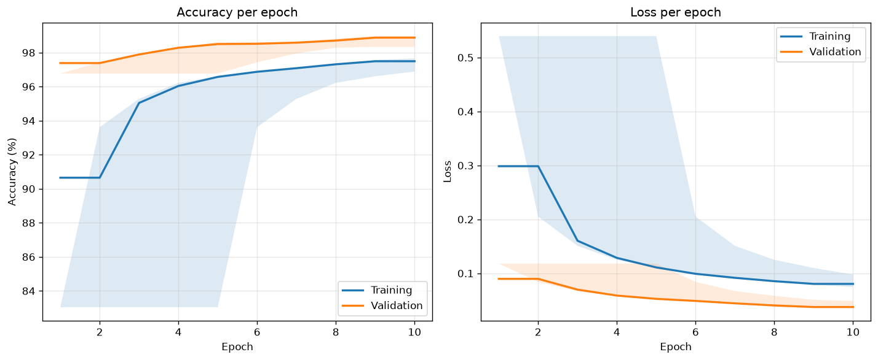
Training and validation curves, SimpleCNN:
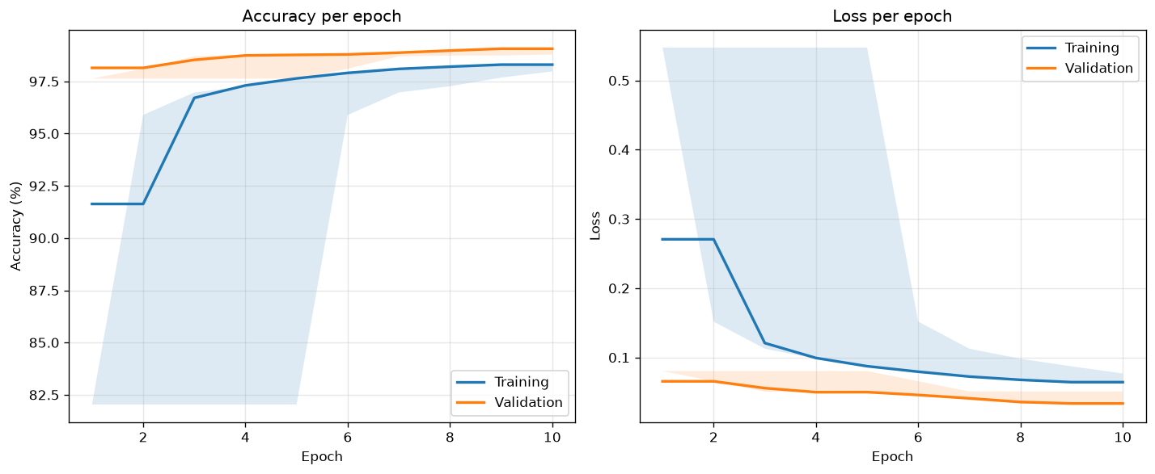
Both plots show a flat line at the end and no overfitting. Validation accuracy is even a bit higher than training accuracy: the gap is -1.19% for VerySimpleCNN and -0.77% for SimpleCNN. This is because training pictures are rotated and cropped while validation pictures are not, so training is the harder task.
SimpleCNN is better: 99.30% against 99.00%, so 0.30 percentage points more. In real numbers it makes 70 mistakes out of 10,000 test pictures, and VerySimpleCNN makes 100. That is 30 mistakes less.

4. Error Analysis
Confusion matrix, VerySimpleCNN:
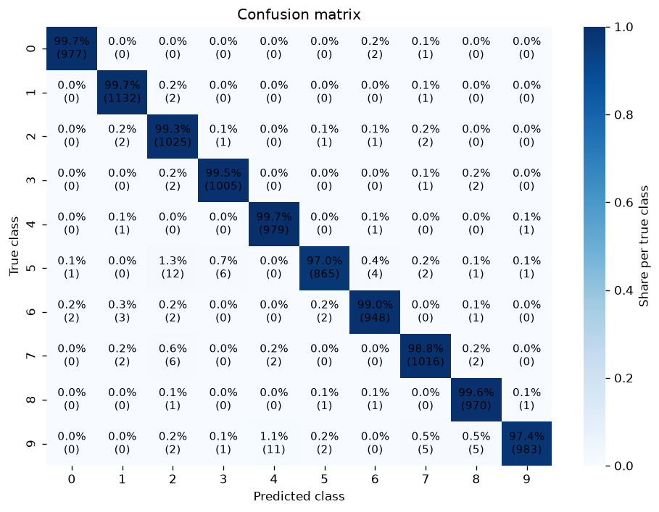
Confusion matrix, SimpleCNN:
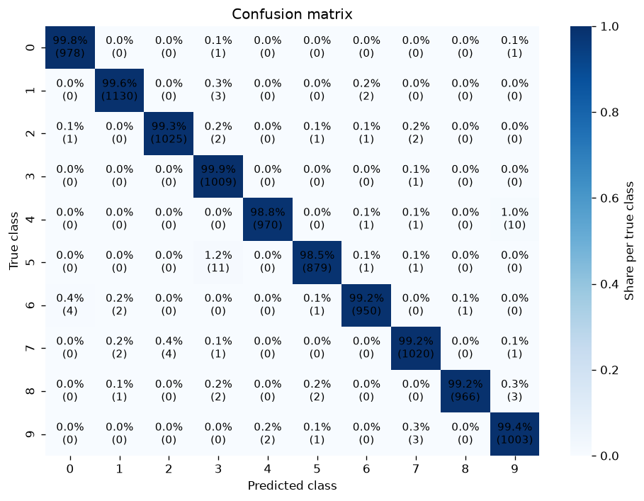
The most frequent mistakes of VerySimpleCNN: 5 taken for 2 (12 times), 9 taken for 4 (11 times), 7 taken for 2 (6 times).
The most frequent mistakes of SimpleCNN: 5 taken for 3 (11 times), 4 taken for 9 (10 times), 7 taken for 2 (4 times).
Both models fail on the same digits. The worst class for VerySimpleCNN is 5 with F1 0.981, for SimpleCNN the worst are 3, 5 and 9, all with F1 0.990. These are digits that look alike when written by hand: 5 and 3 have the same upper curve, 4 and 9 differ only by a closed or open top, 7 and 2 both have a long diagonal line.
SimpleCNN has four conv layers instead of two, so it looks at the picture in more steps: first short strokes, then whole shapes. A closed loop of 9 against an open top of 4 is the kind of detail that needs these extra steps. It also uses dropout, which VerySimpleCNN does not have.

5. Conclusions
- A model 35 times bigger gives only 0.30 percentage points more accuracy: 99.30% against 99.00%. MNIST is an easy dataset and the small model already handles it well.
- SimpleCNN has 35 times more parameters but trains only about 1.2 times slower: 239 ms per batch against 201 ms on CPU. Most of its parameters sit in the fully connected layers, which are cheap to compute compared to the convolutions. In return it makes 30 fewer mistakes out of 10,000. So the big model costs mainly memory, while training time stays almost the same.
- What worked: the augmentation and the dropout. Neither model overfits - the gap between training and validation accuracy is -1.19% for VerySimpleCNN and -0.77% for SimpleCNN, so validation is even a bit better than training. Both models are also well calibrated, with a calibration error of 0.002: when a model says it is 95% sure, it is right in about 95% of cases.
- What did not work: early stopping. It was set with patience 3, but it never triggered - both models kept improving for all 10 epochs. Training ended only because the epochs ran out, so the limit of 10 was probably too low.
- What I would try next: train both models for 20-30 epochs instead of 10, since they were still improving at epoch 10 and early stopping would then have something to catch. I would also remove the horizontal flip from the augmentation - a mirrored digit is not a real digit, and the lecture code itself marks this transform as questionable for digits.

